Bridger-Teton National Forest RAP Data Summary
Matthew Van Scoyoc
2025-06-04
Table of contents
1. Introduction 1
2. Area of Analysis 1
3. Biomass Data 2
4. Cover Data 2
5. References 2
6. Session Info 3

1. Introduction
The Rangeland Analysis Platform (RAP) hosts above-ground biomass and plant cover estimates derived from LANDSAT imagery. RAP above-ground biomass and plant cover data (USDA Agricultural Research Service 2025) from 1986 to 2024 were downloaded on 20 May 2025 using the rpar package (version 1.0.0; Brown 2025) in R (version 4.4.3; R Core Team 2025).

2. Area of Analysis
Alpine and sagebrush ecosystems were identified by Bridger-Teton NF staff as non-forested systems in need of additional data to help inform decision making. LANDFIRE Bio-physical Setting (BpS) data were used to identify the spatial extent of these ecosystems on the Forest (Figure 1). Rocky Mountain Alpine/Montane Sparsely Vegetated Systems, Rocky Mountain Alpine Dwarf-Shrubland, and Rocky Mountain Alpine Turf were selected for alpine ecosystems. Inter-Mountain Basins Montane Sagebrush Steppe and NA were selected for sagebrush ecosystems. RAP data were downloaded for the entire administrative forest boundary and then clipped to the alpine and sagebrush ecosystems for these analyses.
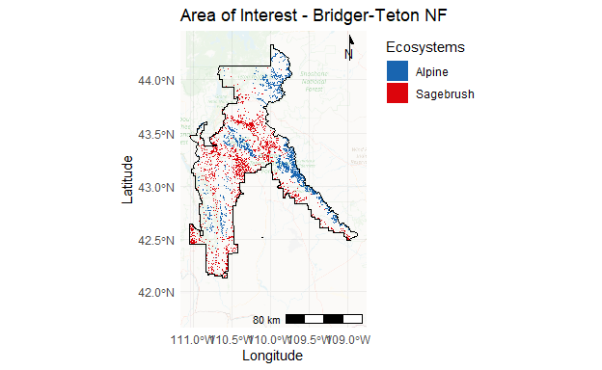

3. Biomass Data
Below is a figure of average annual above-ground biomass (lbs/acre) from 1986 to 2024 for alpine and sagebrush ecosystems (Figure 2).

4. Cover Data
Below is a figure of percent vegetation cover from 1986 to 2024 for alpine and sagebrush ecosystems (Figure 3).

5. References
Brown, A. (2025). rapr: Interface to Rangeland Analysis Platform (RAP) Vegetation Biomass and Cover Products. R package version 1.0.0. http://github.com/brownag/rapr.
Posit team. 2024. RStudio: Integrated Development Environment for R. Posit Software, PBC, Boston, MA. URL http://www.posit.co/.
R Core Team. 2025. R: A language and environment for statistical computing. R Foundation for Statistical Computing, Vienna, Austria. URL https://www.R-project.org/.
USDA Agricultural Research Service. 2025. Rangeland Analysis Platform. https://rangelands.app/. Accessed 20 May 2025.

6. Session Info
This data-driven report was generated using Quarto (version 1.4.555) and R (version 4.4.3; R Core Team 2025) in RStudio (version 2024.4.2.764; Posit team 2024). The following output contains information about the environment this script was run in, including the operating system, R version, and packages used.
R version 4.4.3 (2025-02-28 ucrt)
Platform: x86_64-w64-mingw32/x64
Running under: Windows 11 x64 (build 22631)
Matrix products: default
locale:
[1] LC_COLLATE=English_United States.utf8
[2] LC_CTYPE=English_United States.utf8
[3] LC_MONETARY=English_United States.utf8
[4] LC_NUMERIC=C
[5] LC_TIME=English_United States.utf8
time zone: America/Denver
tzcode source: internal
attached base packages:
[1] stats graphics grDevices utils datasets methods base
other attached packages:
[1] lubridate_1.9.4 forcats_1.0.0 dplyr_1.1.4 purrr_1.0.4
[5] readr_2.1.5 tidyr_1.3.1 tibble_3.2.1 ggplot2_3.5.2
[9] tidyverse_2.0.0 tidyterra_0.7.2 terra_1.8-50 stringr_1.5.1
[13] sf_1.0-20 scales_1.4.0 remotes_2.5.0 prettymapr_0.2.5
[17] ggtext_0.1.2 ggspatial_1.1.9 cowplot_1.1.3
loaded via a namespace (and not attached):
[1] gtable_0.3.6 xfun_0.52 processx_3.8.6 tzdb_0.5.0
[5] ps_1.9.1 vctrs_0.6.5 tools_4.4.3 generics_0.1.4
[9] curl_6.2.2 proxy_0.4-27 pkgconfig_2.0.3 KernSmooth_2.23-26
[13] RColorBrewer_1.1-3 lifecycle_1.0.4 compiler_4.4.3 farver_2.1.2
[17] codetools_0.2-20 htmltools_0.5.8.1 class_7.3-23 yaml_2.3.10
[21] later_1.4.2 pillar_1.10.2 classInt_0.4-11 abind_1.4-8
[25] tidyselect_1.2.1 digest_0.6.37 rosm_0.3.0 stringi_1.8.7
[29] quarto_1.4.4 fastmap_1.2.0 grid_4.4.3 cli_3.6.5
[33] magrittr_2.0.3 dichromat_2.0-0.1 e1071_1.7-16 withr_3.0.2
[37] timechange_0.3.0 rmarkdown_2.29 png_0.1-8 hms_1.1.3
[41] evaluate_1.0.3 knitr_1.50 rlang_1.1.6 gridtext_0.1.5
[45] Rcpp_1.0.14 glue_1.8.0 DBI_1.2.3 xml2_1.3.8
[49] rstudioapi_0.17.1 jsonlite_2.0.0 R6_2.6.1 plyr_1.8.9
[53] units_0.8-7

