Species Occurrnece Data Acquisition
  - White River National Forest
Matthew Van Scoyoc
2025-02-28
Table of contents
1. Overview 2
1.1 Data Sources 2
1.2 Data Limitations 3
1.3 Taxonomic Validation 4
2. Area of Analysis 4
3. Colorado Natural Heritage Program Data 5
4. Global Biodiversity Information Facility Data 6
5. SEINet Data 7
6. Integrated Monitoring in Bird Conservation Regions Data 8
7. Forest Service Data 9
8. References 10
9. Session Info 11

1. Overview
Land management plan revision requires information about species occurrences to inform the revision process. Species occurrence data form state natural heritage programs (NHPs) and publicly accessible repositories can be leveraged to answer species occurrence questions for a national forest or grassland. This document describes the data acquisition, or data pull, process and provides brief summaries of each data set. The majority of this process uses R (version 4.4.2; R Core Team 2024) for repeatability and consistency across land management planning areas.

1.1 Data Sources
Species occurrences records were pulled for a 1-km buffer around the administrative boundary of White River National Forest. These data were clipped to the forest service owned lands, or plan area, for these analyses. Below is a description of each data set used.

1.1.1 State Natural Heritage Programs
State Natural Heritage Programs (NHPs) provide species occurrence data, and habitat and distribution models for federal, state, and non-governmental agencies throughout their state. Spatial element occurrence (EO) data from the Colorado NHP was acquired and used in these analyses.

1.1.2 Global Biodiversity Information Facility
Global Biodiversity Information Facility (GBIF; Global Biodiversity Information Facility 2022a) is a repository of externally sourced species occurrence records from museum collections, academic studies, and citizen science programs. GBIF records requests are staged on GBIF servers and have to be downloaded. See Getting Occurrence Data From GBIF for details. An R script submits a records request using the 1-km buffer around the administrative boundary to spatially query GBIF records in Darwin Core Archive format (GBIF, 2022b) for full data provenance. The data are downloaded, unzipped, and read in to R once the request is available using the rgbif package (version 3.7.8; Chamberlain et al. 2023).

1.1.3 SEINet
SEINet is a data portal that provides a suite of data access tools, including species occurrence data from museums, collections, and state and federal agencies. SEINet data are available through an online data portal and are downloaded manually. A polygon box, or well-known text (WKT) footprint, is drawn around the administrative boundary to query species observations using the Taxonomic Criteria search page (https://swbiodiversity.org/seinet/collections/harvestparams.php). The query results were downloaded in Darwin Core Archive format, manually unzipped, and a script reads them into R.

1.1.4 Integrated Monitoring in Bird Conservation Regions
The Integrated Monitoring in Bird Conservation Regions (IMBCR) is a long-term avian monitoring program coordinated by the Bird Conservancy of the Rockies, and maintains monitoring plots on public lands throughout Forest Service Regions 1-4. IMBCR data spanning 2008-2023 were obtained for Forest Service lands on 12 December, 2023, for use in these analyses (Bird Conservancy of the Rockies 2023). These data were received in and Excel file and an script reads them into R.

1.1.5 Forest Service Data
Wildlife, aquatic biota, rare plant, and invasive plant data from the the Forest Service Enterprise Data Warehouse (EDW), the corporate spatial data repository for the Forest Service, was acquired and clipped to the plan area using ArcGIS Pro (version 3.3.1; ESRI 2024). A script reads them into R.

1.2 Data Limitations

1.2.1 Occurrence Data
These are occurrence, or presence-only, data and can document the presence of species in an area of interest. Probable or possible presence is not quantified, and most importantly, these data cannot determine the absence or abundance of a species. Lack of species observations is not evidence of absence: a lack of observation may be because the species is rare in that area, or because no one ever looked for it there. Similarly, the number of occurrence records is not an indicator of abundance. For example, showy flowering plants or rare birds will trigger many more occurrence records relative to their abundance than “less interesting” or common species. Lastly, the source external species occurrence datasets often lack information on collection level of effort and on species absences which is essential for estimating abundance.

1.2.2 Spatial Accuracy
Species occurrence locations are not validated and may include coordinate data of varying and undocumented precision or accuracy. The occurrence records from this data pull have geographic location coordinates in longitude and latitude and may include country and state codes and location descriptors. Each observation may include an estimate of the location uncertainty, which may range from a few meters to several kilometers or may be missing. Any use of the occurrence locations should consider the location uncertainty and/or precision noted for each observation. Recent observations may be generated using GPS technology, while coordinates in older observations may have been read from a map, and very old observations usually include only verbal descriptions of the observation location. Some of the verbal descriptions may be “geo-referenced” using current maps and historic location names. Also, some source datasets may have the location coordinates deliberately fuzzed to protect the location of sensitive species.

1.2.3 Duplicate Records
Some museum and natural history institutions share their data with state heritage programs, GBIF, and iDigBio; therefore, we can assume that some observations are duplicated. This analysis does not attempt to reduce duplicated records. Instead, this analysis assembles a comprehensive list of species known to occur on the forest or grassland. It is not appropriate to sum the number of species occurrences across data sources or to use these data to estimate populations (see @occurrence_data).

1.2.4 Taxonomy
The classification of living organisms changes frequently, as further specimens and newer techniques change our understanding of the relationships among species, and even change our understanding of the boundaries between distinct taxa. The externally sourced data include verbatim scientific names of varying vintage and a matching of a species’ taxonomic concept to the GBIF Backbone Taxonomy (described below in the @taxa_validation section). Each taxonomic system reflected in the GBIF backbone has different policies for when to accept taxonomic revisions and may not include certain suites of taxa like insects, non-vascular plants, and microorganisms. A single scientific name might refer to completely different sets of organisms in the different systems used in the backbone or a group of organisms may have different scientific names applied in the different systems.

1.3 Taxonomic Validation
Taxonomic names were validated against the GBIF Backbone Taxonomy (GBIF Secretariat 2023) using the taxize package (version 0.10.0; Chamberlain and Szocs 2013, Chamberlain et al. 2023) in R. The GBIF Backbone Taxonomy is based on 105 taxonomic checklists including but not limited to the Catalogue of Life, Integrated Taxonomic Information System, and the International Barcode of Life project. The GBIF Backbone Taxonomy was used because it is a comprehensive taxonomic list with over 4 million accepted names and 3 million synonyms that offers flexible and repeatable tools to programmatically validate taxonomies. Every occurrence record from every list in this data pull was validated with the GBIF Backbone Taxonomy and assigned a unique taxonomic identifier that allowed the taxon to be joined to like taxa. The GBIF Backbone Taxonomy also provided a method to resolve taxonomic conflicts between data sources.

2. Area of Analysis
As stated above, species occurrences records were pulled for a 1-km buffer around the administrative boundary of White River National Forest and were clipped to plan area (i.e., Forest Service land, Figure 1).
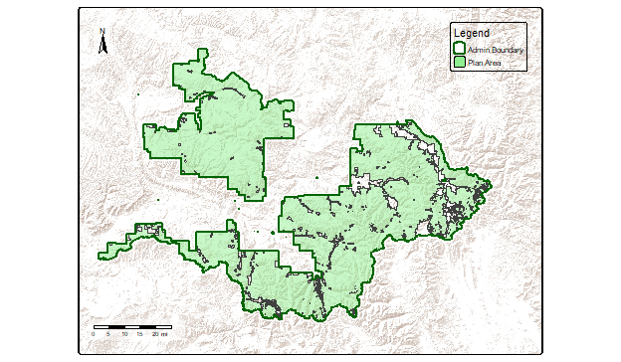
Figure 1. Map of plan area (light green area) showing the administrative boundary (dark green outline).

3. Colorado Natural Heritage Program Data
Data from the Colorado NHP (CNHP) from 2024 were acquired and included in these analyses (Colorado Natural Heritage Program 2024). The data contain 610 records and 46 fields of data. The period of record for the CNHP data spans 1871 to 2023. There are 610 records within the plan area that account for 120 species. Below is a map of the CNHP EO data within the plan area (Figure 2).
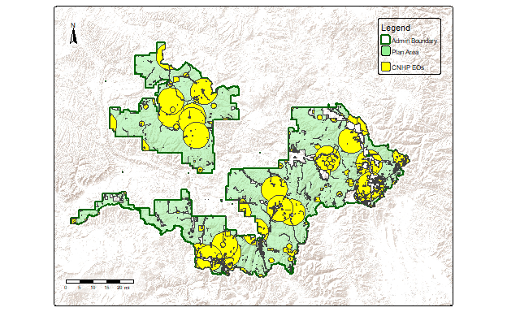
Figure 2. Map of Colorado NHP element occurrence data (yellow areas) within the plan area.

4. Global Biodiversity Information Facility Data
Data was acquired from GBIF on 2 October, 2024, and contain 1,228,353 records and 226 fields of data (Global Biodiversity Information Facility 2024). Records were obtained from 244 sources (e.g., museum collections or citizen science programs). The period of record for the GBIF data spans 1825 to 2024. There are 169,080 records within the plan area that account for 5,506 species. Below is a map of the GBIF species occurrence data within the plan area (Figure 3).
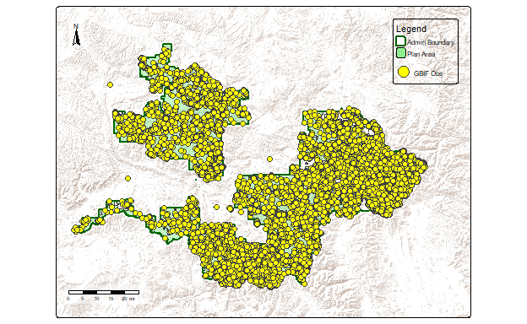
Figure 3. Map of GBIF occurrence data (yellow points) within the plan area.

5. SEINet Data
SEINet data were queried and downloaded on 9 October, 2024, that contian 107,614 records and 95 fields of data (SEINet 2024). Records were obtained from 120 sources. The period of record spans 197 to 9533. There are 29,097 records within the plan area that account for 2,554 species. Below is a map of the SEINet species occurrence data within the plan area (Figure 4).
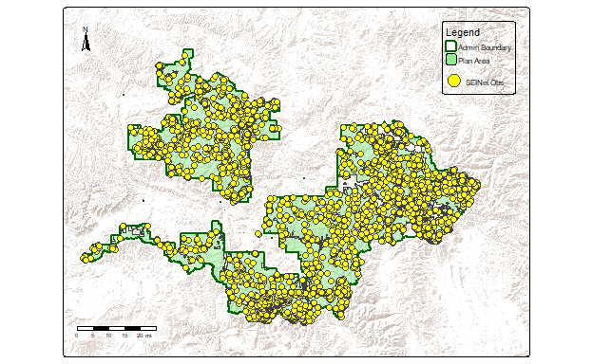
Figure 5. Map of SEINet occurrence data (yellow points) with in the plan area.

6. Integrated Monitoring in Bird Conservation Regions Data
IMBCR data spanning to - were obtained of Forest Service administered lands on 12 December, 2023 (Bird Conservancy of the Rockies 2023). These data contain 44,918 records and 37 fields of data within the administrative boundary of the White River National Forest. There are 40,332 records within the plan area that account for 132 species. Below is a map of the IMBCR species occurrence data within the plan area (Figure 5).
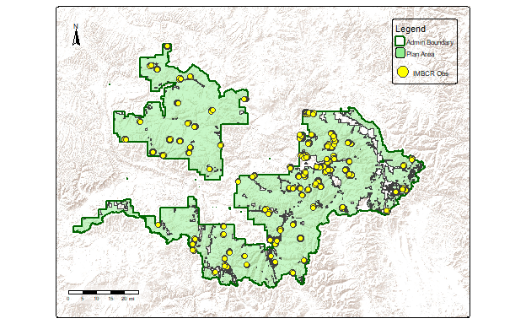
Figure 6. Map of IMBCR occurrence data (yellow points) with in the plan area.

7. Forest Service Data
Wildlife, aquatic biota, rare plant, and invasive plant data from the the Forest Service EDW was acquired on 27 February, 2025 (USDA Forest Service 2024), and clipped to the plan area using ArcGIS Pro (ESRI 2024). These data contain 51,111 records with the period of record spanning 1071 to 6201. Below is a map of the Forest Service species data within the plan area (Figure 6).
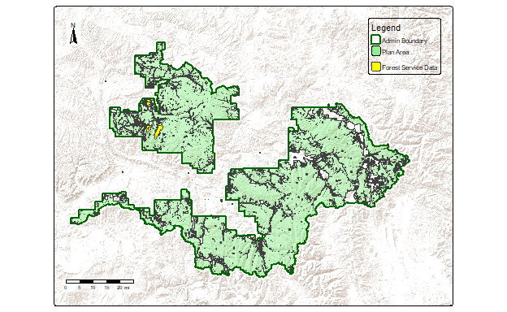
Figure 7. Map of Forest Service species data (yellow areas) within the plan area.

8. References
Bird Conservancy of the Rockies. 2023. Integrated Monitoring in Bird Conservation Regions avian monitoring data. Obtained 2023-12-12.
Chamberlain, Scott, and Eduard Szocs (2013). taxize - taxonomic search and retrieval in R. F1000Research, 2:191. URL: https://f1000research.com/articles/2-191/v2
Chamberlain, Scott, Eduard Szoecs, Zachary Foster, Zebulun Arendsee, Carl Boettiger, Karthik Ram, Ignasi Bartomeus, John Baumgartner, James O’Donnell, Jari Oksanen, Bastian Greshake Tzovaras, Philippe Marchand, Vinh Tran, Maëlle Salmon, Gaopeng Li, and Matthias Grenié. 2020 taxize: Taxonomic information from around the web. R package version 0.10.0. https://github.com/ropensci/taxize
Chamberlain S, Barve V, Mcglinn D, Oldoni D, Desmet P, Geffert L, Ram K. 2023. rgbif: Interface to the Global Biodiversity Information Facility API. R package version 3.7.8. https://CRAN.R-project.org/package=rgbif.
Colorado Natural Heritage Program. 2024. Colorado Natural Heritage Program element occurrence data. Obtained 2024-04-24.
ESRI. 2024. ArcGIS Pro: version 3.3.1. Redlands, CA: Environmental Systems Research Institute.
GBIF Secretariat. 2023. GBIF Backbone Taxonomy. Checklist dataset https://doi.org/10.15468/39omei accessed via GBIF.org on 17 July, 2024.
Global Biodiversity Information Facility. 2022a. GBIF: The Global Biodiversity Information Facility (2022) What is GBIF?. https://www.gbif.org/what-is-gbif.
Global Biodiversity Information Facility. 2022b. What is Darwin Core, and why does it matter? https://www.gbif.org/darwin-core.
GBIF Occurrence Download https://doi.org/10.15468/dl.uj6jd8 Accessed from R via rgbif (https://github.com/ropensci/rgbif) on 2024-10-02.
R Core Team. 2024. R: A language and environment for statistical computing. R Foundation for Statistical Computing, Vienna, Austria. URL https://www.R-project.org/.
Posit team. 2024. RStudio: Integrated Development Environment for R. Posit Software, PBC, Boston, MA. URL http://www.posit.co/.
SEINet Portal Network. 2024. https://swbiodiversity.org/seinet/index.php. Accessed on 9 October, 2024.
US Forest Service, USDA. 2024. Enterprise Data Warehouse. Accessed 27 February, 2024.
Waller, J. 2021. RGBIF: Getting Occurrence Data From GBIF. https://docs.ropensci.org/rgbif/articles/getting_occurrence_data.html.

Table 1. Table Caption.
Column A | Column B | Column C
A | 1 | TRUE
B | 2 | FALSE
C | 3 | NULL

9. Session Info
This data-driven report was generated using Quarto (version 1.4.555) and R (version 4.4.2; R Core Team, 2024) using RStudio (version 2024.4.2.764; Posit team 2024). The following output contains information about the environment this script was run in, including the operating system, R version, and packages used.
R version 4.4.2 (2024-10-31 ucrt)
Platform: x86_64-w64-mingw32/x64
Running under: Windows 11 x64 (build 22631)
Matrix products: default
locale:
[1] LC_COLLATE=English_United States.utf8
[2] LC_CTYPE=English_United States.utf8
[3] LC_MONETARY=English_United States.utf8
[4] LC_NUMERIC=C
[5] LC_TIME=English_United States.utf8
time zone: America/Denver
tzcode source: internal
attached base packages:
[1] stats graphics grDevices utils datasets methods base
other attached packages:
[1] tmap_4.0 targets_1.10.1 sf_1.0-19 lubridate_1.9.4
[5] dplyr_1.1.4
loaded via a namespace (and not attached):
[1] tidyselect_1.2.1 viridisLite_0.4.2 urltools_1.7.3
[4] lazyeval_0.2.2 fastmap_1.2.0 leaflegend_1.2.1
[7] leaflet_2.2.2 stringfish_0.16.0 XML_3.99-0.18
[10] digest_0.6.37 base64url_1.4 timechange_0.3.0
[13] lifecycle_1.0.4 secretbase_1.0.4 processx_3.8.5
[16] terra_1.8-21 magrittr_2.0.3 compiler_4.4.2
[19] rlang_1.1.5 tools_4.4.2 igraph_2.1.4
[22] yaml_2.3.10 data.table_1.16.4 knitr_1.49
[25] htmlwidgets_1.6.4 sp_2.2-0 classInt_0.4-11
[28] curl_6.2.0 xml2_1.3.6 plyr_1.8.9
[31] RColorBrewer_1.1-3 abind_1.4-8 KernSmooth_2.23-26
[34] httpcode_0.3.0 withr_3.0.2 purrr_1.0.4
[37] leafsync_0.1.0 triebeard_0.4.1 grid_4.4.2
[40] cols4all_0.8 e1071_1.7-16 leafem_0.2.3
[43] colorspace_2.1-1 mpsgSE_0.0.0.9000 ggplot2_3.5.1
[46] spacesXYZ_1.5-1 scales_1.3.0 crul_1.5.0
[49] dichromat_2.0-0.1 cli_3.6.3 rmarkdown_2.29
[52] generics_0.1.3 RcppParallel_5.1.10 rstudioapi_0.17.1
[55] httr_1.4.7 rgbif_3.8.1 tmaptools_3.2
[58] DBI_1.2.3 proxy_0.4-27 stringr_1.5.1
[61] stars_0.6-8 slippymath_0.3.1 parallel_4.4.2
[64] s2_1.1.7 base64enc_0.1-3 vctrs_0.6.5
[67] jsonlite_1.8.9 callr_3.7.6 crosstalk_1.2.1
[70] units_0.8-5 maptiles_0.9.0 glue_1.8.0
[73] lwgeom_0.2-14 codetools_0.2-20 ps_1.8.1
[76] leaflet.providers_2.0.0 stringi_1.8.4 gtable_0.3.6
[79] later_1.4.1 raster_3.6-31 quarto_1.4.4
[82] munsell_0.5.1 tibble_3.2.1 logger_0.4.0
[85] pillar_1.10.1 htmltools_0.5.8.1 R6_2.6.0
[88] wk_0.9.4 microbenchmark_1.5.0 oai_0.4.0
[91] evaluate_1.0.3 lattice_0.22-6 png_0.1-8
[94] backports_1.5.0 class_7.3-23 Rcpp_1.0.14
[97] whisker_0.4.1 qs2_0.1.4 xfun_0.50
[100] pkgconfig_2.0.3

