A Report on

‘Industrial Automation Load Management System’
for

Major Project of 4th Year Sem VII
in

Electronics and Telecommunication Engineering
by
- Aditya Waghule
- Ankita Kumbharkar
- Gitanjali Salunkhe
- Samiksha Mane

Under the guidance of

Prof .Vinodkumar Chede



UNIVERSITY OF MUMBAI AY 2026-2027
TERNA ENGINEERING COLLEGE, NAVI MUMBAI

TERNA ENGINEERING COLLEGE, NAVI MUMBAI

Department of Electronics and Telecommunication Engineering

CERTIFICATE

This is to certify that the major project entitled “Industrial Automation Load Management System” is a bonafide work of
- Aditya Waghule ID No: TU2S2425031
- Ankita Kumbharkar ID No: TU2F2324095
- Gitanjali Salunkhe ID No: TU2F2324104
- Samiksha Mane ID No: TU2F2324093

submitted to the University of Mumbai in partial fulfillment of the requirement for the award of Major Project of Fourth Year, Sem-VII in Electronics and Telecommunication Engineering as laid down by University of Mumbai during academic year 2026-27

( )
Examiner/Reviewer

Prof. Vinodkumar Chede
Guide
Dr. Shilpa Kharche Dr. Deven Shah
Head of Department Principal

Table of Contents

Sr.
No. Name of the Topic

Abstract
- INTRODUCTION (scope of the work and its importance)
- LITREATURE SURVEY
  - : Survey of Existing System
  - : Limitations of Existing Systems / Research Gap
  - : Problem Statement and Objectives
  - : Scope
- PROPSED SYSTEM
  - : Framework/Algorithm
  - : Details of Hardware
  - : Design Details
  - : Methodology
- IMPLEMENTATION PLAN FOR NEXT SEMESTER
- CONCLUSION
- REFERENCES

ABSTRACT

The Industrial Automation Load Management System is designed to monitor and control the electrical loads used in industrial applications. In industries, multiple machines and electrical devices operate simultaneously, which can lead to excessive power consumption, overloading, and inefficient energy utilization. This system aims to overcome these problems by providing an efficient and automated method of managing electrical loads.
The proposed system monitors the connected electrical loads and controls their operation according to predefined conditions. The system can also help reduce unnecessary power consumption and improve the overall efficiency of industrial electrical systems.

By implementing automation in load management, the system reduces the need for continuous manual monitoring, improves operational reliability, and supports better utilization of available electrical power. It can be useful in factories, manufacturing units, and other industrial facilities where several electrical loads operate simultaneously.
Thus, the Industrial Automation Load Management System provides a practical approach to efficient power distribution, overload prevention, energy conservation, and reliable industrial operation.

Chapter 1

Introduction
Industrial automation is the use of control systems and technology to operate industrial machines and processes with minimum human intervention. In modern industries, electrical power is required to operate various machines, motors, pumps, lighting systems, and other equipment. Managing these electrical loads efficiently is important for reducing energy consumption, preventing overloading, and ensuring the smooth operation of industrial processes.
The Industrial Automation Load Management System is designed to monitor and control electrical loads automatically according to their power requirements and priority. When multiple machines operate simultaneously, the total electrical demand may exceed the available power capacity. This can result in overloading, power interruptions, equipment damage, and increased energy costs.
To overcome these problems, an automated load management system can monitor the connected loads and switch them ON or OFF based on predefined conditions.
The system can use electrical sensors, a controller, switching devices, and a suitable monitoring interface to perform load management. Switching devices such as relays or contactors are used to control the connected electrical equipment.
The main objective of this project is to improve electrical energy utilization, reduce unnecessary power consumption, prevent overloading, and minimize manual intervention. It also aims to improve the reliability and efficiency of industrial electrical systems.
In conclusion, the Industrial Automation Load Management System provides an effective approach to automated electrical load control. It can be applied in factories, manufacturing plants, and other industrial environments where efficient power management is essential.

Chapter 2

Literature survey

Survey of Existing System
    - Existing industrial systems use electrical meters and sensors to monitor power consumption.
    - Some systems use relays and contactors to switch electrical loads ON and OFF.

    - Load management techniques help reduce peak demand and distribute electrical power efficiently.

    - Priority-based load control is used to maintain essential operations and disconnect non-essential loads when required.

Limitations of Existing Systems / Research Gap

.
    - Basic systems may not provide real-time monitoring of all connected loads.

    - Some systems require continuous manual monitoring.
    - Uncontrolled simultaneous operation of machines can cause overloading.

    - Advanced automation systems may have high installation and maintenance costs.
    - There is a need for a simple, reliable, and cost-effective system that automatically manages loads according to their priority

3 Problem Statement and Objectives
Problem Statement:

Industrial machines consume considerable electrical power. Operating multiple loads simultaneously can lead to overloading, energy wastage, and increased electricity costs. Therefore, an automated system is needed to monitor and control electrical loads efficiently.
Objectives:

  - To monitor the connected electrical loads.
  - To prevent overloading of the electrical system.

  - To reduce unnecessary power consumption.
  - To improve the efficiency and reliability of industrial power management

2.4 Scope
- The system can be used in factories and manufacturing industries.

- It can monitor and control multiple electrical loads.
- It can reduce manual intervention in load management.
- It can support efficient energy utilization and reliable industrial operation.

Chapter 3

Proposed System

Analysis / Framework / Algorithm
    - Analysis
The proposed Industrial Automation Load Management System is designed to automate the monitoring and control of industrial electrical loads using a WBR3 Wi-Fi module. The system enables remote operation of electrical loads through a Wi-Fi-based control mechanism. A 4-channel relay module is used to control individual loads, while a 32A contactor is employed for switching the main power supply to the connected industrial loads. The system provides centralized load control, reduces manual intervention, and improves the efficiency and reliability of industrial operations. By enabling systematic switching of electrical loads, the proposed system helps prevent unnecessary power consumption and supports effective industrial energy management.

    - Framework
The system consists of the following main components:
      - Power Supply: Provides the required power to the control circuit

      - Relay Module: Controls the switching of electrical loads.

      - Electrical Loads: Represent industrial equipment such as motors, pumps, and lighting.

Working principle:
The current sensor sends load information to the microcontroller. The
controller compares the measured load with a predefined limit and switches non-essential loads OFF when necessary. Loads can be restored when the total demand falls within the permitted limit.

Algorithm
      - Start the system.

      - Initialize the, WBR3 Wi-Fi module, relay module, and contactor control circuit.

      - Establish Wi-Fi communication between the controller and the remote control interface.

      - Check the communication status and ensure that the system is ready for operation.

      - Receive the load control commands through the Wi-Fi communication interface.

      - Activate or deactivate the corresponding relay channels according to the received commands .

      - Control the connected industrial electrical loads through the relay module.

      - Operate the 32A contactor to control the main power supply to the connected loads.

      - Update the load control status through the Wi-Fi communication interface.

      - Continuously monitor the incoming control commands and repeat the load switching operation.

      - Stop the system.

: Details of Hardware
    - Hardware Requirements
      - WBR3 Wi-Fi Module: Provides wireless connectivity for IoT-based remote monitoring and control of the industrial load management system.
      - 22 pF Capacitor: Provides small capacitance, commonly used with a crystal oscillator to help stabilize the microcontroller's clock.
      - 1 kΩ Resistor: Limits current and protects sensitive electronic components in the circuit.
      - LED (Light Emitting Diode): Indicates the operating status of the system through visual signals.
      - 5V, 4A SMPS: Converts the input supply into a regulated 5V DC output to power compatible electronic components.
      - Diode: Allows current to flow mainly in one direction and can help protect the circuit against reverse current or voltage spikes, depending on its application.
      - 4-Pole Contactor: Electrically switches multiple power lines to control industrial loads according to the system's control signals.
      - Relay Module: Allows the controller to switch electrical loads automatically based on programmed conditions and load priorities.
      - Fan Connector: Provides the electrical connection for a cooling fan used to remove heat from the system.

      - Connecting Wires: Connect the components and carry power and control signals throughout the circuit.

Working of Hardware
The Industrial Automation Load Management System is designed to monitor and control industrial electrical loads through an automated control mechanism. The system consists of WBR3 Wi-Fi module, 4-channel relay module, 32A contactor, and 5V SMPS. The 5V SMPS provides the required regulated DC power supply to the control circuit. The control signals received through the WBR3 Wi-Fi module. The Wi-Fi module enables wireless communication between the controller and the remote control interface, allowing the connected electrical loads to be operated remotely. The 4-channel relay module is connected to control individual electrical loads. The 32A contactor is used to control the main power supply to the industrial loads.

: Design Details
The design of the Industrial Automation Load Management System focuses on monitoring electrical loads and controlling their operation automatically. The system consists of, a microcontroller, a relay control unit, and connected electrical loads.
- Block Diagram

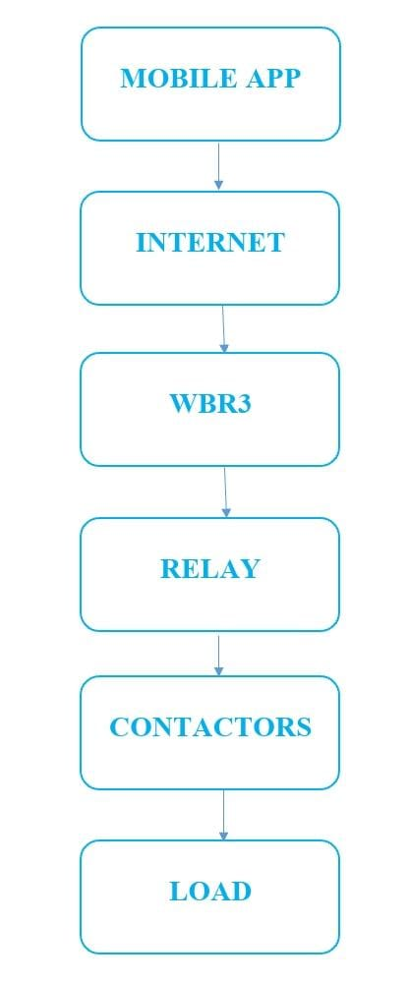
- Schematic Diagram:

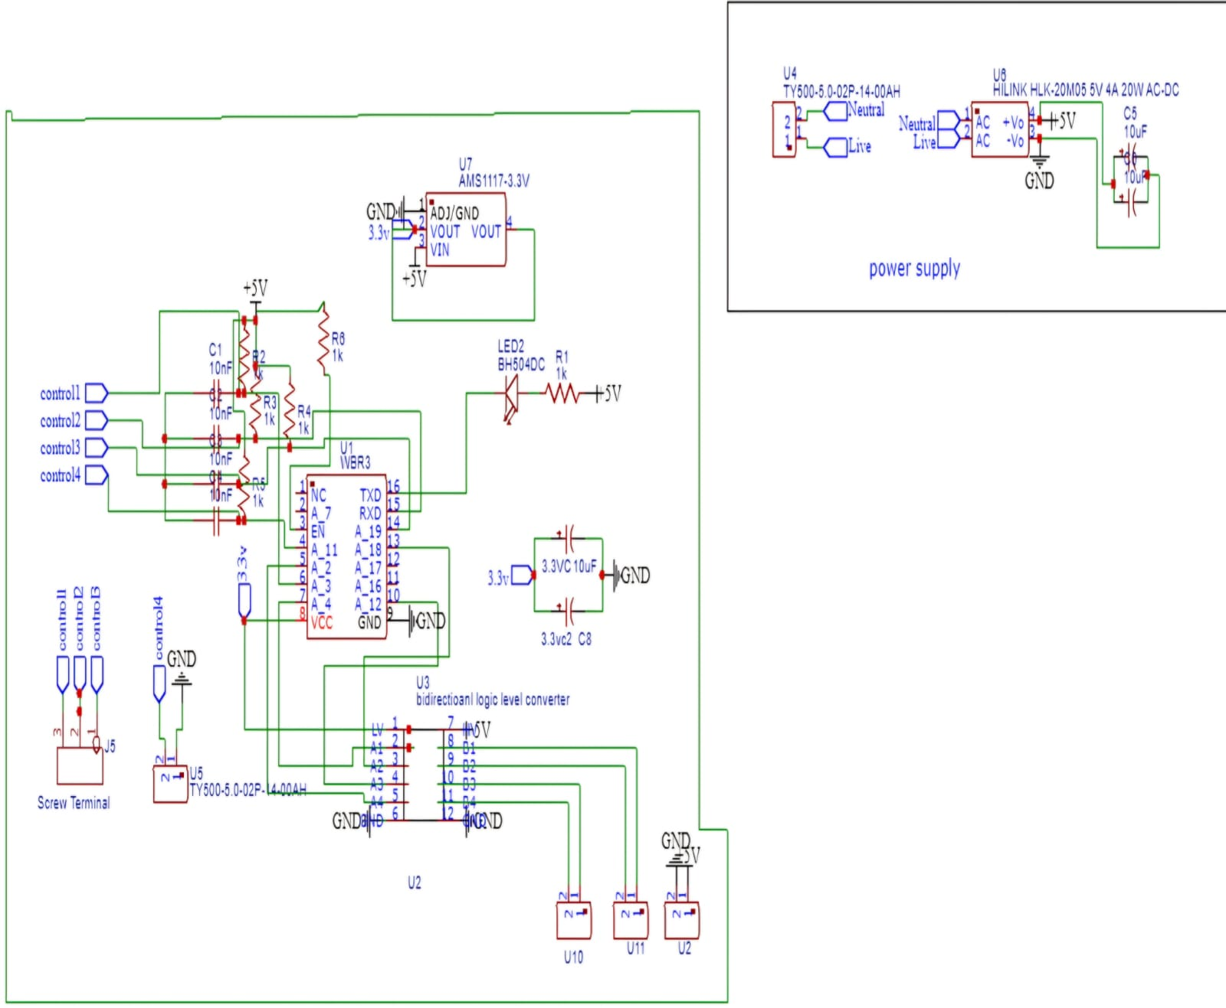
- Basic plan / circuit diagram:
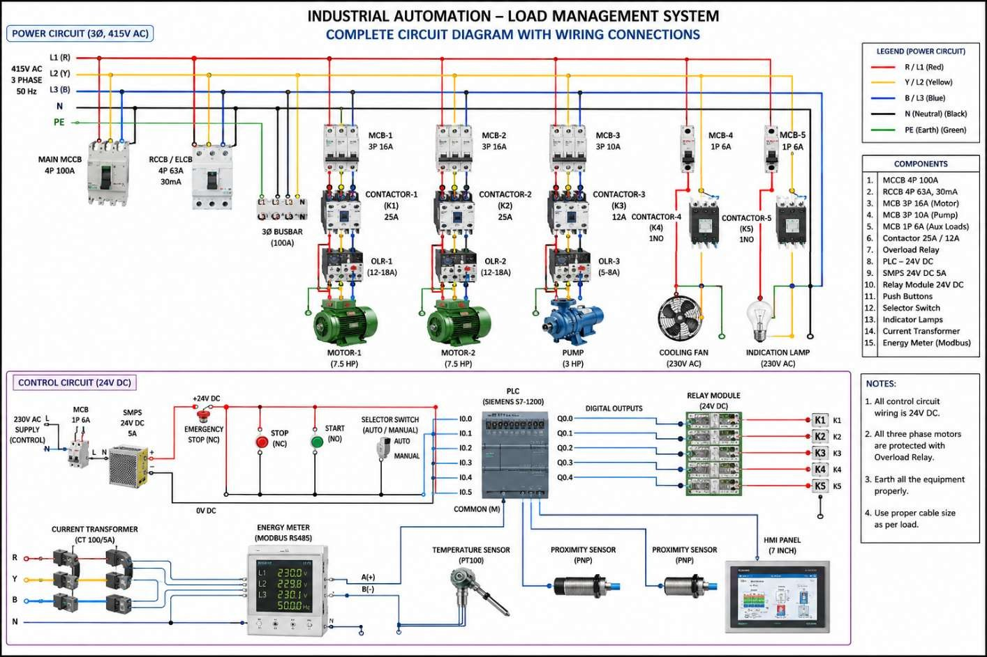

Design Description
  - Input Unit: The input takes 230-volt operating voltage providing a 400-volt output to the load.
  - Switching Unit: Relays or suitably rated contactors switch selected loads ON or OFF based on controller commands.
  - Output Unit: The electrical loads operate according to their assigned priorities.

Design Operation
The Industrial Automation Load Management System operates by controlling industrial electrical loads through a Wi-Fi-based control mechanism. Initially, the 5V SMPS provides the required power supply to the control circuit, and the Arduino Nano is initialized for system operation. The WBR3 Wi-Fi module establishes wireless communication between the controller and the remote-control interface. The Wi-Fi module and processes them according to the required operation. The 4-channel relay module is used to switch individual electrical loads ON or OFF. When a particular load is selected for operation, Similarly, when the load needs to be switched OFF, the controller deactivates the corresponding relay. The 32A contactor is used to control the main power supply to the connected industrial loads, the system continuously receives control commands and performs the required switching operations. This hardware-based system enables centralized and remote control of industrial electrical loads, reduces manual intervention, improves operational convenience, and supports efficient industrial energy management.

Design Considerations
  - Accurate measurement of electrical parameters.

  - Proper selection of the load threshold.

  - Reliable switching and electrical protection

: Methodology
The methodology of the Industrial Automation Load Management System involves designing and implementing an automated system to monitor electrical loads and control their operation according to predefined limits and priorities.
    - Requirement Analysis: Identify the electrical loads, their power requirements, and their priorities. Determine the maximum permissible load limit for the system.

    - Hardware Selection: Select suitable components such as a, current sensors, relay modules, power supply.
    - System Design: Design the circuit and block diagram showing the connections between the sensors, switching devices, and electrical loads.
    - Hardware Implementation: Connect the hardware components according to the circuit design and configure the controller to communicate with the sensors and switching devices.
    - Testing and Validation: Test the system under different load conditions to verify sensor readings, switching operation, and system response.
    - Performance Evaluation: Evaluate the system based on its load control accuracy, response time, reliability, and ability to reduce overloading.

Chapter 4

Industry Focus

Industry access for our project refers to connecting with industries, factories, and automation professionals to understand how electrical loads are monitored, controlled, and managed efficiently.

- Manufacturing industries: Understand how control electrical power is distributed among machines, motors, and other equipment.
- Industrial automation companies: Learn about sensors, relays, contactors, and automated load-control systems.
- Electrical maintenance departments: Understand load monitoring, overload protection, energy consumption, and electrical safety.
- Power management companies: Explore techniques for reducing energy waste and balancing electrical loads.
- Industry professionals: Obtain guidance on practical requirements and system design.

Chapter 5

WBR3 Wi-Fi Module :
  - Purpose: Provides Wi-Fi connectivity for IoT devices.
  - Working: Connects a device to a wireless network so it can send and receive data.
  - Applications: Smart home devices, remote monitoring, and wireless control systems.

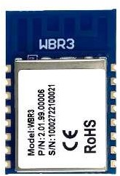

22pF Capacitor:
- Purpose: Stores a small amount of electrical charge.
- Working: Often used in oscillator and crystal circuits to help stabilize the operating frequency.
- Applications: Microcontrollers, crystal oscillators, and RF circuits


LM117 Voltage Regulator :
- Purpose: Provides an adjustable regulated DC output voltage.
- Working: Maintains a controlled output voltage when the input and load conditions vary within its operating limits.
- Applications: Adjustable power supplies and electronic control circuits.



4 Channel Relay Module :
- Working: Each relay uses an electrical control signal to switch its contacts, allowing a low-voltage controller to operate compatible external loads.
- Applications: Home automation, motor control, lighting control, and IoT projects.

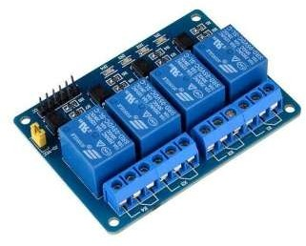

Four Pole contactor :
- Purpose: Switches high-current electrical loads.
- Working: An energized electromagnetic coil moves the contacts to connect or disconnect a power circuit.
- Applications: Industrial motors, pumps, compressors, and electrical panels.

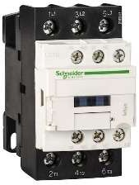

- 1k ohm Resistors:

- Purpose: Limits the flow of electric current in a circuit.
- Working: Produces a voltage drop when current flows through it, according to Ohm’s law
- Applications: Protecting LEDs, limiting current, voltage-divider circuits, and microcontroller interfacing.
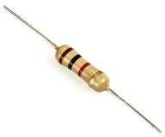

Fan Connectors : picture change
- Purpose: Connects an electric fan to a power supply or control circuit.
- Working: Transfers electrical power and, depending on the connector type, speed-control and speed-feedback signals.

- Applications: Cooling fans, computer systems, electronic equipment, and ventilation systems.
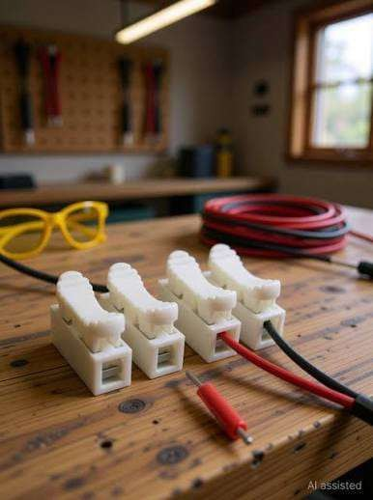

LED (Light Emitting Diode) :
- Purpose: Produces light when electric current flows through it.
- Working: An LED is a semiconductor device that emits light when forward biased.
- Applications: Status indicators, warning lights, displays, and electronic control circuits.



SMPS 5v output 4A:
- Purpose: Converts AC or another suitable input into regulated 5V DC, depending on the model.
- Working: Uses high-frequency switching and regulation circuitry to provide a stable DC output.
- Applications: Microcontrollers, sensors, relay modules, and IoT systems.
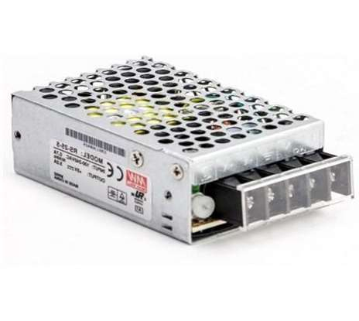

- Wires: 4 sq mm wire:

- Purpose: Connecting different electronic components and carrying electrical power or signals between them.
- Working: Wires provide a conductive path that allows electric current or electrical signals to travel between components.



Chapter 6

CONCLUSION

The Industrial Automation Load Management System aims to improve the efficient utilization of electrical power in industrial applications. The proposed system focuses primarily on managing industrial electrical loads through automation, ensuring that power is distributed and utilized according to predefined load limits and priorities. By using a current sensor, and switching devices, the system monitors electrical loads, detects excessive loading, and automatically disconnects non-essential loads when required.

This project helps reduce the risk of overloading, minimize unnecessary power consumption, and reduce the need for continuous manual monitoring. Automated load management ensures that essential industrial equipment receives priority, improving operational reliability, electrical safety, and overall energy efficiency. The integration of IoT technology further enhances the system by enabling remote monitoring of load conditions and providing real-time information about the system's operation. This allows users to monitor the connected loads more conveniently and make informed decisions regarding power usage.

Industrial Automation Load Management System provides a practical solution for automated industrial load control by combining automation and IoT integration to promote energy conservation, reliable operation, and improved industrial productivity.

Chapter 7

Result
LINK :

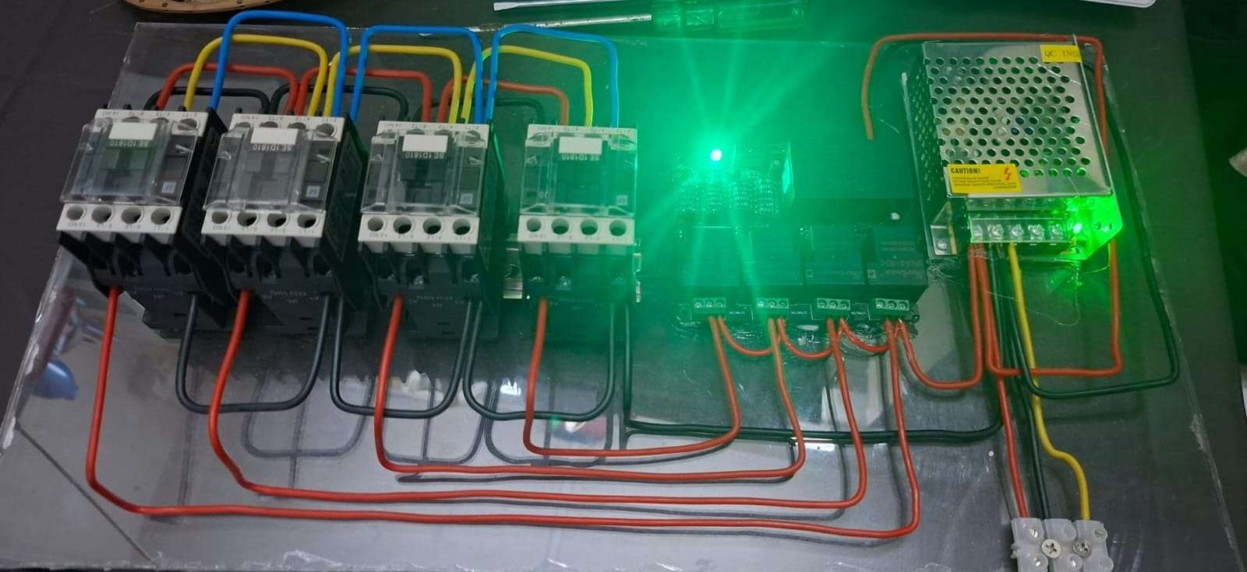

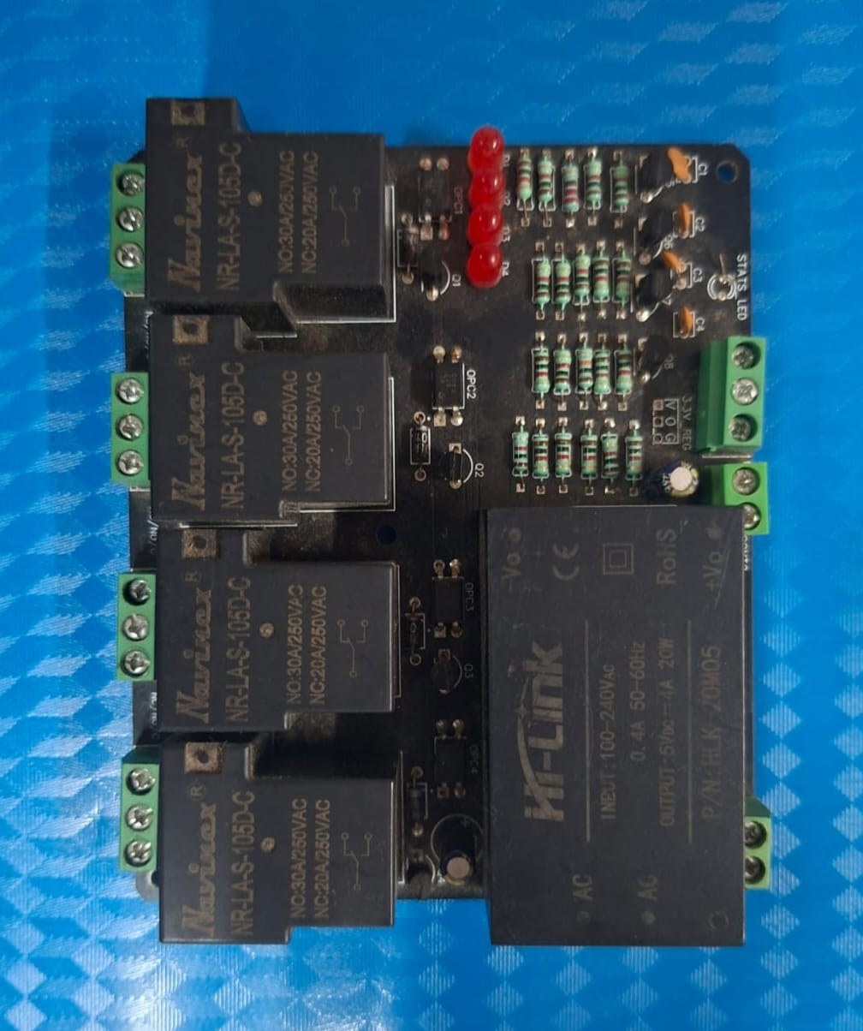

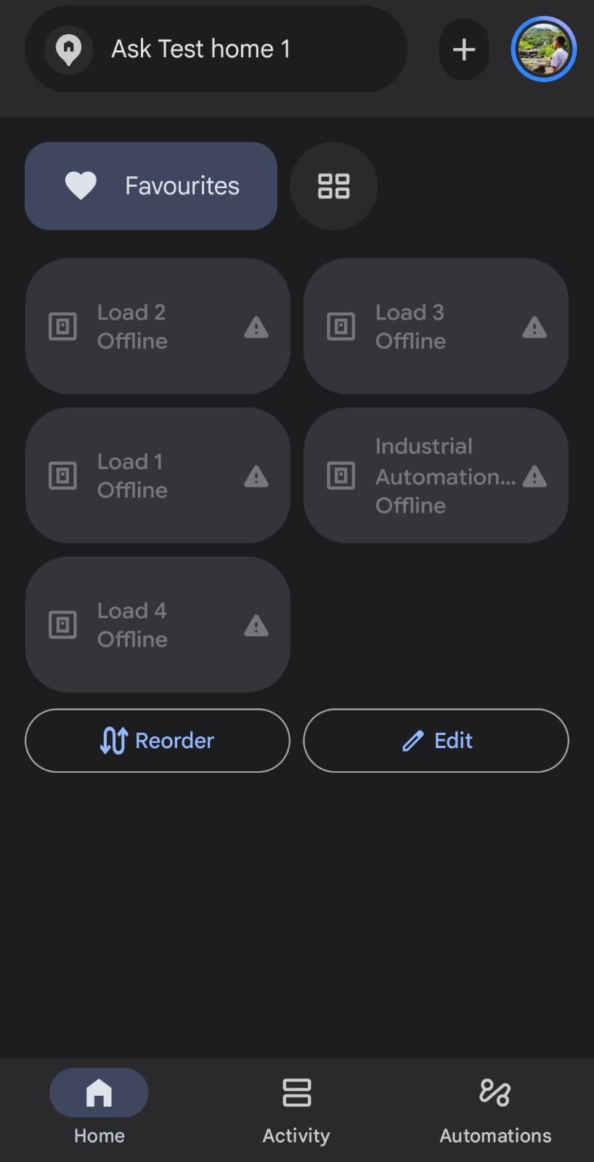



Chapter 8

REFERENCES
- Development of IoT Based Industrial Automation System,” International Journal on Recent and Innovation Trends in Computing and Communication, vol. 11, no. 9, pp. 2179–2184, 2023. Available: https://doi.org/10.17762/ijritcc.v11i9.9221
- A Real-Time Decision Model for Industrial Load Management in a Smart Grid,” Applied Energy, vol. 182, pp. 1488–1497, 2016. Available: https://doi.org/10.1016/j.apenergy.2016.09.021
- International Electrotechnical Commission (IEC), Industrial-process measurement, control and automation. IEC standards and technical resources. Available at: https://www.iec.ch/
- Dynamic Load Sharing at Domestic Level Using the Internet of Things,” International Journal of Integrated Engineering, vol. 12, no. 4, pp. 57–65, 2020. Available: https://journal.uthm.edu.my/index.php/ijie/article/view/5034

