**iMAAP Blackspot System - Functional Test Automation**

**Test Script 1: AddCrashRecordTest**

**Test Objective:**

To verify that the user can add/edit/delete crash (accident) records.

**Scenario:**

* Launch the browser and navigate to the application.
* Login to the application.
* Select 'Crash Records' from the main menu.
* Navigate to the 'Add Crash Record Form'
* Add crash record (crash record, vehicle record, and causality record).
* Verify the added crash record.
* Edit the crash record and verify the edited crash record.
* Delete the crash record.
* Logout of the application.
* Close the browser.

**Test Script 2: ImportCrashDataTest**

**Test Objective:**

To verify that the user can import crash (accident) records.

**Prerequisites:**

The following three Excel files should be placed in the default browse location (e.g., Downloads folder) in the user's system.

* Auto_Crashes_Template1.xlsx (Crash data template)
* Auto_Vehicles_Template1.xlsx (Vehicle data template)
* Auto_Casualties_Template1.xlsx (Casualty data template)

**Scenario:**

* Launch the browser and navigate to the application.
* Log in to the application.
* Select 'Import' from the main menu and navigate to the 'Import' screen.
* Import crash records (crash data, vehicle data, and causality data).
* Verify the crash, vehicle, and casualty count.
* Verify the file details of the imported records.
* Navigate to the 'Crash Records' screen and verify the imported crash records (individual).
* Delete the imported crash records.
* Logout of the application
* Close the browser.

**Test Script 3: HotspotMgmtTest**

**Test Objective:**

To verify that the user can identify a hotspot, and manage it through different stages such as potential, active, and treated.

**Prerequisites:**

Ensure that a saved template ‘Automation Template’ with an area selected on Map for running hotspot analysis should be available in the application.

**Scenario:**

* Launch the browser and navigate to the application.
* Log in to the application.
* Select and navigate to the 'Hotspot Identification' screen from the main menu.
* Select the 'Automation Template' from Open Templates and click Run.
* Select a hotspot from the analysis report and save it as a potential hotspot.
* Navigate to the 'Hotspot Management' screen and move the potential hotspot to ‘Active’.
* Select the active hotspot, add action plan details, select the countermeasures, and define performance goals and save it.
* Move the active hotspot to 'Treated' and verify the treated hotspot.
* Logout of the application
* Close the browser.

**Test Execution:**

Before executing the script, ensure that a valid Username and Password is configured in “Project.Variables”.

Please follow the steps below to run the test script:

1. Open the project from the project folder.

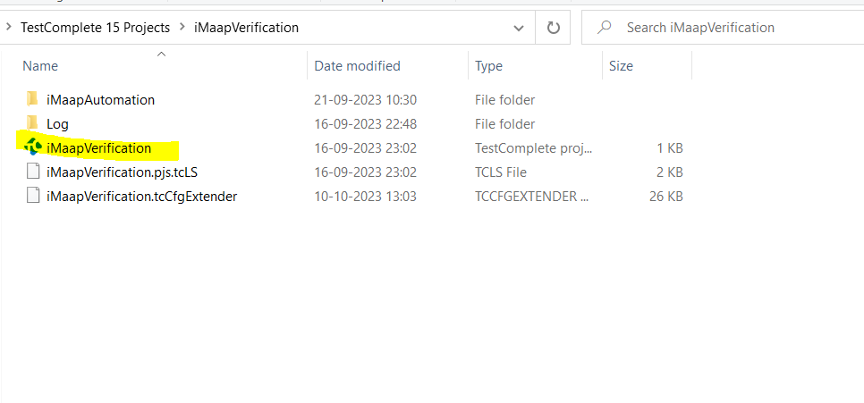

1. Right-click on the test script and click on the ‘Run <testScriptName>'

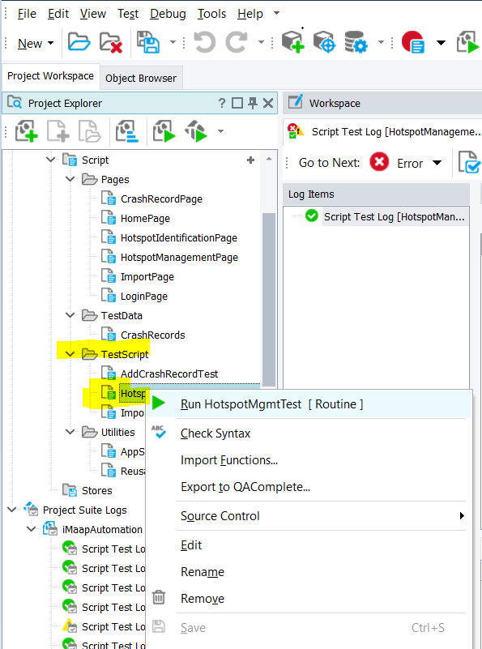

Reports are generated under ‘Project Suite Logs’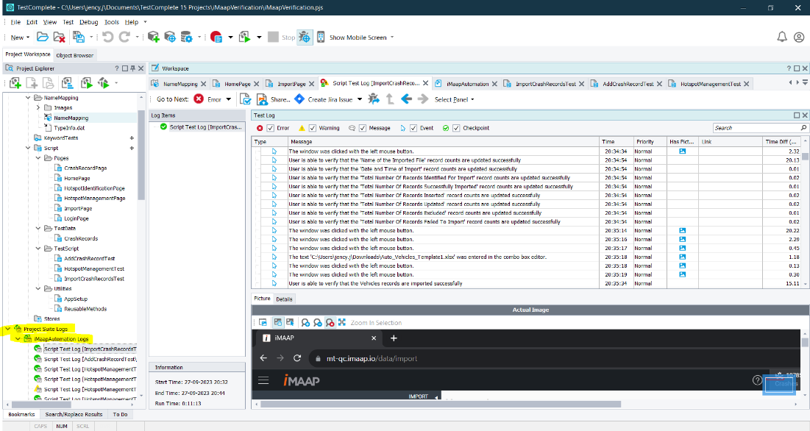

UI selectors are stored in ‘NameMapping’