**PROTOTYPE OF THE PHARMACY MANAGE SYSTEM**

**Sample Form**

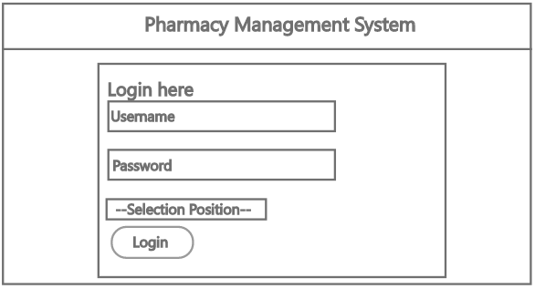

**Home Page Admin**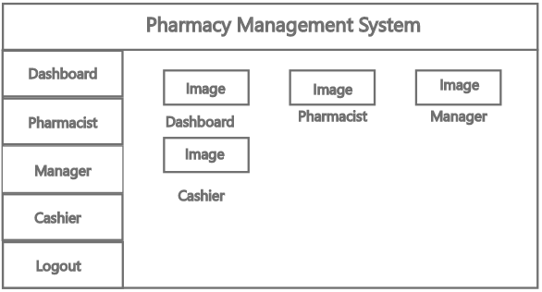

**Home Page Manager**

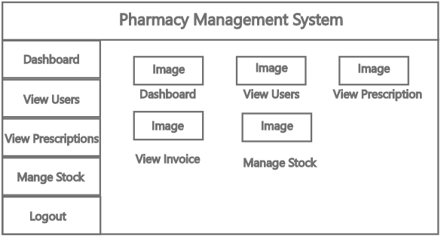

**Home Page Pharmacist**

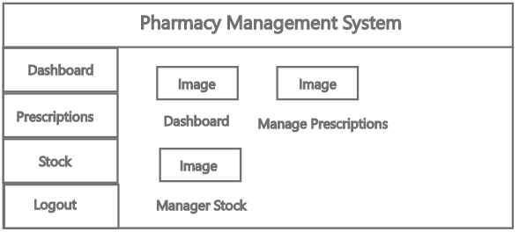

**Home Page Cashier**

