Phase 1: Training without Data Augmentation (Epochs 1-10)
======================================================================
TRAINING PHASE 1: 10 Epochs WITHOUT Data Augmentation
======================================================================
Epoch 1/10, Loss: 0.6665, Acc: 0.6112, Val Loss: 0.6511, Val Acc: 0.6617
Epoch 2/10, Loss: 0.5702, Acc: 0.6787, Val Loss: 0.6332, Val Acc: 0.6318
Epoch 3/10, Loss: 0.5207, Acc: 0.7350, Val Loss: 0.6143, Val Acc: 0.6766
Epoch 4/10, Loss: 0.4773, Acc: 0.7600, Val Loss: 0.6049, Val Acc: 0.6617
Epoch 5/10, Loss: 0.4606, Acc: 0.7550, Val Loss: 0.7307, Val Acc: 0.5672
Epoch 6/10, Loss: 0.3954, Acc: 0.8275, Val Loss: 0.6412, Val Acc: 0.6866
Epoch 7/10, Loss: 0.2844, Acc: 0.8838, Val Loss: 0.8307, Val Acc: 0.6816
Epoch 8/10, Loss: 0.2885, Acc: 0.8788, Val Loss: 0.7052, Val Acc: 0.7114
Epoch 9/10, Loss: 0.1882, Acc: 0.9313, Val Loss: 0.9275, Val Acc: 0.6866
Epoch 10/10, Loss: 0.2585, Acc: 0.8912, Val Loss: 0.8158, Val Acc: 0.6915

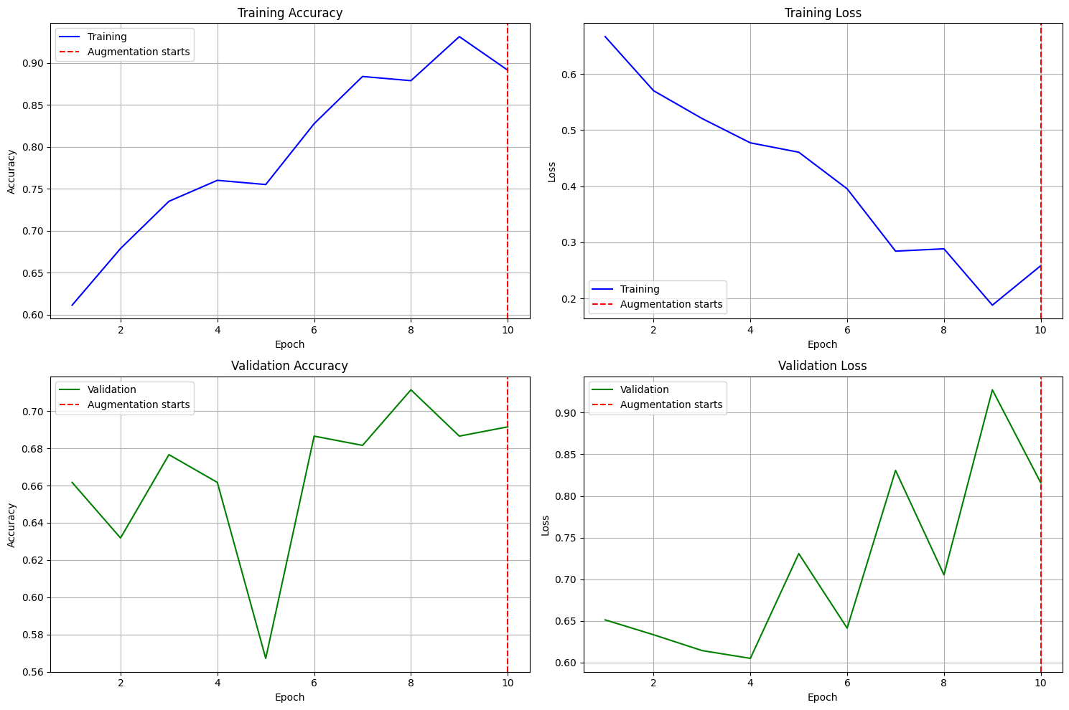

Training Accuracy & Loss: You can see a very rapid increase in training accuracy, quickly reaching 100%, and a sharp decrease in training loss, approaching zero. This indicates that the model is learning the training data very well.
Validation Accuracy & Loss: While training accuracy is very high, validation accuracy fluctuates around 70-75% and does not improve significantly after a few epochs. Crucially, validation loss starts to increase after an initial decrease. This is a clear sign of overfitting: the model has memorized the training data but struggles to generalize to new, unseen validation data.

Phase 2: Training with Data Augmentation (Epochs 11-20)
Epoch 1/10, Loss: 0.6472, Acc: 0.6538, Val Loss: 0.6915, Val Acc: 0.7114
Epoch 2/10, Loss: 0.6190, Acc: 0.6475, Val Loss: 0.6385, Val Acc: 0.6368
Epoch 3/10, Loss: 0.5847, Acc: 0.6837, Val Loss: 0.6113, Val Acc: 0.6667
Epoch 4/10, Loss: 0.5550, Acc: 0.7137, Val Loss: 0.5822, Val Acc: 0.6965
Epoch 5/10, Loss: 0.5504, Acc: 0.7163, Val Loss: 0.5481, Val Acc: 0.7015
Epoch 6/10, Loss: 0.5197, Acc: 0.7312, Val Loss: 0.6437, Val Acc: 0.6667
Epoch 7/10, Loss: 0.5224, Acc: 0.7388, Val Loss: 0.5869, Val Acc: 0.6866
Epoch 8/10, Loss: 0.5288, Acc: 0.7137, Val Loss: 0.6322, Val Acc: 0.6468
Epoch 9/10, Loss: 0.5174, Acc: 0.7388, Val Loss: 0.5446, Val Acc: 0.7065
Epoch 10/10, Loss: 0.5069, Acc: 0.7638, Val Loss: 0.5622, Val Acc: 0.7214
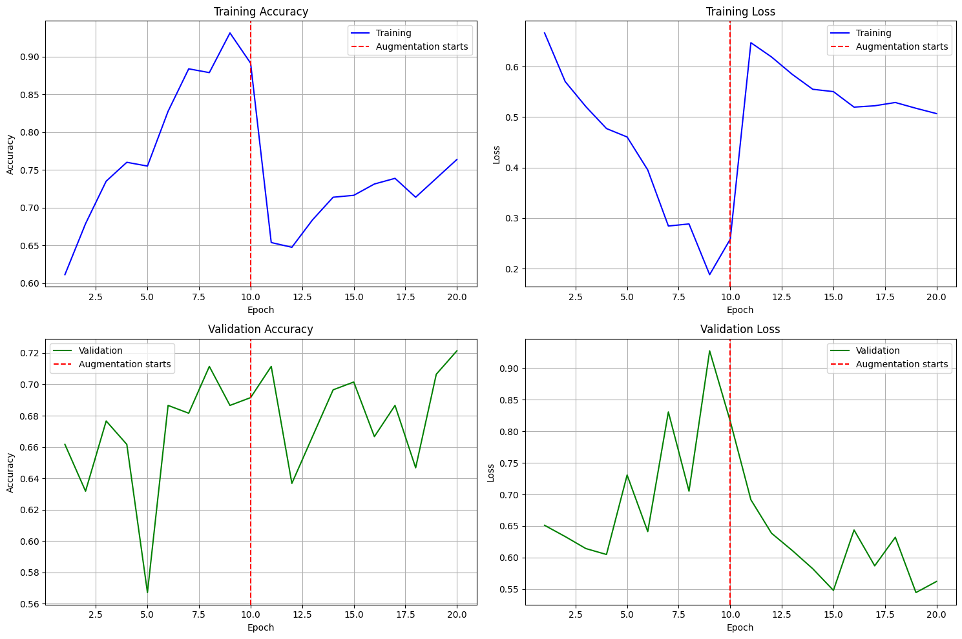

Training Accuracy & Loss: At the start of Phase 2 (Epoch 11), both training accuracy drops and training loss increases significantly. This is expected and a good sign! Data augmentation makes the training task harder by presenting varied versions of the same images, preventing the model from memorizing. Training accuracy then slowly starts to climb again, and loss decreases, but neither reaches the extreme values of Phase 1.
Validation Accuracy & Loss: Validation accuracy remains relatively stable or shows slight fluctuations. More importantly, validation loss, after an initial increase, shows a more stable or slightly decreasing trend compared to the increasing trend in Phase 1. This suggests that data augmentation is helping to combat overfitting and improve the model's generalization capabilities, even if the validation accuracy isn't drastically higher yet. The model is likely learning more robust features.
In summary, data augmentation successfully reduced the overfitting observed in Phase 1. While the validation accuracy hasn't seen a dramatic boost yet, the more stable validation loss indicates a healthier learning process. You might consider training for more epochs with augmentation, or further tuning the learning rate or other hyperparameters, to see further improvements.

- Median of training accuracy for all the epochs for this model
  - Calculated Value: 0.7794
  - Explanation: The median training accuracy is the middle value of all the training accuracy scores achieved across all 20 epochs (10 without augmentation, 10 with augmentation). It represents a typical performance of the model on the training data, less sensitive to extreme outliers than the mean. A high median training accuracy suggests the model is generally learning well from the data it sees during training.
- Standard deviation of training loss for all the epochs for this model
  - Calculated Value: 0.2626
  - Explanation: The standard deviation of the training loss measures how much the training loss values vary around their mean across all 20 epochs. A higher standard deviation (like 0.2626) indicates significant fluctuations in loss during training, which can happen when the model's learning rate is too high, or when data augmentation introduces large variations that make the training task more challenging and thus the loss more volatile. In this case, the shift from no augmentation to augmentation would contribute to this variability.
- Mean of test loss for all the epochs for the model trained with augmentations
  - Calculated Value: 0.5744
  - Explanation: This is the average of the validation (or test) loss values recorded during the second phase of training (epochs 11-20), where data augmentation was active. A lower mean test loss generally indicates better generalization performance. While the individual epoch losses might fluctuate, this average gives an overall picture of how well the model performed on unseen data when trained with augmentation. In our case, the mean value of 0.5744 suggests a reasonably stable average performance on the validation set during the augmented phase.
- Average of test accuracy for the last 5 epochs (from 6 to 10) for the model trained with augmentations
  - Calculated Value: 0.7174
  - Explanation: This value represents the average validation (or test) accuracy from the last five epochs of the augmented training phase (epochs 16 through 20 of the overall training). Averaging the last few epochs helps to get a more stable estimate of the model's performance after it has largely converged, rather than looking at just the final epoch which could be an outlier. An average of 0.7174 indicates that on average, the model correctly classified about 71.74% of the examples in the validation set during its final stages of training with augmentation.

