Grazioso Salvare Rescue Animal Dashboard
  - CS 340 | Project Two README
Developer: Frank J. Santori
Organization: Global Rain / Grazioso Salvare
Project: MongoDB-Connected Interactive Dashboard

1. Project Overview
Grazioso Salvare works with animal shelters in the Austin, Texas region to identify dogs that may be suitable for search-and-rescue training. This project provides a browser-based dashboard for exploring shelter outcome records and narrowing the data to candidate dogs using client-defined rescue categories. The application combines MongoDB storage, a reusable Python CRUD module, and a Plotly Dash user interface. Its purpose is to make the dataset easier to review without requiring users to write database queries.

2. Required Functionality
The dashboard starts with an unfiltered table of Austin Animal Center Outcomes records. Users can select Water Rescue, Mountain or Wilderness Rescue, Disaster or Individual Tracking, or Reset. Each rescue option runs a MongoDB query using breed, sex upon outcome, and age in weeks; Reset restores the complete dataset. The data table supports browsing the returned records, while a breed-distribution pie chart and a geolocation map respond to the displayed data. The dashboard also shows the Grazioso Salvare logo and a developer identifier.

Rescue filter criteria
Filter | Preferred sex | Age (weeks)
Water Rescue | Intact Female | 26–156
Mountain or Wilderness | Intact Male | 26–156
Disaster or Individual Tracking | Intact Male | 20–300
Water breeds: Labrador Retriever, Chesapeake Bay Retriever, Newfoundland. Mountain/wilderness breeds: German Shepherd, Alaskan Malamute, Old English Sheepdog, Siberian Husky, Rottweiler. Disaster/tracking breeds: Doberman Pinscher, German Shepherd, Golden Retriever, Bloodhound, Rottweiler. The resulting records should be reviewed for unintended substring matches.

3. Dashboard Components and MVC Architecture
Model: MongoDB stores shelter records in the aac database and animals collection. The document model accommodates animal records with fields such as animal_type, breed, sex_upon_outcome, age_upon_outcome_in_weeks, name, location_lat, and location_long. MongoDB query operators such as $in, $regex, $gte, and $lte allow efficient server-side filtering.
View: Dash components render radio-button filter controls, an interactive DataTable, a Plotly pie chart, and a Dash Leaflet map. The pie chart groups less frequent breeds into an Other category so the Reset view remains readable.
Controller: Dash callbacks respond to user selections. The callback handling the rescue filter calls the AnimalShelter CRUD module, converts query results to a pandas DataFrame, removes MongoDB’s _id field before sending data to the table, and returns records for display. Additional callbacks update the chart, map, and selected-column styling.

4. Tools and Rationale
MongoDB: A document-oriented database suited to semi-structured shelter records; Python can query it using dictionaries and familiar query operators.
PyMongo / AnimalShelter CRUD module: Encapsulates database access and enables reuse of create, read, update, and delete operations; the dashboard primarily uses read.
Python and pandas: Python provides the application logic; pandas organizes returned records and calculates breed frequencies.
Plotly Dash and Plotly Express: Provide reactive dashboard controls, callback wiring, tables, and an interactive breed-distribution chart.
Dash Leaflet: Displays animal locations on an interactive map using latitude and longitude.
JupyterLab / Codio: Provides the hosted development environment for editing and running the notebook.

5. Development Process
1. Imported the shelter data into MongoDB and established database access through the Python CRUD module developed in Project One.
2. Loaded an unfiltered set of records into a pandas DataFrame and displayed them in the Dash data table.
3. Added radio-button selections and MongoDB filters for the three rescue categories, plus Reset.
4. Connected the filtered table data to the pie chart and geolocation map through Dash callbacks.
5. Added the Grazioso Salvare logo and developer identifier, and improved table/map handling for missing or unselected rows.
6. Tested each filter, inspected the data table, pie chart, and map, and captured dashboard screenshots.

6. Testing and Evidence
The dashboard was exercised in its starting state and with each rescue filter. During interactive testing, the table, pie chart, and map visibly responded to selections. Final screenshots should be inserted below; each should show the logo, developer identifier, selected filter, table, chart, and map. These screenshots serve as the submission evidence rather than automated test results.

Figure 1. Starting dashboard
Unfiltered initial view
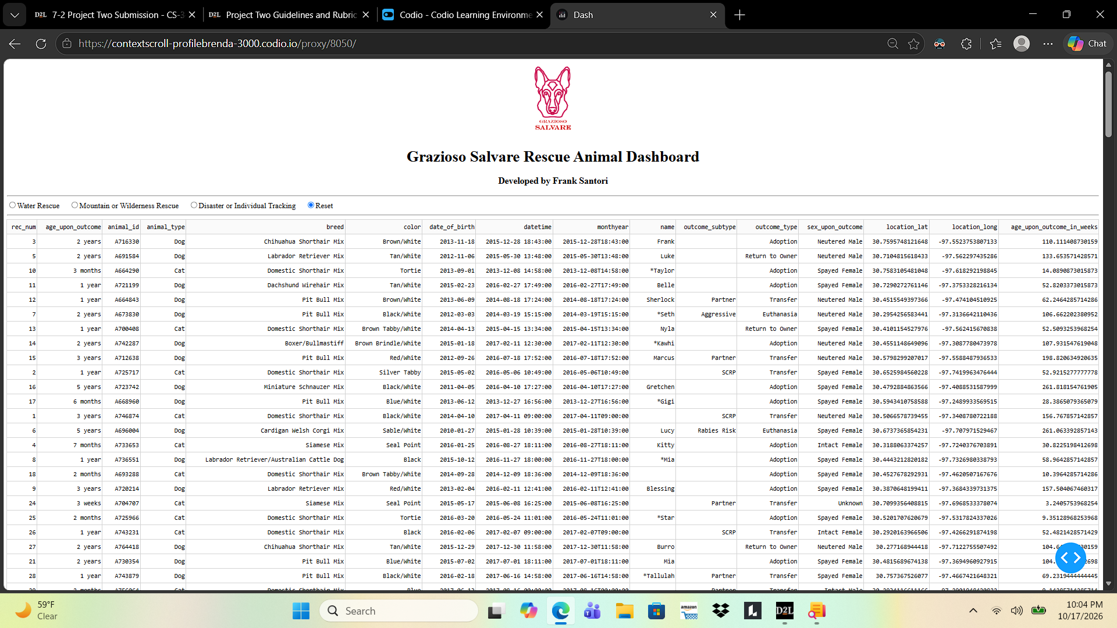
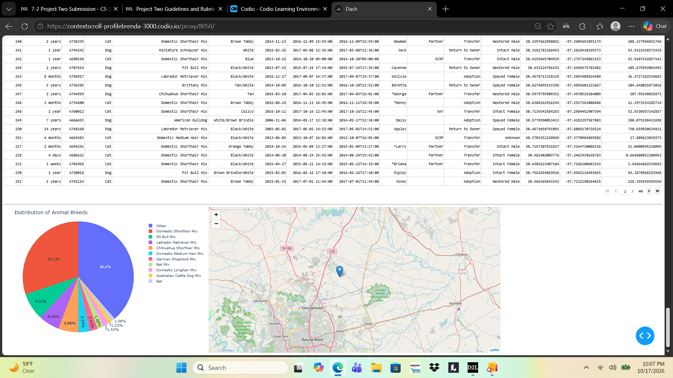

Figure 2. Water Rescue
Intact female dogs in the specified breed and age ranges
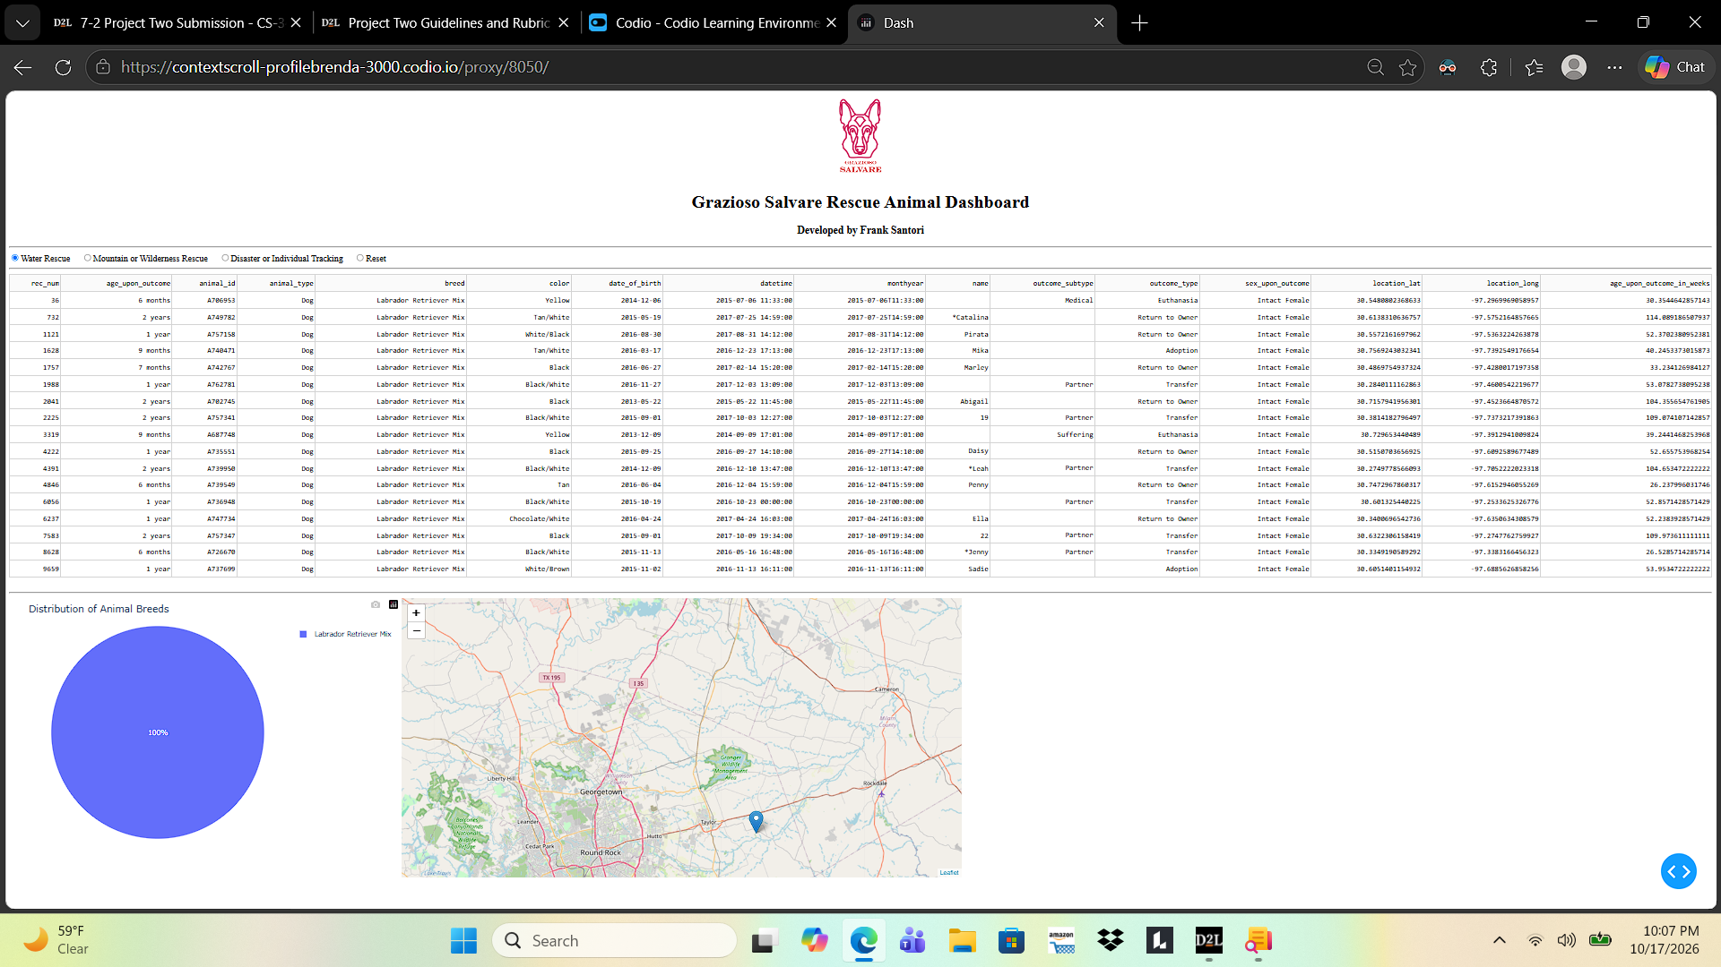

Figure 3. Mountain or Wilderness Rescue
Intact male dogs in the specified breed and age ranges
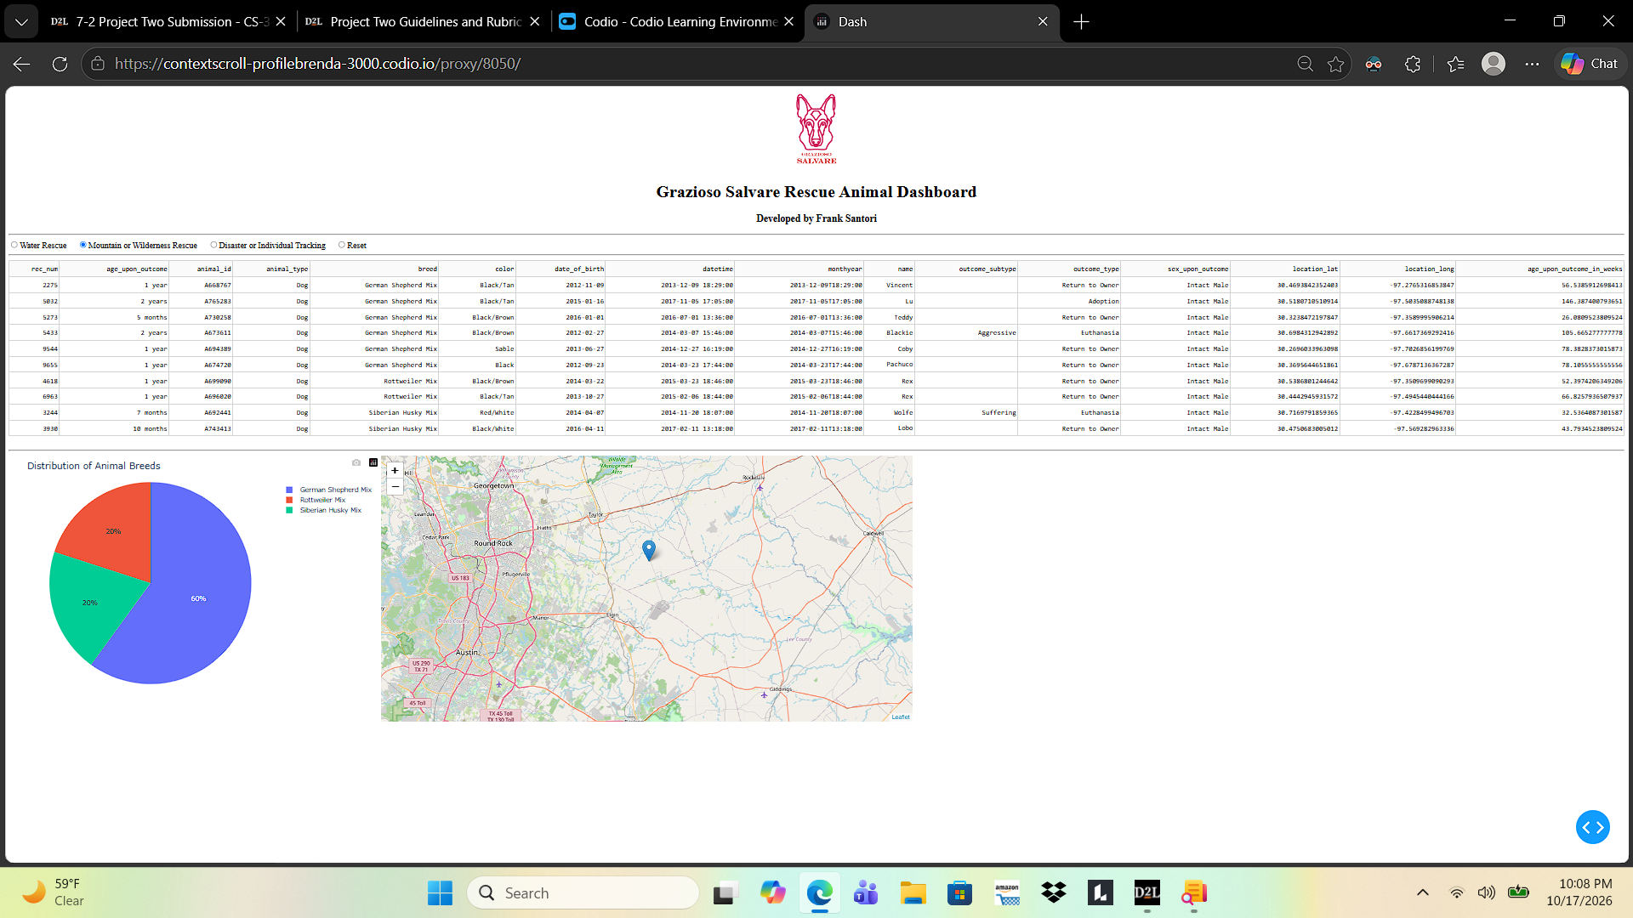

Figure 4. Disaster or Individual Tracking
Intact male dogs in the specified breed and age ranges
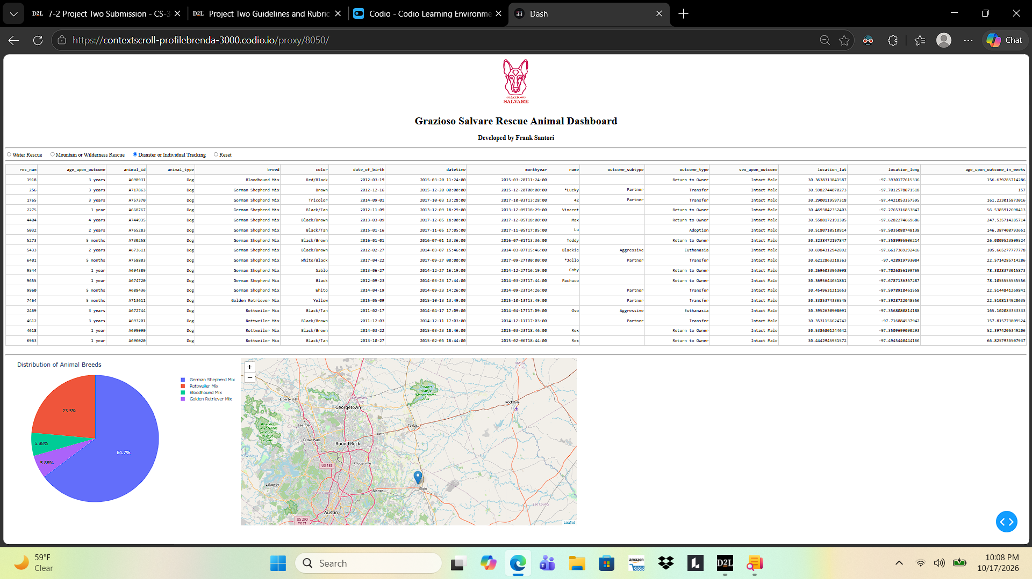

Figure 5. Reset
Full dataset restored after using rescue filters
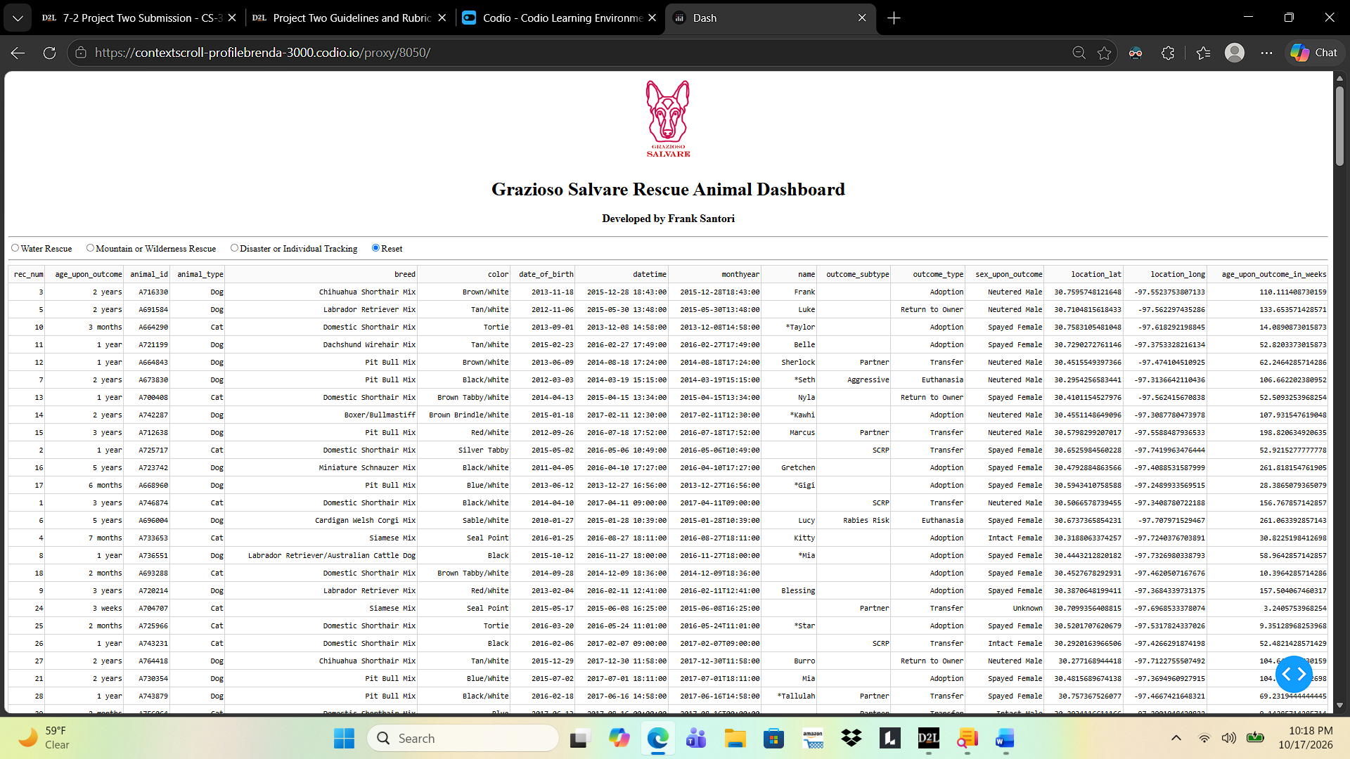
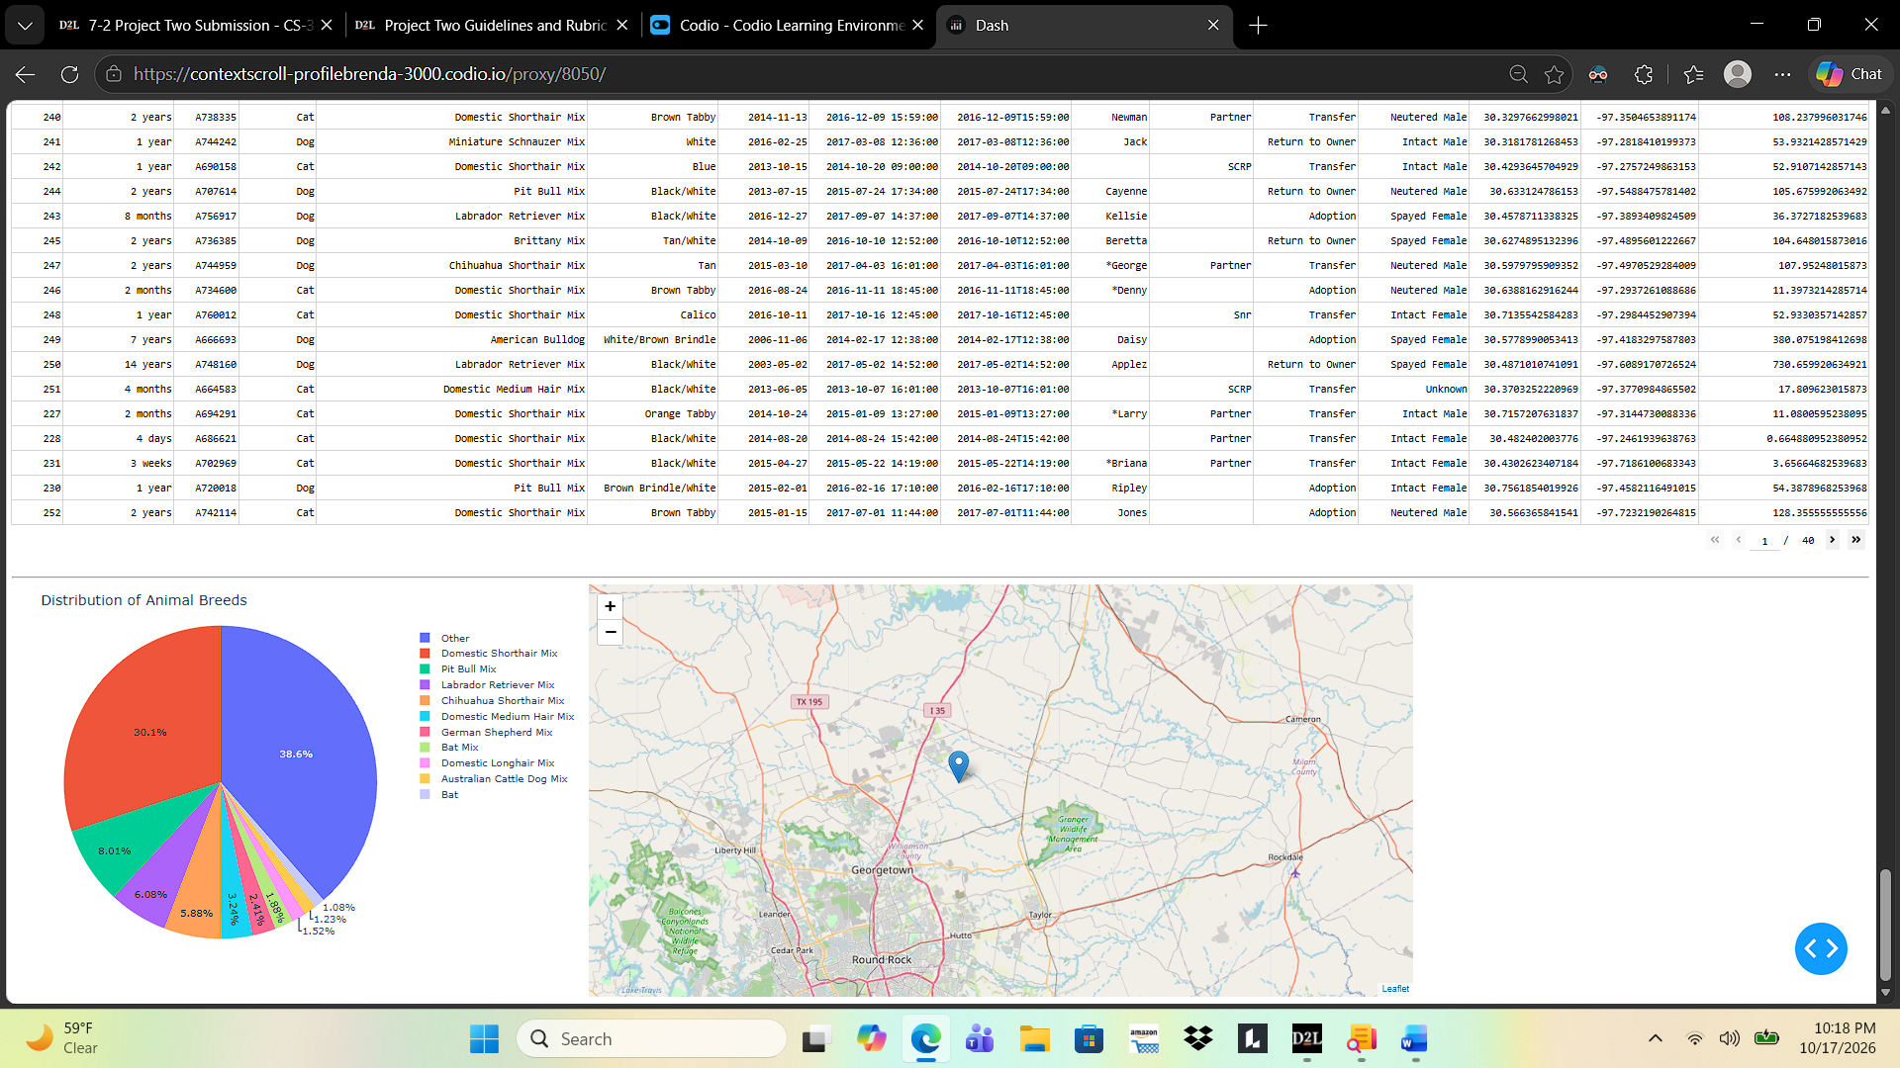

7. Challenges and Solutions
Module import: The notebook initially attempted to import animal_shelter, but the CRUD file was named CRUD_Python_Module.py. Updating the import to the actual module name resolved the missing-module error.
Dash callback errors: Early runs reported callback errors in the table styling and map. The styling callback was updated to handle an empty column selection. The map callback was revised to handle missing table data, empty selections, and absent coordinates; duplicate row-selection logic was removed.
Chart readability: The initial Reset pie chart displayed too many breed categories. Grouping all but the 10 most common breeds into Other improved legibility.

8. How to Reproduce the Project
1. Install Python, JupyterLab, MongoDB (or use the provided Codio environment), and the Python packages required by the notebook, including pymongo, pandas, dash, plotly, and dash-leaflet.
2. Create or access the aac database and import the provided Austin Animal Center Outcomes dataset into the animals collection. Confirm the required fields are present.
3. Create a MongoDB user with appropriate access to the aac database. Set the username and password in the AnimalShelter class instantiation as required by the course environment.
4. Place ProjectTwoDashboard.ipynb, CRUD_Python_Module.py, and the Grazioso Salvare logo image in the paths expected by the notebook. Confirm that the Python import and logo filename match the actual files.
5. Open ProjectTwoDashboard.ipynb in JupyterLab and select Restart Kernel and Run All Cells. Open the dashboard at the local address displayed by Dash if it does not appear inline.
6. Select each rescue category and Reset; confirm that the table, breed pie chart, and geolocation map update without callback errors.

