Frank Scafuri

Professor Bui

CSC 322

31 OCT 2023

Blender Activity

**Checkpoint 0**

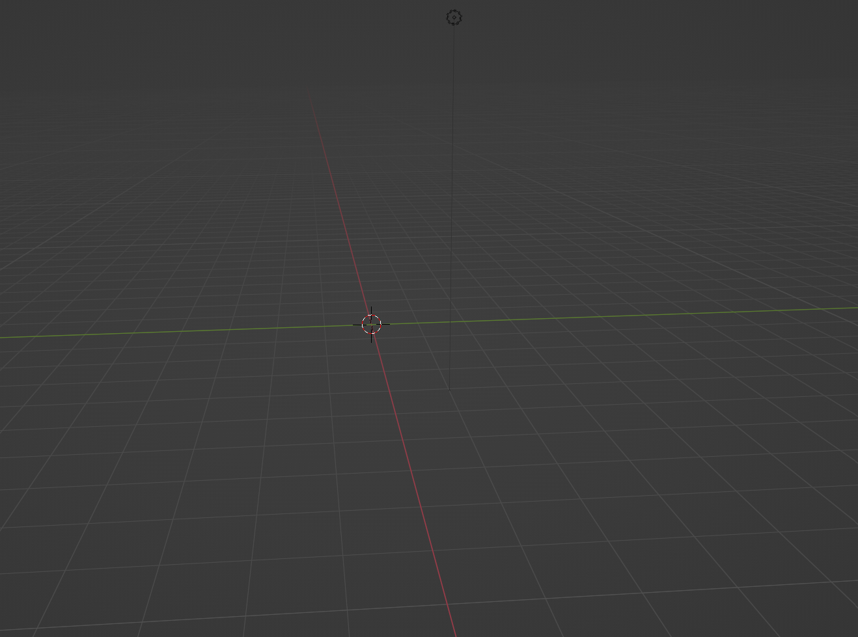

**Checkpoint 1**



**Checkpoint 2**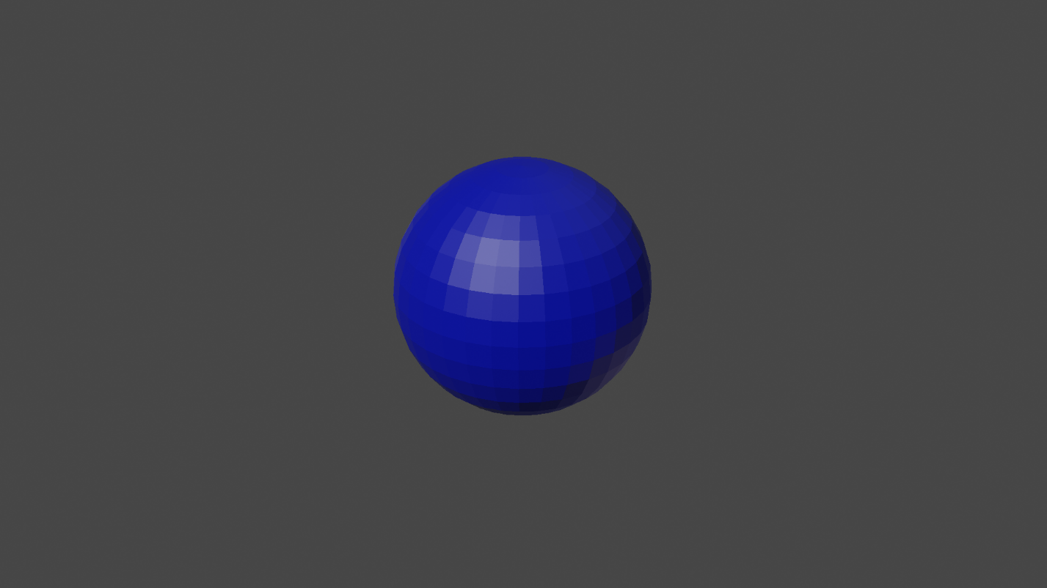

**Checkpoint 3**

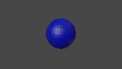

**Checkpoint 4**

The image is smaller and less defined. As you can see, the pixels in the image with less resolution is blurrier and the pixels of the sphere are clearer. The image is less round. Resolution will show how clear an image looks and how many pixels are used to render it.

**Checkpoint 5**

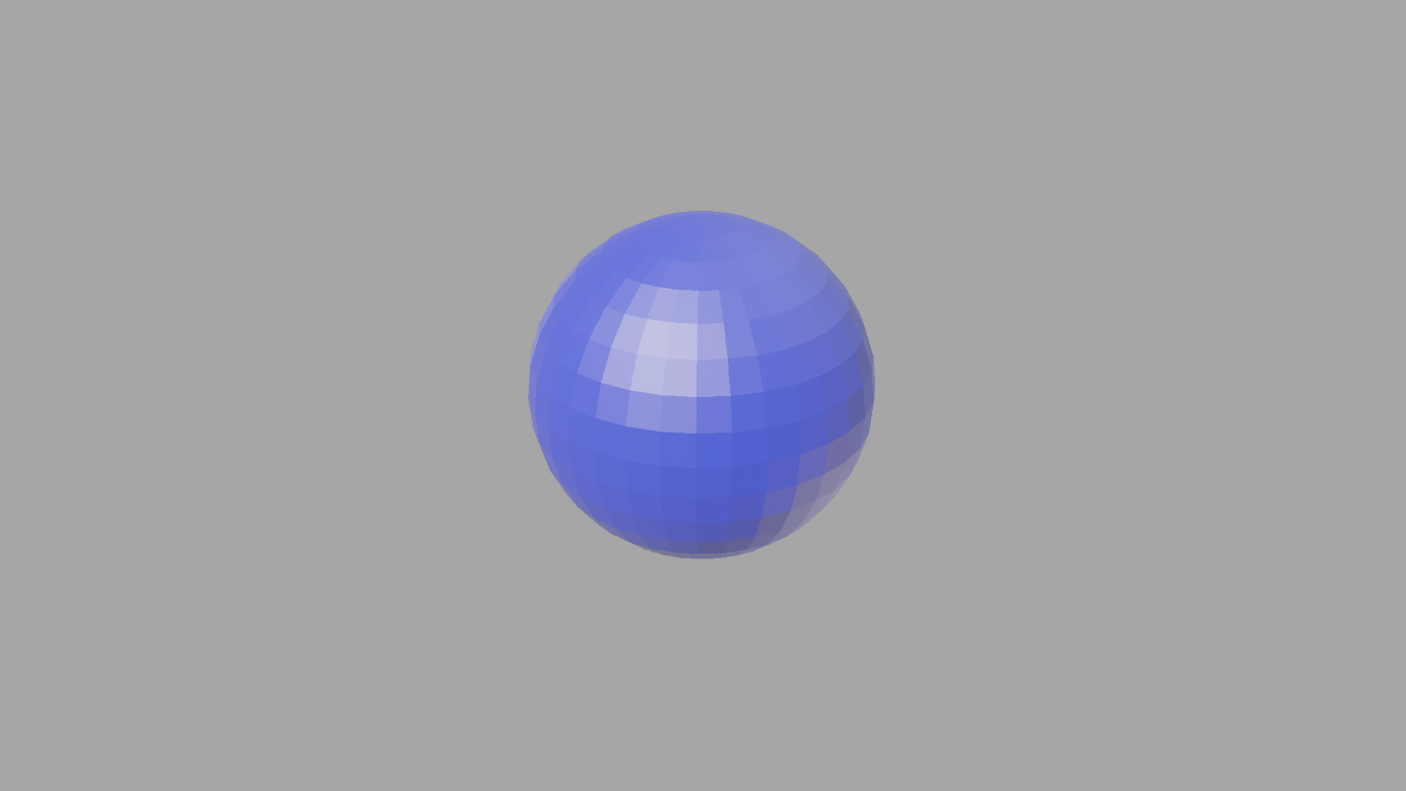

**Checkpoint 6**

Changing the gamma will result in the image being lighter or darker. It affects the intensity of the image. I raised the gamma of this image to 3, while the original is at 1. As we can see, raising the gamma will result in a lighter image because the intensity is increased.

**Questions**

1. Light can act differently in many ways. For instance, light can be reflective. In water and mirrors, light is reflected off the surface, allowing a reflection to be seen. Some objects can refract light, causing the objects on the other side of an object to look different. Finally, objects can absorb the light, which will affect the objects’ molecules and wavelengths.
2. Objects appear to have color based off what light is absorbed and which isn’t. It will either absorb some different wavelengths of light, or color, and reflect and transmit others.
3. The advantage of using YUV is that it separates the image’s brightness and the color into different components. Therefore, you are able to change both, rather than just the colors, like in RGB.
4. In light, colors are created by adding different wavelengths together. By mixing RGB, you will get white light. In paint, colors are created by subtracting wavelengths of light to get rid of undesirable colors. When you combine full RGB, you get black.
5. Green screens are green because they are the furthest color from skin tone. Therefore, they can be easily identified by camera’s color filters.
6. It is needed to reveal the full details of the image and give them dynamic twist and a realistic look.
7. Lights of different wavelengths create different perceptions of color. Light on the red side of the spectrum are long, while the shortest ones are purple.