Frank Scafuri

Professor Bui

CSC 322

7 November 2023

Blender Activity 2

**Checkpoints 1-4**

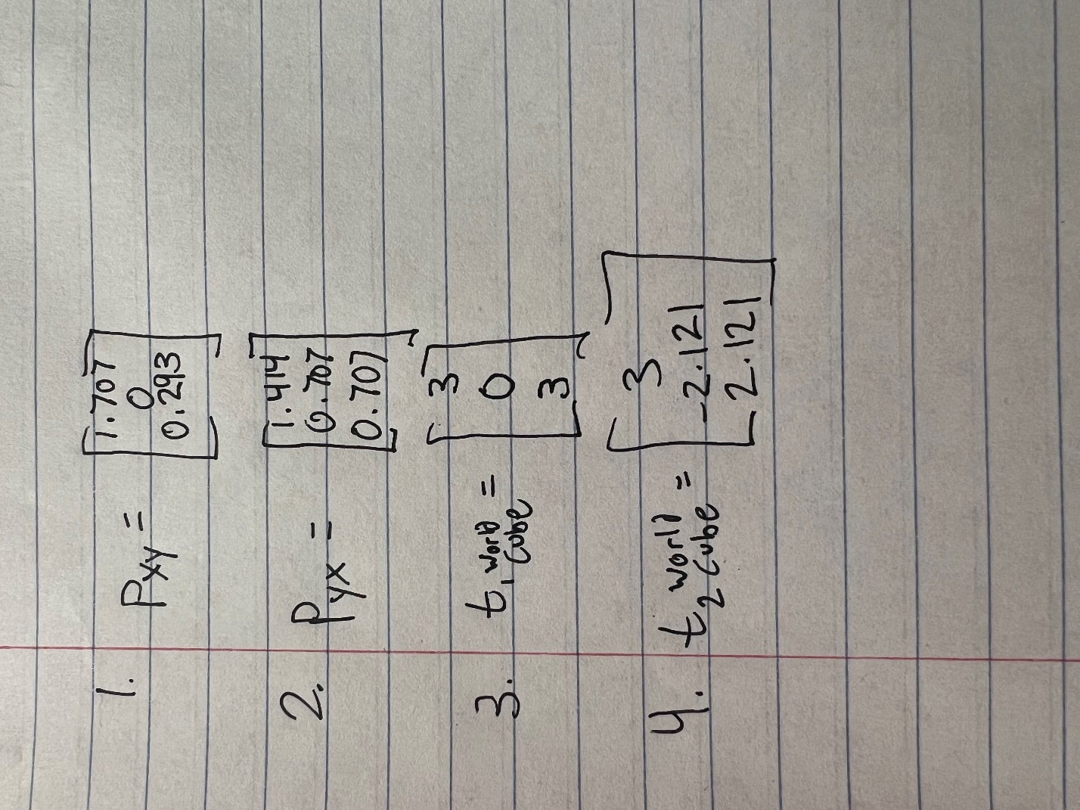

**Checkpoint 5**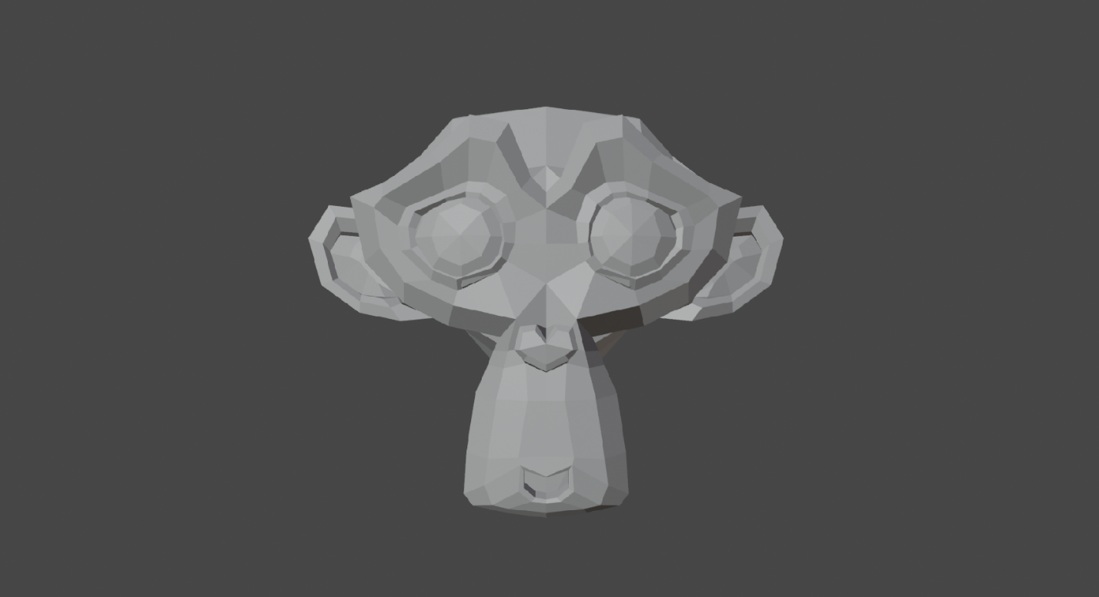

**First Render**

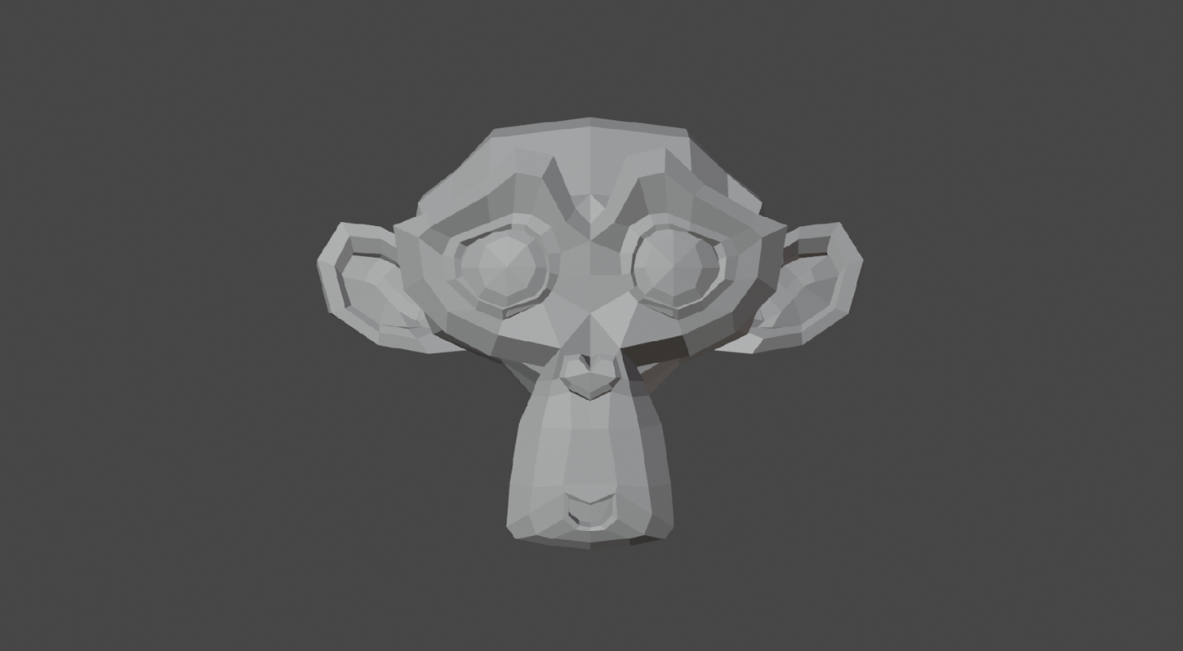

**Second Render**

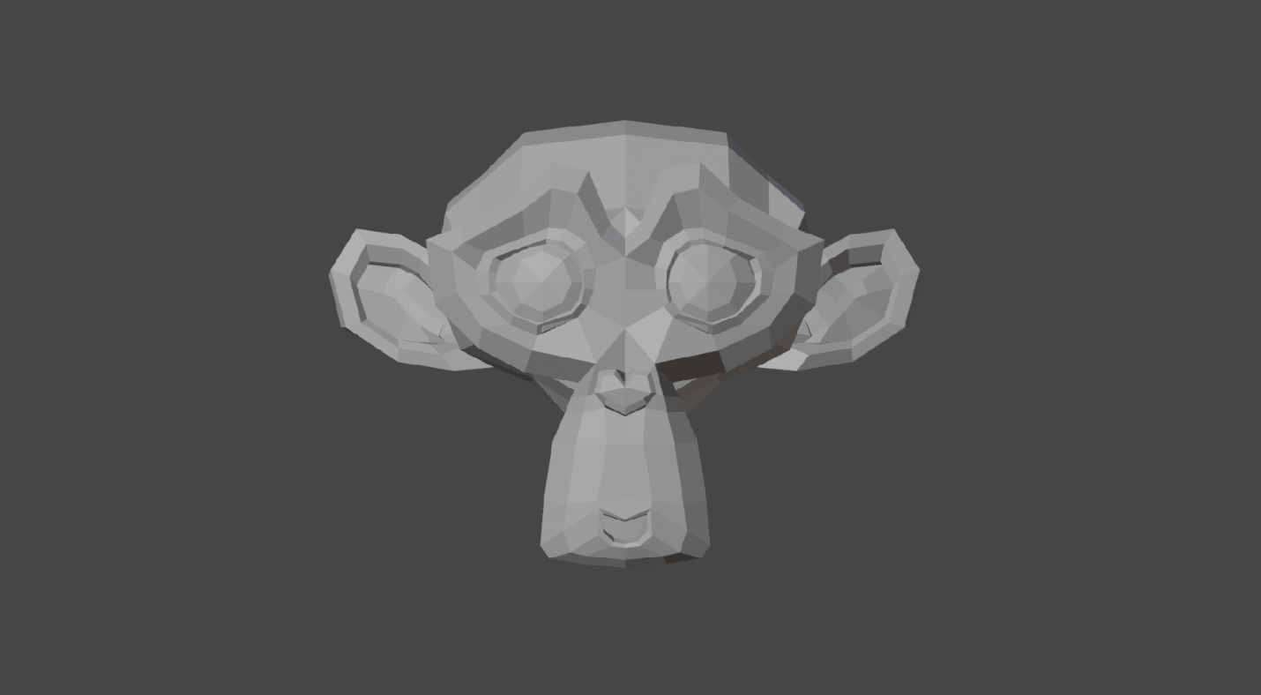

**Third Render**

**Checkpoint 6**

The three images look relatively the same. However, changing the focal length has a result on the zoom of the image. In the first image with a focal length of 25 mm, the forehead of the monkey is hidden by the eyebrows. In the image with a focal length of 100 mm, the forehead is completely visible. The zoom on the image is less, allowing us to see more of the monkey.

**Checkpoint 7**



**Flat Lighting**