Experiment


A1-1
中文 (Official)

Elasticity of cantilever
Part A. Alignment of light path

A1. | 0.6 pt
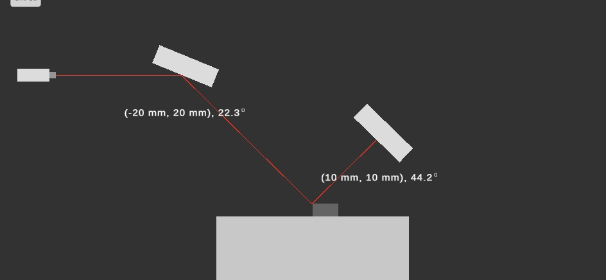 | 0.6 pt

0.8 pt
A2.
 | time  (s) | position  d  (mm) | time  (s) | position  d  (mm) | time  (s) | position  d  (mm)
 | 3 | −0.9755 | 48 | -0.1198 | 93 | -0.1725
 | 6 | -0.8715 | 51 | -0.3864 | 96 | -0.1388
 | 9 | 0.3507 | 54 | -0.3478 | 99 | -0.1922
 | 12 | -0.8273 | 57 | -0.2378 | 102 | -0.1924
 | 15 | −0.7670 | 60 | -0.2643 | 105 | -0.1719
 | 18 | -0.6862 | 63 | -.2736 | 108 | -0.3222
 | 21 | -0.7032 | 66 | -0.1977 | 111 | -0.2693
 | 24 | -0.6178 | 69 | -0.2791 | 114 | -0.2853
 | 27 | −0.4003 | 72 | -0.3188 | 117 | -0.1977

Experiment

A1-2
中文 (Official)

 | 30 | −0.4917 |  | 75 | -0.2977 | 120 | -0.1722
 | 33 | − 0.3722 |  | 78 | −0.1793
 | 36 | −0.3577 |  | 81 | -0.2221
 | 39 | -0.1844 |  | 84 | -0.2435
 | 42 | -0.2876 |  | 87 | -0.2344
 | 45 |  | -0.2192 | 90 | -0.1723
1.0 pt
A3.

(mm) | ̅ (mm) | − ̅ (mm) | standard deviation
-0.1725 | -0.21145 | 0.03895 | -0.00056
-0.1388 | -0.21145 | 0.07265 | -0.00056
-0.1922 | -0.21145 | 0.01925 | -0.00056
-0.1924 | -0.21145 | 0.01905 | -0.00056
-0.1719 | -0.21145 | 0.03955 | -0.00056
-0.3222 | -0.21145 | -0.11075 | -0.00056
-0.2693 | -0.21145 | -0.05785 | -0.00056
-0.2853 | -0.21145 | -0.02385 | -0.00056
-0.1977 | -0.21145 | -0.01375 | -0.00056
-0.1722 | -0.21145 | -0.03925 | -0.00056
reference value of measurement (with standard deviation) ： -0.21145+-0.00056mm

Experiment

A1-3
中文 (Official)

Part B. Deformation of cantilever beam and deduction of Young’s modulus

B1. answer sheet.
1.0 pt
 |  | F (N) |  | d (mm) |  | ̅ = 0 (mm)
 |  | 0 |  | 0.0274 |  | 0.0364
 |  |  |  | 0.0431
 |  |  |  | 0.0497
 |  |  |  | 0.0208
 |  |  |  | 0.0272
 | F (nN) |  | − ⃞ = ∆ (mm) |  | (mm)
 | 2.00 |  | 0.1914 |  | 0.1982
 |  |  | 0.2004
 |  |  | 0.1988
 |  |  | 0.2010
 |  |  | 0.1994
 | 4.00 |  | 0.4232 |  | 0.4160
 |  |  | 0.4187
 |  |  | 0.4087
 |  |  | 0.3978
 |  |  | 0.4315
 | 6.00 |  | 0.6023 |  | 0.6145
 |  |  | 0.6329
 |  |  | 0.6248
 |  |  | 0.5977
 |  |  | 0.6149
 | 8.00 |  | 0.8022 |  | 0.8202
 |  |  | 0.8329
 |  |  | 0.8247
 |  |  | 0.8397
 |  |  | 0.8016

Experiment

A1-4
中文 (Official)

 | 10.00 | 1.0023 | 1.0420
 | 10.00 | 1.0127 | 1.0420
 | 10.00 | 1.1396 | 1.0420
 | 10.00 | 0.9723 | 1.0420
 | 10.00 | 1.0831 | 1.0420

B2. | 1.0 pt
F (nN) | (um) | (mm)
2.00 | 0.1023 | 0.1982
4.00 | 0.2031 | 0.4160
6.00 | 0.3059 | 0.6145
8.00 | 0.4078 | 0.8202
10.00 | 0.5107 | 1.0420

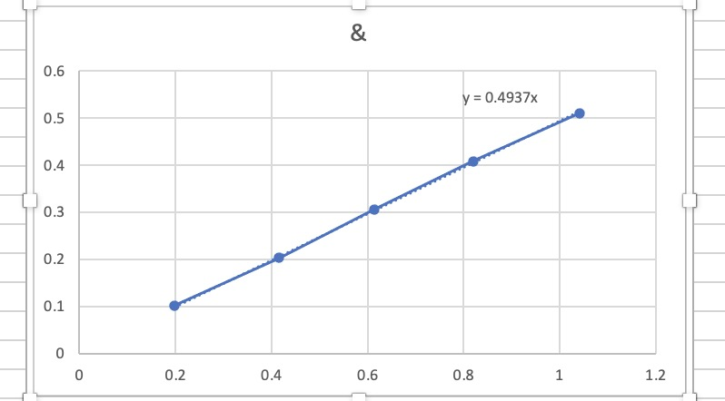

B3.  C1=4.937 × 10-4 | 0.4 pt

Experiment

A1-5
中文 (Official)

Part C. Double layer cantilever beam

C1. |  |  |  |  | 1.0 pt
 | T (K) | d (mm) | ̅ = 0 (mm)
 | 300 | −0.228 | -0.235
 | 300 | −0.225
 | 300 | −0.191
 | 300 | −0.278
 | 300 | −0.253
 | T (K) | − ⃞ = ∆ (mm) |  | (mm)
 | 301 | 0.28522 |  | 0.27865
 | 301 | 0.27123
 | 301 | 0.28013
 | 301 | 0.27357
 | 301 | 0.28312
 | 301.5 | 0.41275 |  | 0.42568
 | 301.5 | 0.41337
 | 301.5 | 0.46275
 | 301.5 | 0.43957
 | 301.5 | 0.39996
 | 302 | 0.52016 |  | 0.55186
 | 302 | 0.56706
 | 302 | 0.54146
 | 302 | 0.54676
 | 302 | 0.58386
 | 302.5 | 0.69866 |  | 0.67530
 | 302.5 | 0.66416
 | 302.5 | 0.68296
 | 302.5 | 0.65346
 | 302.5 | 0.67226
 | 303 | 0.76655

Experiment

A1-6
中文 (Official)

 | 0.77128 | 0.79372
 | 0.81223 | 0.79372
 | 0.80125 | 0.79372
 | 0.81729 | 0.79372

C2. |  |  | 1.0 pt
T (K) | (mm) | (um)
301 | 0.27865 | 0.1452
301.5 | 0.42568 | 0.2123
302 | 0.55186 | 0.2887
302.5 | 0.67530 | 0.3497
303 | 0.79372 | 0.4125

Slope: 1.344✖️10e-7
(m) |  | 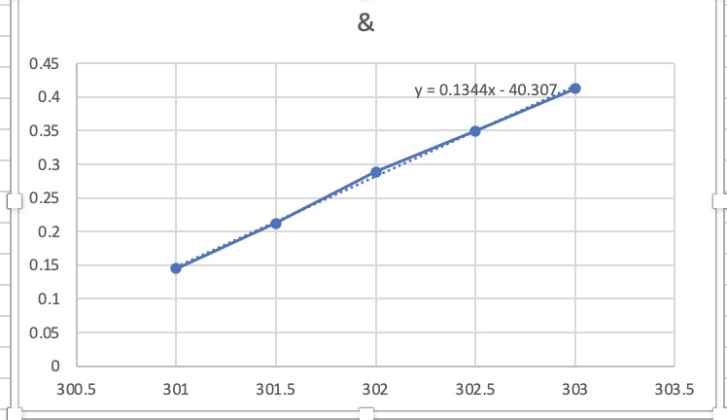

C3. | 0.6 pt
5.01 × 10e10 N/mଶ ()

Experiment

A1-7
中文 (Official)

Part D. Test of molecular-absorption-induced bending of a cantilever beam
D1. |  |  | 0.6 pt
Sample 0 | d (mm) | ̅ = 0 (mm) | 0.6 pt
 | 0.0271 | 0.02568 | 0.6 pt
 | 0.0281 | 0.02568 | 0.6 pt
 | 0.0209 | 0.02568 | 0.6 pt
 | 0.0270 | 0.02568 | 0.6 pt
 | 0.0253 | 0.02568 | 0.6 pt
Sample 1 | − ⃞ = ∆ (mm) | (mm) | 0.6 pt
 | -0.90234 | 0.904052 | 0.6 pt
 | -0.90473 | 0.904052 | 0.6 pt
 | -0.90743 | 0.904052 | 0.6 pt
 | -0.90147 | 0.904052 | 0.6 pt
 | -0.90429 | 0.904052 | 0.6 pt
D2. Assume the function form of the displacement and coverage ratio (CR)
0.6 pt
can be expressed as ： = ଶ ସ . Estimate C2 based on
your data obtained in A9. You can use the correlation between and in A6.
−0.0858

Experiment

A1-8
中文 (Official)

0.8 pt
D3.
 | Sample 2 | − ⃞ = ∆ (mm) | (mm)
 | Sample 2 | -0.66368 | -0.65628
 | Sample 2 | -0.65087 | -0.65628
 | Sample 2 | -0.64889 | -0.65628
 | Sample 2 | -0.65256 | -0.65628
 | Sample 2 | -0.66540 | -0.65628
 | Sample 3 | − ⃞ = ∆ (mm) | (mm)
 | Sample 3 | -0.28148 | -0.27286
 | Sample 3 | -0.27528 | -0.27286
 | Sample 3 | -0.26089 | -0.27286
 | Sample 3 | -0.27757 | -0.27286
 | Sample 3 | -0.26909 | -0.27286

D4.  Sample 2: 0.725% | 0.6 pt
Sample 3: 0.301%

