

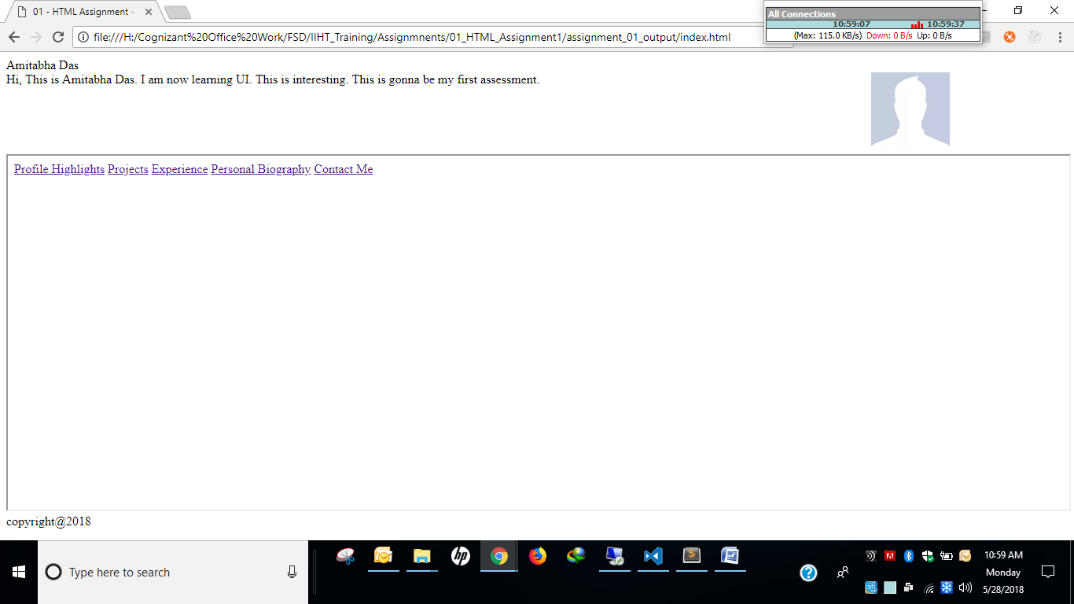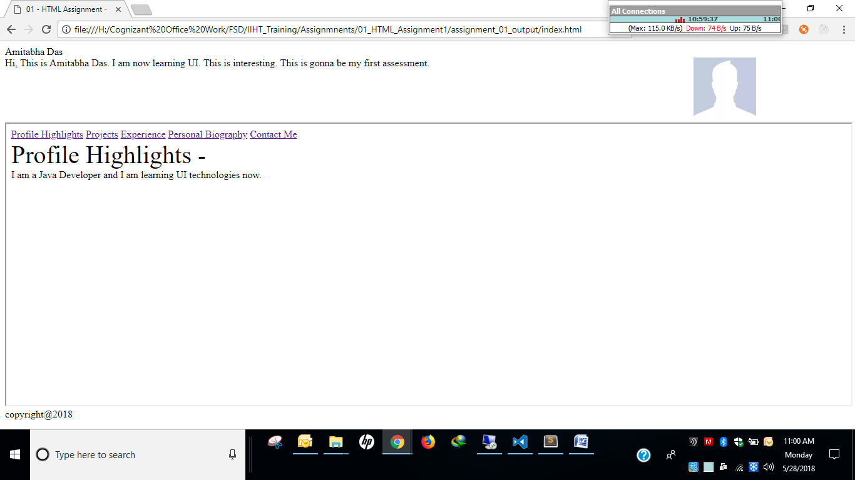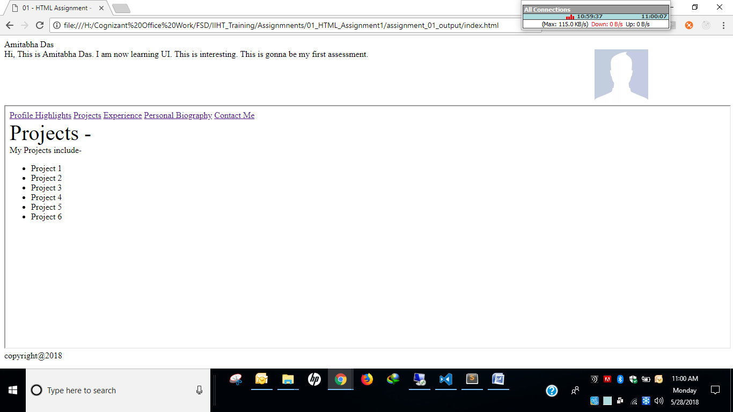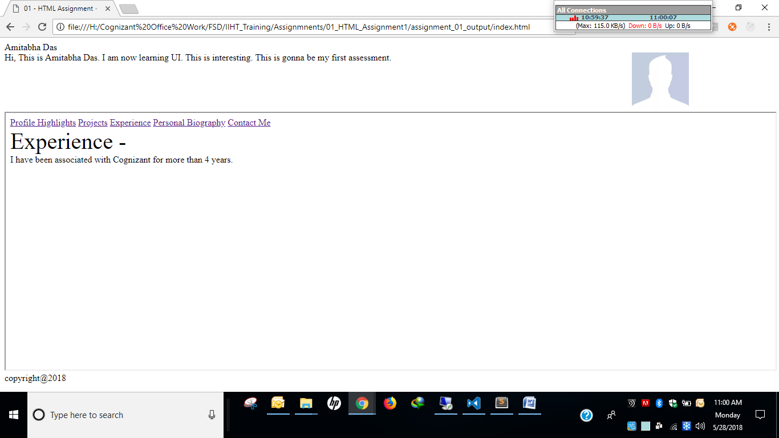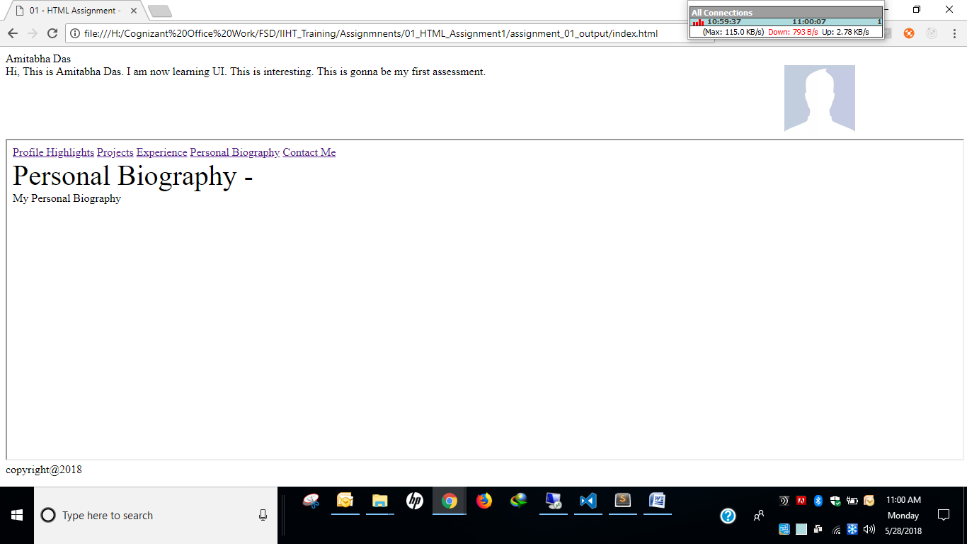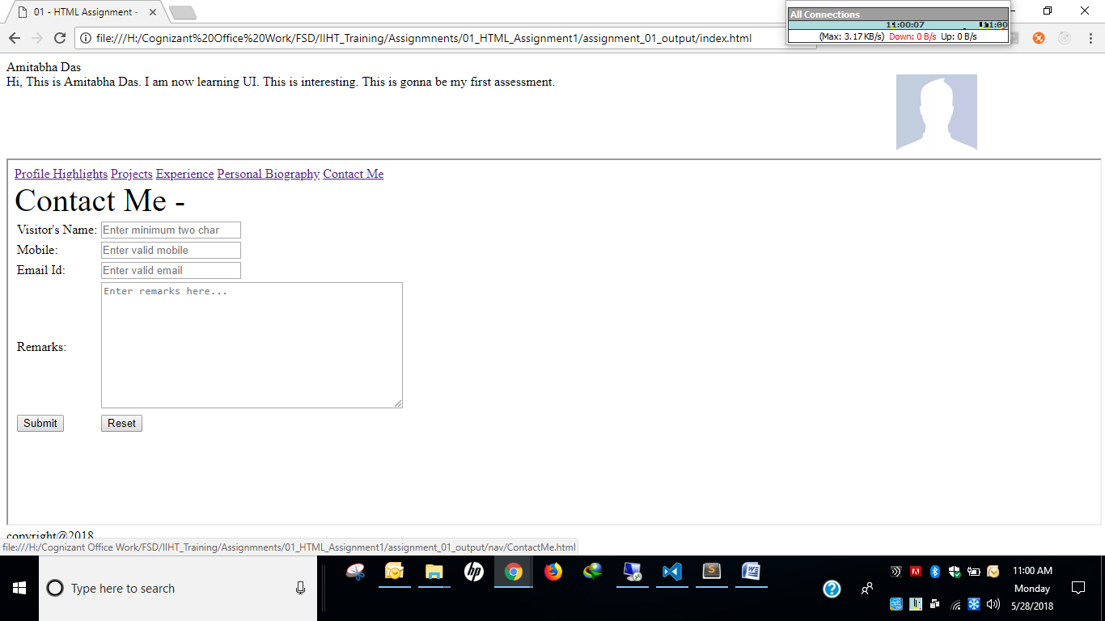

Code Snippets

**index.html**

<!DOCTYPE html>

<html>

<head>

<title>01 - HTML Assignment - 1 JAVA</title>

</head>

<body>

<div>

<header>

Amitabha Das

</header>

<div>

<div>

<section style="width: 80%; float: left; margin-right: 20px;">Hi, This is Amitabha Das. I am now learning UI. This is interesting. This is gonna be my first assessment.</section>

<aside><img alt="Profile pic" src="https://thebenclark.files.wordpress.com/2014/03/facebook-default-no-profile-pic.jpg?w=1200" height="100" width="100"/></aside>

</div>

<iframe src="navigation.html" width="100%" height="450px"></iframe>

</div>

<footer>copyright@2018</footer>

</div>

</body>

</html>

**navigation.html**

<!DOCTYPE html>

<html>

<head>

<title>01 - HTML Assignment - 1 JAVA</title>

</head>

<body>

<div>

<nav>

<a href="nav/ProfileHighlights.html">Profile Highlights</a>

<a href="nav/Projects.html">Projects</a>

<a href="nav/Experience.html">Experience</a>

<a href="nav/PersonalBiography.html">Personal Biography</a>

<a href="nav/ContactMe.html">Contact Me</a>

</nav>

</div>

</body>

</html>

**ContactMe.html**

<!DOCTYPE html>

<html>

<head>

<title>Contact Me</title>

</head>

<body>

<nav>

<a href="ProfileHighlights.html">Profile Highlights</a>

<a href="Projects.html">Projects</a>

<a href="Experience.html">Experience</a>

<a href="PersonalBiography.html">Personal Biography</a>

<a href="ContactMe.html">Contact Me</a>

</nav>

<font style="font-size: 40px;" >Contact Me - </font>

<form>

<table>

<tr>

<td><label>Visitor's Name: </label></td>

<td><input type="text" pattern="[A-Za-z ]{2}" placeholder="Enter minimum two char"></td>

</tr>

<tr>

<td><label>Mobile: </label></td>

<td><input type="number" maxlength="10" placeholder="Enter valid mobile"></td>

</tr>

<tr>

<td><label>Email Id: </label></td>

<td><input type="email" placeholder="Enter valid email"></td>

</tr>

<tr>

<td><label>Remarks: </label></td>

<td><textarea placeholder="Enter remarks here..." rows="10" cols="50"></textarea></td>

</tr>

<tr>

<td><button type="submit" value="Submit">Submit</button></td>

<td><button type="reset" value="Reset">Reset</button></td>

</tr>

</table>

</form>

</body>

</html>

**Experience.html**

<!DOCTYPE html>

<html>

<head>

<title>Experience</title>

</head>

<body>

<nav>

<a href="ProfileHighlights.html">Profile Highlights</a>

<a href="Projects.html">Projects</a>

<a href="Experience.html">Experience</a>

<a href="PersonalBiography.html">Personal Biography</a>

<a href="ContactMe.html">Contact Me</a>

</nav>

<font style="font-size: 40px;" >Experience - </font>

<br>

I have been associated with Cognizant for more than 4 years.

</body>

</html>

**PersonalBiography.html**

<!DOCTYPE html>

<html>

<head>

<title>Personal Biography</title>

</head>

<body>

<nav>

<a href="ProfileHighlights.html">Profile Highlights</a>

<a href="Projects.html">Projects</a>

<a href="Experience.html">Experience</a>

<a href="PersonalBiography.html">Personal Biography</a>

<a href="ContactMe.html">Contact Me</a>

</nav>

<font style="font-size: 40px;" >Personal Biography - </font>

<br>

My Personal Biography

</body>

</html>

**ProfileHighlights.html**

<!DOCTYPE html>

<html>

<head>

<title>Profile Highlights</title>

</head>

<body>

<nav>

<a href="ProfileHighlights.html">Profile Highlights</a>

<a href="Projects.html">Projects</a>

<a href="Experience.html">Experience</a>

<a href="PersonalBiography.html">Personal Biography</a>

<a href="ContactMe.html">Contact Me</a>

</nav>

<font style="font-size: 40px;" >Profile Highlights - </font>

<br>

I am a Java Developer and I am learning UI technologies now.

</body>

</html>

**Projects.html**

<!DOCTYPE html>

<html>

<head>

<title>Projects</title>

</head>

<body>

<nav>

<a href="ProfileHighlights.html">Profile Highlights</a>

<a href="Projects.html">Projects</a>

<a href="Experience.html">Experience</a>

<a href="PersonalBiography.html">Personal Biography</a>

<a href="ContactMe.html">Contact Me</a>

</nav>

<font style="font-size: 40px;" >Projects - </font>

<br>

My Projects include-

<ul>

<li>Project 1</li>

<li>Project 2</li>

<li>Project 3</li>

<li>Project 4</li>

<li>Project 5</li>

<li>Project 6</li>

</ul>

</body>

</html>