Assignment Zip -



Output Screenshots:

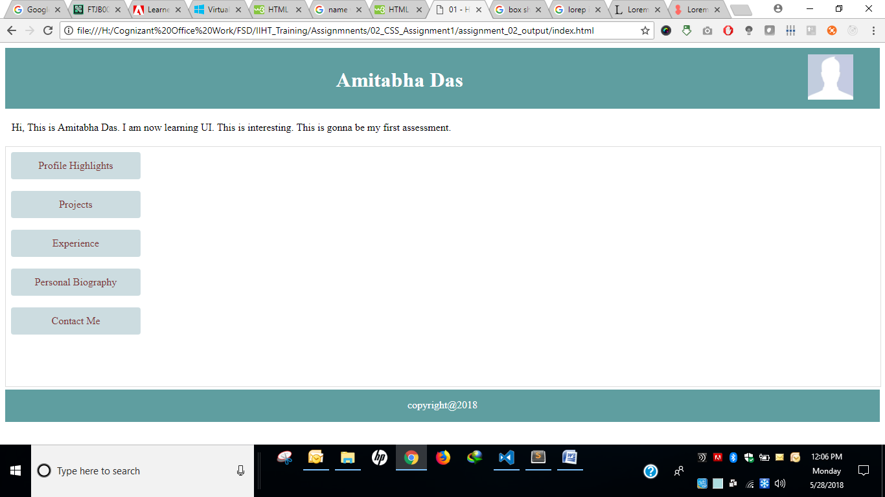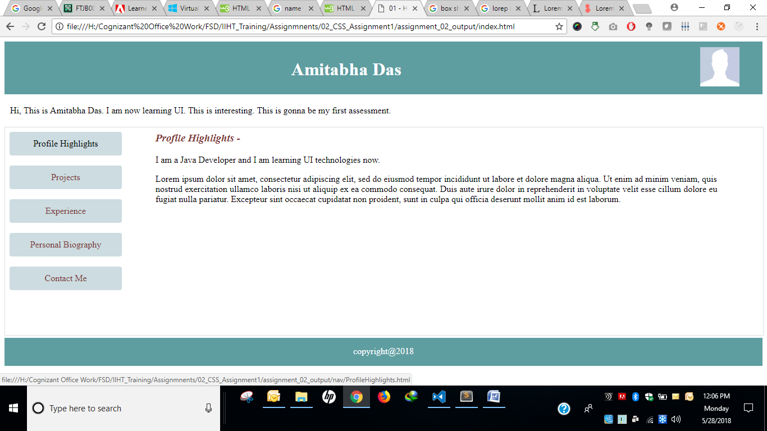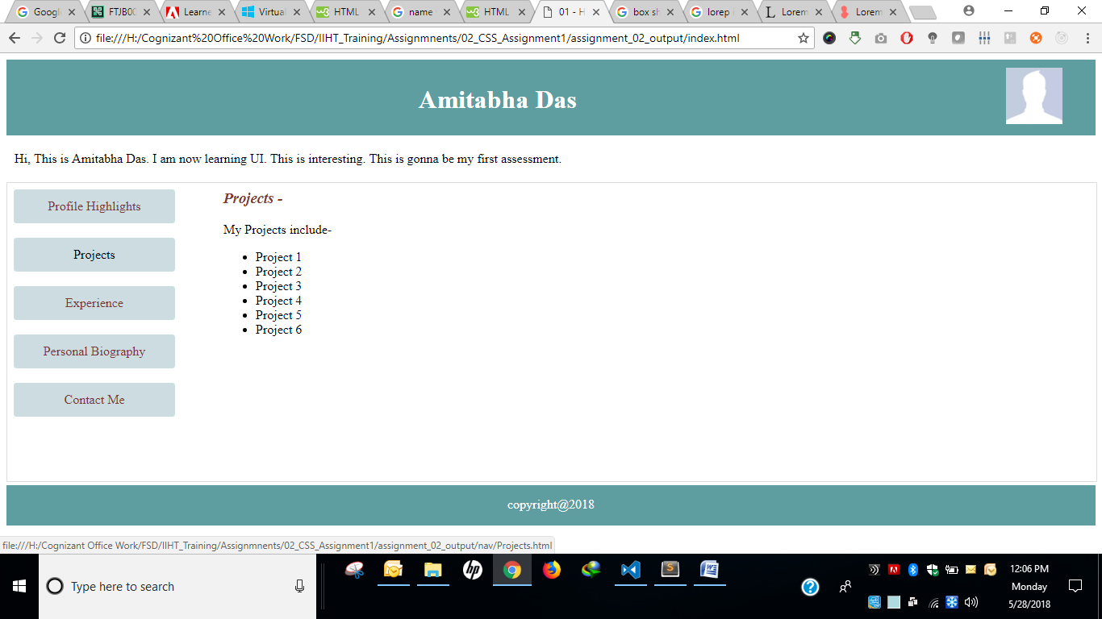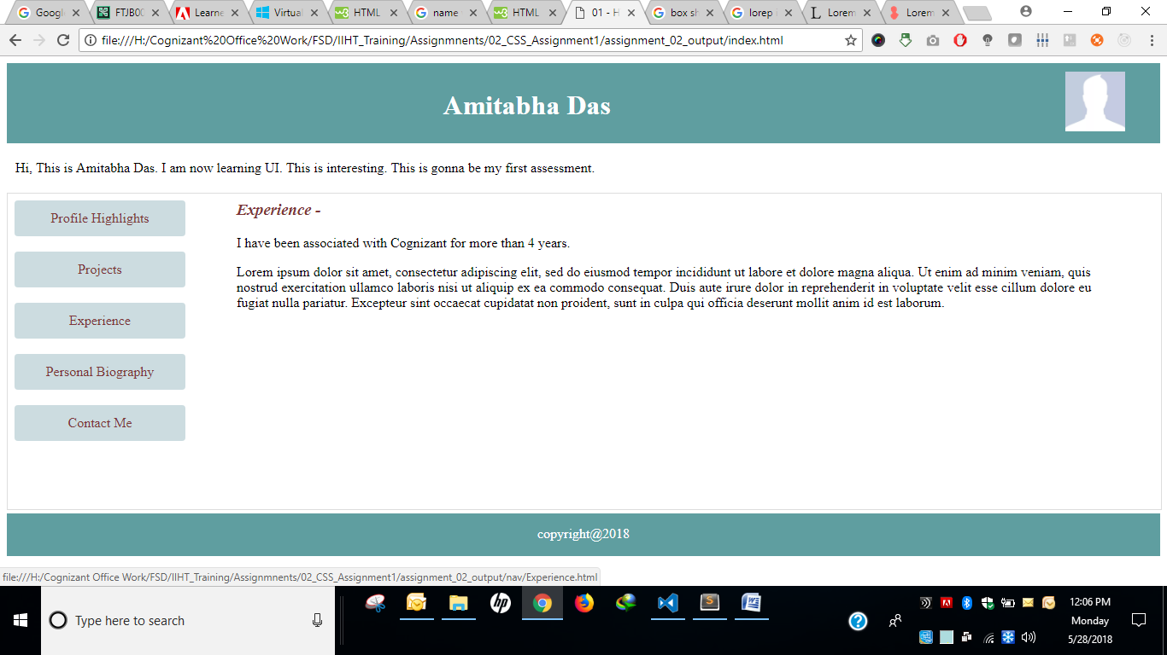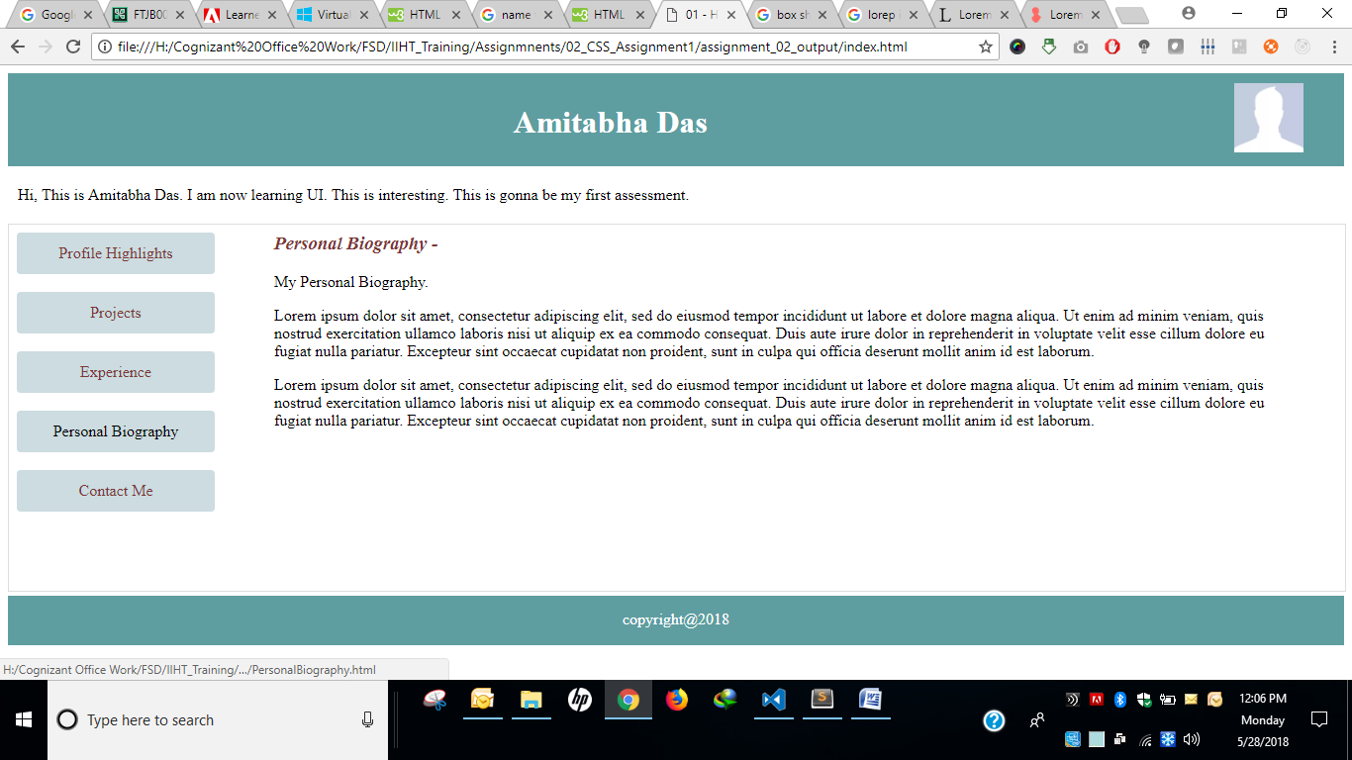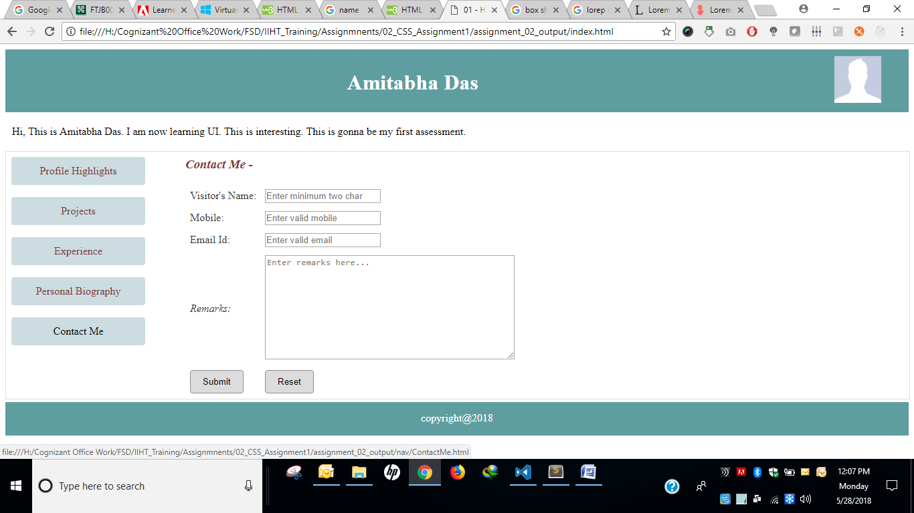

HTML Files

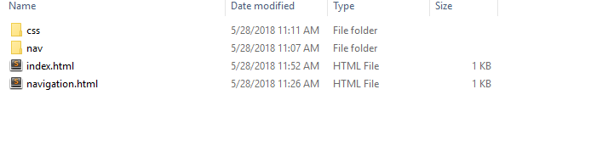

**index.html**

<!DOCTYPE html>

<html>

<head>

<title>01 - HTML Assignment - 1 JAVA</title>

<link rel="stylesheet" type="text/css" href="css/assignment.css">

</head>

<body>

<div>

<header>

<h1>Amitabha Das</h1>

<aside class="image"><img alt="Profile pic" src="https://thebenclark.files.wordpress.com/2014/03/facebook-default-no-profile-pic.jpg?w=1200" height="70" width="70"/></aside>

</header>

<div>

<div>

<section>Hi, This is Amitabha Das. I am now learning UI. This is interesting. This is gonna be my first assessment.</section>

</div>

<iframe src="navigation.html" width="100%" height="370px"></iframe>

</div>

<footer>copyright@2018</footer>

</div>

</body>

</html>

navigation.html

<!DOCTYPE html>

<html>

<head>

<link rel="stylesheet" type="text/css" href="css/assignment.css">

<title>01 - HTML Assignment - 1 JAVA</title>

</head>

<body>

<div>

<nav>

<a href="nav/ProfileHighlights.html">Profile Highlights</a> <br/>

<a href="nav/Projects.html">Projects</a> <br/>

<a href="nav/Experience.html">Experience</a> <br/>

<a href="nav/PersonalBiography.html">Personal Biography</a> <br/>

<a href="nav/ContactMe.html">Contact Me</a>

</nav>

</div>

</body>

</html>

**ContactMe.html**

<!DOCTYPE html>

<html>

<head>

<link rel="stylesheet" type="text/css" href="../css/assignment.css">

<title>Contact Me</title>

</head>

<body>

<nav>

<a href="ProfileHighlights.html">Profile Highlights</a> <br/>

<a href="Projects.html">Projects</a> <br/>

<a href="Experience.html">Experience</a> <br/>

<a href="PersonalBiography.html">Personal Biography</a> <br/>

<a href="ContactMe.html">Contact Me</a>

</nav>

<div class="content">

<h3>Contact Me - </h3>

<form>

<table>

<tr>

<td><label>Visitor's Name: </label></td>

<td><input type="text" pattern="[A-Za-z ]{2}" placeholder="Enter minimum two char"></td>

</tr>

<tr>

<td><label>Mobile: </label></td>

<td><input type="number" maxlength="10" placeholder="Enter valid mobile"></td>

</tr>

<tr>

<td><label>Email Id: </label></td>

<td><input type="email" placeholder="Enter valid email"></td>

</tr>

<tr>

<td><label class="remarks">Remarks: </label></td>

<td><textarea placeholder="Enter remarks here..." rows="10" cols="50"></textarea></td>

</tr>

<tr>

<td><button type="submit" value="Submit">Submit</button></td>

<td><button type="reset" value="Reset">Reset</button></td>

</tr>

</table>

</form>

</div>

</body>

</html>

**Experience.html**

<!DOCTYPE html>

<html>

<head>

<link rel="stylesheet" type="text/css" href="../css/assignment.css">

<title>Experience</title>

</head>

<body>

<nav>

<a href="ProfileHighlights.html">Profile Highlights</a> <br/>

<a href="Projects.html">Projects</a> <br/>

<a href="Experience.html">Experience</a> <br/>

<a href="PersonalBiography.html">Personal Biography</a> <br/>

<a href="ContactMe.html">Contact Me</a>

</nav>

<div class="content">

<h3>Experience - </h3>

<p>I have been associated with Cognizant for more than 4 years.</p>

<p>Lorem ipsum dolor sit amet, consectetur adipiscing elit, sed do eiusmod tempor incididunt ut labore et dolore magna aliqua. Ut enim ad minim veniam, quis nostrud exercitation ullamco laboris nisi ut aliquip ex ea commodo consequat. Duis aute irure dolor in reprehenderit in voluptate velit esse cillum dolore eu fugiat nulla pariatur. Excepteur sint occaecat cupidatat non proident, sunt in culpa qui officia deserunt mollit anim id est laborum.</p>

</div>

</body>

</html>

**PersonalBiography.html**

<!DOCTYPE html>

<html>

<head>

<link rel="stylesheet" type="text/css" href="../css/assignment.css">

<title>Personal Biography</title>

</head>

<body>

<nav>

<a href="ProfileHighlights.html">Profile Highlights</a> <br/>

<a href="Projects.html">Projects</a> <br/>

<a href="Experience.html">Experience</a> <br/>

<a href="PersonalBiography.html">Personal Biography</a> <br/>

<a href="ContactMe.html">Contact Me</a>

</nav>

<div class="content">

<h3>Personal Biography - </h3>

<p>My Personal Biography.</p>

<p>Lorem ipsum dolor sit amet, consectetur adipiscing elit, sed do eiusmod tempor incididunt ut labore et dolore magna aliqua. Ut enim ad minim veniam, quis nostrud exercitation ullamco laboris nisi ut aliquip ex ea commodo consequat. Duis aute irure dolor in reprehenderit in voluptate velit esse cillum dolore eu fugiat nulla pariatur. Excepteur sint occaecat cupidatat non proident, sunt in culpa qui officia deserunt mollit anim id est laborum.</p>

<p>Lorem ipsum dolor sit amet, consectetur adipiscing elit, sed do eiusmod tempor incididunt ut labore et dolore magna aliqua. Ut enim ad minim veniam, quis nostrud exercitation ullamco laboris nisi ut aliquip ex ea commodo consequat. Duis aute irure dolor in reprehenderit in voluptate velit esse cillum dolore eu fugiat nulla pariatur. Excepteur sint occaecat cupidatat non proident, sunt in culpa qui officia deserunt mollit anim id est laborum.</p>

</div>

</body>

</html>

**ProfileHighlights.html**

<!DOCTYPE html>

<html>

<head>

<link rel="stylesheet" type="text/css" href="../css/assignment.css">

<title>Profile Highlights</title>

</head>

<body>

<nav>

<a href="ProfileHighlights.html">Profile Highlights</a> <br/>

<a href="Projects.html">Projects</a> <br/>

<a href="Experience.html">Experience</a> <br/>

<a href="PersonalBiography.html">Personal Biography</a> <br/>

<a href="ContactMe.html">Contact Me</a>

</nav>

<div class="content">

<h3>Profile Highlights - </h3>

<p>I am a Java Developer and I am learning UI technologies now. </p>

<p>Lorem ipsum dolor sit amet, consectetur adipiscing elit, sed do eiusmod tempor incididunt ut labore et dolore magna aliqua. Ut enim ad minim veniam, quis nostrud exercitation ullamco laboris nisi ut aliquip ex ea commodo consequat. Duis aute irure dolor in reprehenderit in voluptate velit esse cillum dolore eu fugiat nulla pariatur. Excepteur sint occaecat cupidatat non proident, sunt in culpa qui officia deserunt mollit anim id est laborum.</p>

</div>

</body>

</html>

**Projects.html**

<!DOCTYPE html>

<html>

<head>

<link rel="stylesheet" type="text/css" href="../css/assignment.css">

<title>Projects</title>

</head>

<body>

<nav>

<a href="ProfileHighlights.html">Profile Highlights</a> <br/>

<a href="Projects.html">Projects</a> <br/>

<a href="Experience.html">Experience</a> <br/>

<a href="PersonalBiography.html">Personal Biography</a> <br/>

<a href="ContactMe.html">Contact Me</a>

</nav>

<div class="content">

<h3>Projects - </h3>

<article>

My Projects include-

<ul>

<li>Project 1</li>

<li>Project 2</li>

<li>Project 3</li>

<li>Project 4</li>

<li>Project 5</li>

<li>Project 6</li>

</ul>

</article>

</div>

</body>

</html>

**assignment.css**

header {

background: cadetblue;

padding: 10px;

color: white;

text-align: center;

}

h1 {

float: left;

width: 90%;

}

section {

margin: 20px 0;

padding-left: 10px;

}

iframe {

border: 1px solid #dddddd;

}

nav {

width: 200px;

float: left;

height: 300px;

}

nav a {

text-decoration: none;

border-radius: 4px;

padding: 12px;

display: block;

text-align: center;

background: #ccdce0;

color: #7d3636;

}

nav a:hover {

color: black;

}

.content {

margin-left: 60px;

margin-right: 10px;

float: left;

width: 75%;

text-align: justify;

}

.content h3 {

margin-top: 0;

color: #7d3636;

font-style: italic;

}

.content label {

color: #373333;

}

.content label.remarks {

font-style: italic;

}

.content table td {

padding: 5px;

}

.content button {

background: #dcdcde;

padding: 9px 18px;

border: 1px solid #928d8d;

border-radius: 4px;

}

footer {

background: cadetblue;

height: 35px;

text-align: center;

color: white;

padding-top: 15px;

}