Assignment Folder Zip -



Output Screenshots

**View From Browser**

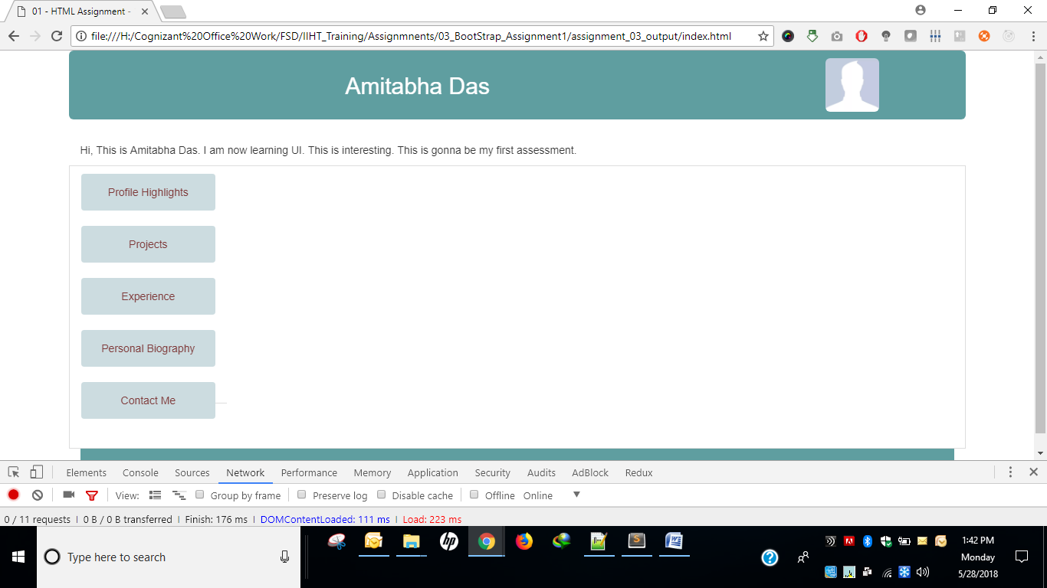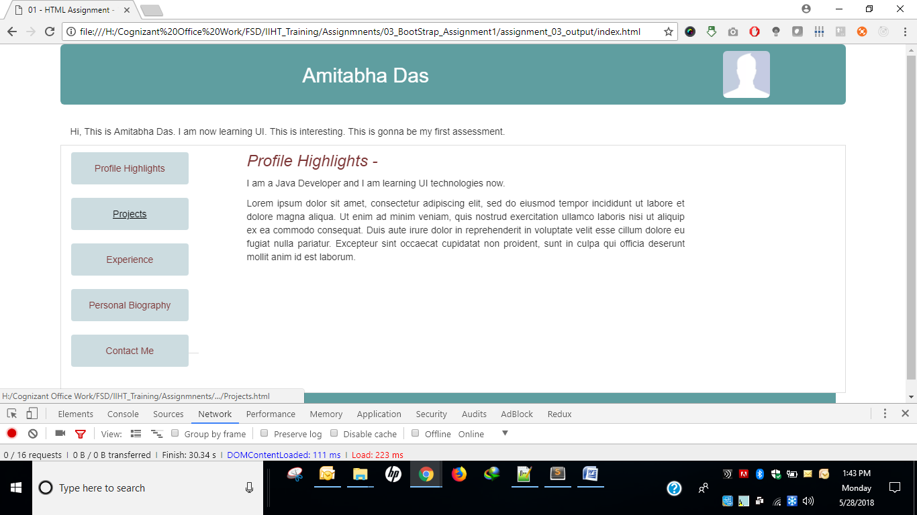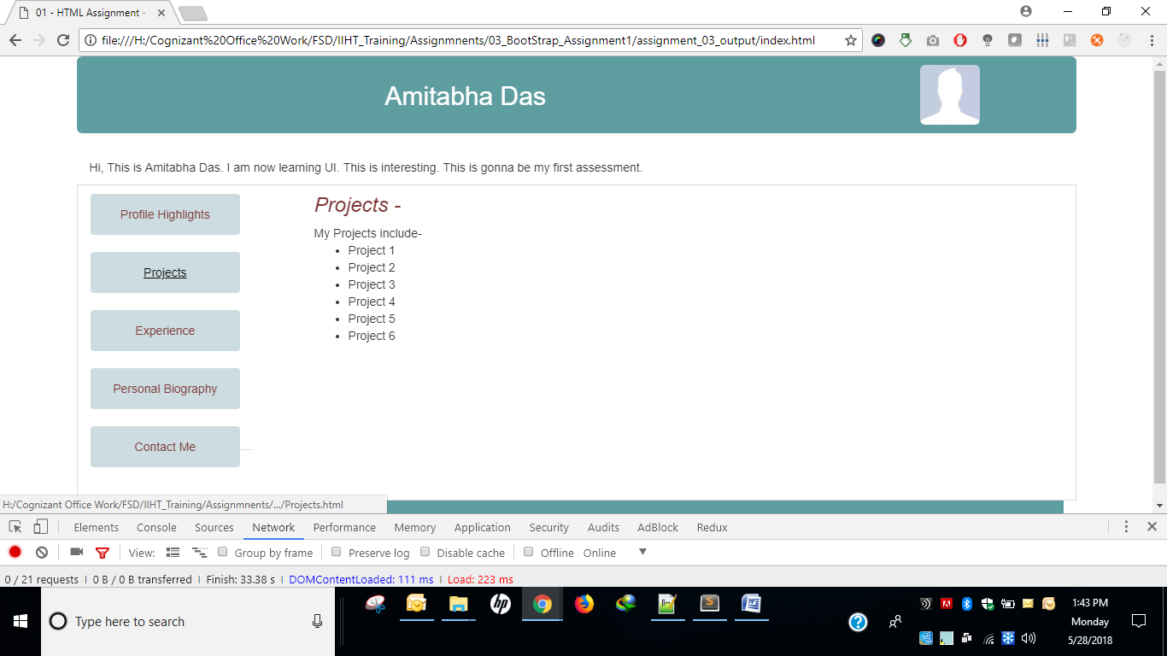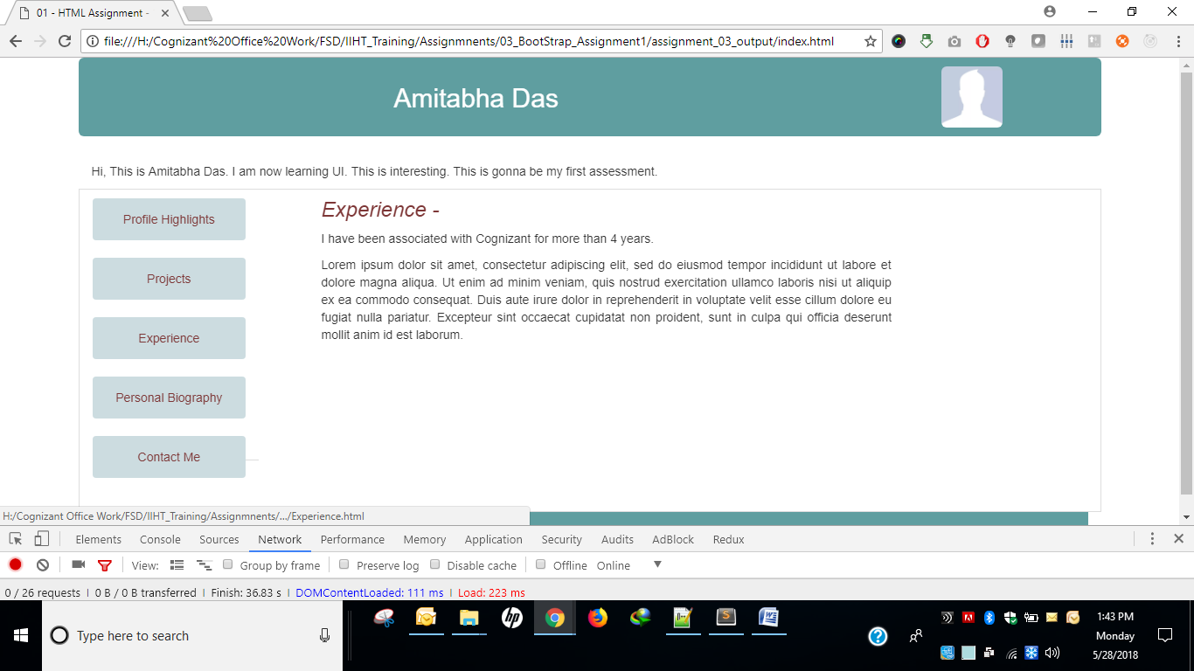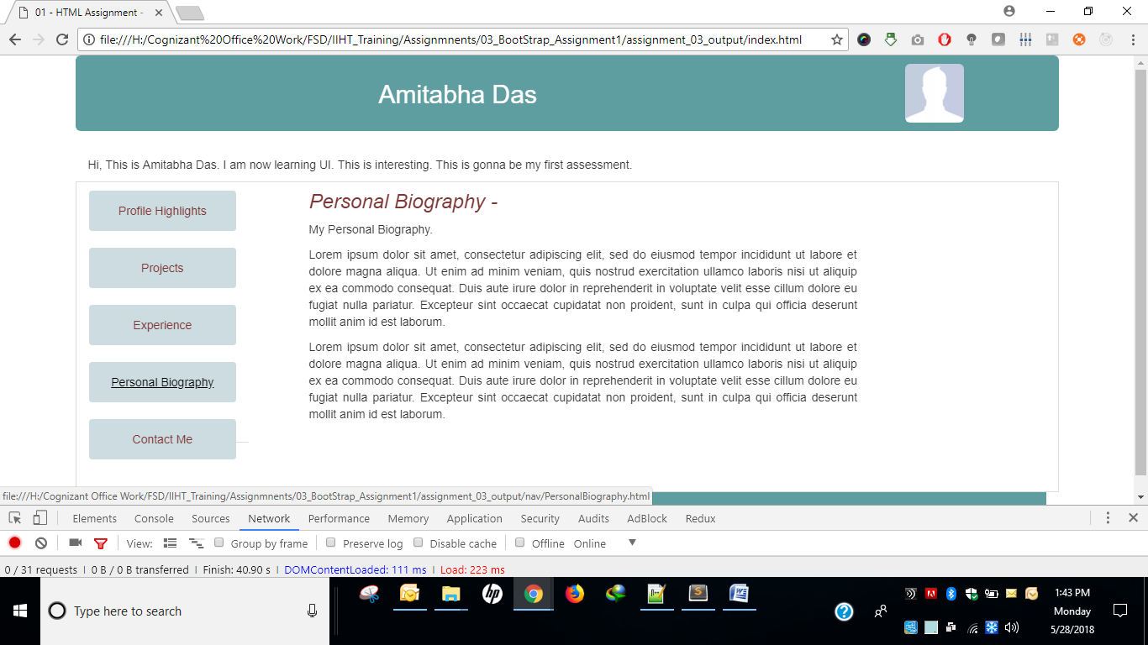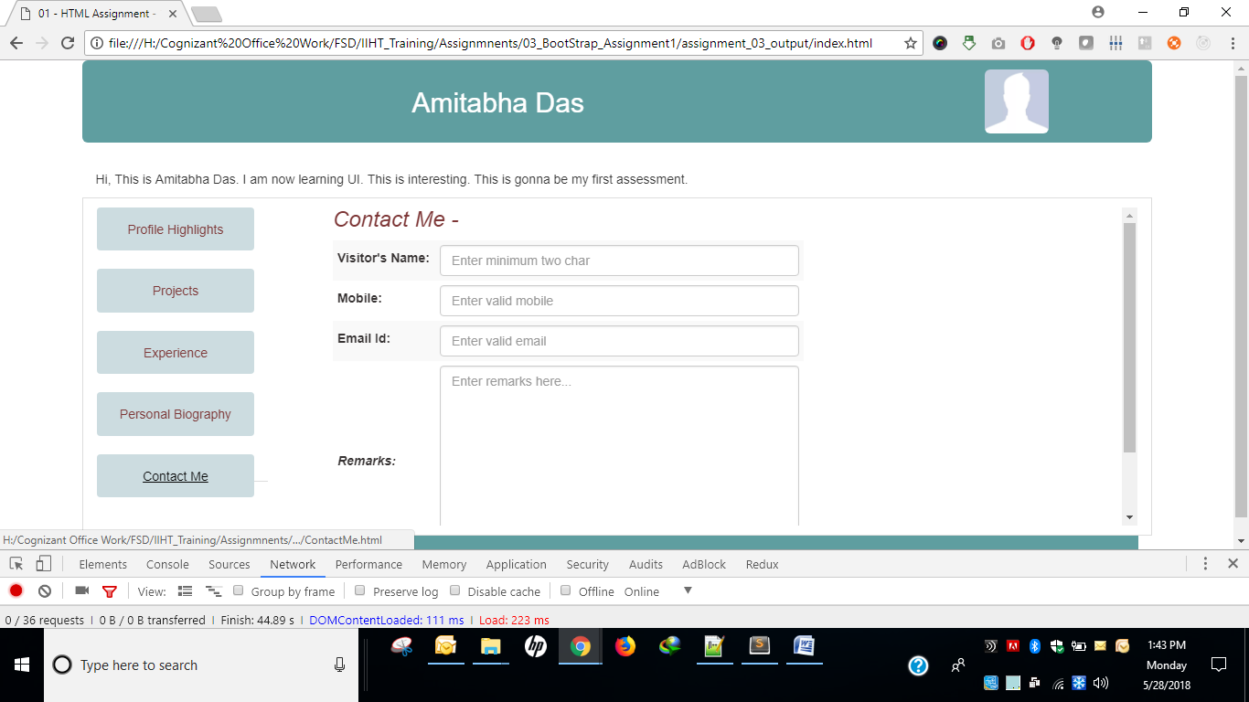

**After Making the pages responsive - View in IPAD**

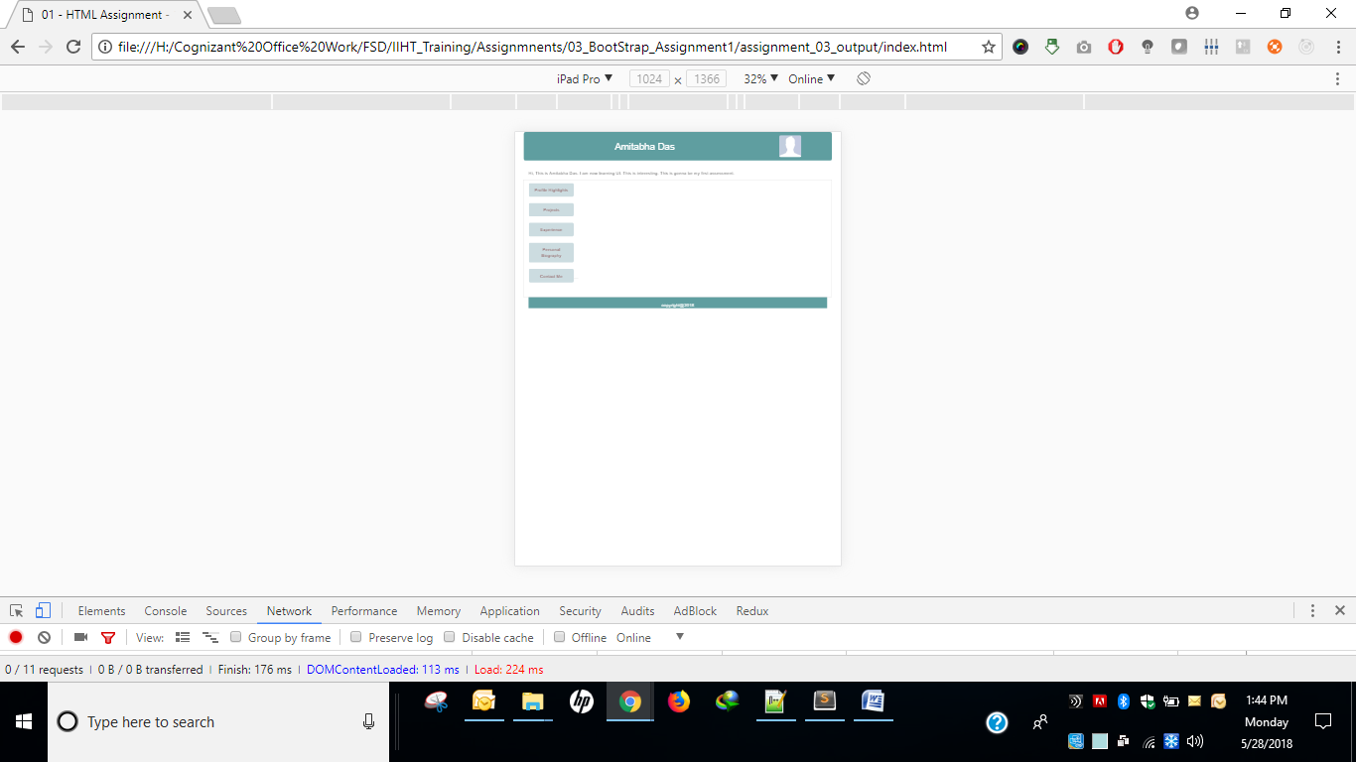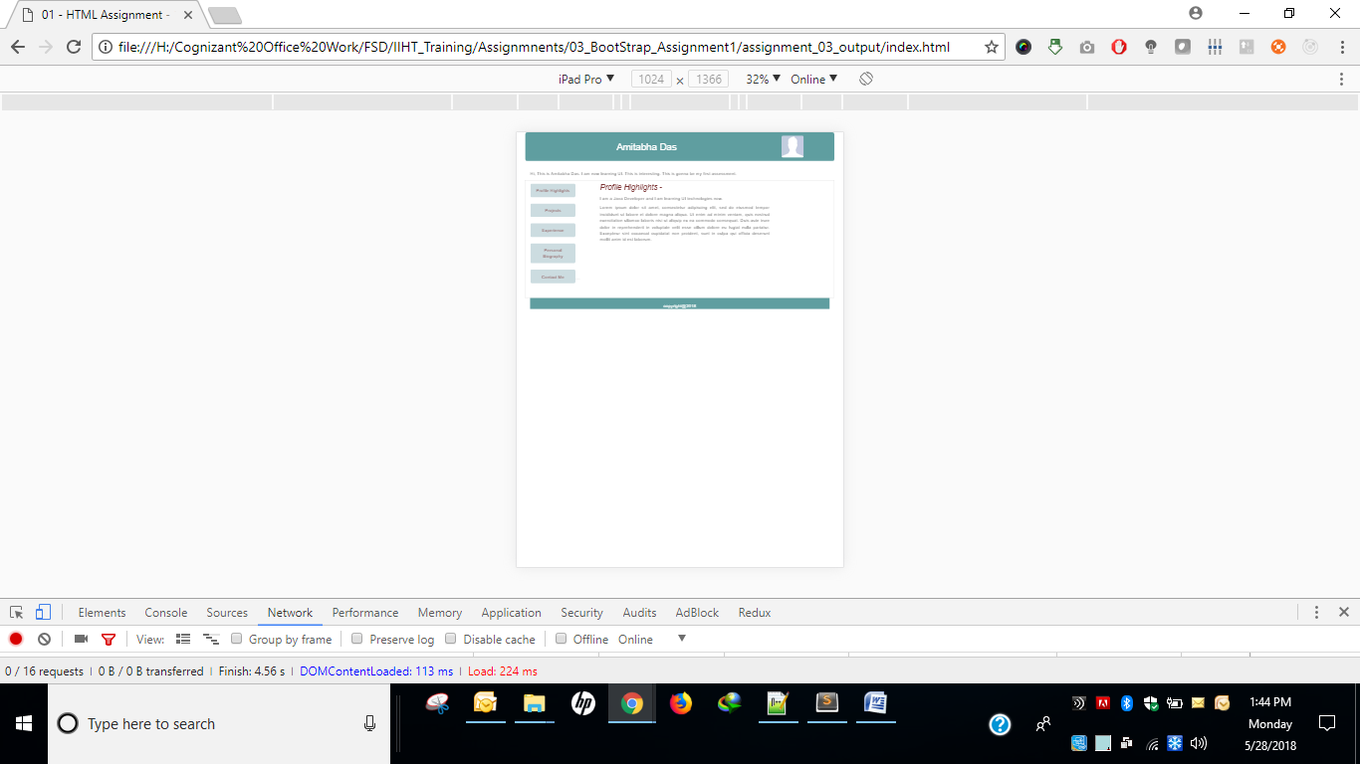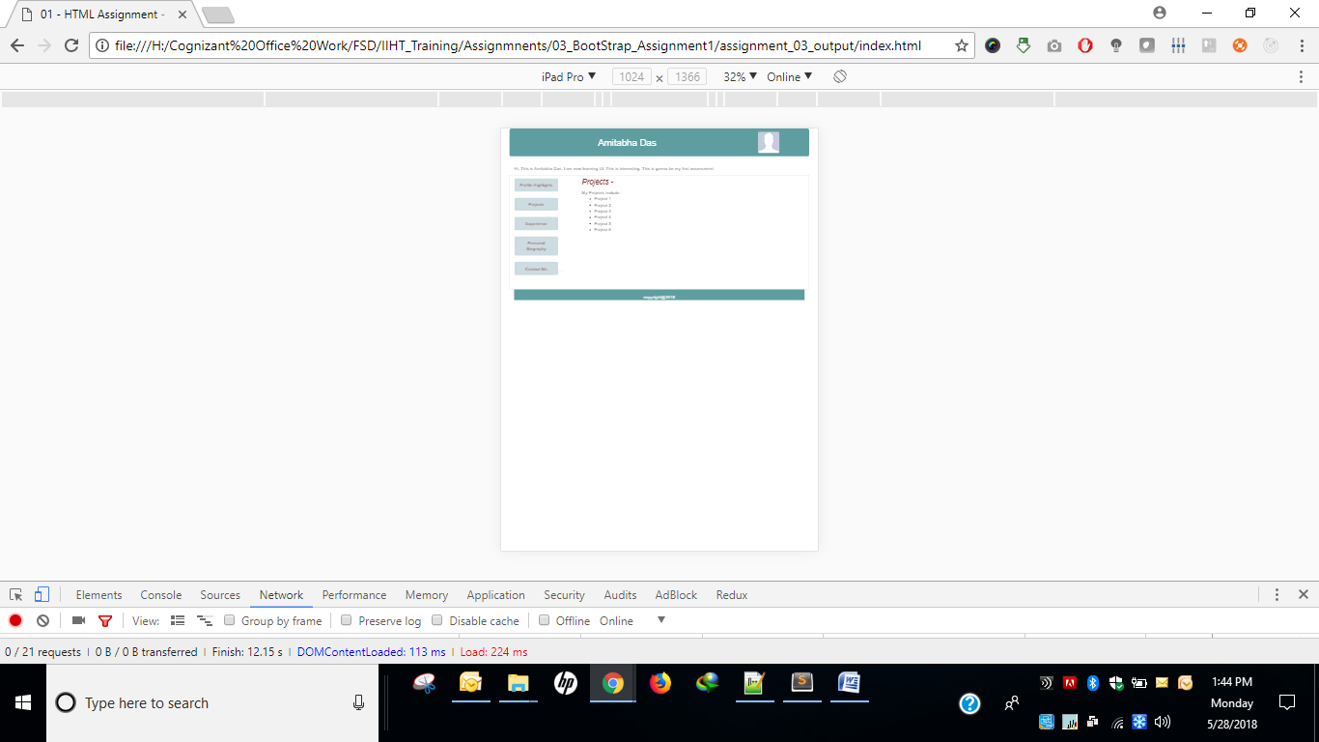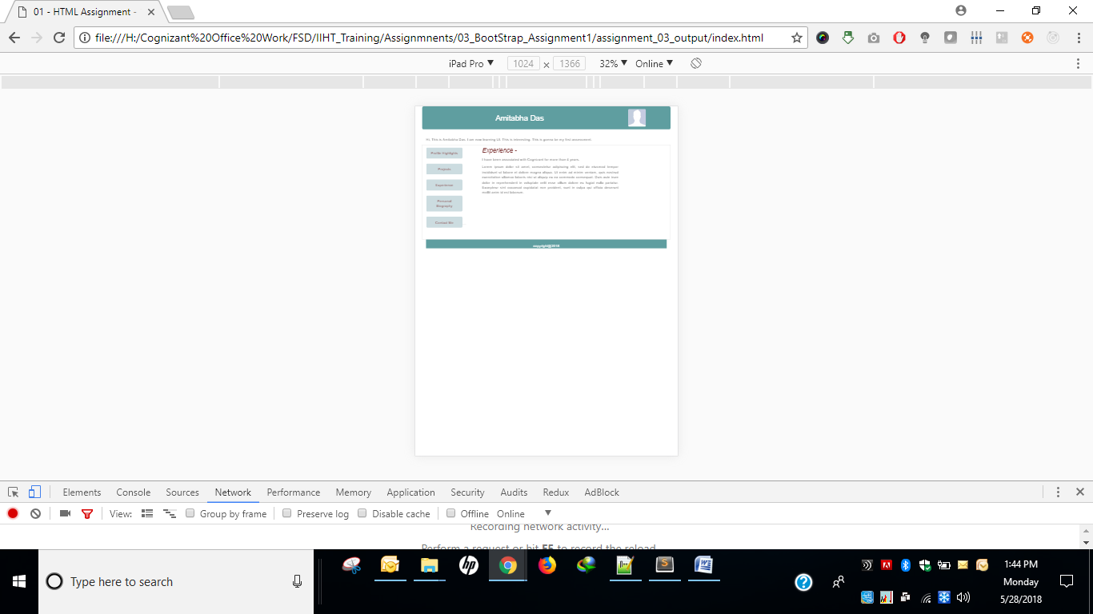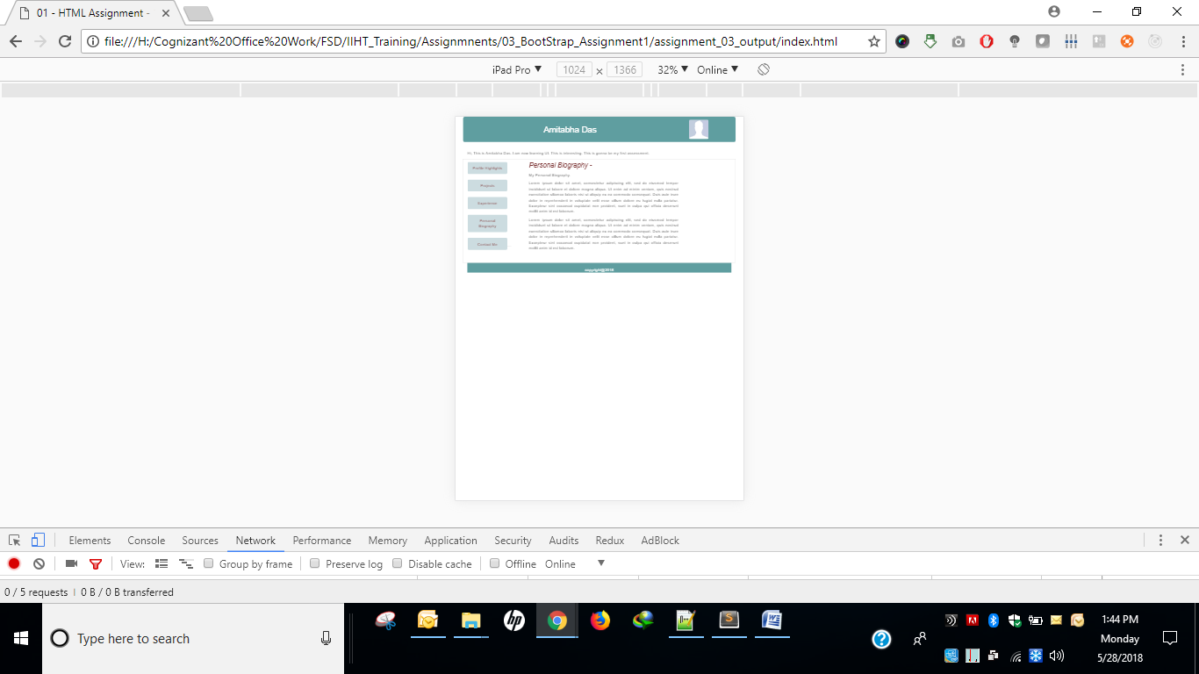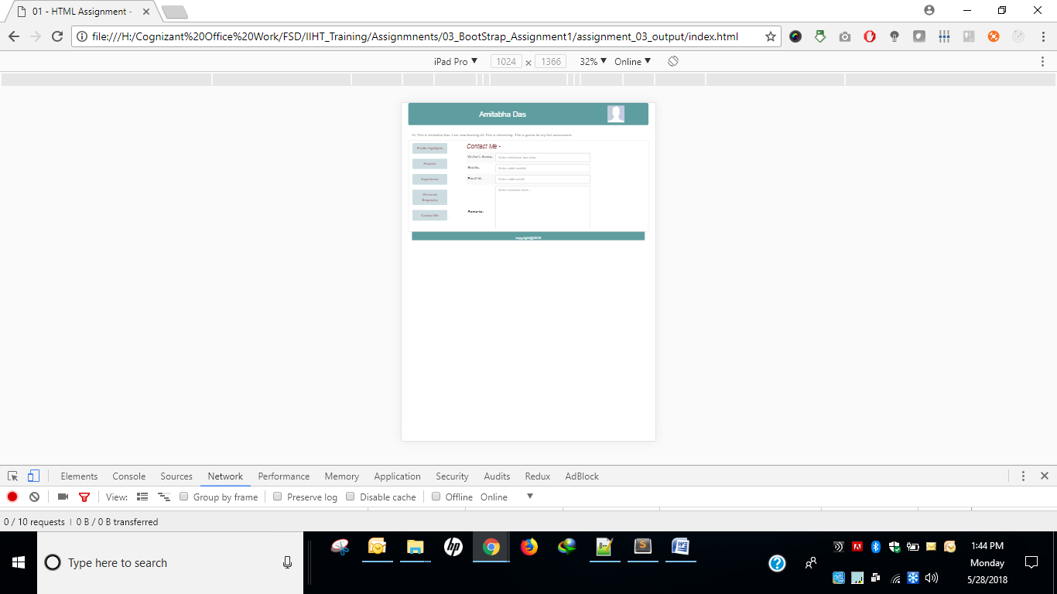

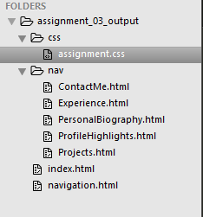

**index.html**

|  |
| --- |
| <!DOCTYPE html>  <html>  <head>  <title>01 - HTML Assignment - 1 JAVA</title>  <link rel="stylesheet" href="https://maxcdn.bootstrapcdn.com/bootstrap/3.3.7/css/bootstrap.min.css">  <link rel="stylesheet" type="text/css" href="css/assignment.css">  <script src="https://ajax.googleapis.com/ajax/libs/jquery/3.3.1/jquery.min.js"></script>  <script src="https://maxcdn.bootstrapcdn.com/bootstrap/3.3.7/js/bootstrap.min.js"></script>  </head>  <body>  <div class="container">  <header class="jumbotron row">  <div class="col-lg-10 col-md-10 col-sm-10 col-xs-12">  <h2>Amitabha Das</h2>  </div>  <aside class="image col-lg-2 col-md-2 col-sm-2 col-xs-12">  <img alt="Profile pic" class="img-rounded" src="https://thebenclark.files.wordpress.com/2014/03/facebook-default-no-profile-pic.jpg?w=1200" height="70" width="70"/>  </aside>  </header>  <div class="row">  <div class="col-xs-12">  <section>Hi, This is Amitabha Das. I am now learning UI. This is interesting. This is gonna be my first assessment.</section>  </div>  <iframe class="col-xs-12" src="navigation.html" width="100%" height="370px"></iframe>  </div>  <footer>copyright@2018</footer>  </div>  </body>  </html> |

**navigation.html**

|  |
| --- |
| <!DOCTYPE html>  <html>  <head>  <link rel="stylesheet" href="https://maxcdn.bootstrapcdn.com/bootstrap/3.3.7/css/bootstrap.min.css">  <link rel="stylesheet" type="text/css" href="css/assignment.css">  <script src="https://ajax.googleapis.com/ajax/libs/jquery/3.3.1/jquery.min.js"></script>  <script src="https://maxcdn.bootstrapcdn.com/bootstrap/3.3.7/js/bootstrap.min.js"></script>  <title>01 - HTML Assignment - 1 JAVA</title>  </head>  <body>  <div>  <nav class="nav nav-tabs col-xs-2">  <a href="nav/ProfileHighlights.html">Profile Highlights</a> <br/>  <a href="nav/Projects.html">Projects</a> <br/>  <a href="nav/Experience.html">Experience</a> <br/>  <a href="nav/PersonalBiography.html">Personal Biography</a> <br/>  <a href="nav/ContactMe.html">Contact Me</a>  </nav>  </div>  </body>  </html> |

**ContactMe.html**

|  |
| --- |
| <!DOCTYPE html>  <html>  <head>  <link rel="stylesheet" href="https://maxcdn.bootstrapcdn.com/bootstrap/3.3.7/css/bootstrap.min.css">  <link rel="stylesheet" type="text/css" href="../css/assignment.css">  <script src="https://ajax.googleapis.com/ajax/libs/jquery/3.3.1/jquery.min.js"></script>  <script src="https://maxcdn.bootstrapcdn.com/bootstrap/3.3.7/js/bootstrap.min.js"></script>  <title>Contact Me</title>  </head>  <body>  <nav class="nav nav-tabs col-xs-2">  <a href="ProfileHighlights.html">Profile Highlights</a> <br/>  <a href="Projects.html">Projects</a> <br/>  <a href="Experience.html">Experience</a> <br/>  <a href="PersonalBiography.html">Personal Biography</a> <br/>  <a href="ContactMe.html">Contact Me</a>  </nav>  <div class="content col-xs-10">  <h3>Contact Me - </h3>  <form>  <table class="table-striped">  <tr class="form-group">  <td><label>Visitor's Name: </label></td>  <td><input class="form-control" type="text" pattern="[A-Za-z ]{2}" placeholder="Enter minimum two char"></td>  </tr>  <tr class="form-group">  <td><label>Mobile: </label></td>  <td><input class="form-control" type="number" maxlength="10" placeholder="Enter valid mobile"></td>  </tr>  <tr class="form-group">  <td><label>Email Id: </label></td>  <td><input class="form-control" type="email" placeholder="Enter valid email"></td>  </tr>  <tr class="form-group">  <td><label class="remarks">Remarks: </label></td>  <td><textarea class="form-control" placeholder="Enter remarks here..." rows="10" cols="50"></textarea></td>  </tr>  <tr class="form-group">  <td><button type="submit" class="btn btn-primary" value="Submit">Submit</button></td>  <td><button type="reset" class="btn" value="Reset">Reset</button></td>  </tr>  </table>  </form>  </div>  </body>  </html> |

**Experience.html**

|  |
| --- |
| <!DOCTYPE html>  <html>  <head>  <link rel="stylesheet" href="https://maxcdn.bootstrapcdn.com/bootstrap/3.3.7/css/bootstrap.min.css">  <link rel="stylesheet" type="text/css" href="../css/assignment.css">  <script src="https://ajax.googleapis.com/ajax/libs/jquery/3.3.1/jquery.min.js"></script>  <script src="https://maxcdn.bootstrapcdn.com/bootstrap/3.3.7/js/bootstrap.min.js"></script>  <title>Experience</title>  </head>  <body>  <nav class="nav nav-tabs col-xs-2">  <a href="ProfileHighlights.html">Profile Highlights</a> <br/>  <a href="Projects.html">Projects</a> <br/>  <a href="Experience.html">Experience</a> <br/>  <a href="PersonalBiography.html">Personal Biography</a> <br/>  <a href="ContactMe.html">Contact Me</a>  </nav>  <div class="content col-xs-10">  <h3>Experience - </h3>  <p>I have been associated with Cognizant for more than 4 years.</p>  <p>Lorem ipsum dolor sit amet, consectetur adipiscing elit, sed do eiusmod tempor incididunt ut labore et dolore magna aliqua. Ut enim ad minim veniam, quis nostrud exercitation ullamco laboris nisi ut aliquip ex ea commodo consequat. Duis aute irure dolor in reprehenderit in voluptate velit esse cillum dolore eu fugiat nulla pariatur. Excepteur sint occaecat cupidatat non proident, sunt in culpa qui officia deserunt mollit anim id est laborum.</p>  </div>  </body>  </html> |

**PersonalBiography.html**

|  |
| --- |
| <!DOCTYPE html>  <html>  <head>  <link rel="stylesheet" href="https://maxcdn.bootstrapcdn.com/bootstrap/3.3.7/css/bootstrap.min.css">  <link rel="stylesheet" type="text/css" href="../css/assignment.css">  <script src="https://ajax.googleapis.com/ajax/libs/jquery/3.3.1/jquery.min.js"></script>  <script src="https://maxcdn.bootstrapcdn.com/bootstrap/3.3.7/js/bootstrap.min.js"></script>  <title>Personal Biography</title>  </head>  <body>  <nav class="nav nav-tabs col-xs-2">  <a href="ProfileHighlights.html">Profile Highlights</a> <br/>  <a href="Projects.html">Projects</a> <br/>  <a href="Experience.html">Experience</a> <br/>  <a href="PersonalBiography.html">Personal Biography</a> <br/>  <a href="ContactMe.html">Contact Me</a>  </nav>  <div class="content col-xs-10">  <h3>Personal Biography - </h3>  <p>My Personal Biography.</p>  <p>Lorem ipsum dolor sit amet, consectetur adipiscing elit, sed do eiusmod tempor incididunt ut labore et dolore magna aliqua. Ut enim ad minim veniam, quis nostrud exercitation ullamco laboris nisi ut aliquip ex ea commodo consequat. Duis aute irure dolor in reprehenderit in voluptate velit esse cillum dolore eu fugiat nulla pariatur. Excepteur sint occaecat cupidatat non proident, sunt in culpa qui officia deserunt mollit anim id est laborum.</p>  <p>Lorem ipsum dolor sit amet, consectetur adipiscing elit, sed do eiusmod tempor incididunt ut labore et dolore magna aliqua. Ut enim ad minim veniam, quis nostrud exercitation ullamco laboris nisi ut aliquip ex ea commodo consequat. Duis aute irure dolor in reprehenderit in voluptate velit esse cillum dolore eu fugiat nulla pariatur. Excepteur sint occaecat cupidatat non proident, sunt in culpa qui officia deserunt mollit anim id est laborum.</p>  </div>  </body>  </html> |

**ProfileHighlights.html**

|  |
| --- |
| <!DOCTYPE html>  <html>  <head>  <link rel="stylesheet" href="https://maxcdn.bootstrapcdn.com/bootstrap/3.3.7/css/bootstrap.min.css">  <link rel="stylesheet" type="text/css" href="../css/assignment.css">  <script src="https://ajax.googleapis.com/ajax/libs/jquery/3.3.1/jquery.min.js"></script>  <script src="https://maxcdn.bootstrapcdn.com/bootstrap/3.3.7/js/bootstrap.min.js"></script>  <title>Profile Highlights</title>  </head>  <body>  <nav class="nav nav-tabs col-xs-2">  <a href="ProfileHighlights.html">Profile Highlights</a> <br/>  <a href="Projects.html">Projects</a> <br/>  <a href="Experience.html">Experience</a> <br/>  <a href="PersonalBiography.html">Personal Biography</a> <br/>  <a href="ContactMe.html">Contact Me</a>  </nav>  <div class="content col-xs-10">  <h3>Profile Highlights - </h3>  <p>I am a Java Developer and I am learning UI technologies now. </p>  <p>Lorem ipsum dolor sit amet, consectetur adipiscing elit, sed do eiusmod tempor incididunt ut labore et dolore magna aliqua. Ut enim ad minim veniam, quis nostrud exercitation ullamco laboris nisi ut aliquip ex ea commodo consequat. Duis aute irure dolor in reprehenderit in voluptate velit esse cillum dolore eu fugiat nulla pariatur. Excepteur sint occaecat cupidatat non proident, sunt in culpa qui officia deserunt mollit anim id est laborum.</p>  </div>  </body>  </html> |

**Projects.html**

|  |
| --- |
| <!DOCTYPE html>  <html>  <head>  <link rel="stylesheet" href="https://maxcdn.bootstrapcdn.com/bootstrap/3.3.7/css/bootstrap.min.css">  <link rel="stylesheet" type="text/css" href="../css/assignment.css">  <script src="https://ajax.googleapis.com/ajax/libs/jquery/3.3.1/jquery.min.js"></script>  <script src="https://maxcdn.bootstrapcdn.com/bootstrap/3.3.7/js/bootstrap.min.js"></script>  <title>Projects</title>  </head>  <body>  <nav class="nav nav-tabs col-xs-2">  <a href="ProfileHighlights.html">Profile Highlights</a> <br/>  <a href="Projects.html">Projects</a> <br/>  <a href="Experience.html">Experience</a> <br/>  <a href="PersonalBiography.html">Personal Biography</a> <br/>  <a href="ContactMe.html">Contact Me</a>  </nav>  <div class="content col-xs-10">  <h3>Projects - </h3>  <article>  My Projects include-  <ul>  <li>Project 1</li>  <li>Project 2</li>  <li>Project 3</li>  <li>Project 4</li>  <li>Project 5</li>  <li>Project 6</li>  </ul>  </article>  </div>  </body>  </html> |