Assignment Folder Zip -



Output Screenshots

**View From Browser**

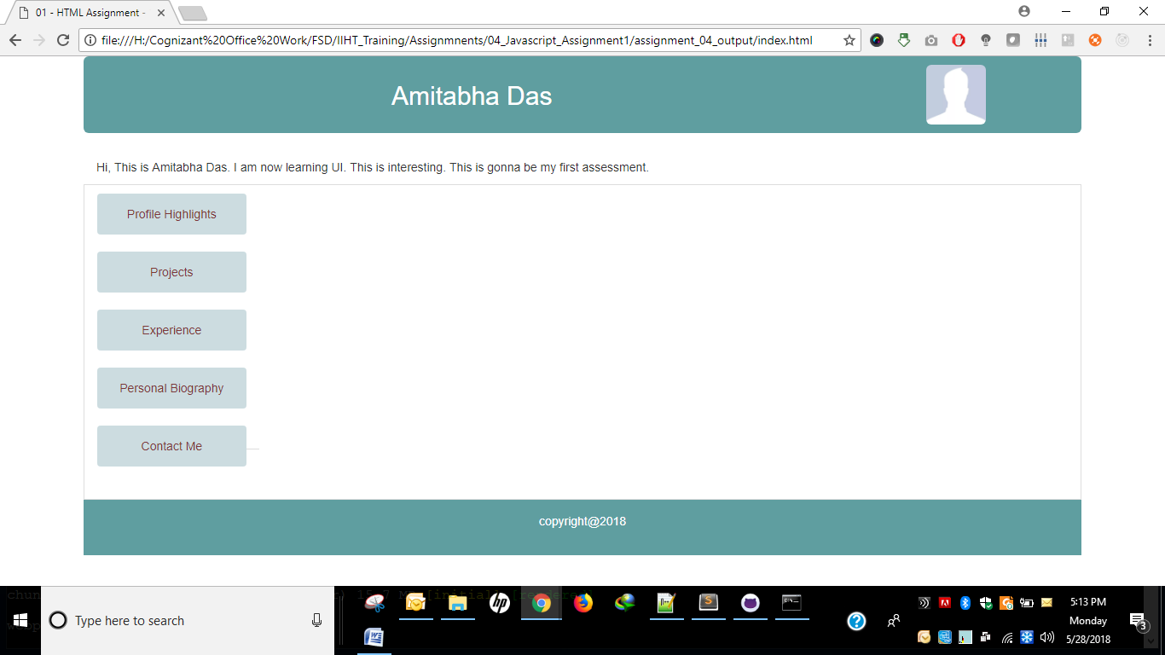 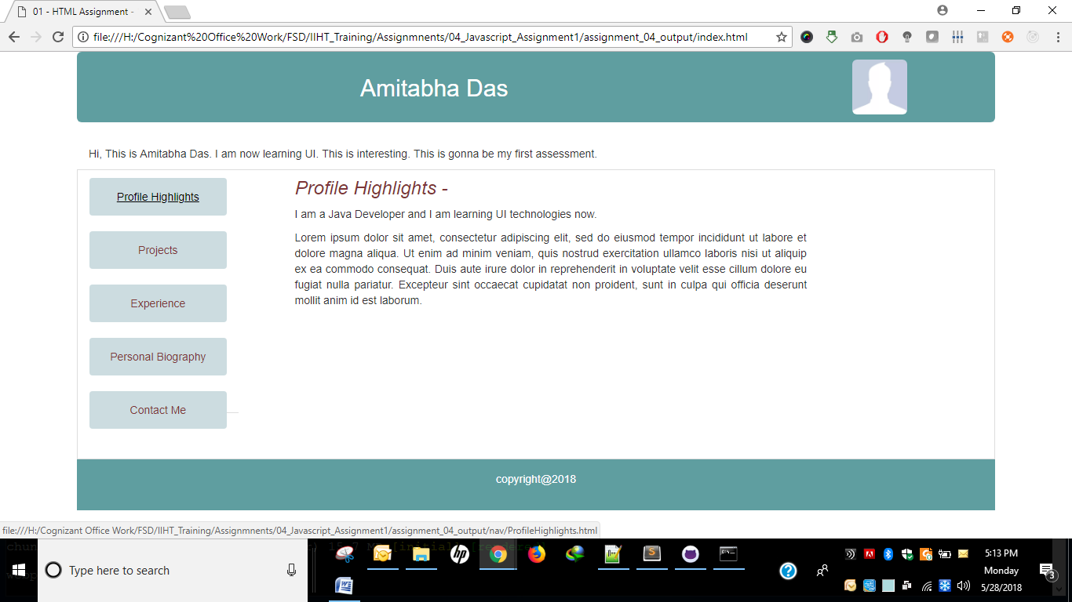 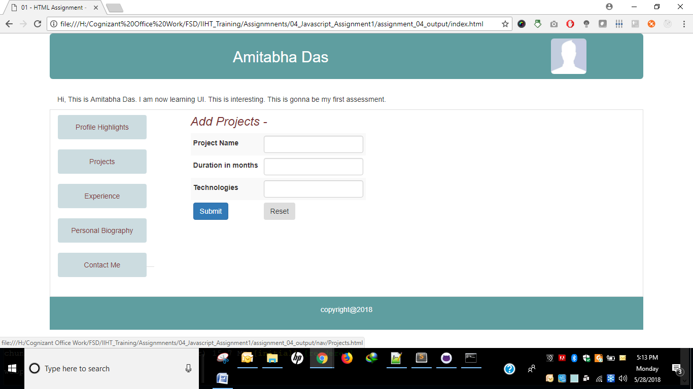 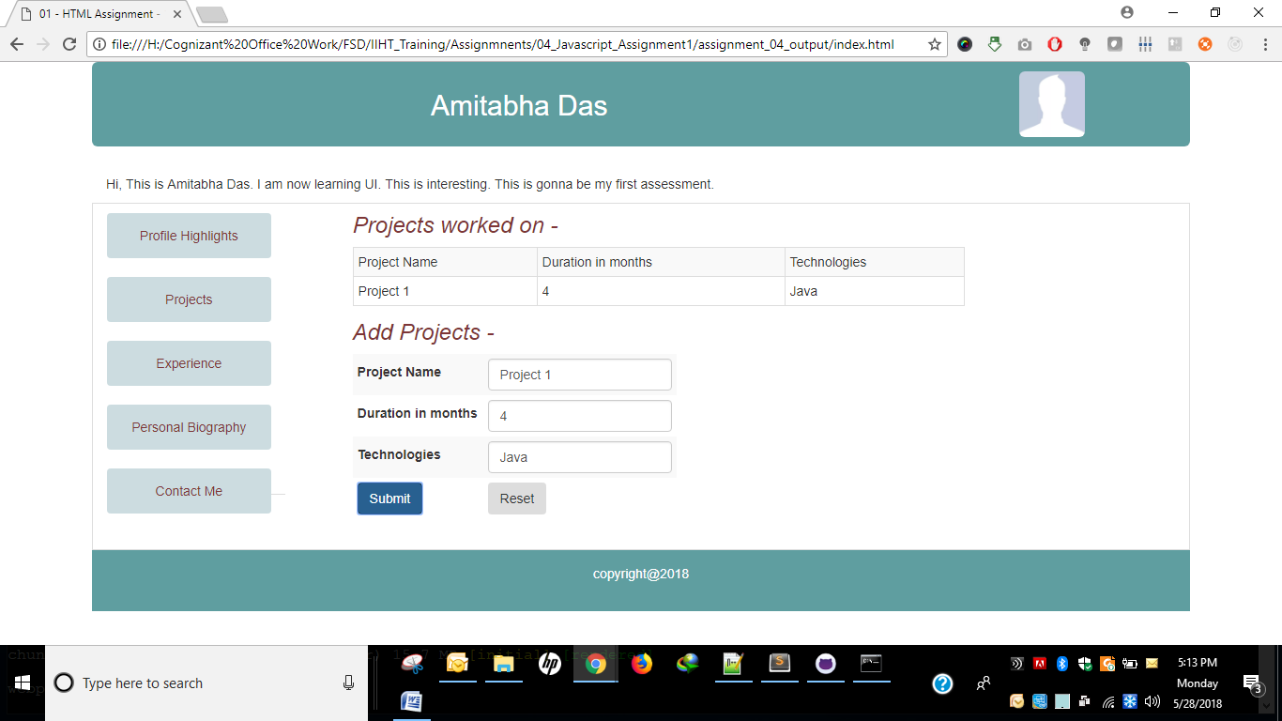 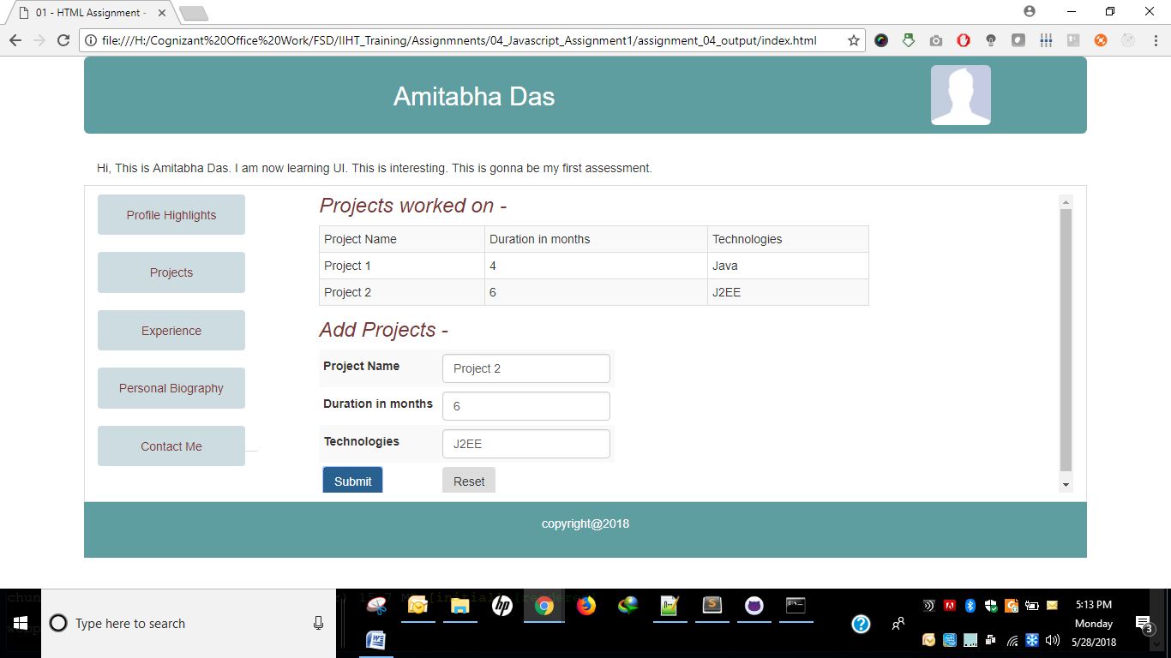 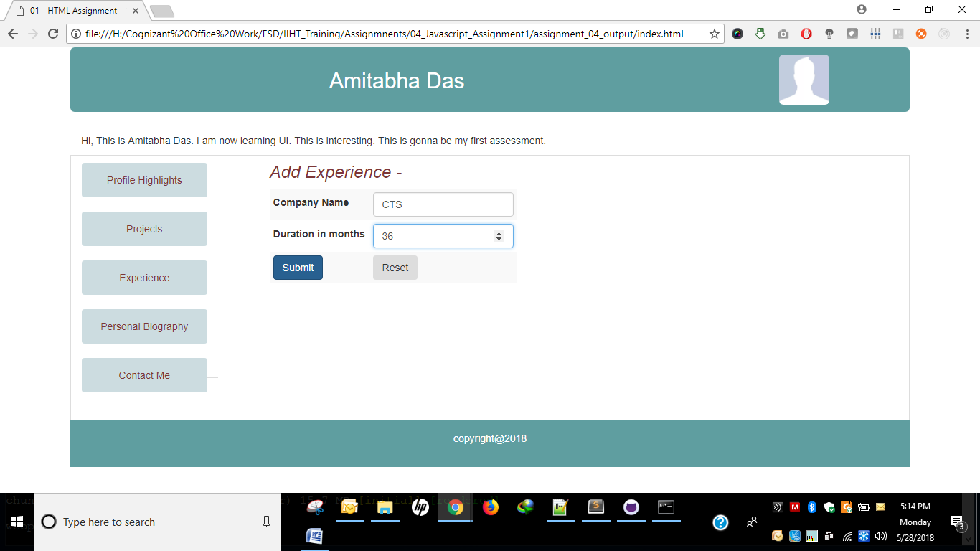 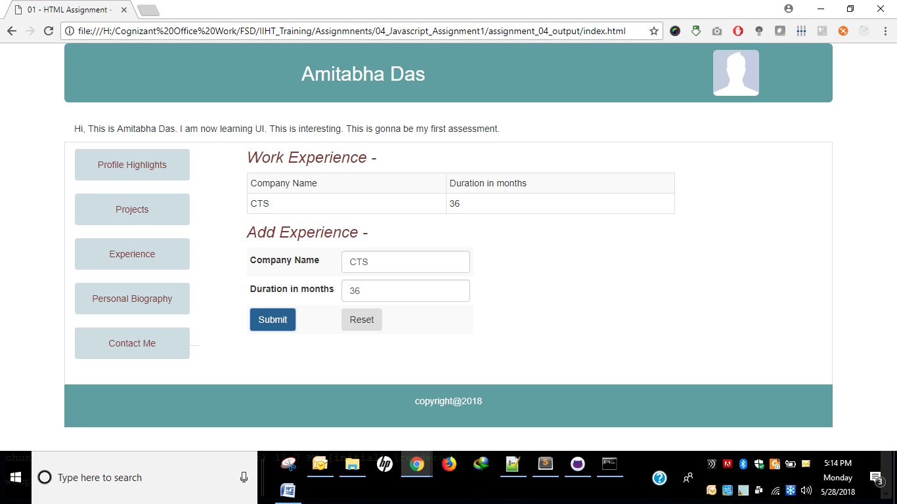 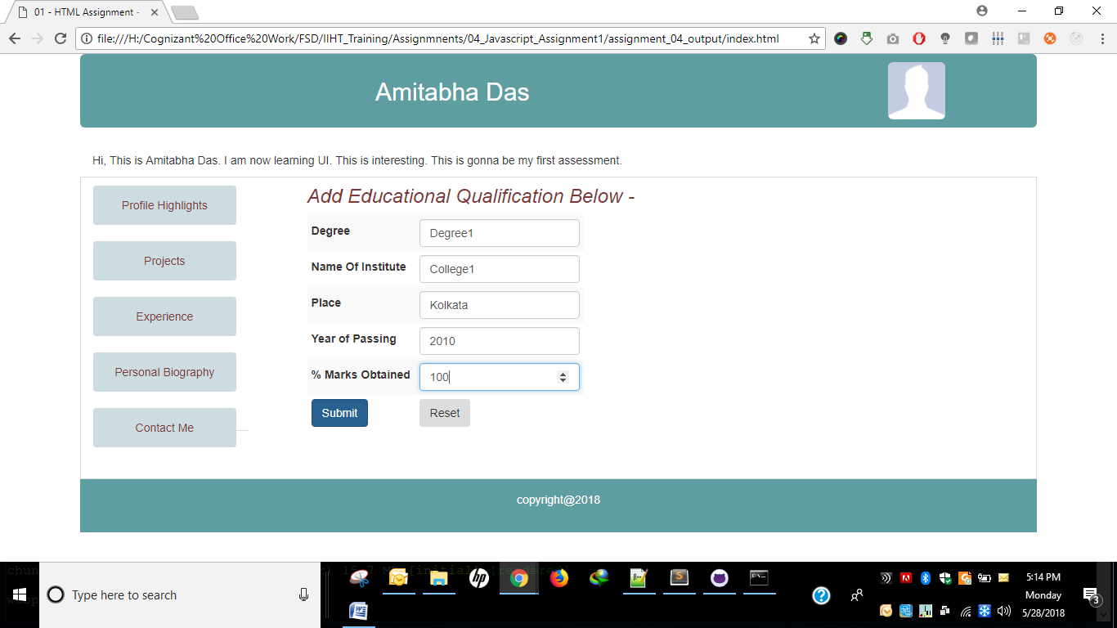 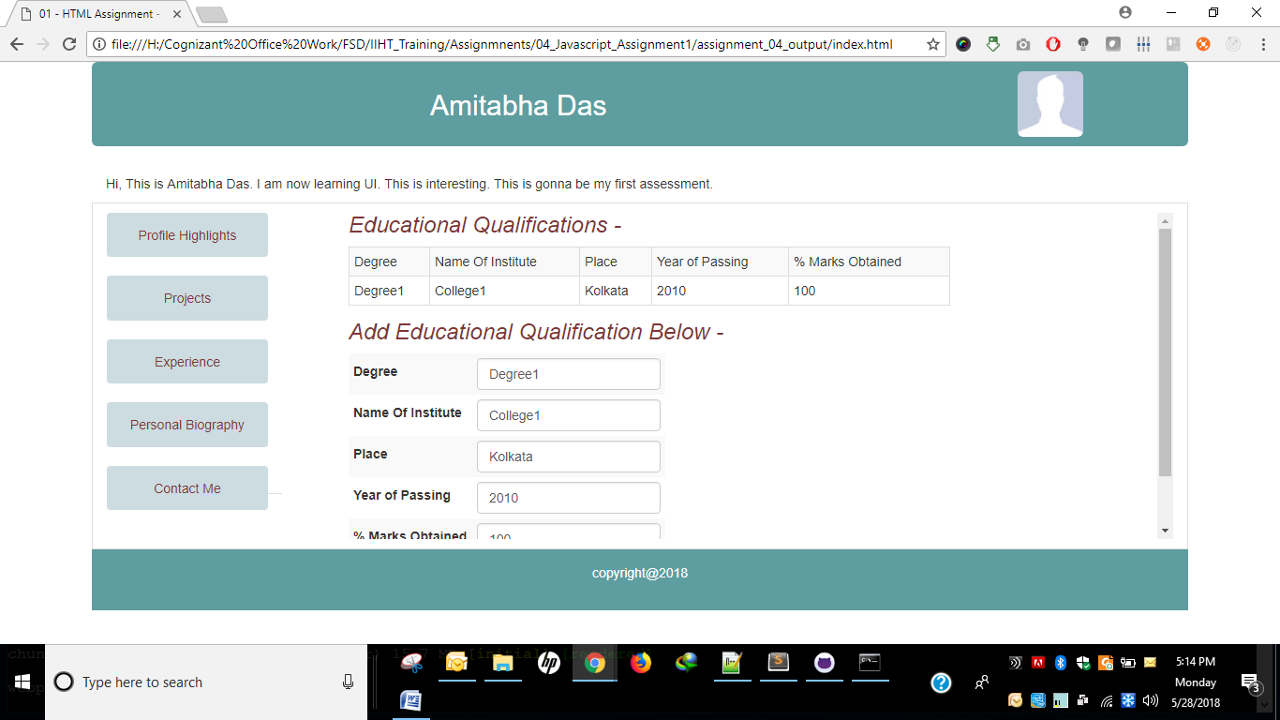 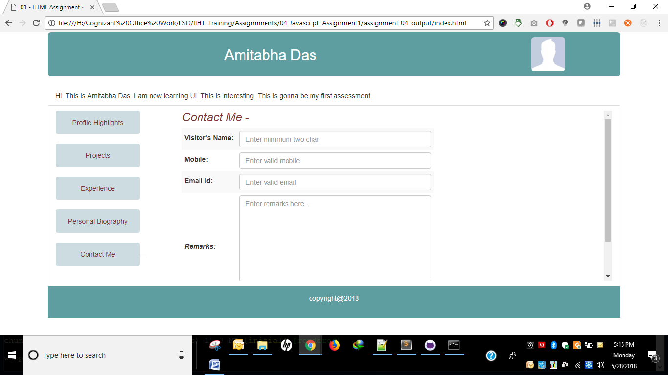

**Folder Structure**

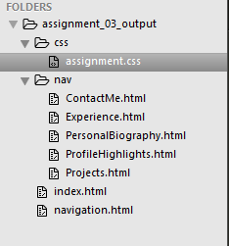

**HTML Code Snippets -**

**index.html**

|  |
| --- |
| <!DOCTYPE html>  <html>  <head>  <title>01 - HTML Assignment - 1 JAVA</title>  <link rel="stylesheet" href="https://maxcdn.bootstrapcdn.com/bootstrap/3.3.7/css/bootstrap.min.css">  <link rel="stylesheet" type="text/css" href="css/assignment.css">  <script src="https://ajax.googleapis.com/ajax/libs/jquery/3.3.1/jquery.min.js"></script>  <script src="https://maxcdn.bootstrapcdn.com/bootstrap/3.3.7/js/bootstrap.min.js"></script>  </head>  <body>  <div class="container">  <header class="jumbotron row">  <div class="col-lg-10 col-md-10 col-sm-10 col-xs-12">  <h2>Amitabha Das</h2>  </div>  <aside class="image col-lg-2 col-md-2 col-sm-2 col-xs-12">  <img alt="Profile pic" class="img-rounded" src="https://thebenclark.files.wordpress.com/2014/03/facebook-default-no-profile-pic.jpg?w=1200" height="70" width="70"/>  </aside>  </header>  <div class="row">  <div class="col-xs-12">  <section>Hi, This is Amitabha Das. I am now learning UI. This is interesting. This is gonna be my first assessment.</section>  </div>  <iframe class="col-xs-12" src="navigation.html" width="100%" height="370px"></iframe>  </div>  <footer class="row">copyright@2018</footer>  </div>  </body>  </html> |

**navigation.html**

|  |
| --- |
| <!DOCTYPE html>  <html>  <head>  <link rel="stylesheet" href="https://maxcdn.bootstrapcdn.com/bootstrap/3.3.7/css/bootstrap.min.css">  <link rel="stylesheet" type="text/css" href="css/assignment.css">  <script src="https://ajax.googleapis.com/ajax/libs/jquery/3.3.1/jquery.min.js"></script>  <script src="https://maxcdn.bootstrapcdn.com/bootstrap/3.3.7/js/bootstrap.min.js"></script>  <title>01 - HTML Assignment - 1 JAVA</title>  </head>  <body>  <div>  <nav class="nav nav-tabs col-xs-2">  <a href="nav/ProfileHighlights.html">Profile Highlights</a> <br/>  <a href="nav/Projects.html">Projects</a> <br/>  <a href="nav/Experience.html">Experience</a> <br/>  <a href="nav/PersonalBiography.html">Personal Biography</a> <br/>  <a href="nav/ContactMe.html">Contact Me</a>  </nav>  </div>  </body>  </html> |

**ContactMe.html**

|  |
| --- |
| <!DOCTYPE html>  <html>  <head>  <link rel="stylesheet" href="https://maxcdn.bootstrapcdn.com/bootstrap/3.3.7/css/bootstrap.min.css">  <link rel="stylesheet" type="text/css" href="../css/assignment.css">  <script src="https://ajax.googleapis.com/ajax/libs/jquery/3.3.1/jquery.min.js"></script>  <script src="https://maxcdn.bootstrapcdn.com/bootstrap/3.3.7/js/bootstrap.min.js"></script>  <title>Contact Me</title>  </head>  <body>  <nav class="nav nav-tabs col-xs-2">  <a href="ProfileHighlights.html">Profile Highlights</a> <br/>  <a href="Projects.html">Projects</a> <br/>  <a href="Experience.html">Experience</a> <br/>  <a href="PersonalBiography.html">Personal Biography</a> <br/>  <a href="ContactMe.html">Contact Me</a>  </nav>  <div class="content col-xs-10">  <h3>Contact Me - </h3>  <form>  <table class="table-striped">  <tr class="form-group">  <td><label>Visitor's Name: </label></td>  <td><input class="form-control" type="text" pattern="[A-Za-z ]{2,}" placeholder="Enter minimum two char"></td>  </tr>  <tr class="form-group">  <td><label>Mobile: </label></td>  <td><input class="form-control" type="number" maxlength="10" placeholder="Enter valid mobile"></td>  </tr>  <tr class="form-group">  <td><label>Email Id: </label></td>  <td><input class="form-control" type="email" placeholder="Enter valid email"></td>  </tr>  <tr class="form-group">  <td><label class="remarks">Remarks: </label></td>  <td><textarea class="form-control" placeholder="Enter remarks here..." rows="10" cols="50"></textarea></td>  </tr>  <tr class="form-group">  <td><button type="submit" class="btn btn-primary" value="Submit">Submit</button></td>  <td><button type="reset" class="btn" value="Reset">Reset</button></td>  </tr>  </table>  </form>  </div>  </body>  </html> |

**Experience.html**

|  |
| --- |
| <!DOCTYPE html>  <html>  <head>  <link rel="stylesheet" href="https://maxcdn.bootstrapcdn.com/bootstrap/3.3.7/css/bootstrap.min.css">  <link rel="stylesheet" type="text/css" href="../css/assignment.css">  <script src="https://ajax.googleapis.com/ajax/libs/jquery/3.3.1/jquery.min.js"></script>  <script src="https://maxcdn.bootstrapcdn.com/bootstrap/3.3.7/js/bootstrap.min.js"></script>  <title>Experience</title>  <script type="text/javascript">  function addWorkExperience() {  var companyTable = document.getElementById("companyTable");  var tableBody = companyTable.getElementsByTagName('tbody')[0];  var tableWrapperDiv = document.getElementById("tableWrapper");  var newTableRow = document.createElement('tr');  newTableRow.setAttribute('class', 'form-group');  var errorMessage = '';  var valueArray = [];  var companies = ['Company Name', 'Duration in months'];  valueArray.push(document.getElementById("companyNameText").value);  valueArray.push(document.getElementById("durationText").value);  for(var i=0; i<valueArray.length; i++) {  var tableData = document.createElement('td');  tableData.innerHTML = valueArray[i];  if (valueArray[i].trim()) {  newTableRow.append(tableData);  } else {  errorMessage += 'Please enter proper value for ' + companies[i] + ' field \n';  }  }  if (errorMessage) {  alert(errorMessage)  } else {  tableWrapperDiv.style.display = 'block';  tableBody.append(newTableRow);  }  }  </script>  </head>  <body>  <nav class="nav nav-tabs col-xs-2">  <a href="ProfileHighlights.html">Profile Highlights</a> <br/>  <a href="Projects.html">Projects</a> <br/>  <a href="Experience.html">Experience</a> <br/>  <a href="PersonalBiography.html">Personal Biography</a> <br/>  <a href="ContactMe.html">Contact Me</a>  </nav>  <div class="content col-xs-10">  <div id="tableWrapper">  <h3>Work Experience - </h3>  <table class="table-bordered table-striped" id="companyTable" width="100%">  <tr class="form-group">  <td>Company Name</td>  <td>Duration in months</td>  </tr>  </table>  </div>  <h3>Add Experience - </h3>  <form>  <table class="table-striped">  <tr class="form-group">  <td><label>Company Name</label></td>  <td><input class="form-control" type="text" id="companyNameText" required="required"></td>  </tr>  <tr class="form-group">  <td><label>Duration in months</label></td>  <td><input class="form-control" type="number" id="durationText" required="required"></td>  </tr>  <tr class="form-group">  <td><button type="button" class="btn btn-primary" value="Add Project" onclick="addWorkExperience();">Submit</button></td>  <td><button type="reset" class="btn" value="Reset">Reset</button></td>  </tr>  </table>  </form>  </div>  </div>  </body>  </html> |

**PersonalBiography.html**

|  |
| --- |
| <!DOCTYPE html>  <html>  <head>  <link rel="stylesheet" href="https://maxcdn.bootstrapcdn.com/bootstrap/3.3.7/css/bootstrap.min.css">  <link rel="stylesheet" type="text/css" href="../css/assignment.css">  <script src="https://ajax.googleapis.com/ajax/libs/jquery/3.3.1/jquery.min.js"></script>  <script src="https://maxcdn.bootstrapcdn.com/bootstrap/3.3.7/js/bootstrap.min.js"></script>  <title>Personal Biography</title>  <script type="text/javascript">  function checkYOP(yearOfPassing) {  var myYearOfPassingDate = new Date(yearOfPassing);  var todayDate = new Date();    return (myYearOfPassingDate > todayDate);  }  function addQualification() {  var qualificationTable = document.getElementById("qualificationTable");  var tableBody = qualificationTable.getElementsByTagName('tbody')[0];  var tableWrapperDiv = document.getElementById("tableWrapper");  var newTableRow = document.createElement('tr');  newTableRow.setAttribute('class', 'form-group');  var errorMessage = '';  var valueArray = [];  var qualifications = ['Degree', 'Institute Name', 'Place', 'Year of passing', 'Marks obtained'];  valueArray.push(document.getElementById("degreeText").value);  valueArray.push(document.getElementById("instituteNameText").value);  valueArray.push(document.getElementById("institutePlaceText").value);  valueArray.push(document.getElementById("yearOfPassingText").value);  valueArray.push(document.getElementById("marksObtainedText").value);  for(var i=0; i<valueArray.length; i++) {  var tableData = document.createElement('td');  tableData.innerHTML = valueArray[i];  if (valueArray[i].trim()) {  /*if(qualifications[i] === 'Year of passing') {  if(checkYOP(valueArray[i])) {  newTableRow.append(tableData);  } else {  errorMessage += 'Please enter proper value for ' + qualifications[i] + ' field \n';  }  }*/  newTableRow.append(tableData);  } else {  errorMessage += 'Please enter proper value for ' + qualifications[i] + ' field \n';  }  }  if (errorMessage) {  alert(errorMessage)  } else {  tableWrapperDiv.style.display = 'block';  tableBody.append(newTableRow);  }  }  </script>  </head>  <body>  <nav class="nav nav-tabs col-xs-2">  <a href="ProfileHighlights.html">Profile Highlights</a> <br/>  <a href="Projects.html">Projects</a> <br/>  <a href="Experience.html">Experience</a> <br/>  <a href="PersonalBiography.html">Personal Biography</a> <br/>  <a href="ContactMe.html">Contact Me</a>  </nav>  <div class="content col-xs-10">  <div id="tableWrapper">  <h3>Educational Qualifications - </h3>  <table class="table-bordered table-striped" id="qualificationTable" width="100%">  <tr class="form-group">  <td>Degree</td>  <td>Name Of Institute</td>  <td>Place</td>  <td>Year of Passing</td>  <td>% Marks Obtained</td>  </tr>  </table>  </div>  <h3>Add Educational Qualification Below - </h3>  <form>  <table class="table-striped">  <tr class="form-group">  <td><label>Degree</label></td>  <td><input class="form-control" type="text" id="degreeText" required="required"></td>  </tr>  <tr class="form-group">  <td><label>Name Of Institute</label></td>  <td><input class="form-control" type="text" id="instituteNameText" required="required"></td>  </tr>  <tr class="form-group">  <td><label>Place</label></td>  <td><input class="form-control" type="text" id="institutePlaceText" required="required"></td>  </tr>  <tr class="form-group">  <td><label>Year of Passing</label></td>  <td><input class="form-control" type="number" id="yearOfPassingText" required="required"></td>  </tr>  <tr class="form-group">  <td><label>% Marks Obtained</label></td>  <td><input class="form-control" type="number" id="marksObtainedText" required="required"></td>  </tr>  <tr class="form-group">  <td><button type="button" class="btn btn-primary" value="Add Qualification" onclick="addQualification();">Submit</button></td>  <td><button type="reset" class="btn" value="Reset">Reset</button></td>  </tr>  </table>  </form>  </div>  </body>  </html> |

**ProfileHighlights.html**

|  |
| --- |
| <!DOCTYPE html>  <html>  <head>  <link rel="stylesheet" href="https://maxcdn.bootstrapcdn.com/bootstrap/3.3.7/css/bootstrap.min.css">  <link rel="stylesheet" type="text/css" href="../css/assignment.css">  <script src="https://ajax.googleapis.com/ajax/libs/jquery/3.3.1/jquery.min.js"></script>  <script src="https://maxcdn.bootstrapcdn.com/bootstrap/3.3.7/js/bootstrap.min.js"></script>  <title>Profile Highlights</title>  </head>  <body>  <nav class="nav nav-tabs col-xs-2">  <a href="ProfileHighlights.html">Profile Highlights</a> <br/>  <a href="Projects.html">Projects</a> <br/>  <a href="Experience.html">Experience</a> <br/>  <a href="PersonalBiography.html">Personal Biography</a> <br/>  <a href="ContactMe.html">Contact Me</a>  </nav>  <div class="content col-xs-10">  <h3>Profile Highlights - </h3>  <p>I am a Java Developer and I am learning UI technologies now. </p>  <p>Lorem ipsum dolor sit amet, consectetur adipiscing elit, sed do eiusmod tempor incididunt ut labore et dolore magna aliqua. Ut enim ad minim veniam, quis nostrud exercitation ullamco laboris nisi ut aliquip ex ea commodo consequat. Duis aute irure dolor in reprehenderit in voluptate velit esse cillum dolore eu fugiat nulla pariatur. Excepteur sint occaecat cupidatat non proident, sunt in culpa qui officia deserunt mollit anim id est laborum.</p>  </div>  </body>  </html> |

**Projects.html**

|  |
| --- |
| <!DOCTYPE html>  <html>  <head>  <link rel="stylesheet" href="https://maxcdn.bootstrapcdn.com/bootstrap/3.3.7/css/bootstrap.min.css">  <link rel="stylesheet" type="text/css" href="../css/assignment.css">  <script src="https://ajax.googleapis.com/ajax/libs/jquery/3.3.1/jquery.min.js"></script>  <script src="https://maxcdn.bootstrapcdn.com/bootstrap/3.3.7/js/bootstrap.min.js"></script>  <title>Projects</title>  <script type="text/javascript">  function addProject() {  var projectTable = document.getElementById("projectTable");  var tableBody = projectTable.getElementsByTagName('tbody')[0];  var tableWrapperDiv = document.getElementById("tableWrapper");  var newTableRow = document.createElement('tr');  newTableRow.setAttribute('class', 'form-group');  var errorMessage = '';  var valueArray = [];  var projects = ['Project Name', 'Duration in months', 'Technologies'];  valueArray.push(document.getElementById("projectNameText").value);  valueArray.push(document.getElementById("durationText").value);  valueArray.push(document.getElementById("technologiesText").value);  for(var i=0; i<valueArray.length; i++) {  var tableData = document.createElement('td');  tableData.innerHTML = valueArray[i];  if (valueArray[i].trim()) {  newTableRow.append(tableData);  } else {  errorMessage += 'Please enter proper value for ' + projects[i] + ' field \n';  }  }  if (errorMessage) {  alert(errorMessage)  } else {  tableWrapperDiv.style.display = 'block';  tableBody.append(newTableRow);  }  }  </script>  </head>  <body>  <nav class="nav nav-tabs col-xs-2">  <a href="ProfileHighlights.html">Profile Highlights</a> <br/>  <a href="Projects.html">Projects</a> <br/>  <a href="Experience.html">Experience</a> <br/>  <a href="PersonalBiography.html">Personal Biography</a> <br/>  <a href="ContactMe.html">Contact Me</a>  </nav>  <div class="content col-xs-10">  <div id="tableWrapper">  <h3>Projects worked on - </h3>  <table class="table-bordered table-striped" id="projectTable" width="100%">  <tr class="form-group">  <td>Project Name</td>  <td>Duration in months</td>  <td>Technologies</td>  </tr>  </table>  </div>  <h3>Add Projects - </h3>  <form>  <table class="table-striped">  <tr class="form-group">  <td><label>Project Name</label></td>  <td><input class="form-control" type="text" id="projectNameText" required="required"></td>  </tr>  <tr class="form-group">  <td><label>Duration in months</label></td>  <td><input class="form-control" type="number" id="durationText" required="required"></td>  </tr>  <tr class="form-group">  <td><label>Technologies</label></td>  <td><input class="form-control" type="text" id="technologiesText" required="required"></td>  </tr>  <tr class="form-group">  <td><button type="button" class="btn btn-primary" value="Add Project" onclick="addProject();">Submit</button></td>  <td><button type="reset" class="btn" value="Reset">Reset</button></td>  </tr>  </table>  </form>  </div>  </body>  </html> |