Task Tracker Project - FSD Training

**Documentation**

**Application Screenshots**

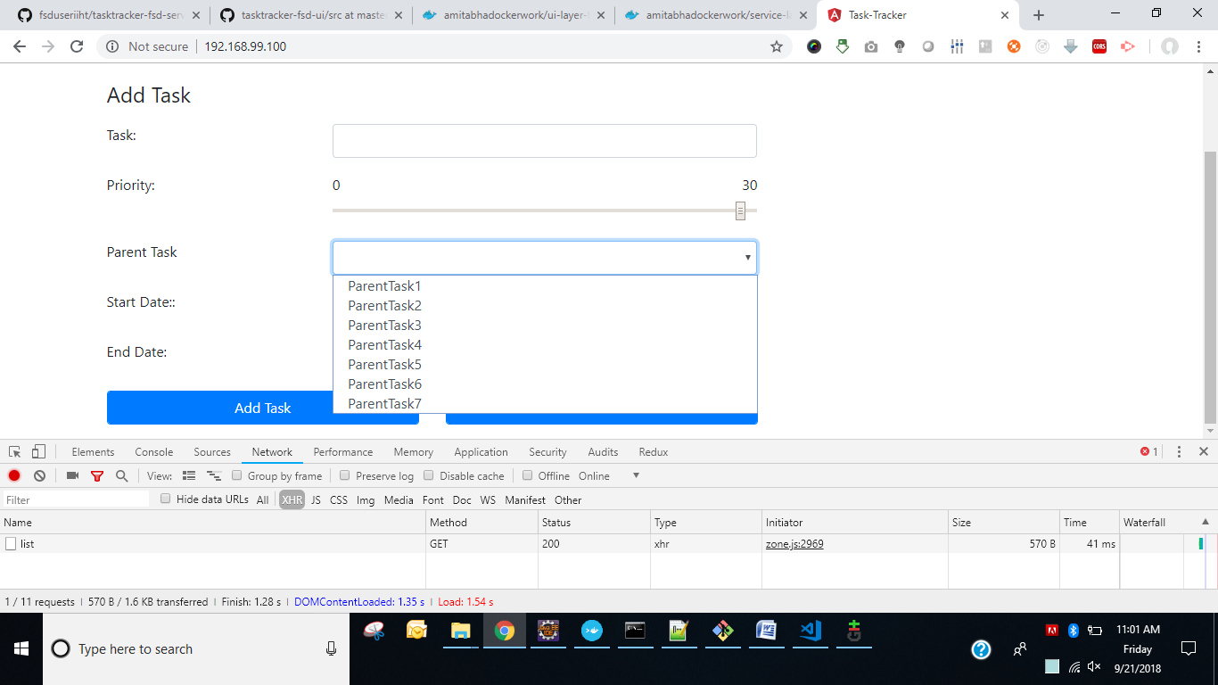

Adding a Task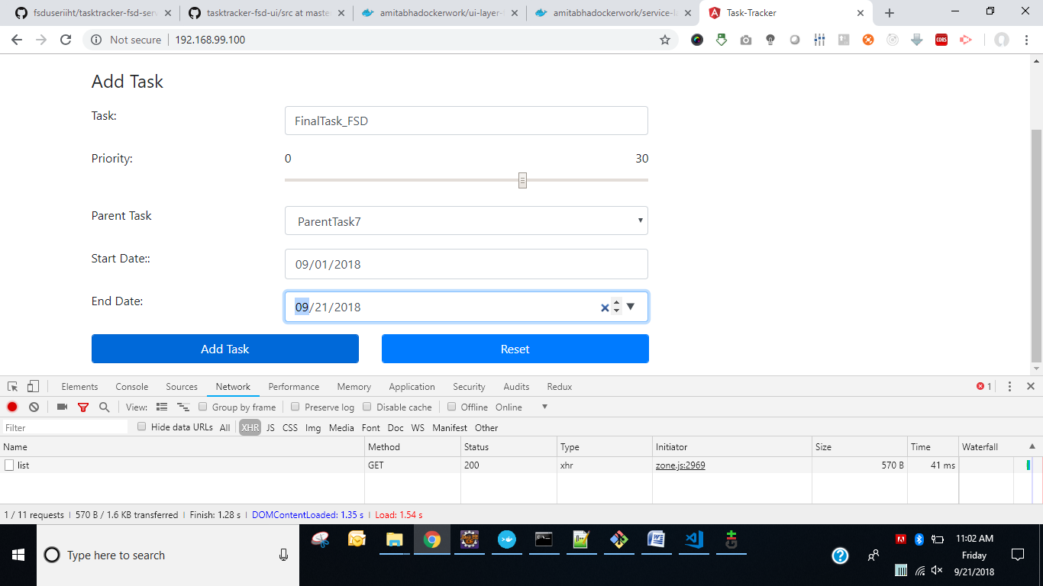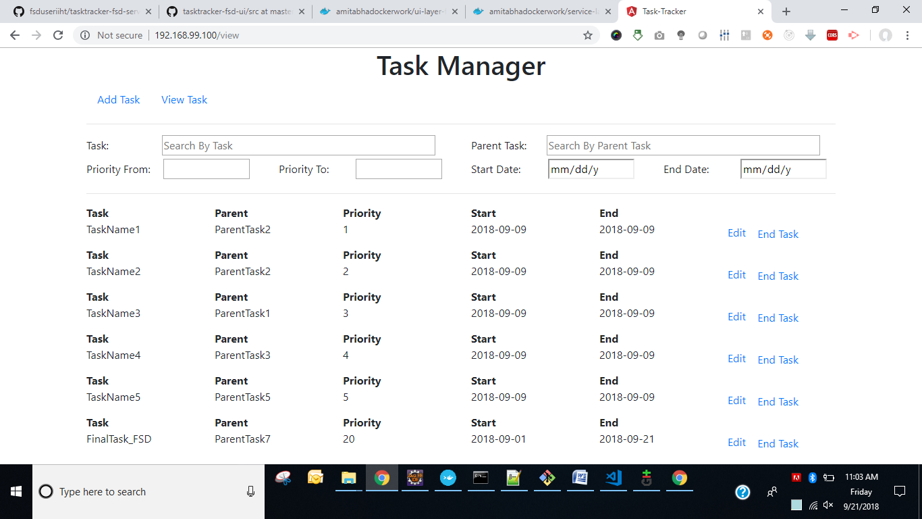

Search Task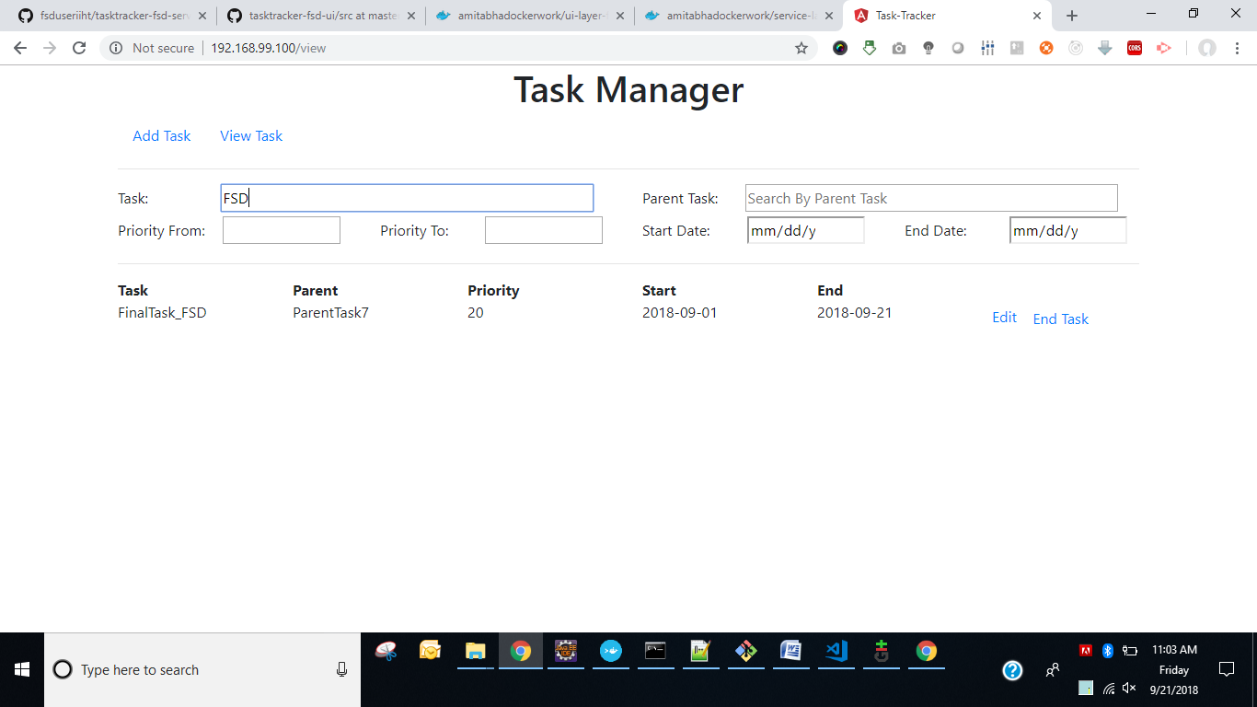

Update Task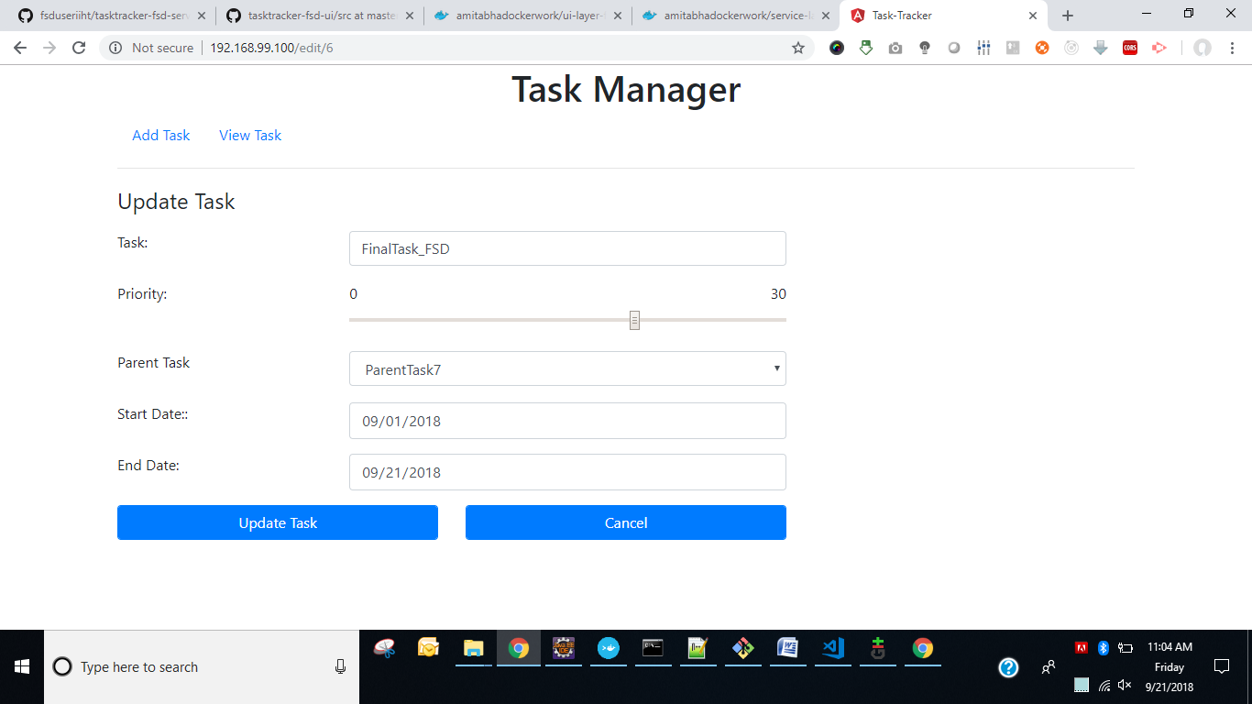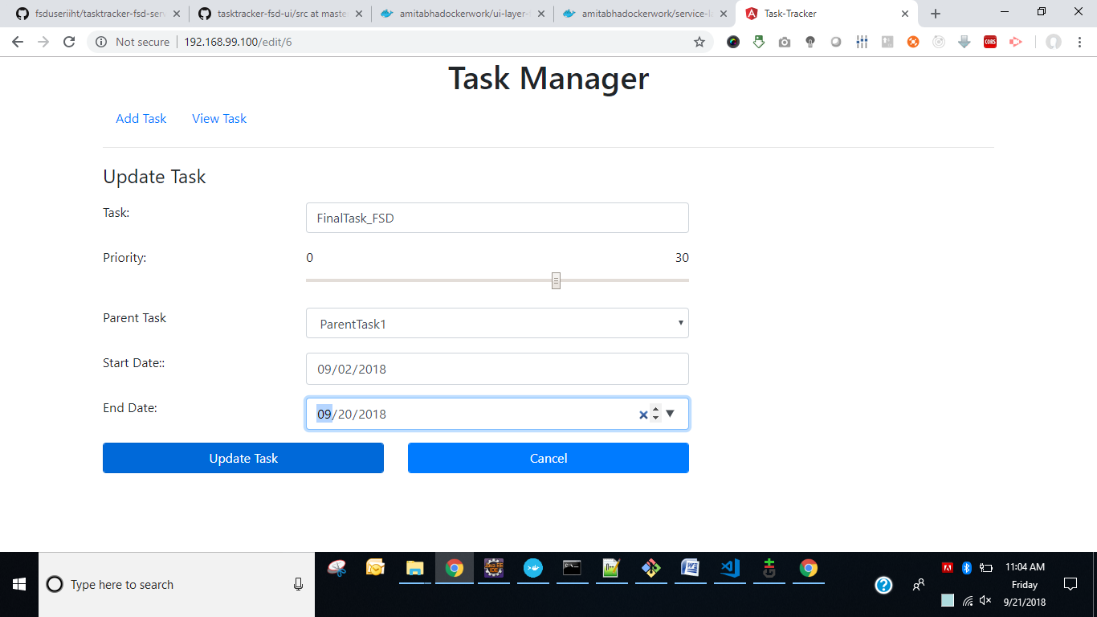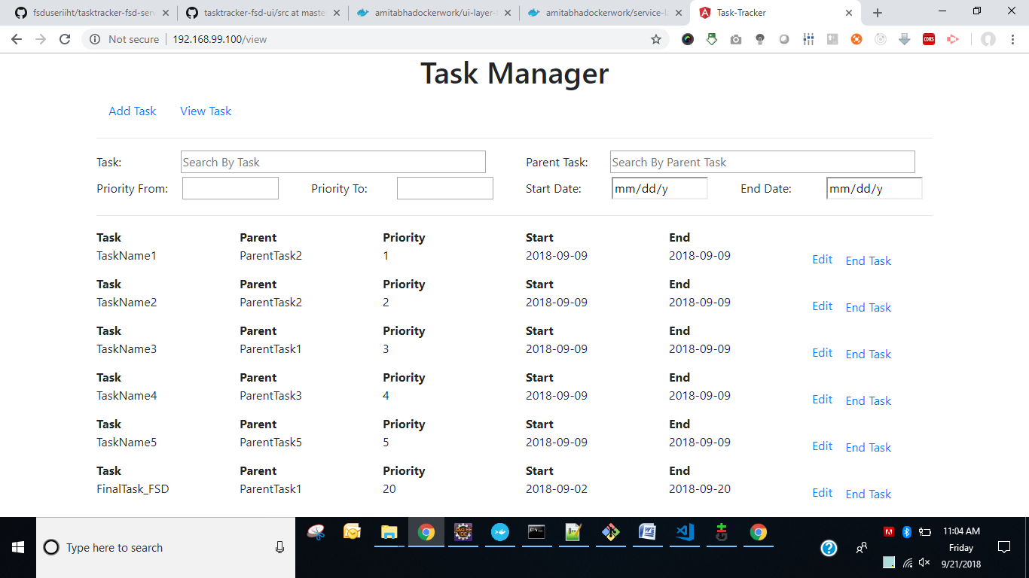

End Task Deleted **TaskName5**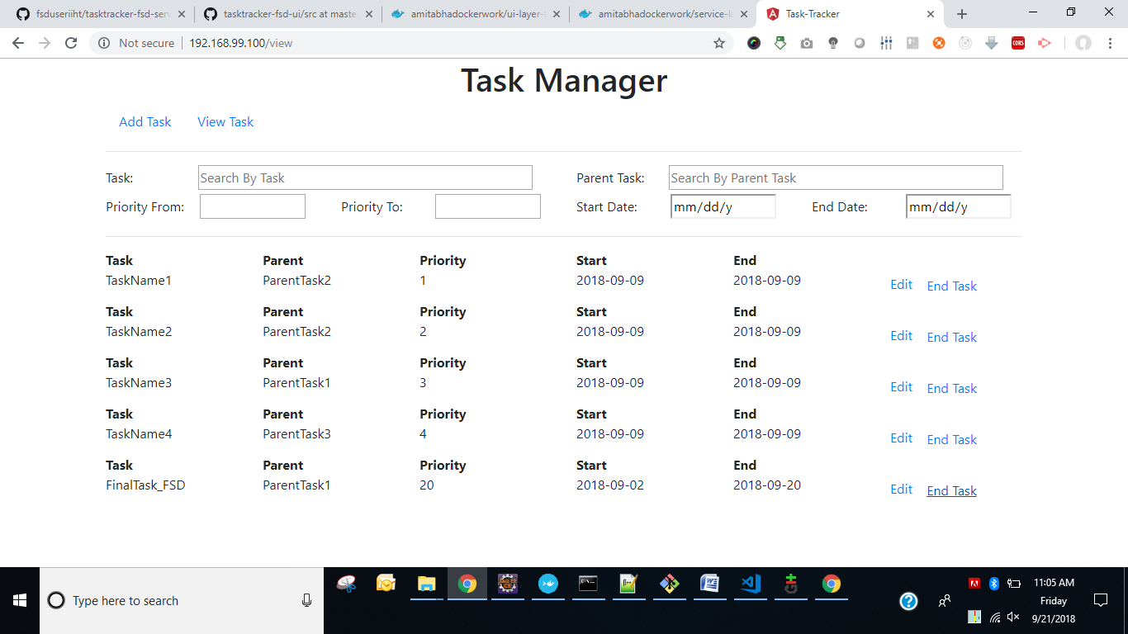

**Service Call Information**

|  |  |  |  |
| --- | --- | --- | --- |
| **Service call for List All Parents**   |  | | --- | | **Request URL: http://192.168.99.100:8080/tasktrackerbackend/parent/list**  Request Method: GET  Status Code: 200  Remote Address: 192.168.99.100:8080  Referrer Policy: no-referrer-when-downgrade |  |  | | --- | |  |  |  | | --- | | [{"parentId":101,"parentTask":"ParentTask1"},{"parentId":102,"parentTask":"ParentTask2"},{"parentId":103,"parentTask":"ParentTask3"},{"parentId":104,"parentTask":"ParentTask4"},{"parentId":105,"parentTask":"ParentTask5"},{"parentId":106,"parentTask":"ParentTask6"},{"parentId":107,"parentTask":"ParentTask7"}] | |

|  |  |  |  |
| --- | --- | --- | --- |
| **Service call for Create Task**   |  | | --- | | **Request URL: http://192.168.99.100:8080/tasktrackerbackend/task/**  Request Method: POST  Status Code: 200  Remote Address: 192.168.99.100:8080  Referrer Policy: no-referrer-when-downgrade |  |  | | --- | |  |  |  | | --- | | New Task Saved to Database...[TaskPOJO [taskId=6, task=FinalTask_FSD, parentId=107, parentTask=ParentTask7, startDate=Sat Sep 01 00:00:00 GMT 2018, endDate=Fri Sep 21 00:00:00 GMT 2018, priority=20]] | |

|  |  |  |  |
| --- | --- | --- | --- |
| **Service call for List All Task**   |  | | --- | | **Request URL: http://192.168.99.100:8080/tasktrackerbackend/task/list**  Request Method: GET  Status Code: 200  Remote Address: 192.168.99.100:8080  Referrer Policy: no-referrer-when-downgrade |  |  | | --- | |  |  |  | | --- | | [{"taskId":1,"task":"TaskName1","parentId":102,"parentTask":"ParentTask2","startDate":"2018-09-09T00:00:00.000+0000","endDate":"2018-09-09T00:00:00.000+0000","priority":1},{"taskId":2,"task":"TaskName2","parentId":102,"parentTask":"ParentTask2","startDate":"2018-09-09T00:00:00.000+0000","endDate":"2018-09-09T00:00:00.000+0000","priority":2},{"taskId":3,"task":"TaskName3","parentId":101,"parentTask":"ParentTask1","startDate":"2018-09-09T00:00:00.000+0000","endDate":"2018-09-09T00:00:00.000+0000","priority":3},{"taskId":4,"task":"TaskName4","parentId":103,"parentTask":"ParentTask3","startDate":"2018-09-09T00:00:00.000+0000","endDate":"2018-09-09T00:00:00.000+0000","priority":4},{"taskId":5,"task":"TaskName5","parentId":105,"parentTask":"ParentTask5","startDate":"2018-09-09T00:00:00.000+0000","endDate":"2018-09-09T00:00:00.000+0000","priority":5},{"taskId":6,"task":"FinalTask_FSD","parentId":107,"parentTask":"ParentTask7","startDate":"2018-09-01T00:00:00.000+0000","endDate":"2018-09-21T00:00:00.000+0000","priority":20}] | |

|  |  |  |  |
| --- | --- | --- | --- |
| **Service call for Edit a task from View Page**   |  | | --- | | **Request URL: http://192.168.99.100:8080/tasktrackerbackend/task/6**  Request Method: PUT  Status Code: 200  Remote Address: 192.168.99.100:8080  Referrer Policy: no-referrer-when-downgrade |  |  | | --- | |  |  |  | | --- | | Task[task id = 6] Updated in Database...TaskPOJO [taskId=6, task=FinalTask_FSD, parentId=101, parentTask=ParentTask1, startDate=Sun Sep 02 00:00:00 GMT 2018, endDate=Thu Sep 20 00:00:00 GMT 2018, priority=20] | |

|  |  |  |  |
| --- | --- | --- | --- |
| **Service call for Delete a Task from View Page using End Task Button**   |  | | --- | | **Request URL: http://192.168.99.100:8080/tasktrackerbackend/task/5**  Request Method: DELETE  Status Code: 200  Remote Address: 192.168.99.100:8080  Referrer Policy: no-referrer-when-downgrade |  |  | | --- | |  |  |  | | --- | | ParentTask[parent id = 5] Deleted from database... | |

**Git Hub repository related information**

**https://github.com/fsduseriiht/tasktracker-fsd-service**

**https://github.com/fsduseriiht/tasktracker-fsd-ui**

**Docker Hub related information**

**https://hub.docker.com/r/amitabhadockerwork/service-layer-fsd/**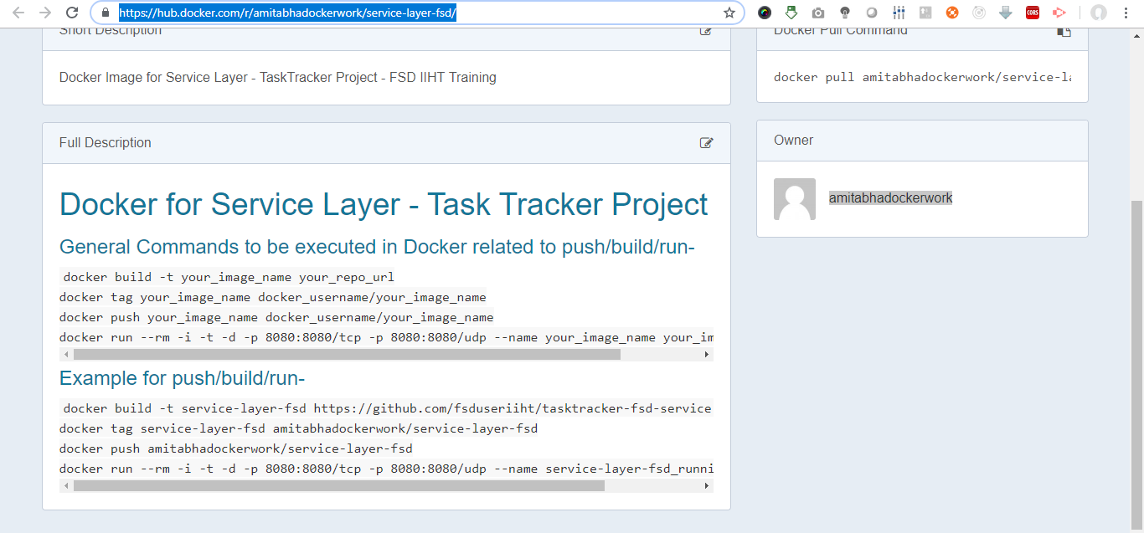

**https://hub.docker.com/r/amitabhadockerwork/ui-layer-fsd/**