Normal:

Epoch 0:  
['test_loss: 2.30194091796875', 'test_acc: 0.8999999761581421']  
['train_loss: 2.0455563068389893', 'train_acc: 0.9001399874687195']

Epoch 1:  
['test_loss: 1.8153867721557617', 'test_acc: 0.9005500078201294']  
['train_loss: 1.7373223304748535', 'train_acc: 0.9011480212211609']

Epoch 2:  
['test_loss: 1.6335487365722656', 'test_acc: 0.9031199812889099']  
['train_loss: 1.6176056861877441', 'train_acc: 0.9042800068855286']

Epoch 3:  
['test_loss: 1.5588891506195068', 'test_acc: 0.9080600142478943']  
['train_loss: 1.532537817955017', 'train_acc: 0.9075419902801514']

Epoch 4:  
['test_loss: 1.4824594259262085', 'test_acc: 0.9095900058746338']  
['train_loss: 1.4537007808685303', 'train_acc: 0.911575973033905']

Epoch 5:  
['test_loss: 1.4081382751464844', 'test_acc: 0.914900004863739']  
['train_loss: 1.385785460472107', 'train_acc: 0.9150840044021606']

Epoch 6:  
['test_loss: 1.4041907787322998', 'test_acc: 0.9132000207901001']  
['train_loss: 1.3266487121582031', 'train_acc: 0.9185519814491272']

Epoch 7:  
['test_loss: 1.2944579124450684', 'test_acc: 0.918910026550293']  
['train_loss: 1.2737408876419067', 'train_acc: 0.9213680028915405']

Epoch 8:  
['test_loss: 1.2366917133331299', 'test_acc: 0.922760009765625']  
['train_loss: 1.2197201251983643', 'train_acc: 0.924235999584198']

Epoch 9:  
['test_loss: 1.1771386861801147', 'test_acc: 0.9260600209236145']  
['train_loss: 1.1700561046600342', 'train_acc: 0.927046000957489']

Epoch 10:  
['test_loss: 1.1300946474075317', 'test_acc: 0.9292700290679932']  
['train_loss: 1.1249055862426758', 'train_acc: 0.9291599988937378']

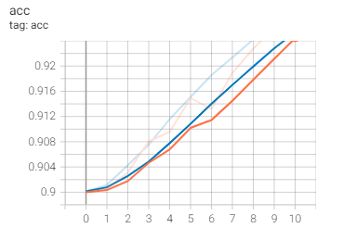

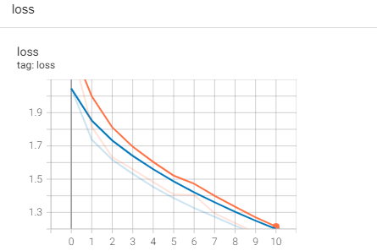

filters = 10 and 20

Epoch 0:  
['test_loss: 2.306229591369629', 'test_acc: 0.8999999761581421']  
['train_loss: 2.127157688140869', 'train_acc: 0.9000300168991089']

Epoch 1:  
['test_loss: 1.9104975461959839', 'test_acc: 0.9003599882125854']  
['train_loss: 1.8357161283493042', 'train_acc: 0.9003480076789856']

Epoch 2:  
['test_loss: 1.7700222730636597', 'test_acc: 0.9006999731063843']  
['train_loss: 1.721685767173767', 'train_acc: 0.901308000087738']

Epoch 3:  
['test_loss: 1.6911568641662598', 'test_acc: 0.9008899927139282']  
['train_loss: 1.650829553604126', 'train_acc: 0.9024199843406677']

Epoch 4:  
['test_loss: 1.617496371269226', 'test_acc: 0.9037100076675415']  
['train_loss: 1.5945357084274292', 'train_acc: 0.9047120213508606']

Epoch 5:  
['test_loss: 1.5448838472366333', 'test_acc: 0.9079099893569946']  
['train_loss: 1.5434714555740356', 'train_acc: 0.9071059823036194']

Epoch 6:  
['test_loss: 1.6114568710327148', 'test_acc: 0.9060900211334229']  
['train_loss: 1.4973236322402954', 'train_acc: 0.909280002117157']

Epoch 7:  
['test_loss: 1.4375299215316772', 'test_acc: 0.9120500087738037']  
['train_loss: 1.454047679901123', 'train_acc: 0.9114739894866943']

Epoch 8:  
['test_loss: 1.487711787223816', 'test_acc: 0.9107300043106079']  
['train_loss: 1.4164990186691284', 'train_acc: 0.9134039878845215']

Epoch 9:  
['test_loss: 1.389090657234192', 'test_acc: 0.9145900011062622']  
['train_loss: 1.3846583366394043', 'train_acc: 0.914870023727417']

Epoch 10:  
['test_loss: 1.3920958042144775', 'test_acc: 0.9154300093650818']  
['train_loss: 1.3550838232040405', 'train_acc: 0.9164140224456787']

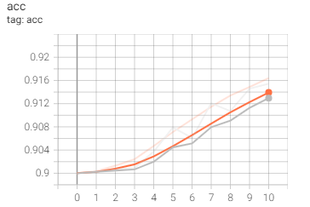

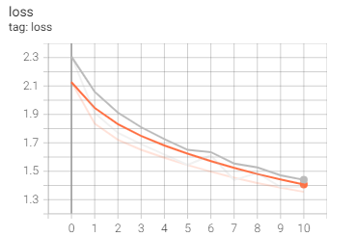

ConvLayers 1&2: 64 filter, ConvLayers 3&4: 32 filters

Kernel size = 1

Epoch 0:  
['test_loss: 2.300689458847046', 'test_acc: 0.8999999761581421']  
['train_loss: 2.2380292415618896', 'train_acc: 0.8999999761581421']

Epoch 1:  
['test_loss: 2.1136386394500732', 'test_acc: 0.8999999761581421']  
['train_loss: 2.061737298965454', 'train_acc: 0.89997798204422']

Epoch 2:  
['test_loss: 2.0184338092803955', 'test_acc: 0.8999999761581421']  
['train_loss: 2.0055365562438965', 'train_acc: 0.9001280069351196']

Epoch 3:  
['test_loss: 1.988690972328186', 'test_acc: 0.9003300070762634']  
['train_loss: 1.9813611507415771', 'train_acc: 0.9003139734268188']

Epoch 4:  
['test_loss: 1.9588316679000854', 'test_acc: 0.9006199836730957']  
['train_loss: 1.961653232574463', 'train_acc: 0.90037602186203']

Epoch 5:  
['test_loss: 1.9392329454421997', 'test_acc: 0.9006100296974182']  
['train_loss: 1.9433518648147583', 'train_acc: 0.900409996509552']

Epoch 6:  
['test_loss: 1.9222826957702637', 'test_acc: 0.9006800055503845']  
['train_loss: 1.9254424571990967', 'train_acc: 0.9004819989204407']

Epoch 7:  
['test_loss: 1.9045811891555786', 'test_acc: 0.900629997253418']  
['train_loss: 1.908747673034668', 'train_acc: 0.900596022605896']

Epoch 8:  
['test_loss: 1.8878045082092285', 'test_acc: 0.9005399942398071']  
['train_loss: 1.8915797472000122', 'train_acc: 0.9006999731063843']

Epoch 9:  
['test_loss: 1.867720603942871', 'test_acc: 0.9007800221443176']  
['train_loss: 1.8748581409454346', 'train_acc: 0.9008259773254395']

Epoch 10:  
['test_loss: 1.8955323696136475', 'test_acc: 0.9003000259399414']  
['train_loss: 1.858991026878357', 'train_acc: 0.901170015335083']

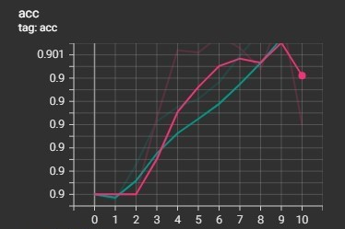

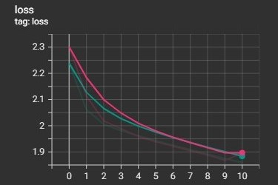

filter size from conv layer 1&2 switchesd with filter size from conv layer 3&4

Epoch 0:  
['test_loss: 2.302516460418701', 'test_acc: 0.8999999761581421']  
['train_loss: 2.2853143215179443', 'train_acc: 0.8999999761581421']

Epoch 1:  
['test_loss: 2.2393136024475098', 'test_acc: 0.8999999761581421']  
['train_loss: 2.125232219696045', 'train_acc: 0.8999800086021423']

Epoch 2:  
['test_loss: 2.0483617782592773', 'test_acc: 0.8999800086021423']  
['train_loss: 2.0058157444000244', 'train_acc: 0.9001100063323975']

Epoch 3:  
['test_loss: 1.9510387182235718', 'test_acc: 0.9002599716186523']  
['train_loss: 1.8834856748580933', 'train_acc: 0.9005079865455627']

Epoch 4:  
['test_loss: 1.809450626373291', 'test_acc: 0.9009900093078613']  
['train_loss: 1.7738151550292969', 'train_acc: 0.9009699821472168']

Epoch 5:  
['test_loss: 1.7280211448669434', 'test_acc: 0.9010199904441833']  
['train_loss: 1.7090399265289307', 'train_acc: 0.9016339778900146']

Epoch 6:  
['test_loss: 1.6792407035827637', 'test_acc: 0.9020599722862244']  
['train_loss: 1.6718262434005737', 'train_acc: 0.9023879766464233']

Epoch 7:  
['test_loss: 1.7938421964645386', 'test_acc: 0.9004799723625183']  
['train_loss: 1.6443545818328857', 'train_acc: 0.9030380249023438']

Epoch 8:  
['test_loss: 1.6519309282302856', 'test_acc: 0.9041399955749512']  
['train_loss: 1.6150037050247192', 'train_acc: 0.9037799835205078']

Epoch 9:  
['test_loss: 1.6206034421920776', 'test_acc: 0.9041200280189514']  
['train_loss: 1.5863056182861328', 'train_acc: 0.9049699902534485']

Epoch 10:  
['test_loss: 1.6745597124099731', 'test_acc: 0.9034000039100647']  
['train_loss: 1.5589840412139893', 'train_acc: 0.9060360193252563']

