**Kocaeli University Electronics and Telecommunication Engineering**

**Digital Communications Laboratory**

**Experiment 2: Pulse Code Modulation (PCM) - Simulink Lab Report (04.03.2024)**

|  |
| --- |
| Name-Surname-Number: Hüseyin Alkan Aksel-210207027 |
| Name-Surname-Number:Yiğit Alp İnceöz-210207048 |
| Name-Surname-Number:Berk Tayfun-210207068 |

In digital communication system, input of the modulator must be digital signal. If the signal source generates an analog signal, it should be converted digital form via analog-to-digital converter (ADC). ADC includes three steps:

1. Sampling
2. Quantization
3. Pulse Code Modulation (PCM).

$x_{s}$ and $x_{c}$ denote sampled signal output and quantization level, respectively. The quantization error (e) is calculated as follows:

$${e= x}_{s}-x_{c}$$

All required blocks and parameters for the PCM Block experiment are given in Figures 1 and Table 1. Based on these, build the below diagram in Simulink and answer the following questions in detail.

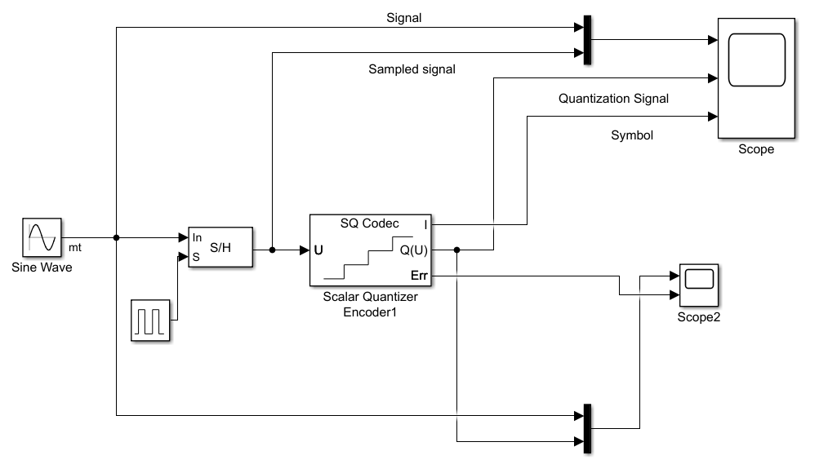

**Figure 1**. A basic PCM block

**The required blocks are given below:**

1. Sine Wave Generator

2. Sample and Hold

3. Scaler Quantization Encoder

4. Scope and Mux blocks

**Parameters of Sine Wave and Quantization Blocks**

|  |  |
| --- | --- |
|  |  |
| **Figure 2**. Block Parameters | |

**Q1)** Set signal frequency as 1 Hz and phase pi/2, sampling frequency as 10 Hz. Run the code for 1 seconds and fill the table. What is the maximum quantization error?

|  |  |  |  |  |  |  |  |  |  |  |
| --- | --- | --- | --- | --- | --- | --- | --- | --- | --- | --- |
| Time (S) | 0 | 0.1 | 0.2 | 0.3 | 0.4 | 0.5 | 0.6 | 0.7 | 0.8 | 0.9 |
| Output of the sampled signal | 0 | 0.809 | 0.309 | -0.309 | -0.809 | -1 | -0.809 | -0.309 | 0.309 | 0.809 |
| Output of the quantization | -0.25 | 0.75 | 0.25 | 0.25 | -0.75 | -0.75 | -0.75 | -0.25 | 0.25 | 0.75 |
| Quantization error (look at “Scope 2”) | 0.25 | 0.059 | 0.059 | 0.059 | -0.059 | -0.25 | -0.059 | -0.059 | 0.059 | 0.059 |
| PCM value (“Symbol” signal that is connected to “Scope”) | 1 | 3 | 2 | 1 | 0 | 0 | 0 | 1 | 2 | 3 |

**Q2)** How many bits are used in **Q1**?

N = 2 bit , L = 4 level

**Q3)** If 3 bits are used in quantization, write quantization levels and PCM code for each quantization level (in binary numbers) in the table below (*use zero level for output*).

|  |  |  |  |  |  |  |  |  |
| --- | --- | --- | --- | --- | --- | --- | --- | --- |
|  | 1 | 2 | 3 | 4 | 5 | 6 | 7 | 8 |
| Quantization levels | 0.125 | 0.250 | 0.375 | 0.5 | 0.625 | 0.750 | 0.875 | 1 |
| PCM Code (binary) | 111 | 101 | 010 | 000 | 000 | 010 | 101 | 111 |

**Q4)** What is the interval of the quantization level for 3 bits case (quantization step)?

Its Delta/2 and Delta = 0.25, 0.25/2 => 0.125 saniye

**Q5)** Calculate the quantization error power for 2 bits and 3 bits. Make comment.

SNR Formula = 6.02 * n

So the difference of power with 2 and 3 bits is 6.02 dB