Faith James
Dr. Huang
COSC 647
9 November 2026
Database Security in PostgreSQL: Auditing, Logging, Alerts, and Encryption
This report examines the free, open-source security features of PostgreSQL, focusing on the PostgreSQL Audit Extension (pgAudit). It covers the four areas named in the lab, tracing, auditing, alerts, and encryption, and describes a hands-on test of each.
Introduction to the Features
PostgreSQL’s built-in logging records statements as unstructured text that is hard to feed into compliance tools (JusDB). pgAudit adds session auditing, which records whole classes of statements, and object auditing, which records activity on chosen tables, with each entry beginning with AUDIT: (pgAudit, "pgaudit/pgaudit"). Row-level security limits each user to their own rows (PostgreSQL Global Development Group, "Row Security"). Triggers can call NOTIFY to alert any client running LISTEN (PostgreSQL Global Development Group, "NOTIFY"). The pgcrypto extension encrypts columns and hashes passwords in SQL (PostgreSQL Global Development Group, "F.26. pgcrypto"), and SSL/TLS protects data on the network (PostgreSQL Global Development Group, "Secure TCP/IP Connections").
Hands-On Testing
I installed PostgreSQL 16.15 on Ubuntu Linux with the free pgAudit 16.0 package, added pgAudit to shared_preload_libraries, enabled SSL, and restarted the server. I then created a database named labdb and installed both extensions (fig. 1).
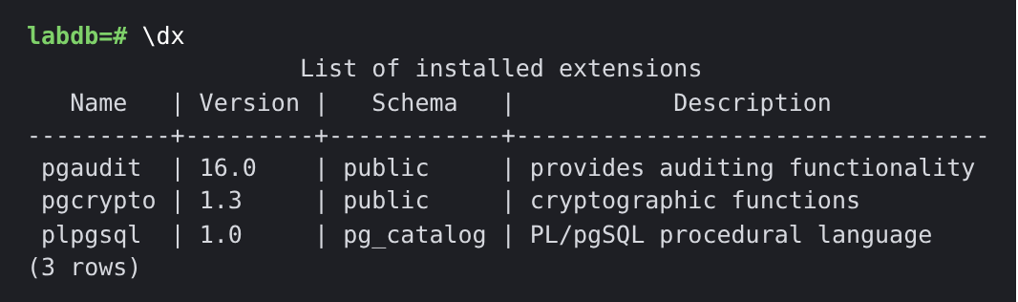
Fig. 1. The \dx command listing the installed pgaudit and pgcrypto extensions.
With pgaudit.log set to write, ddl, I created an employees table, inserted three rows, updated a salary, and read the table. The log recorded the CREATE TABLE, INSERT, and UPDATE but not the SELECT, as configured (fig. 2). For object auditing, I granted an auditor role SELECT on only the salary column; a query of names left no entry, while a query of salaries did (fig. 3).
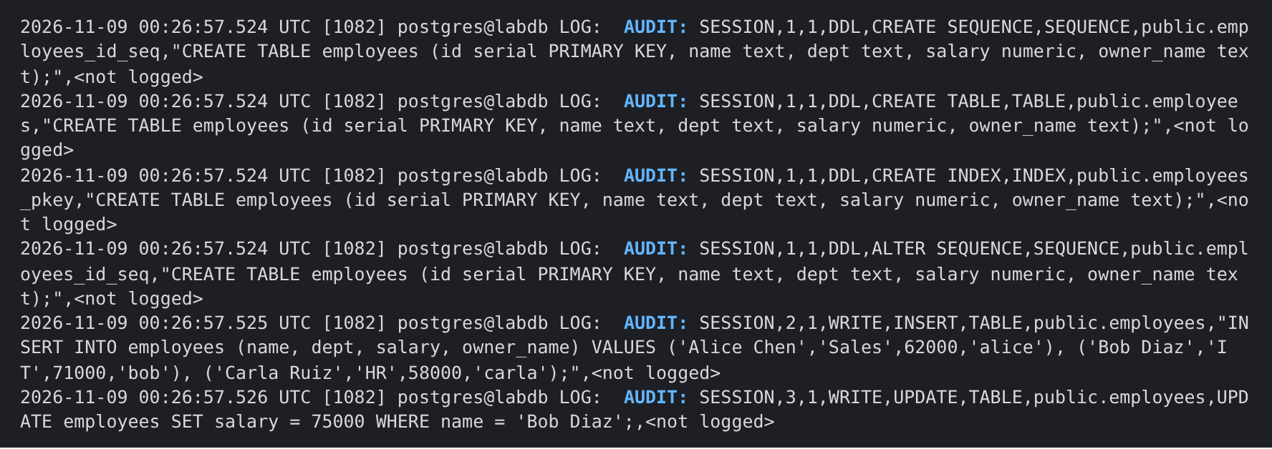
Fig. 2. Session auditing: AUDIT entries written to the server log for the CREATE TABLE, INSERT, and UPDATE run as hr_admin. The SELECT does not appear because the READ class was not enabled.
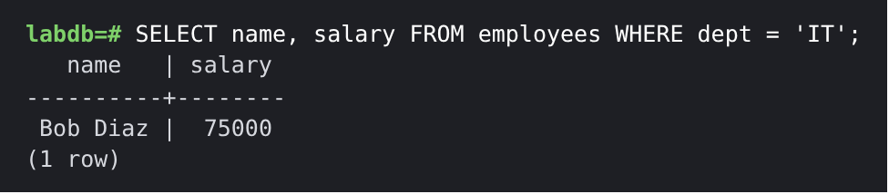
Fig. 3. Object auditing: the query that reads the audited salary column (top) and the OBJECT audit entry it produced (bottom).
Next, a row-level security policy let each user see only rows where owner_name matched their login, so the same query returned different results for alice and bob (fig. 4). For alerts, I wrote a trigger that calls pg_notify when a salary rises by more than ten percent. A monitoring session running LISTEN received an alert when Alice Chen’s salary jumped from 62,000 to 90,000, while a small raise was ignored (fig. 5).
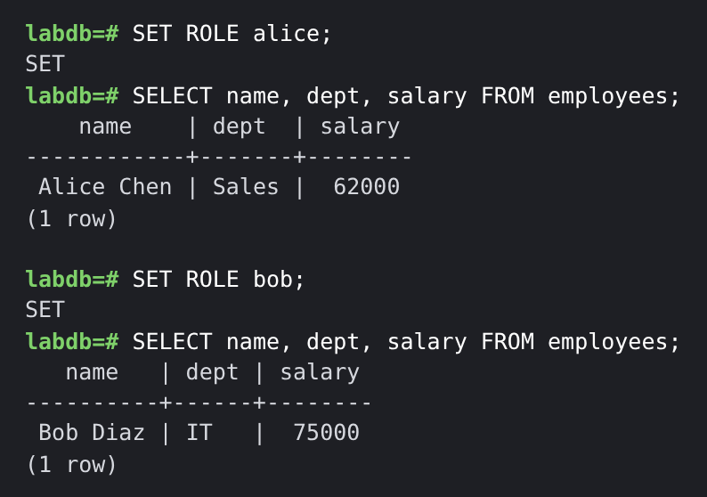
Fig. 4. Row-level security: the same query returns only Alice’s row for alice and only Bob’s row for bob.
Fig. 5. The alert received by the monitoring session after hr_admin raised Alice Chen’s salary from 62,000 to 90,000.
Finally, I encrypted a sample Social Security number with AES-256 using pgp_sym_encrypt. The stored value was unreadable, the correct key decrypted it, and a wrong key was rejected; a bcrypt password hash also passed and failed login checks correctly (fig. 6). A connection with sslmode=require used TLS 1.3 with 256-bit encryption (fig. 7).
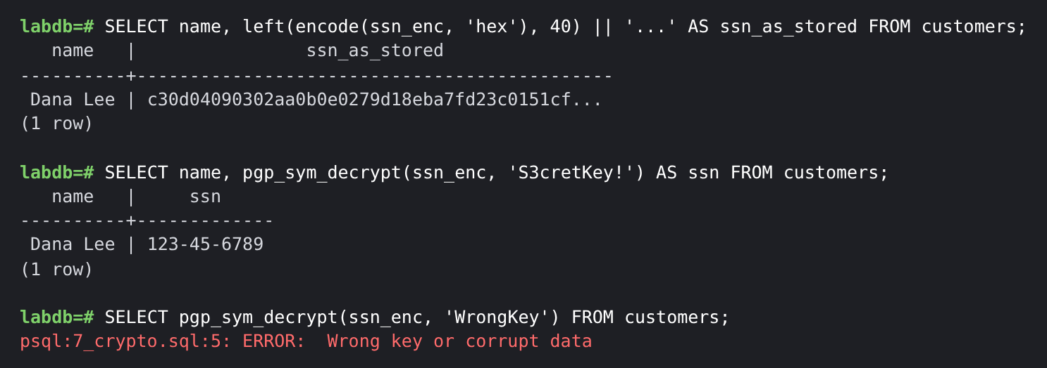
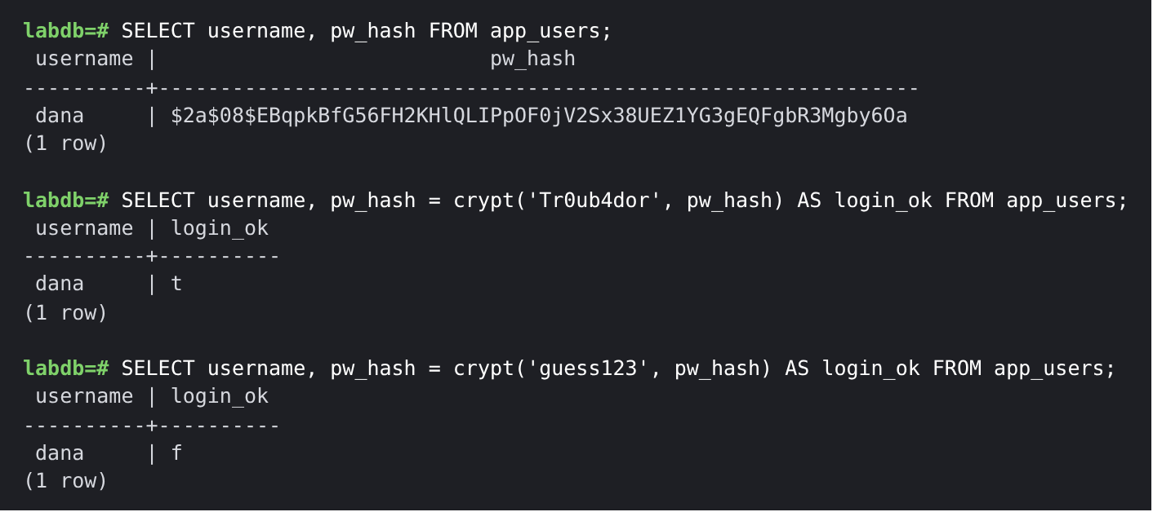
Fig. 6. pgcrypto: the encrypted SSN as stored, decrypted with the correct key, and rejected with a wrong key (top); a bcrypt password hash and login checks (bottom).
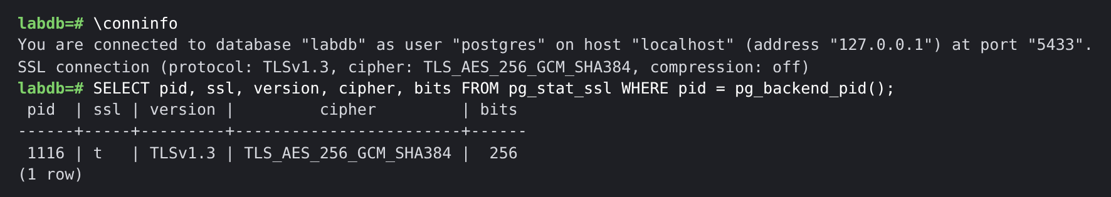
Fig. 7. TLS 1.3 connection details reported by \conninfo and the pg_stat_ssl view.
User Experience
The tools are powerful but demanding. Everything is configured through SQL and text files, with no graphical console for audits or alerts. pgAudit requires a server restart to install, although later setting changes only need pg_reload_conf(), and cloud platforms such as Supabase reduce setup to a toggle (Supabase). Audit logs are easy to filter, but volume grows quickly; one CREATE TABLE produced four audit lines, and AWS advises monitoring storage (Amazon Web Services). pgcrypto uses familiar SQL but leaves key management to the user (Neon).
Pros and Cons
A key strength is that pgAudit keeps passwords out of the log (Amazon Web Services), unlike built-in logging (Microsoft). In my test, built-in logging recorded a new password in plain text while pgAudit replaced it with <REDACTED> (fig. 8).
Fig. 8. The same ALTER ROLE command logged by built-in statement logging (password visible) and by pgAudit (password redacted).
Pros:
- Every feature is free and supported by major cloud providers.
- Audit entries are consistent and filterable at the session or object level.
- Row-level security, NOTIFY, pgcrypto, and TLS are built in.
Cons:
- Setup requires configuration files, a restart, and no graphical interface.
- pgAudit cannot reliably audit superusers, and entries may be lost in a crash (pgAudit, "pgaudit/pgaudit").
- NOTIFY reaches only connected clients, and encrypted columns cannot be searched efficiently.
Conclusion
PostgreSQL with pgAudit and pgcrypto provides a complete, free set of database security controls. In this lab, each feature worked as documented. These tools suit organizations willing to invest setup time and manage log volume, but the lack of a graphical interface is a barrier for beginners.

Works Cited
Amazon Web Services. "Using pgAudit to Log Database Activity." Amazon RDS User Guide, docs.aws.amazon.com/AmazonRDS/latest/UserGuide/Appendix.PostgreSQL.CommonDBATasks.pgaudit.html. Accessed 8 Nov. 2026.
JusDB. "pgAudit: PostgreSQL Audit Logging for SOC2, PCI-DSS, and HIPAA Compliance." JusDB, 5 Mar. 2026, www.jusdb.com/blog/pgaudit-postgresql-audit-logging-compliance.
Microsoft. "Audit Logging in Azure Database for PostgreSQL Flexible Server." Microsoft Learn, 16 July 2026, learn.microsoft.com/en-us/azure/postgresql/security/security-audit.
Neon. "The pgcrypto Extension." Neon Docs, 5 June 2026, neon.com/docs/extensions/pgcrypto.
pgAudit. "pgaudit/pgaudit: PostgreSQL Audit Extension." GitHub, github.com/pgaudit/pgaudit. Accessed 8 Nov. 2026.
PostgreSQL Global Development Group. "F.26. pgcrypto—Cryptographic Functions." PostgreSQL 18 Documentation, www.postgresql.org/docs/current/pgcrypto.html. Accessed 8 Nov. 2026.
---. "NOTIFY." PostgreSQL 18 Documentation, www.postgresql.org/docs/current/sql-notify.html. Accessed 8 Nov. 2026.
---. "Row Security Policies." PostgreSQL 18 Documentation, www.postgresql.org/docs/current/ddl-rowsecurity.html. Accessed 8 Nov. 2026.
---. "Secure TCP/IP Connections with SSL." PostgreSQL 18 Documentation, www.postgresql.org/docs/current/ssl-tcp.html. Accessed 9 Nov. 2026.
Supabase. "PGAudit: Postgres Auditing." Supabase Docs, 5 Oct. 2026, supabase.com/docs/guides/database/extensions/pgaudit.

