  - Parkinson’s Progression Markers Initiative (PPMI) resting-state fMRI data availability and usage

Nessa Kim* (Stanford University, Department of Neurology and Neurological Sciences)
Colin McDaniel* (Stanford University, Department of Neurology and Neurological Sciences)
Christian La (Stanford University, Department of Neurology and Neurological Sciences)
Kathleen L. Poston# (Stanford University, Department of Neurology and Neurological Sciences & (by courtesy) Neurosurgery)
The Parkinson’s Progression Marker Initiative Investigators

* Contributed equally
# Corresponding Author
PPMI Project ID: NA

Summary (or Abstract)

We present usage information of the PPMI dataset comprising 384 resting-state functional MRI scans acquired from 194 participants. Scans were acquired between 2012 and 2019 cross-sectionally and longitudinally using a 3-Tesla MRI scanners from nine institutions in the US and Europe. Participants groups included newly diagnosed de novo Parkinson’s disease, scans without evidence of a dopaminergic deficit (SWEDD), prodromal, genetic participants with and without Parkinson’s disease, and healthy older adults. We provide information regarding the source data, detailed visit timing information, quality control measures including head motion analysis, and determination of medication usage. This report aims to facilitate efficient and effective usage of this invaluable dataset for the collective effort of validating potential functional connectivity biomarkers in people with Parkinson’s disease.

Method
Participants and longitudinal timepoints
The current PPMI study comprises five cohorts followed longitudinally using standardized data acquisition protocols at 21 clinical sites [1]. Each participating PPMI site received approval from an ethical standards committee on human experimentation before study initiation and obtained written informed consent for research from all individuals participating in the study.

Because the PPMI imaging protocol added rs-fMRI in 2012, after study initiation, and because the protocol limited rs-fMRI acquisition to sites using 3 Tesla MRI, only a subset of the enrolled participants completed a rs-fMRI scan. The rs-fMRI scans were scheduled to be acquired at baseline and at specific annual visits thereafter: the healthy control group was scanned at visit BL (0 months) and V04 (12 months) and the non-healthy control groups (i.e., PD, SWEDD, Prodromal, Genetic Cohort) were scanned at BL, V04, V06 (24 months), and V10 (48 months) [2].

Imaging data
The rs-fMRI sequence was intended to run for 8 minutes and 24 seconds, using axial acquisition oriented along the AC-PC plane and covering the vertex and as much of the cerebellum as possible. The participants were instructed to rest quietly with their eyes open, clear their mind and not fall asleep. The PPMI rs-fMRI dataset includes four different scan sequences for acquisition (Table 1). A stringent quality control process was initially implemented on the USC Laboratory of Neuroimaging (LONI) platform, which excluded scans from download based on scan quality measures such as framewise displacement (FD) and temporal signal-to-noise ratio [3]. This was later revised to allow individual investigators to determine the usability of the data based on their own analysis purposes. Thus, the revised quality control protocol only excluded scans with < 100 volumes (< 4 minutes of data acquired) or if the scan presented a clinically significant abnormal finding.

Series description | ep2d_RESTING_STATE | ep2d_bold_rest | ep2d_bold_rest | ep2d_RESTING_STATE
Field strength | 3T | 3T | 3T | 3T
Flip angle | 80 degrees | 80 degrees | 80 degrees | 80 degrees
Manufacturer | SIEMENS | SIEMENS | SIEMENS | SIEMENS
Manufacturer model* | TrioTim | Prisma fit | Prisma fit | TrioTim
Matrix* | 476x462 | 476x462 | 518x518 | 518x518
Voxel size* | 3.29x3.29 | 3.29x3.29 | 3.00 x3.00 | 3.00 x3.00
Slice thickness* | 3.30 | 3.30 | 3.00 | 3.00
Pulse sequence | EP | EP | EP | EP
Volumes* | 210 | 210 | 164 | 164
TE | 25ms | 25ms | 25ms | 25ms
TR | 2400ms | 2400ms | 2400ms | 2400ms
Number of scans | 334** | 44 | 5 | 1

Table 1. Description of the four PPMI rs-fMRI scan sequences from the Image & Data Archive (IDA) powered by LONI. *Characteristics or parameters that differ between scan sequences. **Number includes 2 incomplete scans that collected 112 and 126 volumes out of the expected 210.

Head motion assessment
Image conversion
We converted the DICOM images downloaded from the PPMI website to 4D NIfTI files using the dcm2niix tool included in MRIcroGL 64-bit software [4]. This software utilizes the DICOM header information to compile the volumes into the correct order.

Preprocessing
We preprocessed the raw dataset using the CONN Toolbox, an open-source MATLAB/SPM-based cross-platform software. Preprocessing consisted of the following steps: SPM12 realignment to the first scan volume, centering to the origin via translation, slice-timing correction (ascending slice order), and outlier identification for extracting movement parameters and global signal intensity for each volume [5, 6]. For each scan, we quantified head motion by calculating volume-to-volume FD as described by Power and colleagues [7], which converts rotations to displacements about a 50 mm sphere (|dx| + |dy| + |dz| + 50|da| + 50|db| + 50|dc|).

Next, we centered the T1-weighted structural scans (MPRAGE, 1×1×1-1.2 voxel size) scans to the origin via translation; coregistered them with the same participants’ functional scans; segmented the structural scans into grey matter, white matter, cerebral spinal fluid, bone, soft tissues (binarized with a threshold of 0.5 and eroded); and spatially normalized them to MNI space, reslicing to a 1-mm voxel size. The same deformation field was applied to the functional data, which was resliced to a 2-mm voxel size. Finally, functional scans underwent smoothing by spatial convolution with a Gaussian kernel of 6 mm [12].

Summary statistics
We evaluated the amount of motion in all the available scans and created a summary in order to assist investigators in determining the dataset that is most appropriate for their planned analyses. Using the FD time series produced from preprocessing, we identified outlier volumes within each scan using various thresholds for outlier detection: global signal z > 5 or FD > 0.5 mm for lenient detection, FD > 0.35 mm for intermediate detection, and FD > 0.2 mm for stringent detection [8]. Within each threshold, we determined the number of participants/scans with at most 40% outlier volumes detected. Because a minimum of five minutes of data is recommended for computing correlations [8, 9], we allow up to 40% outlier volumes, and require 5 minutes remaining for scans shorter than 210 volumes. However, investigators using spike regression [10, 11] or volume removal (i.e., “scrubbing” [7]) may find that allowing up to 40% of outlier volumes could result in a large loss of data. To vary the percentage of outliers allowed, we then determined the number of participants/scans with at most 10% and 25% outlier volumes, in addition to the 40%, using lenient outlier detection (exclude if global signal z > 5 or FD > 0.5 mm).

Dopaminergic medication
All PD participants initially enrolled in PPMI were de novo at baseline and remained de novo for at least 6 months. However, most started taking dopaminergic medications to treat the motor symptoms of PD within the first two years of the study, around the time that rs-fMRI was added to the protocol [1]. Therefore, we needed to determine the usage of dopaminergic medications at the time of rs-fMRI scan acquisition after the baseline visit in the de novo PD and at all timepoints in the non-de novo PPMI cohorts (Table 2).

 | BL | V04 - V12
Control | N/A | N/A
PD | de novo | Determine
SWEDD | de novo | Determine
Prodromal | N/A | Determine
Genetic PD | Determine | Determine
Genetic Unaffected | N/A | Determine

Table 2. Participants for which medication usage must be determined, by cohort and timepoint. ’N/A’ indicates that the determination of medication usage is not applicable in this cohort and timepoint. ‘De novo’ indicates a timepoint where participants were required to have not yet started dopaminergic medications. ‘Determine’ indicates that the participant might have started dopamine replacement therapy prior to the scan timepoint, and therefore the medication usage must be determined by the researcher.

For PPMI participants who have started levodopa, dopamine agonist or combination therapy, the “OFF” medications state is defined as not having taken dopaminergic medication for more than 6 hours [12]. No further details were recorded regarding whether or not the participant felt they were in the ON or OFF state. Therefore, we used the time elapsed from the participant’s last dose of PD medication to the start of their rs-fMRI sequence to determine whether a participant was ON or OFF medication, described in Figure 1. We also identified scans with unknown medication usage when this information could not be determined from any of the records.

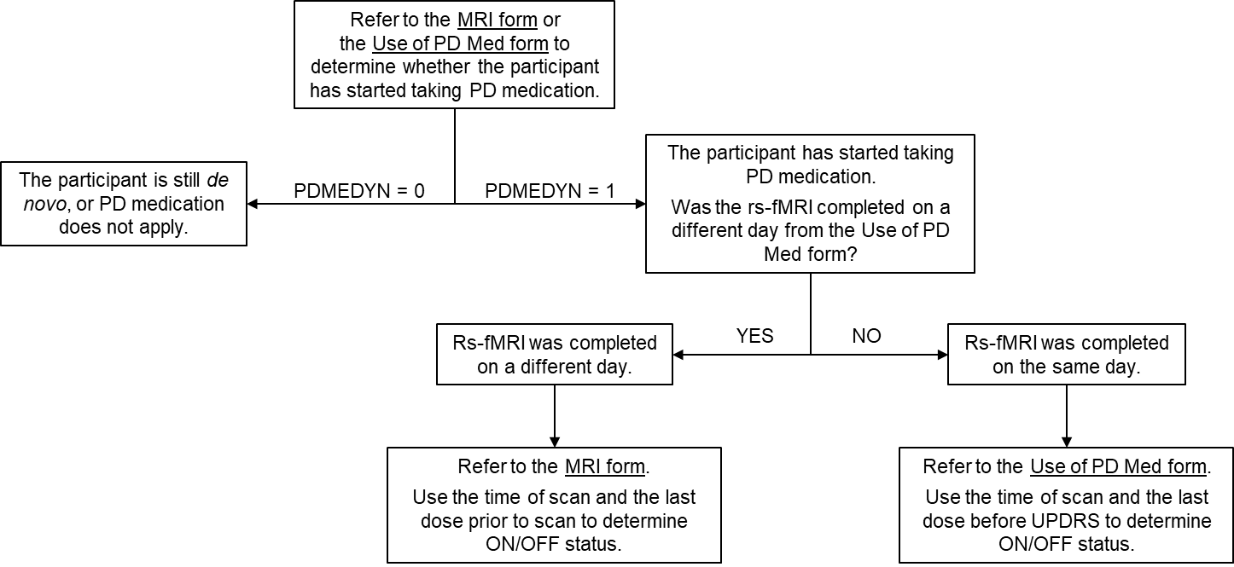
Figure 1. Steps to determine PD medication usage of rs-fMRI scans. The field ‘PDMEDYN’ indicates whether the participant had started taking medication for PD, where “1” = Yes and “0” = No.

References

1. Marek, K., et al., The Parkinson's progression markers initiative (PPMI) - establishing a PD biomarker cohort. Ann Clin Transl Neurol, 2018. 5(12): p. 1460-1477.
2. Enrolled Subject Schedule of Activities, in Protocol. 2018, Parkinson's Progression Markers Initiative.
3. Rex, D.E., J.Q. Ma, and A.W. Toga, The LONI pipeline processing environment. Neuroimage, 2003. 19(3): p. 1033-1048.
4. Li, X., et al., The first step for neuroimaging data analysis: DICOM to NIfTI conversion. J Neurosci Methods, 2016. 264: p. 47-56.
5. Mazaika, P., et al., Artifact repair for fMRI data from high motion clinical subjects. Human Brain Mapping, 2007: p. 2007.
6. Whitfield-Gabrieli, S. and A. Nieto-Castanon, Conn: a functional connectivity toolbox for correlated and anticorrelated brain networks. Brain connectivity, 2012. 2(3): p. 125-141.
7. Power, J.D., et al., Spurious but systematic correlations in functional connectivity MRI networks arise from subject motion. Neuroimage, 2012. 59(3): p. 2142-2154.
8. Power, J.D., et al., Methods to detect, characterize, and remove motion artifact in resting state fMRI. Neuroimage, 2014. 84: p. 320-341.
9. Van Dijk, K.R., et al., Intrinsic functional connectivity as a tool for human connectomics: theory, properties, and optimization. Journal of neurophysiology, 2010. 103(1): p. 297-321.
10. Lemieux, L., et al., Modelling large motion events in fMRI studies of patients with epilepsy. Magn Reson Imaging, 2007. 25(6): p. 894-901.
11. Satterthwaite, T.D., et al., An improved framework for confound regression and filtering for control of motion artifact in the preprocessing of resting-state functional connectivity data. Neuroimage, 2013. 64: p. 240-56.
12. General Operations Manual, in Assessments. 2017, Parkinson's Progression Markers Initiative. p. 6-7.

About the Authors
This document was prepared by Dr. Kathleen Poston, Department of Neurology, Stanford University. For more information please contact Dr. Poston by email at klposton@stanford.edu.

Notice: This document is presented by the author(s) as a service to PPMI data users. However, users should be aware that no formal review process has vetted this document and that PPMI cannot guarantee the accuracy or utility of this document.

