New Test Data

Tuesday, 13 January 2015

1:56 PM

|  |  |
| --- | --- |
| **Subject** | **RE: Early optimisation experiments with Python Sambuca [SEC=UNCLASSIFIED]** |
| **From** | [Stephen.Sagar@ga.gov.au](mailto:Stephen.Sagar@ga.gov.au) |
| **To** | Collins, Daniel (IM&T, Kensington); Botha, Hannelie (O&A, Black Mountain); Malthus, Tim (O&A, Dutton Park); Anstee, Janet (O&A, Black Mountain) |
| **Sent** | Monday, 5 January 2015 9:58 AM |

Hey Daniel,

Hope your break was good!

I’ve prepared some extra data to use in tests as we discussed before Christmas. I’ve generated a test data spectra based on the following parameter values, so you can see how successful the algorithm is at retrieving them, and test the how you apply the sensor filter with more complicated response curves:

CHL – 0.15

CDOM – 0.006

TR – 0.28

Q – 0.23   (ie q1(coral) =23% and q2(sand)=77%))

H – 7.53m

The SIOP values/spectra and substrates remain the same as the Matlab data/test.

I generated the initial spectra at the full 1nm resolution:

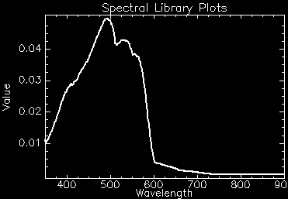

I then resampled used the filter for the Quickbird Sensor, which looks like this, with response curves for each of the 4 bands (Blue,Green,Red,NIR):

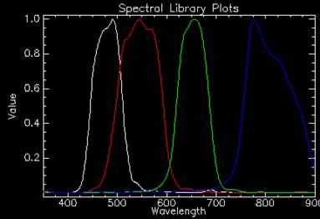

This creates the synthetic 4 band data to be inverted. I have then added random Gaussian noise of sigma=0.001 to the each of the four bands (so the noise/NeDR will just be a constant flat 0.001). Below is the original (white) and noise-added (red) spectra. You could try inverting both of these and see what effect the noise has on getting the right parameters back.

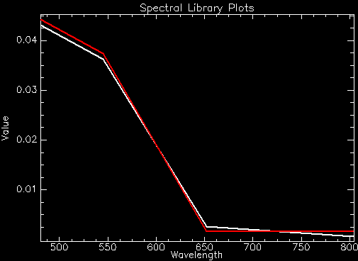

I have included all these data in the zip file, both as envi spectra libraries and as ASCII txt files. I’ve left the headers and wavelengths in the ASCII files for info, you can delete as appropriate for your code.

Any questions, just give me a buzz ☺

Cheers

Steve