Freedom Pact

Considering that:
Access to software determines who may participate in a society where most interactions rely on digital technologies;
Free Software, which everyone may use, study, share and improve, enables political, economic, and cultural participation for everyone;
The use of Open Standards¹ is critical to achieve interoperability between different IT systems in Europe, and ensure the long-term accessibility of information;
Software patents are incompatible with Free Software and are a menace to society and economy, because they restrict innovation, damage businesses and put collaborative creativity in great danger;
Free Software helps to boost European economy by enabling small and medium sized companies to compete on a local and regional level against existing software monopolies;
Free Software is essential for public bodies to break free from vendor lock-in, obtain value for money, and promote the growth of European businesses;

I pledge to:
- promote the use of Free Software in all areas of public life, in particular in the educational sector, so that students can learn in freedom
- promote legislation to make Free Software the first choice in public procurement throughout Europe
- promote policies in favour of Free Software and oppose policies that discriminate against it.
- promote the widest possible use of Open Standards in the public sector, as well as the publication and archiving of all public data and documents in formats based on Open Standards
- ensure that all software developed with public funds is released as Free Software, so other administrations and the public can benefit from it
- strengthen consumers' rights so as to promote users control over their own devices and oppose any measures endangering it
- oppose any provision that aims at establishing software patents in Europe and work to end the European Patent Office's practice of granting patents on computer-implemented inventions

Freedom Pact

I am . . . . . . . . . . . . . . . . . . . . . . . . . . . . . . . . . (your name)
I am a member of . . . . . . . . . . . . . . . . . . . . . . . . . . . . . . . . . (name of your political party)
from . . . . . . . . . . . . . . . . . . . . . . . . . . . . . . . . . (name of your country)
and I am a candidate in the European elections 2014.

By signing the Freedom Pact, your name will be publicly visible on our campaigns page
http://fsfe.org/campaigns/askyourcandidates/ep2014/ayc-ep2014
With this, you can show all European voters that you actually care about Free Software and Open Standards to build a Free Society. To do so, please print and fill out this Freedom Pact and send it to the address given in the imprint on the bottom of this page.

I hereby sign the Freedom Pact

. . . . . . . . . . . . . . . . . . . . . . . . . . . . . . . . . , on . . . . . . . . . . . . . . .
(your signature) (date)

Imprint:
The “Freedom Pact” is an initiative of the Free Software Foundation Europe (FSFE) – a non-profit organisation dedicated to promoting Free Software and working to build a free digital society.

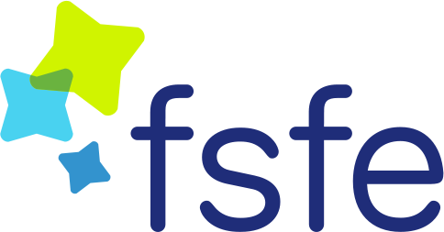
Free Software Foundation Europe e.V. (FSFE)
Schönhauser Allee 6/7
10119 Berlin
Germany

For a definition of Open Standards, see: http://fsfe.org/activities/os/def.en.html

