La economía del conocimiento en el Siglo 21

Considering that:
- In a society where most interactions rely on digital technologies, it is Free Software – which everyone may use, study, share and improve – that enables political, economic, and cultural participation for everyone.
- The use of Open Standard data formats are critical to achieve interoperability between different IT systems in Europe, and together with Free Software, they are essential for public bodies to break free from vendor lock-in, and to act autonomously.
- Free Software helps to grow the Spanish IT economy and creates domestic employment by enabling small and medium sized companies to compete on a local and regional level against existing foreign software monopolies.
- Free Software is essential for public bodies to act autonomously, participate globally and grow wealth locally.

I promise to:
- promote the use of Free Software in all areas of public life, public administration and public education
- promote legislation to make Free Software the first choice in public procurement
- promote policies in favour of Free Software and oppose policies that discriminate against it
- ensure a legal requirement, that all software developed with public funds is released as Free Software, so other administrations and the public can benefit from it
- promote the widest possible use of Open Standards in the public sector, as well as the publication and archiving of all public data and documents in formats based on Open Standards

Freedom Pact

My name is . . . . . . . . . . . . . . . . . . . . . . . . . . . . . . . . . . . . . . . . . . . . . . . . . . . . . . . (your name)

I am a member of . . . . . . . . . . . . . . . . . . . . . . . . . . . . . . . . . . . . . (name of your political party)

and I am a candidate for the national elections 2015 in Spain.

With your signature, you agree that your name will be publicly visible on our campaigns page
http://examp.le
That helps you to show all Spanish voters that you actually care about the autonomy of Spain, the growth of local IT economy in Spain and technological welfare for the people of Spain.

To do so, please print and fill out this pact and send it by post or email to the address given in the imprint on the bottom of this page.

I hereby sign the pact

. . . . . . . . . . . . . . . . . . . . . . . . . . . . . . . . . , on . . . . . . . . . . . . . . .
(your signature) (date)

Imprint:
“La economia y el conocimiento en el Siglo 21” is an initiative of the Free Software Foundation Europe (FSFE) – a non-profit organisation dedicated to promoting Free Software and working to build a free digital society.

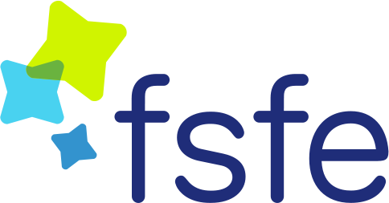
Free Software Foundation Europe e.V. (FSFE)
Schönhauser Allee 6/7
10119 Berlin
Germany

