|  |
| --- |
| Exsae Technologies |
| Within Learning |
| You only know you truly understand it if you can imagine it |

|  |
| --- |
| Funduluka Shangala  5/16/2021 |

The only laws of matter are those that our minds must fabricate and the only laws of mind are fabricated for it by matter – James Clerk Maxwell

**Table of contents**

Introduction 3

Human intelligence 3

Imagination 3

Learning 3

General Learning 4

The learning process 4

# Introduction

The definition of intelligence is controversial, varying in what its abilities are and whether or not it is quantifiable. In most cases it can be thought of as a very general mental capability that, among other things, involves the ability to reason, plan, solve problems, think abstractly, comprehend complex ideas, learn quickly and learn from experience.

## Human intelligence

Human intelligence is the intellectual power of humans, which is marked by complex cognitive feats and high levels of motivation and self-awareness. It enables humans to remember descriptions of things and use those descriptions in future behaviours. It gives humans the cognitive abilities to learn, form concepts, understand and reason, including the capacities to recognize patterns, innovate, plan, solve problems, and employ language to communicate.

## Imagination

Imagination is the ability to produce and simulate novel objects, sensations, and ideas in the mind without any immediate input of the senses. It is also described as the forming of experiences in one’s mind, which can be re-creations of past experiences such as vivid memories with imagined changes, or they can be completely invented and possibly fantastic scenes. Imagination helps make knowledge applicable in solving problems and is fundamental to integrating experience and the learning process.

## Learning

Learning is the process of acquiring new understanding, knowledge, behaviours, skills, values, attitudes, and preferences. Some learning is immediate, induced by a single event, but much skill and knowledge accumulate from repeated experiences.

# General Learning

We acquire new memory every second of our lives, most of the memory we acquire becomes our knowledge and the rest is forgotten. Our imagination, on the other hand, relies on our memory and knowledge to recreate images and simulations in our minds. With imagination, we can create new understanding from our memory with the aid of what we already know. This becomes our new knowledge, as such, knowledge keeps growing for as long as we keep imagining.

## The learning process

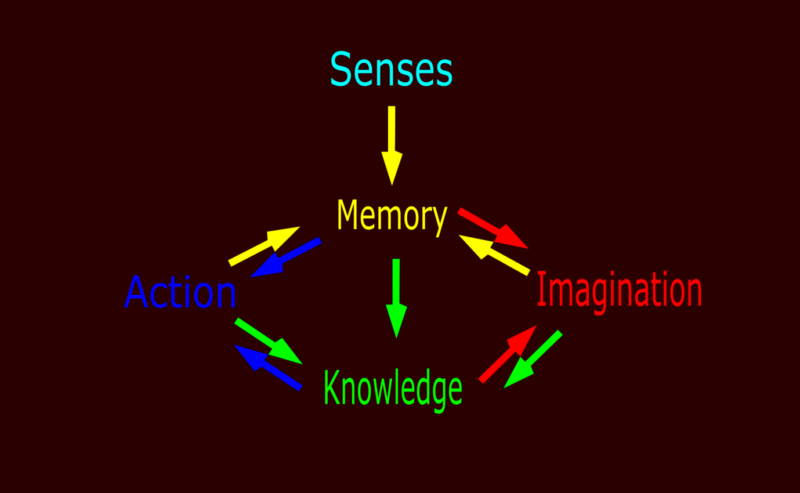

Figure : Learning diagram

The human senses collect data from the environment into memory some of this data is processed into knowledge, whereas most of it is left in memory which eventually fades away in time. Therefore, in our memory we have random data from all our senses i.e touch, taste, hearing, seeing and smelling.

Through thinking, particular data in our memory is transmuted to knowledge either directly or indirectly. A successful transmutation of data in memory into knowledge is understanding. This happens when the mind manages to connect the data together into a more compact form of information which cannot easily be forgotten – a distinguished group of similar data.

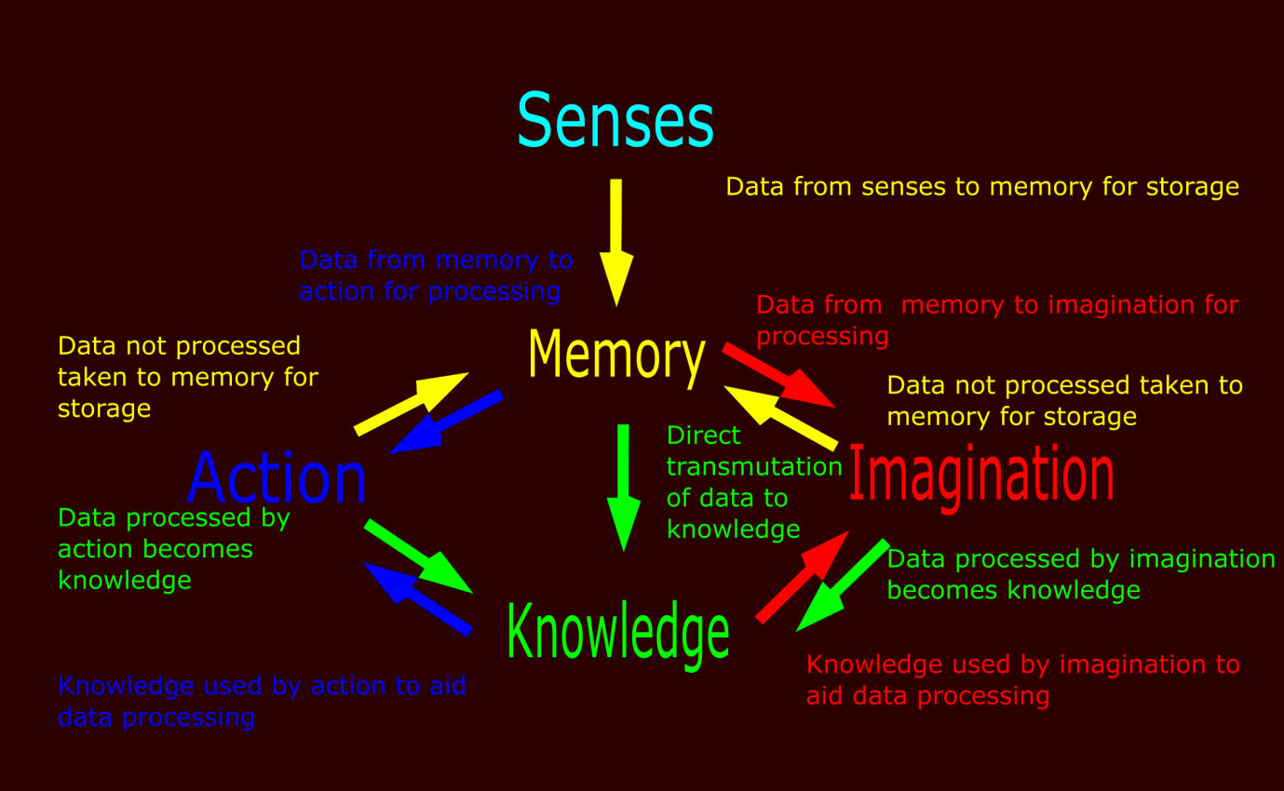

Figure : Detailed learning diagram

In most cases a direct transmutation is not enough to process most of the data in memory. This is where imagination and action comes in.

Through imagination: data in memory can be recollected to produce an automation based on the knowledge available about that group of data. From this automation, new knowledge and new data can be obtained.

Through action: data in memory can be acted out in the real world. By simply replicating what one remembers with the aid of what they already know, they can obtain new knowledge. The knowledge that comes out of this in most cases is skill, experience, etc. and from action new data can be generated.

It is not so often that one can put their data in memory into action, its usually easier to just understand directly. This is what often affects how fast someone is able to learn something, relying only on direct transmutation of data in memory to knowledge. Those who utilize all the three ways of acquiring knowledge are found to be fast learners.