Lecture 6, lab class 5: CFA/SEM practice questions

1. Confirmatory factor analysis
2. Is a measurement model.
3. Is a structural equation model.
4. Can hypothesise that certain factors loadings are zero.
5. All of the above.
6. What type of factor analysis does the following diagram represent?

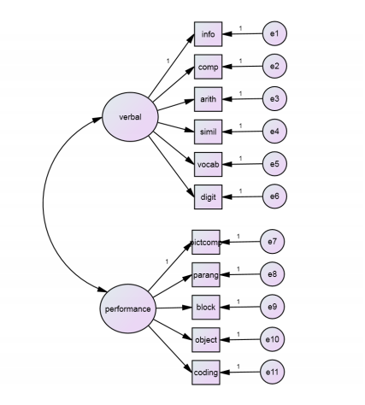

1. Confirmatory
2. Exploratory
3. Either confirmatory or exploratory
4. None of the above
5. What type of factor analysis does the following diagram represent?

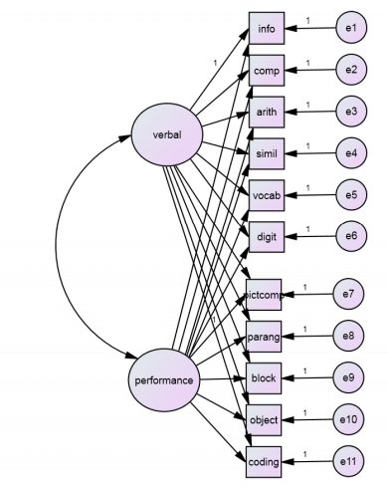

1. Confirmatory
2. Exploratory
3. Either confirmatory or exploratory
4. None of the above
5. A difference between exploratory and confirmatory factor analysis is:
6. In EFA you can constrain the factors to be uncorrelated but cannot constrain particular factor loadings to be 0, whereas in CFA you can constrain some factor loadings to be 0.
7. In CFA you can constrain the factors to be uncorrelated but cannot constrain particular factor loadings to be 0, whereas in EFA you can constrain some factor loadings to be 0.
8. EFA can restrict the number of factors whereas CFA cannot
9. CFA can restrict the number of factors whereas EFA cannot
10. In the drawing conventions for CFA
    1. An observed variable is represented by a rectangle, and an unobserved variable by an ellipse or circle.
    2. A factor is represented by a rectangle, and an unobserved variable by an ellipse or circle.
    3. An unobserved variable is represented by a rectangle, and an observed variable by an ellipse or circle.
    4. An error is represented by a rectangle, and a factor by an ellipse or circle.
11. To assess fit for a CFA, it is best to cite
    1. An absolute fit statistic measuring the discrepancy between model and data
    2. A comparative fit statistic measuring a comparison with no common factor
    3. A fit statistic taking into account parsimony, adjusting the discrepancy for sample size and number of parameters
    4. All of the above.
12. We fix one factor loading to 1 in order to ensure:
    1. That the model is identifiable
    2. That the scale of the factor is set.
13. Which of the following is true?
    1. Underidentified CFA models should be avoided because they have fewer free parameters than observations, and hence it’s not possible to uniquely estimate model parameters.
    2. Overidentified CFA models should be avoided because they have fewer free parameters than observations, and hence prevent tests of model fit.
    3. Just-identified CFA models should be avoided because they tend to fit poorly.
    4. Underidentified CFA models should be used because they never fit the data perfectly.
14. How many free parameters does the following model have to estimates, and how many unique variance covariance terms does the model have?

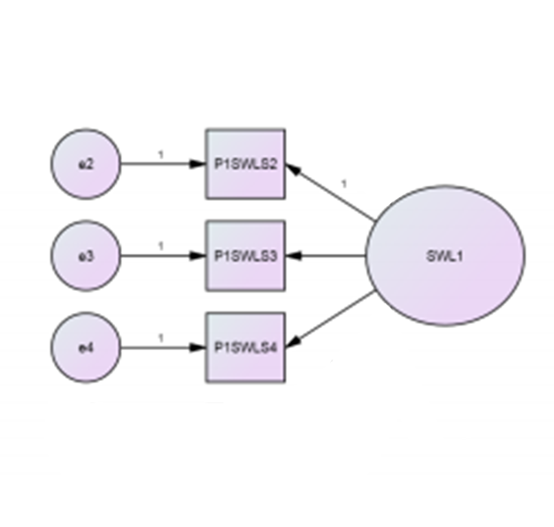

1. 2 free parameters to estimate, 3 unique variance covariance terms
2. 6 free parameters to estimate, 3 unique variance covariance terms
3. 6 free parameters to estimate, 6 unique variance covariance terms
4. 7 free parameters to estimate, 9 unique variance covariance terms
5. The model pictured in question 9 is:
6. Underidentified
7. Just identified
8. Over-identified
9. Zesty