Supplementary Table 1 Demographic and clinical characteristics of patients in AD and EC groups (CSF samples)
Variables | EC, n=26 | AD, n=25 | p value
Age, y, mean±SD | 70.2±8.5 | 69.5±9.9 | 0.796
Education, y, mean±SD | 11.4±3.4 | 8.52±4.6 | 0.010
Female gender, n(%) | 10(38.5) | 13(52.0) | 0.404
MMSE score, mean±SD | 27.7±1.8 | 12.8±6.4 | <0.001
Hyperlipidemia, n(%) | 10(38.5) | 12(48.0) | 0.382
Hypertension, n(%) | 11(42.3) | 7(28.0) | 0.577
Diabetes mellitus, n(%) | 3(11.5) | 4(16.0) | 0.703
ApoEε4 carrier, n(%) | 4(15.4) | 9(36.0) | 0.116
CSF Aβ40 (pg/ml), mean±SD | 392.9±65.1 | 367.3±98.4 | 0.277
CSF Aβ42 (pg/ml), mean±SD | 425.7±140.5 | 243.4±99.9 | <0.001
CSF total tau (pg/ml), mean±SD | 325.5±104.7 | 466.8±231.2 | 0.030
CSF ptau181 (pg/ml), mean±SD | 55.4±29.2 | 127.5±53.5 | <0.001
Abbreviations: AD, Alzheimer’s disease; EC, elderly controls without neurologic disorders; CSF, cerebrospinal fluid; MMSE, mini-mental state examination.

Supplementary Table 2 The discriminatory values of serum and CSF biomarkers in AD vs EC.
ROC analysis | AUC | P value | 95% CI
Serum p75NTR-ECD | 0.752 | <0.001 | 0.695-0.808
Serum Aβ42 | 0.585 | 0.014 | 0.519-0.651
Serum Aβ40 | 0.635 | <0.001 | 0.570-0.699
Serum total Aβ | 0.658 | <0.001 | 0.595-0.721
Serum Aβ42/40 | 0.557 | 0.097 | 0.490-0.624
Serum ptau181 | 0.702 | <0.001 | 0.642-0.763
Serum total tau | 0.679 | <0.001 | 0.614-0.744
Serum ptau181/Aβ42 | 0.565 | 0.061 | 0.497-0.632
Serum total tau/Aβ42 | 0.515 | 0.659 | 0.447-0.584
CSF p75NTR-ECD | 0.815 | <0.001 | 0.700-0.931
CSF Aβ42 | 0.871 | <0.001 | 0.774-0.967
CSF Aβ40 | 0.560 | 0.462 | 0.397-0.723
CSF total Aβ | 0.803 | <0.001 | 0.684-0.922
CSF Aβ42/40 | 0.835 | <0.001 | 0.720-0.950
CSF ptau181 | 0.908 | <0.001 | 0.817-0.998
CSF total tau | 0.678 | 0.030 | 0.525-0.830
CSF ptau181/Aβ42 | 0.974 | <0.001 | 0.940-1.000
CSF tau/Aβ42 | 0.851 | <0.001 | 0.743-0.958
Abbreviations: AD, Alzheimer’s disease; EC, elderly controls without neurologic disorders; AUC, the area under ROC; 95% CI, 95% confidence interval.

Supplementary Table 3 The discriminatory values of serum and CSF p75NTR-ECD combining with other biomarkers in AD vs EC.
ROC analysis | AUC | P value | 95% CI | Sensitivity,% | Specificity,% | Accuracy, %
Serum p75NTR-ECD & serum Aβ42 | 0.772 | <0.001 | 0.718-0.826 | 62.2 | 79.8 | 71.0
Serum p75 NTR-ECD & serum Aβ40 | 0.788 | <0.001 | 0.735-0.841 | 83.3 | 57.3 | 70.3
Serum p75 NTR-ECD & serumTotal Aβ | 0.799 | <0.001 | 0.747-0.850 | 79.5 | 69.7 | 74.6
Serum p75 NTR-ECD & serum Aβ42/Aβ40 | 0.768 | <0.001 | 0.713-0.824 | 70.5 | 76.7 | 73.6
Serum p75 NTR-ECD & serum ptau181 | 0.794 | <0.001 | 0.743-0.845 | 77.6 | 68.2 | 72.9
Serum p75 NTR-ECD & serum total tau | 0.774 | <0.001 | 0.720-0.828 | 59.6 | 82.9 | 71.3
Serum p75 NTR-ECD & serum ptau181/Aβ42 | 0.750 | <0.001 | 0.693-0.806 | 67.3 | 74.4 | 70.9
Serum p75 NTR-ECD & serum total tau/Aβ42 | 0.754 | <0.001 | 0.698-0.810 | 60.9 | 80.6 | 70.8
CSF p75 NTR-ECD & CSF Aβ42 | 0.934 | <0.001 | 0.870-0.997 | 88.0 | 88.5 | 88.2
CSF p75 NTR-ECD & CSF Aβ40 | 0.820 | <0.001 | 0.703-0.937 | 76.0 | 84.6 | 80.3
CSF p75 NTR-ECD & CSF total Aβ | 0.905 | <0.001 | 0.823-0.986 | 88.0 | 80.7 | 84.4
CSF p75 NTR-ECD & CSF Aβ42/Aβ40 | 0.906 | <0.001 | 0.822-0.990 | 84.0 | 92.3 | 88.2
CSF p75 NTR-ECD & CSF ptau181 | 0.942 | <0.001 | 0.875-1.000 | 100.0 | 80.8 | 90.4
CSF p75 NTR-ECD & CSF total tau | 0.818 | <0.001 | 0.702-0.935 | 76.0 | 80.8 | 78.4
CSF p75 NTR-ECD & CSF ptau181/Aβ42 | 0.980 | <0.001 | 0.949-1.000 | 96.0 | 96.2 | 96.1
CSF p75 NTR-ECD &CSF total tau/Aβ42 | 0.888 | <0.001 | 0.793-0.983 | 80.0 | 92.3 | 86.2
Abbreviations: AD, Alzheimer’s disease; EC, elderly controls without neurologic disorders; AUC, the area under ROC; 95% CI, 95% confidence interval.

Supplementary Figure 1
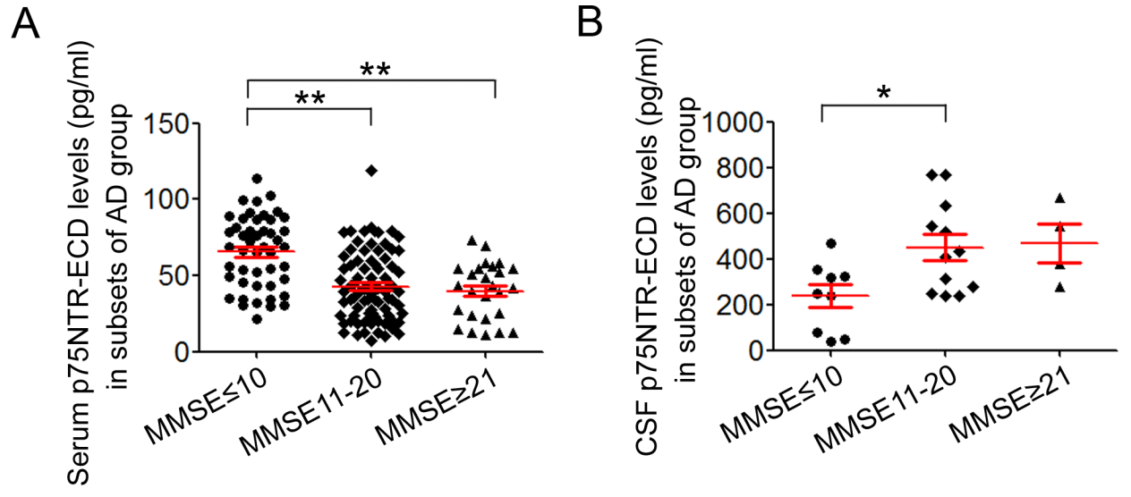
Supplementary Figure 1 The levels of serum or CSF p75NTR-ECD in three subsets of AD patients: MMSE≤10, MMSE 11-20 and MMSE≥21. (A): Serum p75NTR-ECD concentrations in the three subsets. MMSE≤10, n=47; MMSE 11-20, n=83; MMSE≥21, n=26. (B): CSF p75NTR-ECD concentrations in the three subsets. MMSE≤10, n=9; MMSE 11-20, n=12; MMSE≥21; n=4. Mean ± S.E.M., one-way ANOVA, Tukey’s test.

