Supplementary Figures
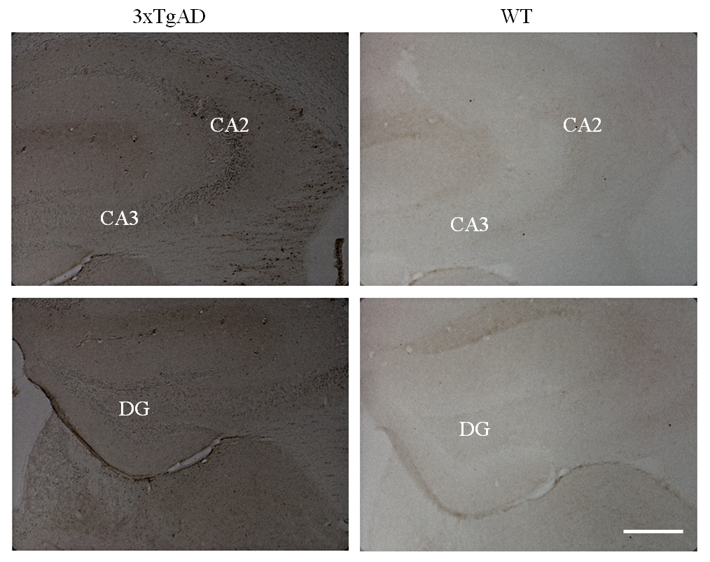
Supplementary Figure 1 – Neurofibrillary tangles expression levels are significantly higher in old 3xTgAD mice model of AD as compared to control age-matched WT mice
This is only a preliminary figure. We will repeat the procedure, quantify, and make new figure soon
Immunohistochemistry staining of neurofibrillary tangles using AT8 antibody in coronal brain slices derived from hippocampi of very old (16 months) mice model of AD and their age-matched C57B WT controls. Higher expression of neurofibrillary tangles in all sub-regions of the hippocampi of 3xTgAD mice as compared to their age-matched C57B controls. DG, dentate gyrus. Scale bar = 250 µm

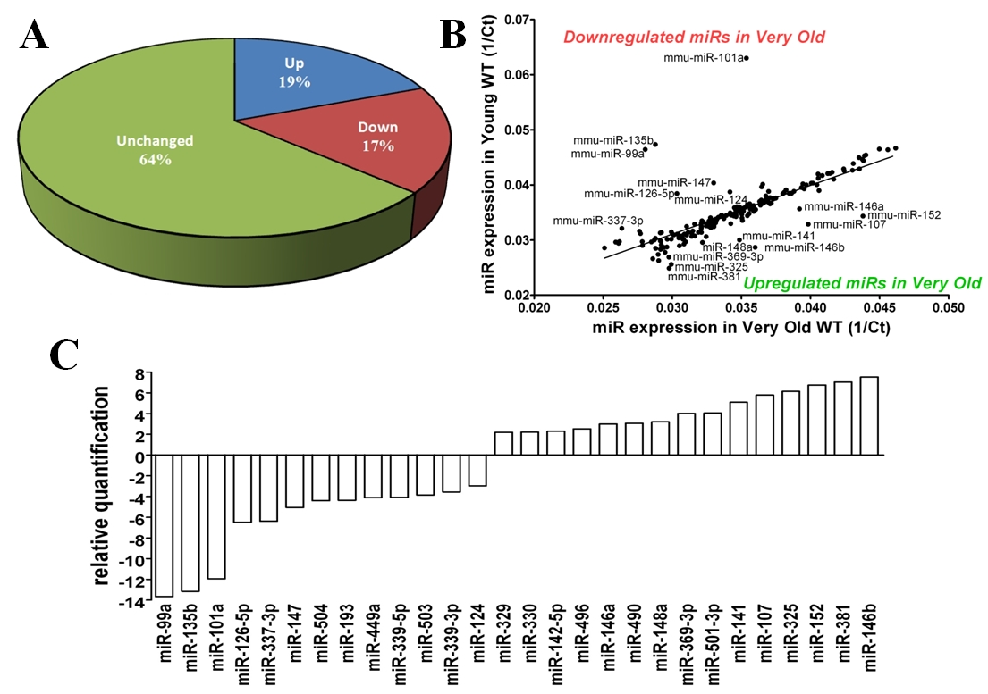
Supplementary Figure 2 - Hippocampal miRNAs global expression signature in WT C57BL/6J natural aging
A
General distribution of miRNAs modulation derived from very old (16-months-old) WT C57BL/6J mice compared to young (4-months-old) WT C57BL/6J mice. (A) Distribution chart of miRNAs changes showing miRNAs that were upregulated (Up), downregulated (Down), or unchanged (Unchanged). (B) Scatter-plot representation of miRNAs expression changes. While most of the miRNAs were not modulated in very old WT C57BL/6J mice (presented around and on the regression graph) some miRNAs were upregulated (below the regression graph), and some were downregulated (above the regression graph), compared to young WT C57BL/6J mice. Values are presented as 1/threshold-cycle (1/Ct). Presented are properly-detected miRNAs with Ct<40 and fold change>2 or <1/2. (C) Relative Quantification (RQ) of miRNAs that were upregulated with RQ>2 or downregulated with RQ<-2

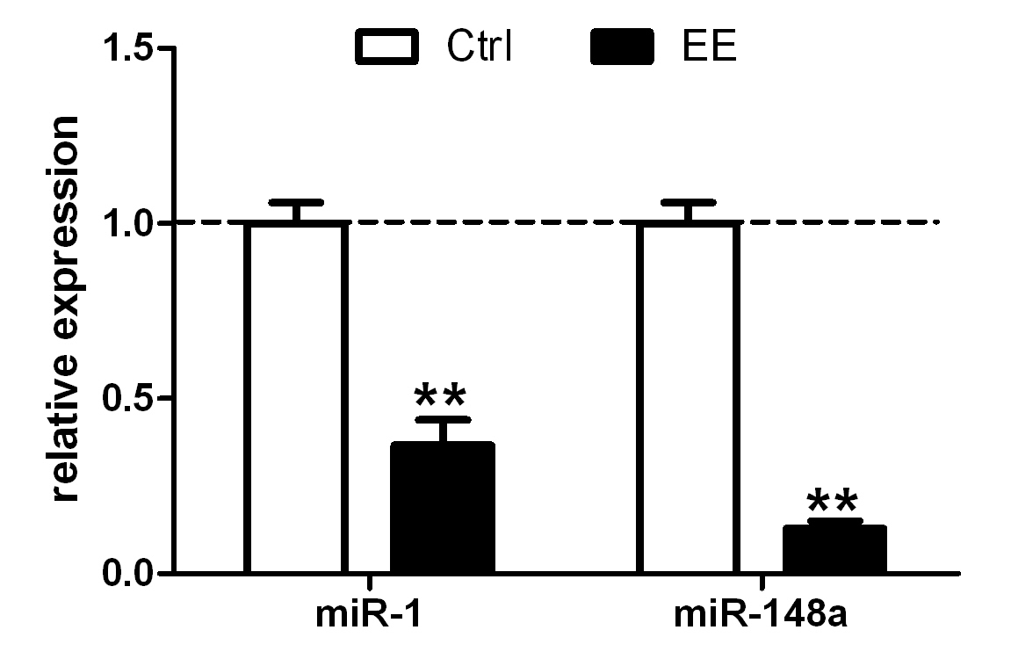

Supplementary Figure 3 - Validation of changes in miRNAs level using qRT-PCR
qRT-PCR assay was utilized to validate the expression levels of miR-1 and miR-148a in WT C57B mice that were exposed to EE and their control group. qRT-PCR showed significant decrease in the expression of the tested miRNAs following EE similarly to the TLDA results. Samples were extracted from the hippocampi of 3 mice per group. **p<0.005

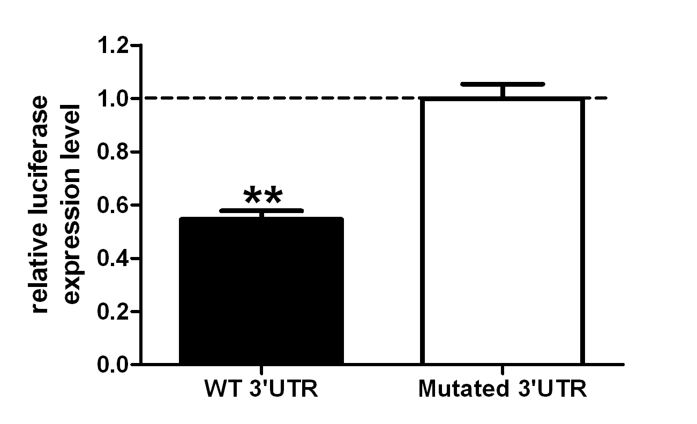

Supplementary Figure 4 – stxbp5l (tomosyn2) is modulated by miR-325
MiR-325 reduced luciferase activity by 45%, indicating a direct regulation of tomosyn2 by this miRNA. Fragment of 2094bp of stxbp5l (tomosyn2) that includes the relevant miRNAs binding sites was cloned into psiCHECK™-2 plasmid downstream to the Renilla Luciferase Reporter gene. This plasmid (or its mutated version) was cotransfected along with a plasmid containing the correlated pre-miR-325 to HEK293 cells. Renilla luciferase activity was measured 48 h following transfections and normalized to Firefly luciferase activity and transfections with control plasmid instead of a miRNA. Values are presented as mean ± S.E.M (n=3). **p<0.002

Supplementary Tables

Pathway Name | Pathway ID | Number of Genes | p-value
SNARE interactions in vesicular transport | mmu04130 | 11 | 5.81E-04
Axon guidance | mmu04360 | 28 | 1.09E-04
Long-term depression | mmu04730 | 16 | 8.03E-03
TGF-beta signaling pathway | mmu04350 | 21 | 3.22E-04
VEGF signaling pathway | mmu04370 | 16 | 3.62E-03
mTOR signaling pathway | mmu04150 | 16 | 4.69E-05
Focal adhesion | mmu04510 | 42 | 1.17E-06
Adherens junction | mmu04520 | 24 | 5.19E-08
Gap junction | mmu04540 | 19 | 3.85E-03
Tight junction | mmu04530 | 24 | 6.30E-03

Supplementary Table 1 - Downregulated cellular pathways in very old mice model of Alzheimer’s disease
To find common cellular pathways that were downregulated in very old mice model of Alzheimer’s disease we analyzed 4 upregulated miRNAs (with proper detection parameters). These miRNAs are: miR-1, miR-15a, miR-429 and miR-873.

Pathway Name | Pathway ID | Number of Genes | p-value
SNARE interactions in vesicular transport | mmu04130 | 14 | 0.02171
Calcium signaling pathway | mmu04020 | 6 | 0.025991
Long-term potentiation | mmu04720 | 11 | 2.75E-08
Long-term depression | mmu04730 | 9 | 0.001678
Axon guidance | mmu04360 | 60 | 7.76E-11
Regulation of actin cytoskeleton | mmu04810 | 87 | 4.8E-11
mTOR signaling pathway | mmu04150 | 3 | 2.71E-11
TGF-beta signaling pathway | mmu04350 | 42 | 6.83E-08
MAPK signaling pathway | mmu04010 | 25 | 9.47E-07
T cell receptor signaling pathway | mmu04660 | 32 | 0.0133
Gap junction | mmu04540 | 6 | 0.000199
Tight junction | mmu04530 | 5 | 0.021494
Focal adhesion | mmu04510 | 87 | 4.46E-14
Adherens junction | mmu04520 | 34 | 3.41E-06

Supplementary Table 2 - Downregulated cellular pathways related to the Alzheimer’s disease early-markers subgroup
To find common cellular pathways that were downregulated in the "AD early markers" subgroup we analyzed the involvement of upregulated miRNAs from this subgroup (with proper detection parameters).

Pathway Name | Pathway ID | Number of Genes | p-value
SNARE interactions in vesicular transport | mmu04130 | 5 | 0.00775
Long-term potentiation | mmu04720 | 7 | 0.001645
Axon guidance | mmu04360 | 19 | 1.81E-09
Regulation of actin cytoskeleton | mmu04810 | 21 | 1.9E-05
mTOR signaling pathway | mmu04150 | 8 | 4.6E-06
MAPK signaling pathway | mmu04010 | 24 | 2E-05
T cell receptor signaling pathway | mmu04660 | 10 | 0.003089
VEGF signaling pathway | mmu04370 | 7 | 0.003966
Adherens junction | mmu04520 | 14 | 5.91E-10
Focal adhesion | mmu04510 | 24 | 5.28E-09
Gap junction | mmu04540 | 13 | 2.9E-06

Supplementary Table 3 - Downregulated cellular pathways related to the Alzheimer’s disease-specific subgroup
To find common cellular pathways that were downregulated in the Alzheimer’s disease-specific subgroup we analyzed upregulated miRNAs (with proper detection parameters).
miRNA name | Expression in Young AD  (Fold change) | Expression in Very old AD (Fold change)
miR-15a | 2.22 | 3.04
miR-103 | 0.12 | 0.24
miR-125a-3p | 0.02 | 0.08
miR-126-5p | 0.09 | 82.03
miR-148a | 213.04 | 0.01
miR-152 | 7.44 | 0.20
miR-188-5p | 0.42 | 2.15
miR-197 | 2.45 | 0.44
miR-325 | 52.89 | 0.09
miR-337-3p | 0.29 | 89.95
miR-429 | 2.25 | 5.52
miR-547 | 5.47 | 0.10

Supplementary Table 4 - Differential regulation of hippocampal miRNAs along Alzheimer’s disease pathology
miRNAs expression levels in young (4-months-old) and very old (16-months-old) mice model for Alzheimer’s disease modulate along the disease pathology. Green represents upregulation while red represents downregulation modulation in miRNAs expression compare to the relevant age-matched WT C57B control mice (fold change of 1). Presented are properly-detected miRNAs with Ct<40 and fold change>2 or <1/2 in both young and very old mice model of AD.

Pathway Name | Pathway ID | Number of Genes | p-value
MAPK signaling pathway | mmu04010 | 64 | 1.03639E-06
Focal adhesion | mmu04510 | 52 | 1.11078E-06
Axon guidance | mmu04360 | 39 | 1.166E-06
Regulation of actin cytoskeleton | mmu04810 | 55 | 1.49648E-06
mTOR signaling pathway | mmu04150 | 19 | 7.56658E-05
TGF-beta signaling pathway | mmu04350 | 26 | 0.000261663
Cell cycle | mmu04110 | 29 | 0.000705044
Adherens junction | mmu04520 | 21 | 0.001835005
Insulin signaling pathway | mmu04910 | 33 | 0.00196671
Oxidative phosphorylation | mmu00190 | 1 | 0.002022002
Long-term potentiation | mmu04720 | 18 | 0.00579892
Gap junction | mmu04540 | 22 | 0.013139006
Ribosome | mmu03010 | 1 | 0.014278616
VEGF signaling pathway | mmu04370 | 18 | 0.016401823
Long-term depression | mmu04730 | 18 | 0.033261568

Supplementary Table 5 - Downregulated cellular pathways in natural aging process of C57BL/6J mice
To find common cellular pathways that were downregulated in the natural aging of WT C57BL/6J mice we analyzed upregulated miRNAs (with proper detection parameters). These miRNAs are: miR-146b, miR-152, miR-107, miR-141, miR-148a, miR-496, miR-142-5p, miR-330, miR-329 and miR-184.

Pathway Name | Pathway ID | Number of genes | p-value
Renal cell carcinoma | mmu05211 | 38 | 2.38041E-11
Colorectal cancer | mmu05210 | 42 | 1.66934E-10
Chronic myeloid leukemia | mmu05220 | 34 | 3.21206E-07
Glioma | mmu05214 | 29 | 1.19878E-06
Acute myeloid leukemia | mmu05221 | 27 | 3.438E-06
Endometrial cancer | mmu05213 | 24 | 1.65823E-05
Non-small cell lung cancer | mmu05223 | 24 | 1.65823E-05
Pancreatic cancer | mmu05212 | 30 | 1.65823E-05
Prostate cancer | mmu05215 | 34 | 2.96831E-05
Type II diabetes mellitus | mmu04930 | 21 | 7.94276E-05
Ubiquitin mediated proteolysis | mmu04120 | 43 | 0.000115486
Melanoma | mmu05218 | 27 | 0.000249271
Melanogenesis | mmu04916 | 33 | 0.000690534
Small cell lung cancer | mmu05222 | 30 | 0.000815516
Basal cell carcinoma | mmu05217 | 18 | 0.025382887
Type I diabetes mellitus | mmu04940 | 2 | 0.037162722

Supplementary Table 6 - Upregulated cellular pathways in natural aging process of C57BL/6J mice
To find common cellular pathways that were upregulated in the natural aging of WT C57BL/6J mice we analyzed downregulated miRNAs (with proper detection parameters). These miRNAs are: miR-135b, miR-101a, miR-126-5p, miR-103, miR-467b, miR-200b, miR-130b, miR-448, miR-500, and miR-429.

miR | Expression  regulation | Fold  change | Predicted  genes targeted | Physiological  function
miR-147 | Down | Ct>40 | Syt13, bdnf | - Synaptic transmission  - Neurons survival signaling  - Synapses and neurons growth and differentiation  - Long-term memory  - BDNF is highly active in the hippocampus
miR-128 | Down | Ct>40 | BAG2 | - BAG2 is involved with tau degradation  - miR-128 was shown to be upregulated in AD
miR-148a | Down | Ct>40 | CaMKII(luciferase) syt, NMDA-R, vamp and more | - Enriched in the synapse  - Highly involved with "Calcium signaling" pathway  - May impair LTP, synaptic plasticity and neurotransmission by targeting CaMKII
miR-218 | Down | 0.59 | Rims1 | - Synaptic transmission
miR-1 | Down | 0.75 | BDNF | - Neurons survival signaling  - Synapses and neurons growth and differentiation  - Long-term memory  - BDNF is highly active in the hippocampus
miR-495 | Down | 0.85 | BDNF
miR-467a | Down | 0.31 | BDNF
miR-191 | Down | 0.6 | BDNF

Supplementary Table 7 - Downregulated miRNAs in the hippocampus of WT C57B mice following EE
Description of part of the downregulated miRNAs derived from WT C57B mice that were exposed to enriched environment. Table describes miR number, expression regulation, predicted and verified target genes and the physiological function. Luciferase=mRNA was proved to be a target of the relevant miRNA by luciferase reporter assay. Ct>40 means the threshold cycle was too high for the calculation to be quantitative, however it could be used in a qualitative manner.

Pathway Name | Pathway ID | Number of Genes | p-value
Axon guidance | mmu04360 | 46 | 1.12E-09
Focal adhesion | mmu04510 | 60 | 2.47E-09
Regulation of actin cytoskeleton | mmu04810 | 56 | 3.89E-06
Adherens junction | mmu04520 | 26 | 1.49E-05
TGF-beta signaling pathway | mmu04350 | 29 | 2.83E-05
MAPK signaling pathway | mmu04010 | 59 | 2.22E-04
Melanoma | mmu05218 | 23 | 2.49E-04
mTOR signaling pathway | mmu04150 | 18 | 6.76E-04
Long-term potentiation | mmu04720 | 20 | 1.55E-03
Cell cycle | mmu04110 | 28 | 3.88E-03
VEGF signaling pathway | mmu04370 | 20 | 5.41E-03
Gap junction | mmu04540 | 23 | 1.20E-02
T cell receptor signaling pathway | mmu04660 | 23 | 1.79E-02

Supplementary Table 8 - Upregulated cellular pathways in WT C57B mice following EE
To find common cellular pathways that were upregulated in WT C57B mice following EE we analyzed 10 most considerably downregulated miRNAs. These miRNAs included: miR-298, miR-223, miR-199a, miR-130b, miR-107, miR-329, miR-331, miR-200a, miR-193, and miR-488.

miRNA name | Expression following EE (Fold change) | Expression in Young AD (Fold change)
miR-107 | 0.096 | 26.82
miR-125a-3p | 0.25 | 0.02
miR-126-3p | 856.45 | 0.44
miR-133b | 0.091 | 2.54
miR-188-5p | 2.37 | 0.42
miR-199a-3p | 0.062 | 3.43
miR-219 | 0.22 | 3.10
miR-223 | 0.025 | 2.45
miR-324-3p | 0.43 | 2.19
miR-325 | 11.06 | 52.89
miR-329 | 0.13 | 2.79
miR-330 | 0.22 | 11.57
miR-335-5p | 0.41 | 0.01
miR-342-5p | 0.28 | 3249.50
miR-429 | 0.35 | 2.25
Supplementary Table 9 - Differential substantial regulation of hippocampal miRNAs in mice following EE and in young mice model of Alzheimer’s disease
miRNAs expression levels in young (4-months-old) mice model of Alzheimer’s disease and WT C57B mice that were exposed to EE are substantially differentially modulated. Green represents upregulation while red represents downregulation modulation in miRNAs expression compare to the relevant age-matched WT C57B control mice (fold change of 1). Presented are properly-detected miRNAs with Ct<40 and fold change>2 or <1/2.

Expression in Very old AD (Fold change) | Expression following EE (Fold change) | miRNA name
miR-124 | 0.034 | 0.02
miR-125a-3p | 0.25 | 0.08
miR-188-5p | 2.37 | 2.15
miR-200b | 3.39 | 2.56
miR-325 | 11.06 | 0.09
miR-361 | 0.401 | 0.47
miR-429 | 0.352 | 5.52
miR-448 | 2.43 | 2.29
miR-449a | 0.32 | 8.03
Supplementary Table 10 - Differential substantial regulation of hippocampal miRNAs in mice following EE and in very old mice model of Alzheimer’s disease
miRNAs expression levels in very old (16-months-old) mice model of Alzheimer’s disease and WT C57B mice that were exposed to EE are substantially differentially modulated. Green represents upregulation while red represents downregulation modulation in miRNAs expression compare to the relevant age-matched WT C57B control mice (fold change of 1). Presented are properly-detected miRNAs with Ct<40 and fold change>2 or <1/2.

