Supplementary Material

For the SimShort simulated metagenome, we also compared FOCUS against PhymnBL, and RAIphy the tools default database in for other taxonomic levels (see Supplemental Fig. 1 - 5). The same was done for the SimHC synthetic metagenome (see Supplemental Fig. 6 - 8).
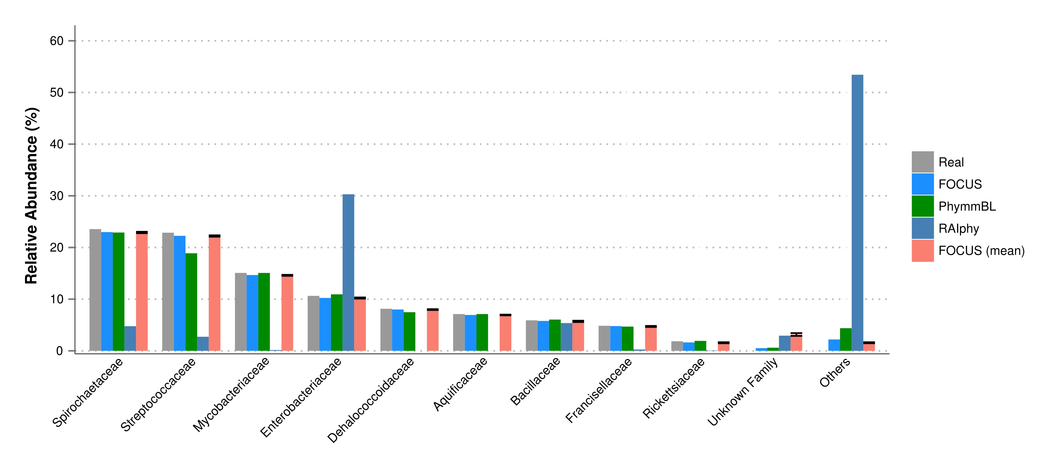

Supplemental Fig. 1. Family-level taxonomy classification for the SimShort dataset using FOCUS, PhymnBL, RAIphy, and FOCUS (mean).

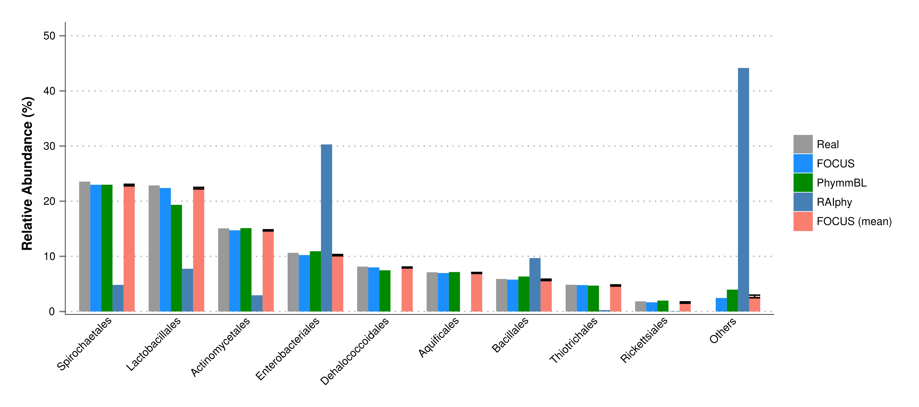

Supplemental Fig. 2. Order-level taxonomy classification for the SimShort dataset using FOCUS, PhymnBL, RAIphy, and FOCUS (mean).

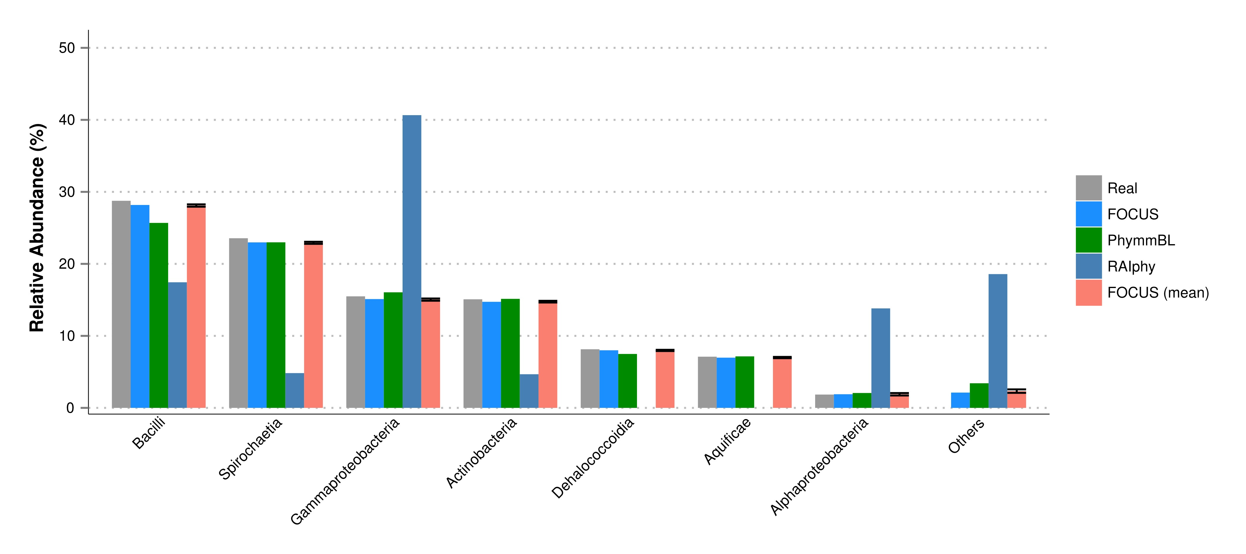

Supplemental Fig. 3. Class-level taxonomy classification for the SimShort dataset using FOCUS, PhymnBL, RAIphy, and FOCUS (mean).

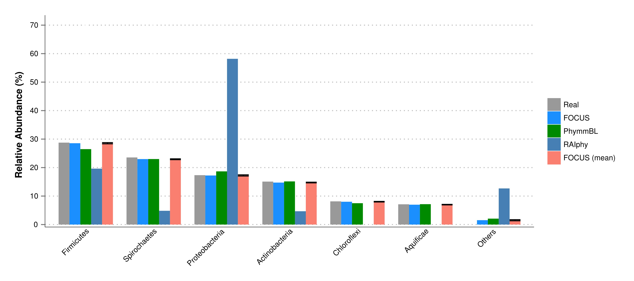 Supplemental Fig. 4. Phylum-level taxonomy classification for the SimShort dataset using FOCUS, PhymnBL, RAIphy, and FOCUS (mean).

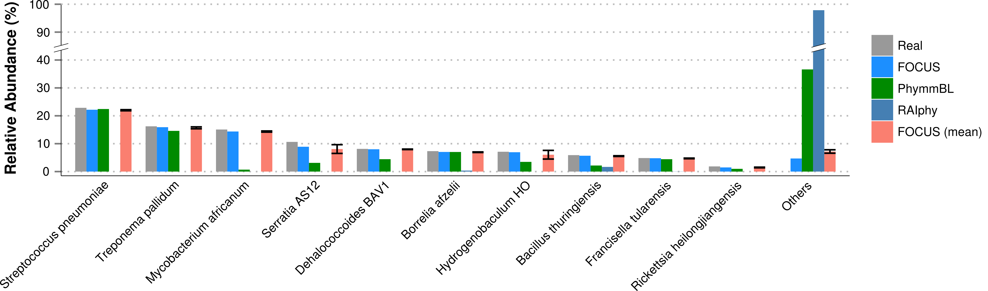

Supplemental Fig. 5. Species-level taxonomy classification for the SimShort dataset using FOCUS, PhymnBL, RAIphy, and FOCUS (mean).

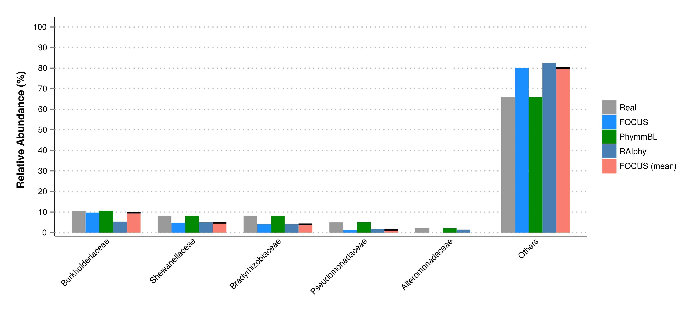
Supplemental Fig. 6. Family-level taxonomy classification for the SimHC dataset using FOCUS, PhymnBL, RAIphy, and FOCUS (mean).

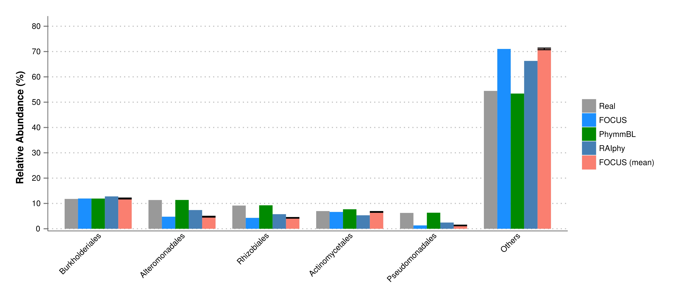

Supplemental Fig. 7. Order-level taxonomy classification for the SimHC dataset using FOCUS, PhymnBL, RAIphy, and FOCUS (mean).

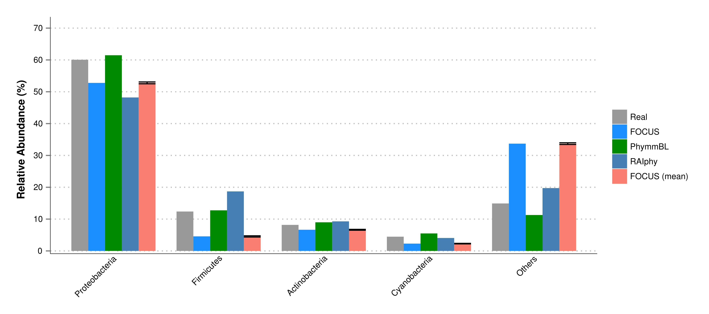

Supplemental Fig. 8. Phylum-level taxonomy classification for the SimHC dataset using FOCUS, PhymnBL, RAIphy, and FOCUS (mean).

