Effect Sizes Over Time

## Abstract

This article uses a mixed effects meta-regression framework to estimate the change in average effect sizes in psychological research using a database of over 130,000 effect size estimates from over 9,000 articles published in 5 APA journals from 1985 to 2013 {Nuijten, 2015 #550}. The results of this analysis suggest that the average effect size reported in psychological research is decreasing by -0.004 (95% CI [-0.005, -0.004]) Fisher Z transformed correlation coefficient units per year, representing an estimated correlation coefficient decrease of -0.1 from 1985 to 2013. Possibly of more interest to researchers is the question of how main or focal analyses have changed over time in psychology. Examining just the first reported test of each paper as a proxy for the main analysis shows broad agreement with analyses including all results (a -0.003 estimated yearly change, 95% CI [-0.004, -0.002]). However, looking at the largest effect reported in each paper suggests that there has been a slight increase in effect sizes over time, a 0.0015 (95% CI [0.0002, 0.0028]) Fisher z score change per year, an estimated increase from 1985 to 2013 of 0.023 in correlation coefficient units. Together these results suggest that there has been a small decrease in the average effect sizes reported in psychology over time, although the degree to which this decrease is reflective of a decrease in the size of the focal or main effects under study in psychology is an open question.

## Introduction

An important question in understanding the history of psychological science is whether effect sizes have changed over time. Are we studying smaller effects over time, having already studied the “low hanging fruit” (Baumeister, 2016)? Or could methodological reforms and the increasing awareness of the importance of measurement in research design lead to increased effect sizes (Greenland, 2017; Loken & Gelman, 2017; Nelson, Simmons, & Simonsohn, 2018)? This paper uses an extensive database of over 130,000 effect size estimates from over 10,000 articles published in 5 APA journals from 1985 to 2013 collected as part of (Nuijten et al., 2015) to examine how effect sizes have changed in psychological research over this period.

The question of how effect sizes have changed over time is both of intrinsic interest, and has important implications for understanding the results of large scale statistical power surveys of psychological research (e.g., (Cohen, 1962; Rosnow & Rosenthal, 1989; Szucs & Ioannidis, 2017)). Most of the efforts to estimate the statistical power of psychological research have used Cohen’s effect size benchmarks (Cohen, 1988), and as such any comparison of these studies over time assumes that effect sizes have been stable. According to our recent meta-analysis 46 power surveys including over 8,000 individual studies published from 1932-2014 [cite meta-analysis], the average statistical power of psychological research is .23 95% CI [.17, .29] for “small” effect sizes (effect sizes equivalent to r = .1 or Cohen’s d = .2), .62 95% CI [.55, .69] to detect medium effects (r = .3 or Cohen’s d = 0.5)), and .80, 95% CI [.68, .92] to detect large effects (effects equivalent to 0.8 Cohen’s d or r = .5) [cite meta-analysis]. This same analysis also suggests that there has been little-to-no change in the average statistical power of research conducted in psychology to detect these effect size benchmarks over time. However, in order to know whether the statistical power of psychological research has changed over time, it is necessary to know whether the effect sizes under study in psychological research have changed.

A small number of previous studies have extracted effect size benchmarks from psychological research in domains as varied as social (Richard, Bond Jr, & Stokes-Zoota, 2003), management (Bosco, Aguinis, Singh, Field, & Pierce, 2015; Paterson, Harms, Steel, & Credé, 2015) and clinical psychology (Haase, Waechter, & Solomon, 1982). Estimates of the average effect size in various subfields range from an mean correlation coefficient of .21 seen in social psychology meta-analyses (Richard et al., 2003), to a mean effect of 0.94 Cohen’s d (equivalent to r = .42) seen across Statistical tests reported in recent cognitive neuroscience, psychology and psychiatry articles published in high impact journals (Szucs & Ioannidis, 2017). However, we have not identified any studies which have adequate statistical precision to make strong inferences about the size or direction of the change in effect sizes over time. We know of just one study which attempted to examine the degree and direction of change in average effect sizes over time. (Paterson et al., 2015), which found a small negative correlation (r = -.05, 95% CI [-0.121, 0.02]) between the reported magnitude of correlations and their year of publication in 776 meta-analytic conclusions from meta-analyses in management psychology. The current analysis allows us to examine the average effect size reported in psychological research, and allows us to precisely estimate the change in effect sizes over time across fields of psychological research.

### Method

This analysis uses the dataset developed in (Nuijten et al., 2015), a study examining the number of errors in statistical tests reported in psychology articles (all data from <https://osf.io/gdr4q/>). This dataset includes 258105 statistical test results from 16695 articles. Nuijten et al. (2018) extracted this database from using regular expressions, exploiting the APA style guide’s strict rules for reporting statistical test results and to extract all chi square, t tests, F tests, Z tests, and correlations reported in APA style from articles published in eight major psychology journals from 1985 until 2013.

The current paper only uses a subset of these studies, those reporting in journals for which results were available going back to 1985. This analysis therefore includes data from five psychology journals chosen to be representative of the main subdisciplines of psychology research; Journal of Applied Psychology (JAP; Applied Psychology), Journal of Consulting and Clinical Psychology (JCCP; Clinical Psychology) , Developmental Psychology (DP; Developmental Psychology), Journal of Experimental Psychology: General (JEPG; Experimental Psychology), and Journal of Personality and Social Psychology (JPSP; Social Psychology). The excluded Journals (PLOS, Psychological Science, Frontiers in Psychology) have only began to be published in the last 15 years. The included subset includes a total of 200763 statistical test results from a total of 11825 articles published from 1985 to 2013.

### Effect size extraction and conversion

All test statistics were converted to Fisher Z transformed correlation coefficients (henceforth ) following (Open Science Collaboration, 2015) for visualization and analysis, see supplementary materials 1 for detailed explanations of the transformations used. Negative effect sizes (i.e., negative correlations) were set to be positive for analysis and visualization. Standard errors were estimated as , taking the degrees of freedom for the denominator minus two as n (or just the degrees of freedom minus two in the case of correlations and t tests). Because typical APA notation for z tests does not report the included sample size in a standardized formal (and therefore this information was not available in this dataset), Z scores were excluded from analyses (n = 7539). As it was not possible to derive valid standard errors for F statistics with effect degrees of freedom above 1 (n = 19585) or for Chi square statistics (n = 21855), these analyses were excluded from the multilevel meta-analysis (see Figure 1 for histograms comparing effect sizes included in each analysis and those derived from the entire sample). An additional subset of results were excluded from all analyses as they produced standard errors or Z transformed correlation coefficients which could not be estimated or were infinite (n = 19698, e.g., studies which reported impossible test statistics such as “F(0, 55) = 5.71, p < .05” or “r(66) = 5.42, p < .001” and studies with of < 6). A total of 132086 effect size estimates with valid standard errors from 9472 articles were extracted and are included in the meta-regression analyses below.

## Analysis

Multilevel meta-regression was performed to examine the relationship between year of publication and reported effect sizes.

The multilevel-meta-regression includes random effects for individual tests (), articles () and journals (), and includes year of publication of each article as a fixed effect (). This analysis was performed using nlme (Pinheiro, Bates, DebRoy, Sarkar, & Team, 2018) in R version 3.5.1 (R Development Core Team, 2018) using restricted maximum likelihood estimation.

As a check on whether the exclusion of F statistics with of greater than one and analyses is likely to change the results, this multilevel model was reperformed including all of the statistical tests for which correlations could be estimated and estimating standard errors as for F tests and for tests. This anlysis includes a total of n = 170324 effects after excluding all invalid results (i.e., analyses where it was not possible to estimate a standard error or correlation using the above methods due to issues such as degrees of freedom below 5 or impossible test statistic values being given). This analysis led to estimates of the change in effect sizes over time which are practically identical to those presented below (i.e., which differ by < -0.002)

### Accounting for peripheral tests

Due to the large sample size included in this analysis, it was not feasible to manually label which statistical tests included were, for example, manipulation tests or randomization tests, and it is almost certain that a large proportion of those tests reported are in fact not tests of the main hypotheses of each paper. This means that any observed change in effect sizes could be driven by changes in reporting practices, such as an changing number of reported manipulation or randomization checks over time. In order to account for this issue, two main methods were used to attempt to identify the focal test of each article. (a) Multilevel mixed effects meta-regression was performed looking just at the first statistical test reported in each paper. (b) Multilevel mixed effects meta-regression was performed using just the largest effect size reported in each paper. For (b), in 84 cases where there were ties within papers for the largest effect size, the first of the two equal outcome size analyses was taken.

These multilevel-meta-regression includes random effects for individual articles and journal , and includes year of publication of each article as a fixed effect (). These analyses did not include random effects for each statistical test, as each article only provides a single effect size. Valid standard errors were calculable for effect sizes from a total of 9472 articles for analyses (a) and (b), all of which are included in these analyses. These analyses were performed using the R package metafor (Viechtbauer, 2010) using restricted maximum likelihood estimation.

### Deviations from preregistration

All analyses were tested and developed on a subset of 0.01% of the dataset before being pre-registered. After preregistration, 36 additional reported test statistics were excluded using non-preregistered rules (3 which reported an r of 1, leading to an infinite Cohen’s z, and 33 test which were parsed by statcheck as reporting impossible test statistics). All random effects meta-regressions were performed with an additional random effect at the lowest level (i.e., at the effect level) than was preregistered, as this was thought to be more conceptually appropriate as all tests within a paper cannot be assumed to have estimated the same parameter. The analyses performed on all data (i.e., those which do not attempt exclude peripheral tests) were estimated using the R package nlme in lieu of metafor as the memory requirements of metafor exceeded those that we had easy access to (requiring > 160 gbs of RAM). The results should be identical for all practical purposes (e.g., reperforming the two analyses which attempted to account for peripheral analyses in nlme lead to parameter estimates that differed by less than .000001 from that produced using metafor).

## Results

### Descriptives

The mean effect size reported in this study in correlation coefficient terms is 0.335 and the median is 0.29. Overall, the distribution of effect sizes in the meta-analytic subset is close to that seen in the full dataset, although the median and means are slightly higher (at 0.362 and 0.318 respectively). The effect sizes seen when examining only the highest effect size reported in each paper are much higher on average (with a mean correlation coefficient of 0.596 and a median of 0.62). See table 1 and figure 1 for a full list of descriptives about and histograms of the distribution of effect sizes in each subsample. It is noteworthy that the mean effect sizes seen across the whole sample are remarkably close to Cohen’s suggested “medium” effect size benchmark value of r = .3, although the upper are the lower and upper quantiles (0.182, 0.447) are, respectively, higher and lower than Cohen’s “Small” and “Medium” effect size benchmarks (.1 and .5), an occurrence that has been noted in other subfields of research (Quintana, 2017).

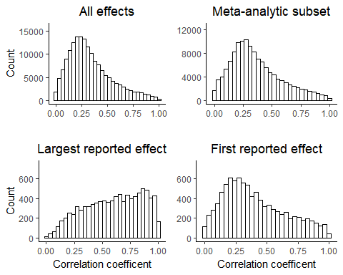

Figure 1. Histograms of reported effect sizes transformed to correlation coefficients, for all results which could be transformed to correlation coefficients, the meta-analytic subset, the the first reported effect size in each paper, and the largest reported effect size in each paper.

Table 1. Descriptives of the reported effect sizes in this sample in and correlation coefficient terms.

|  |  |  |  |  |  |  |  |  |  |  |  |
| --- | --- | --- | --- | --- | --- | --- | --- | --- | --- | --- | --- |
| Subsample | Effect size | n | Mean | sd | Min | 25th percentile | Median | 75th percentile | Max | Range | Skew |
| All data | Correlation | 170324 | 0.335 | 0.209 | 0.000 | 0.182 | 0.290 | 0.447 | 1.00 | 1.000 | 0.894 |
| All data | Fisher’s z | 170324 | 0.387 | 0.332 | 0.000 | 0.184 | 0.299 | 0.481 | 6.18 | 6.183 | 3.027 |
| Meta-analytic subset | Correlation | 132086 | 0.362 | 0.218 | 0.000 | 0.203 | 0.318 | 0.489 | 1.00 | 1.000 | 0.747 |
| Meta-analytic subset | Fisher’s z | 132086 | 0.426 | 0.358 | 0.000 | 0.206 | 0.330 | 0.534 | 6.18 | 6.183 | 2.830 |
| Largest reported effect | Correlation | 9472 | 0.596 | 0.251 | 0.001 | 0.398 | 0.620 | 0.815 | 1.00 | 0.999 | -0.269 |
| Largest reported effect | Fisher’s z | 9472 | 0.842 | 0.575 | 0.001 | 0.421 | 0.725 | 1.143 | 6.18 | 6.182 | 1.598 |
| First reported effect | Correlation | 9472 | 0.404 | 0.245 | 0.000 | 0.211 | 0.351 | 0.572 | 1.00 | 1.000 | 0.558 |
| First reported effect | Fisher’s | 9472 | 0.500 | 0.430 | 0.000 | 0.214 | 0.367 | 0.650 | 4.68 | 4.681 | 2.109 |

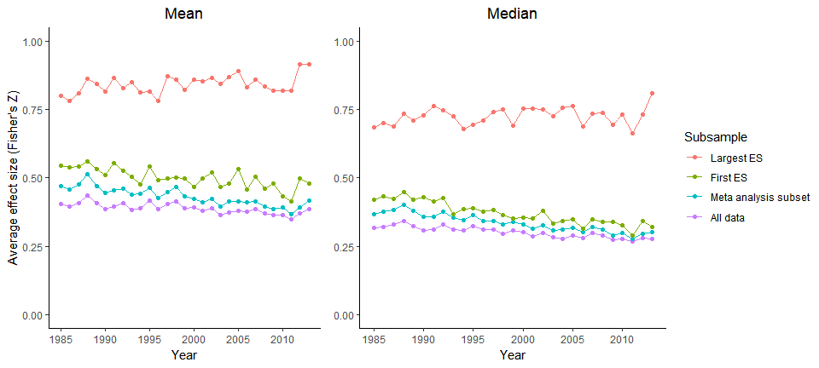

Figure [ESs over time]. Plots of the mean and median effect sizes per year (in Fisher Z transformed correlation coefficients) by the subsamples used in analyses.

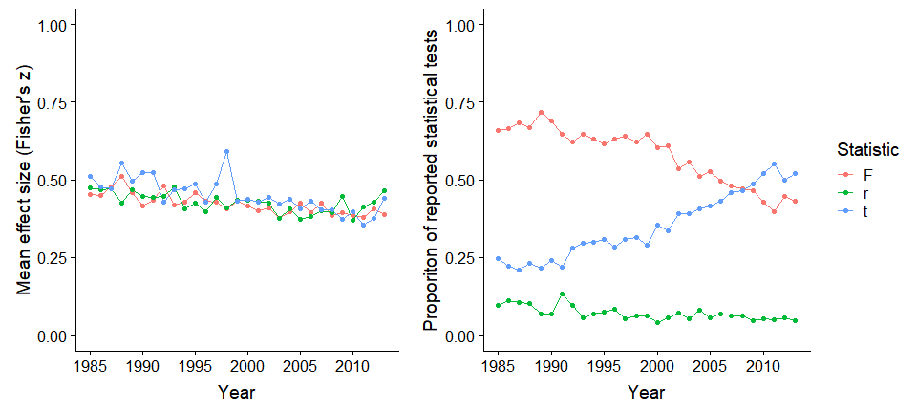

Figure [effectByStat]. A plot of the mean effect sizes per year (left, in Fisher Z transformed correlation coefficients) as transformed from the various effect size measures, and of the proportion of reported statistical tests of each type included in the current analysis (right).

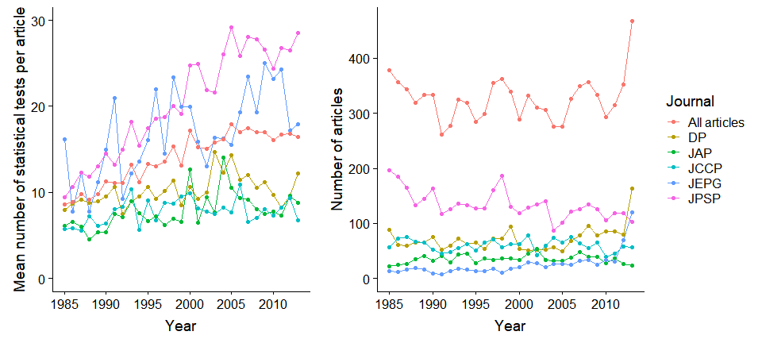

Figure [n tests]. A plot of the mean number of tests reported in each article (left), and the number of articles reported by journal and overall (right).

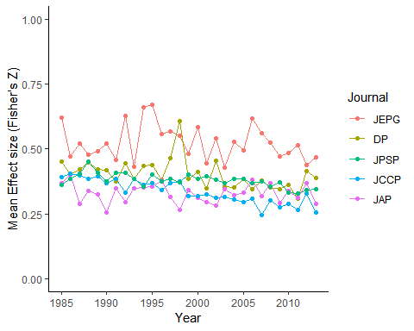

Figure [trends by J]. A plot of the mean effect size reported in each journal by Year.

The proportion of t tests in this sample has increased over time, relative to F tests and correlations, see figure [effectByStat]. There are no obvious differences between the average reported effect size in each unit (mean for correlations = 0.427 , mean for F statistics = 0.421, mean for t statistics = 0.434), and the trend over time appears to be consistent among all sources of effect sizes (see figure [effectByStat]).

The number of t, F and correlational statistical tests reported in APA style per article has increased considerably over time in this sample (i.e., of articles that reported at least one), from a mean of 9.578 reported per article in 1985 - 1990, to a mean of 16.59 from 2009 - 2013 (note that these averages only include articles with at least one reported statistical test). See figure [n tests] for a plot of the mean number of tests reported per article over time, and a plot of the number of articles reported in each journal included in this current analysis.

### Analysis Results

An exploratory analysis shows that there is a low correlation between year of publication and effect size () of r(170324) =-0.074, p < .001, 95% CI [-0.079, -0.069. When averaging the effect sizes seen in each article to avoid issues of non-independence of statistical tests within articles and estimating the correlation between year and effect size we find a very weak association between effect size and year of publication, r(10399]) = -0.08, p < .001, 95% CI [-0.099, -0.061].

The multilevel meta-regression including estimates a decrease per year of -0.004, 95% CI [-0.005, -0.004]. Unsurprisingly given that articles likely report multiple statistical tests of different hypotheses in each article there is a large amount of unexplained effect size heterogeneity in effect sizes, QE(132085) = 38658.96, p = < .001, = 97.69 (Nakagawa & Santos, 2012). This suggests that 98% of residual variance in effect sizes is due to effect size heterogeneity (i.e., variance in the true effect size differences), while the remaining 102% is attributable to sampling variance. More variance is attributable to the article and effect level than to the project ( = 0.033, = 0.053, compared to = 0.006), representing a very low interclass correlation (ICC) for the journal of 0.06, and a moderate ICC for the article of 0.36.

Table [nice MLME sum datMeta]. Multilevel meta-regression output including all data with valid standard errors. = 132086, = 9472.

|  |  |  |  |  |  |
| --- | --- | --- | --- | --- | --- |
| Estimate | 95% CI LB | 95% CI UB | SE | p | Random effects |
| 0.412 | 0.346 | 0.478 | 0.033 | < .001 |  |
| -0.004 | -0.005 | -0.004 | 0.000 | < .001 |  |
|  |  |  |  |  | Effect variance = 0.053, n = 132086 |
|  |  |  |  |  | Article variance = 0.033, n = 9472 |
|  |  |  |  |  | Journal variance = 0.006, n = 5 |
|  |  |  |  |  | QE(132085) = 38658.96, p = < .001 |

Including only the first reported statistical test in each paper provides similar results, suggesting a small decrease over time, with a -0.003 (95% CI [-0.004, -0.002]) estimated yearly change according to the model including only the first reported effect effects. The estimated value (96.72) is functionally identical to those of the model including all data with valid SEs. Looking at the variance partitioning more variance is attributable to the article level than to the journal level ( = 0.138, compared to = 0.007), representing a low interclass correlation (ICC) for the journal of 0.047.

Table [nice MLME sum datMetaFirst]. Multilevel meta-regression output including the first reported effect size in each article, = 9472.

|  |  |  |  |  |  |
| --- | --- | --- | --- | --- | --- |
| Estimate | 95% CI LB | 95% CI UB | SE | p | Random effects |
| 0.484 | 0.411 | 0.557 | 0.037 | < .001 |  |
| -0.003 | -0.004 | -0.002 | 0.000 | < .001 |  |
|  |  |  |  |  | Journal variance = 0.007, n = 5 |
|  |  |  |  |  | Article variance = 0.138, n = 9472 |
|  |  |  |  |  | QE(9471) = 190471.31, p < .001 |

Including only the largest effect reported in APA style in each paper leads to a different story, a predicted yearly increase of 0.002 (95% CI [0. 0002, 0.003]). Again, the estimated value (97.9) is functionally identical to those of the dataset including all data. Again, more variance is again attributable to the article level than to the journal level ( = 0.259, compared to = 0.038) leading to a low interclass correlation (ICC) for the journal of 0.127.

Table [nice MLME sum datMetaLargest]. Multilevel meta-regression output including just the largest reported effect size in each article, = 9472.

|  |  |  |  |  |  |
| --- | --- | --- | --- | --- | --- |
| Estimate | 95% CI LB | 95% CI UB | SE | p | Random effects |
| 0.815 | 0.645 | 0.986 | 0.087 | < .001 |  |
| 0.002 | 0.000 | 0.003 | 0.001 | 0.022 |  |
|  |  |  |  |  | Journal variance = 0.038, n = 5 |
|  |  |  |  |  | Article variance = 0.259, n = 9472 |
|  |  |  |  |  | QE(9471) = 306395.25, p < .001 |

### Discussion

Overall, there was a small decrease in the mean effect sizes seen across the examined time period; going from a mean reported effect of r = 0.403 between 1985 - 1990, to a mean reported effect size of 0.335 in last five years included in this dataset, 2009 - 2013. The results of the random effects meta-regression accounting for random effects nested within articles and journals supports this idea, showing an estimated yearly decrease in effect sizes of -0.004 (95% CI [-0.005, -0.004]) in units. This corresponds to an estimated correlation coefficient decrease of -0.10 in the estimated average effect size from 1985 to 2013. Looking just at the first reported statistical test in each article as a proxy for the main result of each paper, there is also a decrease in the average effect sizes reported over time, going from an average correlation of 0.44 between 1985 - 1990, to a mean reported correlation of 0.371 from 2009 to 2013. According to the results of the meta-regression including only the first APA reported result in each paper, there is an estimated yearly decrease of 0.003 (95% CI [-0.004, -0.002]) in units. Over the 28 year time period included in this database, this represents an estimated decrease of -0.07in correlation coefficient terms. While the estimated amount of change year-to-year is not large by any means, but the cumulative effect over time is noticeable, and these results suggest that the body of literature saying that statistical power has been consistently low over time in psychology may in fact be optimistic (e.g., (Sedlmeier & Gigerenzer, 1989; Szucs & Ioannidis, 2017). If effect sizes have in fact decreased, the average power of psychological research will likely have also decreased slightly.

However, looking only at the largest reported effect in each paper, this trend is no longer apparent. There was an average correlation of 0.598 in 1985 - 1990, compared to a mean of 0.593 in 2009 - 2013, a slight increase in the size of the largest reported effect in each paper. Results from multilevel meta-regression show an estimated yearly increase of 0.002 (95% CI [0.0002, 0.003]) in units, or alternatively an estimated increase of r = 0.023 between 1985 and 2013. There are several possible explanations for this result. Firstly, this results could accurately demonstrate that the average size of the focal effects under study in psychological research is increasing slightly over time. Alternatively, this effect could be driven in part by the increasing number of statistical tests reported per article during this period of time(see figure Figure [n tests]). Assuming that all performed tests are reported or at least that the largest observed test result is reported, if more analyses are being performed over time (and assuming that the tests performed are at least somewhat independent), selecting the largest reported effect out of each article should show an increased average effect size on the basis of sampling variability alone. In any case, the estimated change over time is so small as to be practically dismissible, with an estimated increase of just r = 0.023 over the 28 years of studies included in this analysis.

#### Limitations and conclusions

It should be noted that the sample is limited to articles published in 5 APA journals in a limited time period (1985 - 2013) and the results may not generalize outside of this population. Secondly, the method used to collect effect sizes from the literature, using regular expressions to extract statistical tests has its limitations. This method only captures statistical tests results reported in-text (i.e., not in tables) in APA style, and the observed effects could be driven by changes in reporting practices. Thirdly, it was not feasible to manually identify the main or focal analysis of each paper in a dataset this large, and the methods used in this paper are approximations (evidenced by the fact that the results of these two analyses point in different directions).

It is also worth noting that in ANOVA designs or multiple regression where there is more than one factor or covariate included, the effect size conversion used leads to the exclusion of any non-focal variables’ variance. This means that a study which includes a variable as a covariate will lead to a larger observed effect size than a study which does not include the covariate, although the relationship between the focal variable and a given outcome measure remains constant (Olejnik & Algina, 2003). When the extracted effect sizes are based on F statistics, changes in the observed relationships over time could be caused by changing habits in the use of variables in regression or ANOVA designs. However, the trend over time appears to be consistent across different statistical tests (see Figure [effectByStat]), and for many purposes (e.g., power analysis) the effect size of interest is accurately represented by this value.

Finally, given the effect of publication bias in psychological literature, it is unclear whether the results reported in journal articles are representative of the results that should be expected in planning an experiment (Fanelli, 2010; Rosenthal, 1979), and caution is advised before they are used for this purpose (e.g., using these results to estimate the average effect sizes that should be expected across psychology). The effect sizes reported here are likely to be inflated to some degree due to publication and reporting biases (Hedges, 1992). A recent re-analysis of all of the large scale replication studies (such as (Open Science Collaboration, 2015)) suggests that the amount of effect size inflation seen in non-clinical behavioral science is approximately 19%, with a 95% highest probability density interval of 11% to 28% [cite publication bias paper].

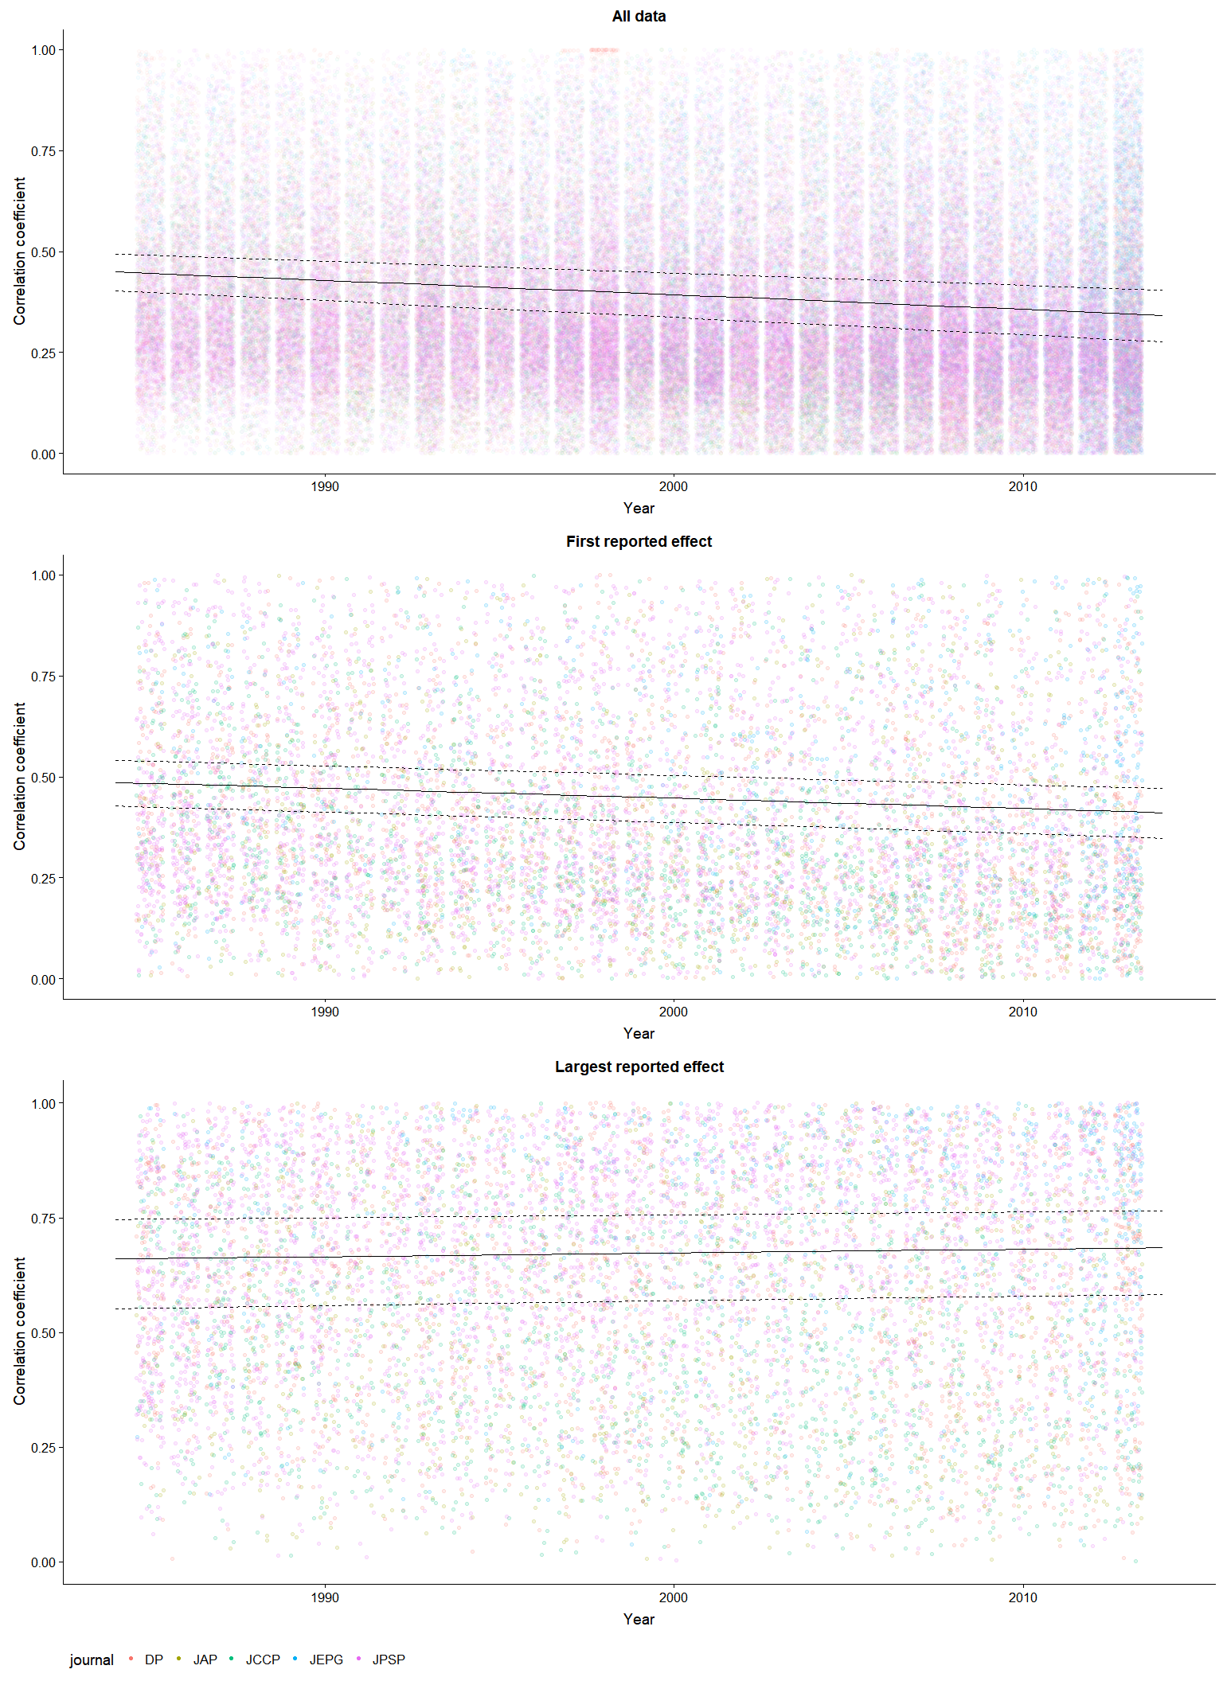

Figure [jitter] A jitter plot of the reported effect sizes in this dataset plotted over time, with an overlaid multilevel meta-regression plot (see Table [nice MLME sum datMeta] for model parameters, the plotted output has been converted to correlation coefficient units).

#### Conclusion

This analysis suggests that there was a decrease in the average size of the effects reported in psychology research papers from 1985 to 2013. It also suggests that there was at most a negligible increase in the average size of focal effects from 1985 to 2013, although the direction of this change is uncertain. This result supports recent research suggesting that the average statistical power of psychology research has remained consistently low across time [meta-analysis], and highlights the need for researchers to consider the expected effect sizes of their research during the planning of their studies in order to avoid unknowingly performing underpowered or imprecise research.

### References

Baumeister, R. F. (2016). Charting the future of social psychology on stormy seas: Winners, losers, and recommendations. *Journal of Experimental Social Psychology, 66*, 153-158. doi:<https://doi.org/10.1016/j.jesp.2016.02.003>

Bosco, F. A., Aguinis, H., Singh, K., Field, J. G., & Pierce, C. A. (2015). Correlational effect size benchmarks. *Journal of Applied Psychology, 100*, 431-449. doi:10.1037/a0038047

Cohen, J. (1962). The statistical power of abnormal-social psychological research: A review. *The Journal of Abnormal and Social Psychology, 65*, 145-153. doi:10.1037/h0045186

Cohen, J. (1988). Statistical power analysis for the behavioral sciences (2nd ed.). Hillsdale, New Jersey: Erlbaum.

Fanelli, D. (2010). “Positive” Results Increase Down the Hierarchy of the Sciences. *PLOS ONE, 5*, e10068. doi:10.1371/journal.pone.0010068

Greenland, S. (2017). Invited Commentary: The Need for Cognitive Science in Methodology. *American Journal of Epidemiology, 186*, 639-645. doi:10.1093/aje/kwx259

Haase, R. F., Waechter, D. M., & Solomon, G. S. (1982). How significant is a significant difference? Average effect size of research in counseling psychology. *Journal of Counseling Psychology, 29*, 58-65. doi:10.1037/0022-0167.29.1.58

Hedges, L. V. (1992). Modeling Publication Selection Effects in Meta-Analysis. *Statistical Science, 7*, 246-255.

Loken, E., & Gelman, A. (2017). Measurement error and the replication crisis. *Science, 355*, 584. doi:10.1126/science.aal3618

Nakagawa, S., & Santos, E. S. A. (2012). Methodological issues and advances in biological meta-analysis. *Evolutionary Ecology, 26*, 1253-1274. doi:10.1007/s10682-012-9555-5

Nelson, L. D., Simmons, J., & Simonsohn, U. (2018). Psychology's Renaissance. *Annual Review of Psychology, 69*, 511-534. doi:10.1146/annurev-psych-122216-011836

Nuijten, M. B., Hartgerink, C. H. J., van Assen, M. A. L. M., Epskamp, S., & Wicherts, J. M. (2015). The prevalence of statistical reporting errors in psychology (1985–2013). *Behavior Research Methods*, 1-22. doi:10.3758/s13428-015-0664-2

Olejnik, S., & Algina, J. (2003). Generalized eta and omega squared statistics: measures of effect size for some common research designs. *Psychological Methods, 8*, 434-447. doi:10.1037/1082-989x.8.4.434

Open Science Collaboration. (2015). Estimating the reproducibility of psychological science. *Science, 349*.

Paterson, T. A., Harms, P. D., Steel, P., & Credé, M. (2015). An Assessment of the Magnitude of Effect Sizes: Evidence From 30 Years of Meta-Analysis in Management. *Journal of Leadership & Organizational Studies, 23*, 66-81. doi:10.1177/1548051815614321

Pinheiro, J., Bates, D., DebRoy, S., Sarkar, D., & Team, R. C. (2018). nlme: Linear and Nonlinear Mixed Effects Models. R

package version 3.1-137, URL: <https://CRAN.R-project.org/package=nlme>.

Quintana, D. S. (2017). Statistical considerations for reporting and planning heart rate variability case‐control studies. *Psychophysiology, 54*, 344-349. doi:10.1111/psyp.12798

R Development Core Team. (2018). R: A language and environment for statistical computing (Version 3.5.0). Vienna, Austria: R Foundation for Statistical Computing. Retrieved from <http://www.R-project.org>

Richard, F. D., Bond Jr, C. F., & Stokes-Zoota, J. J. (2003). One hundred years of social psychology quantitatively described. *Review of General Psychology, 7*, 331-363. doi:10.1037/1089-2680.7.4.331

Rosenthal, R. (1979). The file drawer problem and tolerance for null results. *Psychological Bulletin, 86*, 638-641.

Rosnow, R. L., & Rosenthal, R. (1989). Statistical procedures and the justification of knowledge in psychological science. *American Psychologist, 44*, 1276-1284. doi:10.1037/0003-066X.44.10.1276

Sedlmeier, P., & Gigerenzer, G. (1989). Do studies of statistical power have an effect on the power of studies? *Psychological Bulletin, 105*, 309-316. doi:10.1037/0033-2909.105.2.309

Szucs, D., & Ioannidis, J. P. A. (2017). Empirical assessment of published effect sizes and power in the recent cognitive neuroscience and psychology literature. *PLOS Biology, 15*, e2000797. doi:10.1371/journal.pbio.2000797

Viechtbauer, W. (2010). Conducting Meta-Analyses in R with the metafor Package. *Journal Of Statistical Software, 36*, 48. doi:10.18637/jss.v036.i03

## Appendix

### Conversion

All statistical tests extracted were transformed into correlation coefficients as follows, using the methods reported in (Open Science Collaboration, 2015).

t statistics:

Where is the observed t statistic and is the degrees of freedom of the t test.

F statistics:

Where is the observed F statistic and is the degrees of freedom of the numerator and is degrees of freedom of the denominator.

Chi square statistics:

Where is the observed statistic and is the associated degrees of freedom.

All values were then transformed into fisher Z transformed correlation coefficients using:

Standard errors for these statistics when derived from F tests with denominator degrees of freedom of 1, t tests, and correlation coefficients were estimated as: