8. False

5.Partition by tpep_dropoff_datetime and Cluster on VendorID

7.GCP bucket

6. 310.24 MB for non-partitioned table and 26.84 MB for the partitioned table

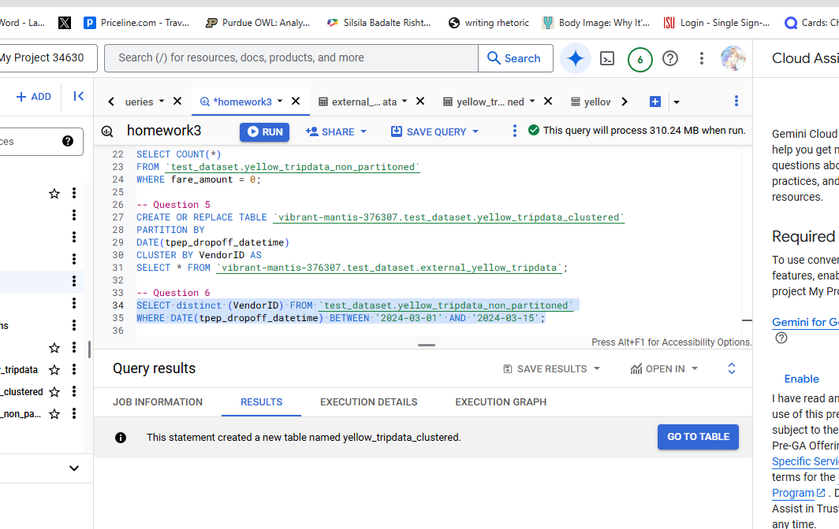

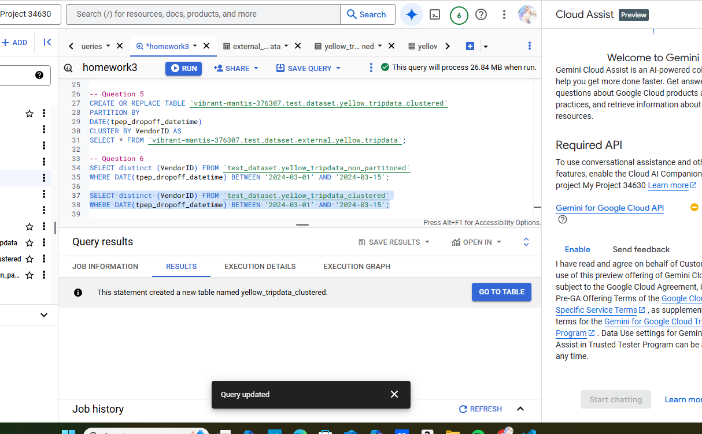

4. 8333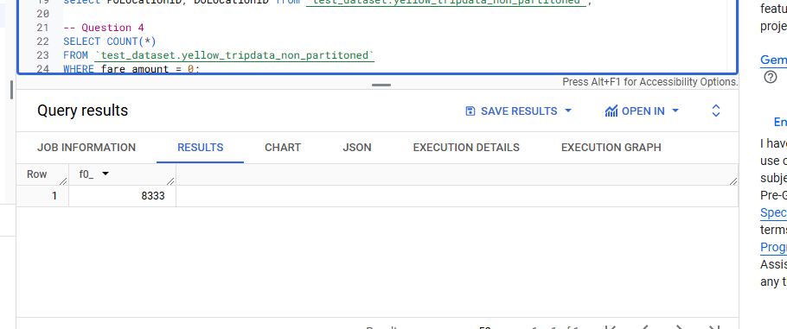

2. 0 MB for the External Table and 155.12 MB for the Materialized Table

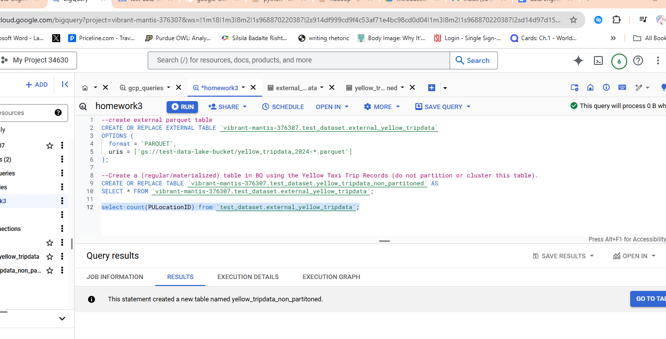

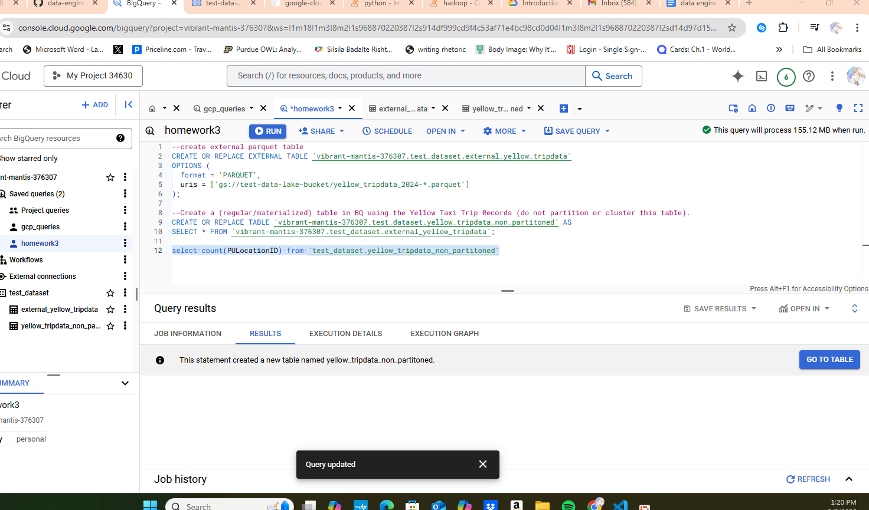

1.

* 20,332,093

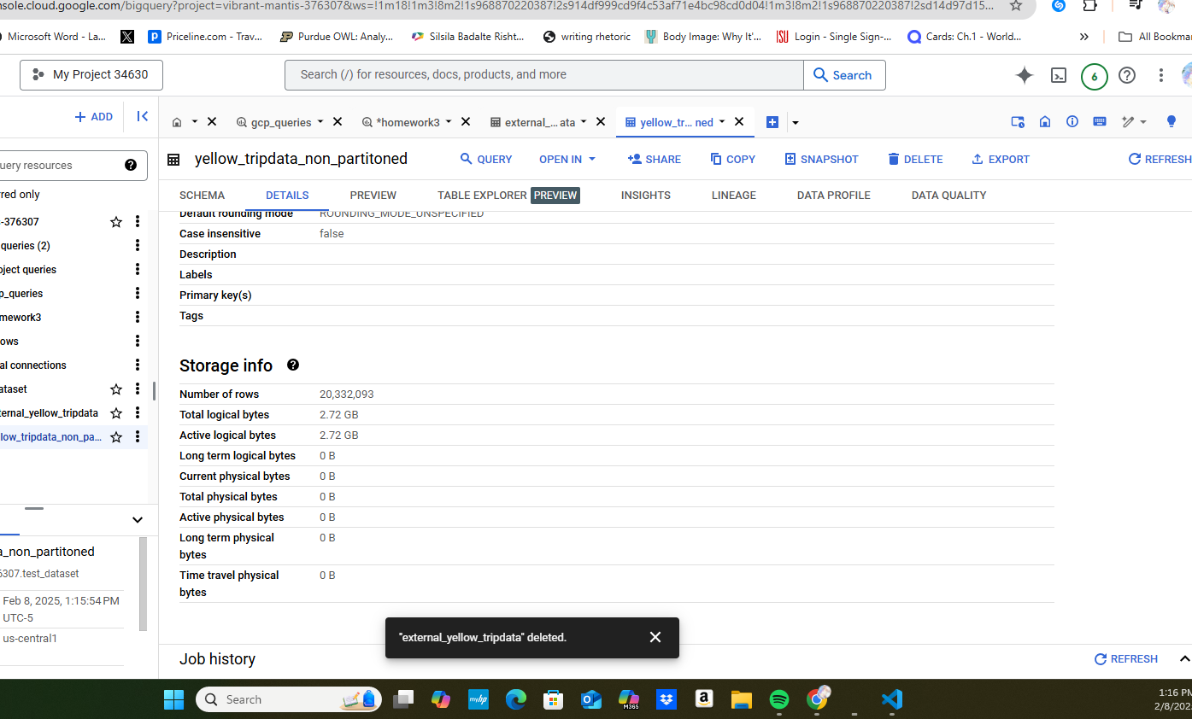

3.

* BigQuery is a columnar database, and it only scans the specific columns requested in the query. Querying two columns (PULocationID, DOLocationID) requires reading more data than querying one column (PULocationID), leading to a higher estimated number of bytes processed.

