1.select * from myproject.my_nyc_tripdata.ext_green_taxi

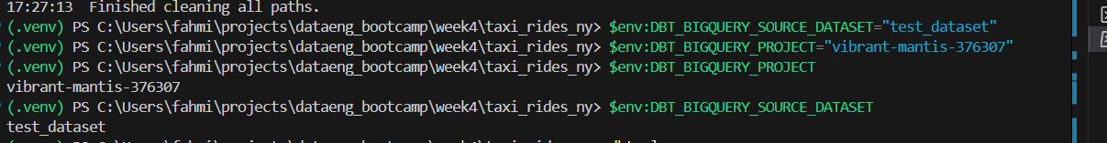

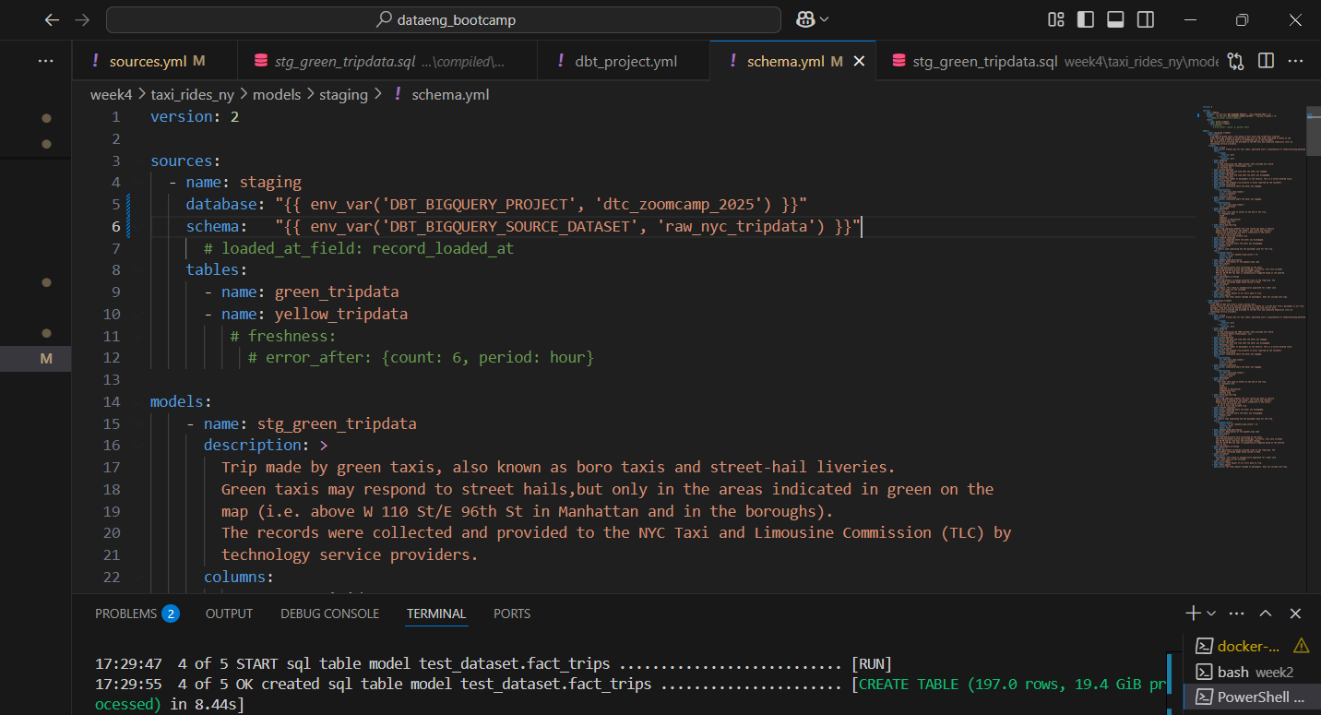

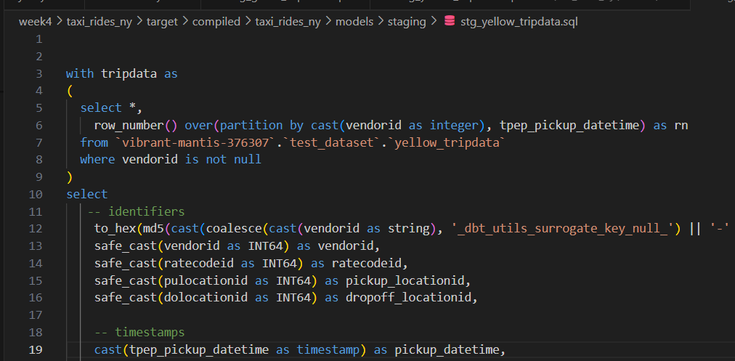

2. Update the WHERE clause to pickup_datetime >= CURRENT_DATE - INTERVAL '{{ var("days_back", env_var("DAYS_BACK", "30")) }}' DAY

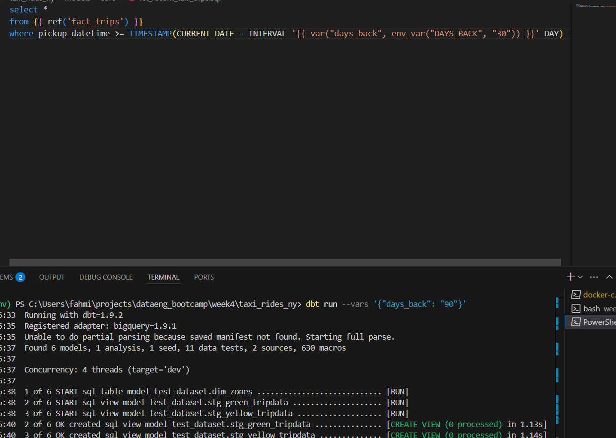

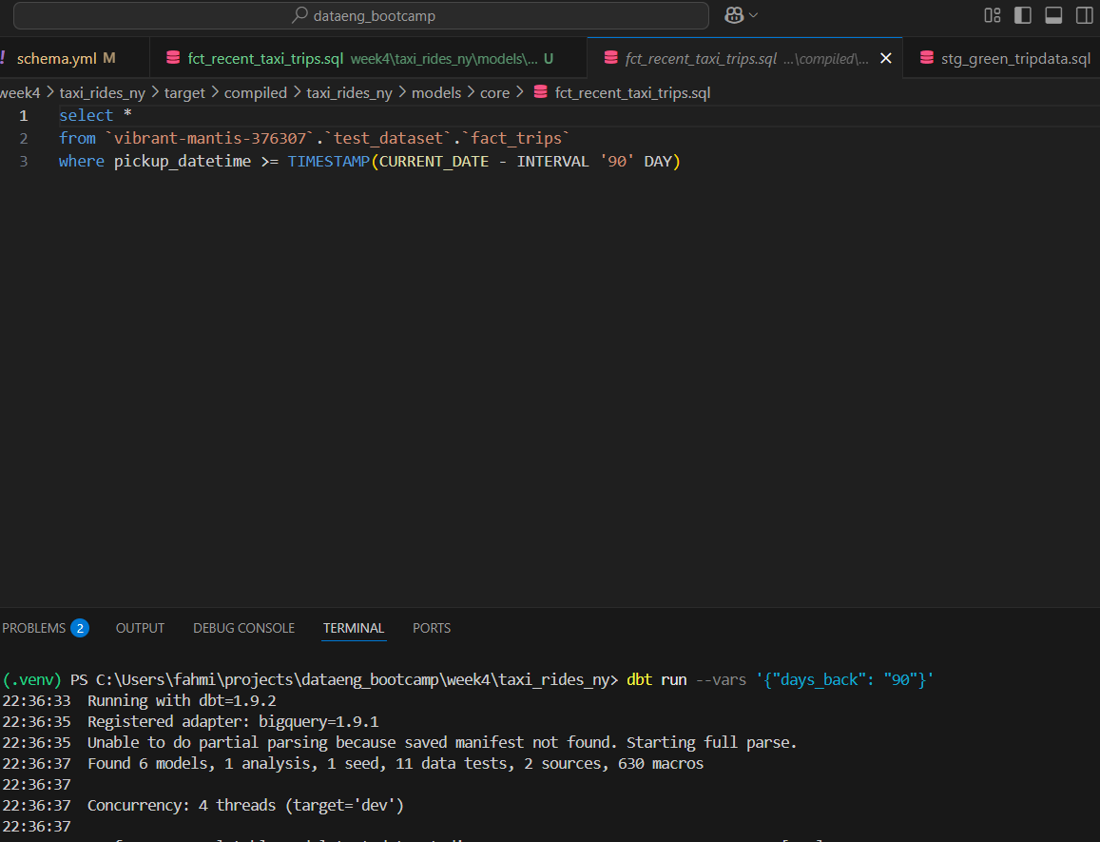

3.

* 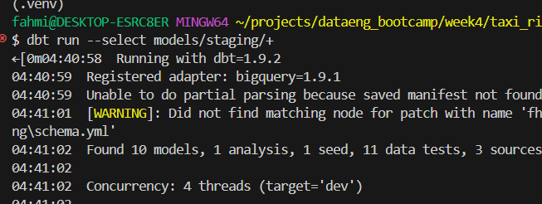

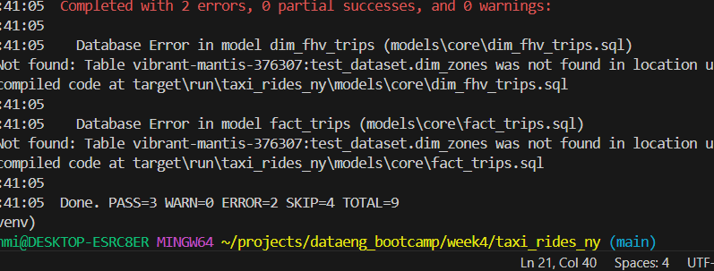

4. When no env variable is set

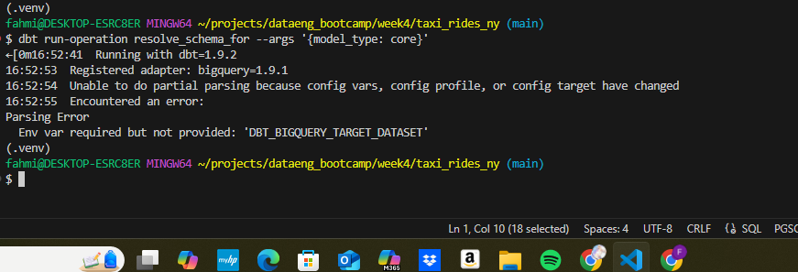

* Setting a value for DBT_BIGQUERY_TARGET_DATASET env var is mandatory, or it'll fail to compile
* When using core, it materializes in the dataset defined in DBT_BIGQUERY_TARGET_DATASET
* When using staging, it materializes in the dataset defined in DBT_BIGQUERY_STAGING_DATASET, or defaults to DBT_BIGQUERY_TARGET_DATASET
* When using stg, it materializes in the dataset defined in DBT_BIGQUERY_STAGING_DATASET, or defaults to DBT_BIGQUERY_TARGET_DATASET

5.

* green: {best: 2020/Q1, worst: 2020/Q2}, yellow: {best: 2020/Q1, worst: 2020/Q2}

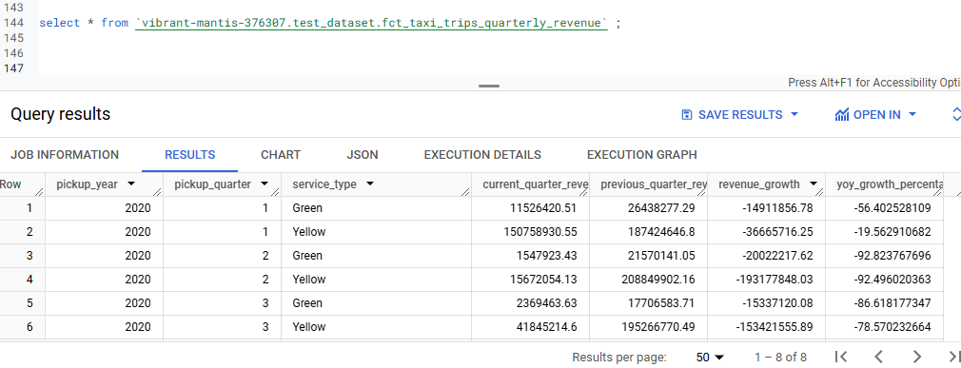

6.green: {p97: 55.0, p95: 45.0, p90: 26.5}, yellow: {p97: 31.5, p95: 25.5, p90: 19.0}

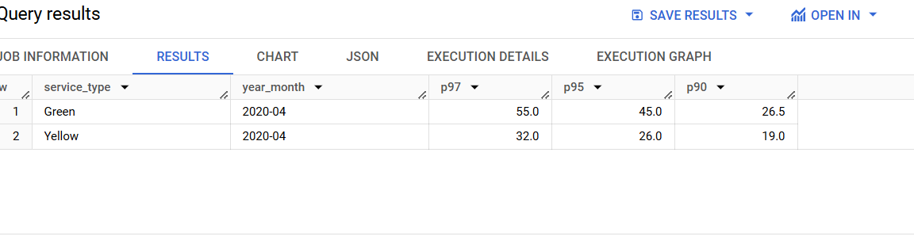

6.

* LaGuardia Airport, Chinatown, Garment District

