**High Impact Skills Development Program**

**in Artificial Intelligence, Data Science, and Blockchain**

**Project Title**: Online Retail Segmentation.

**1. Customer Segmentation by Purchase Frequency**

Group customers into segments based on their purchase frequency, such as high, medium, and low frequency customers. This can help you identify your most loyal customers and those who need more attention. 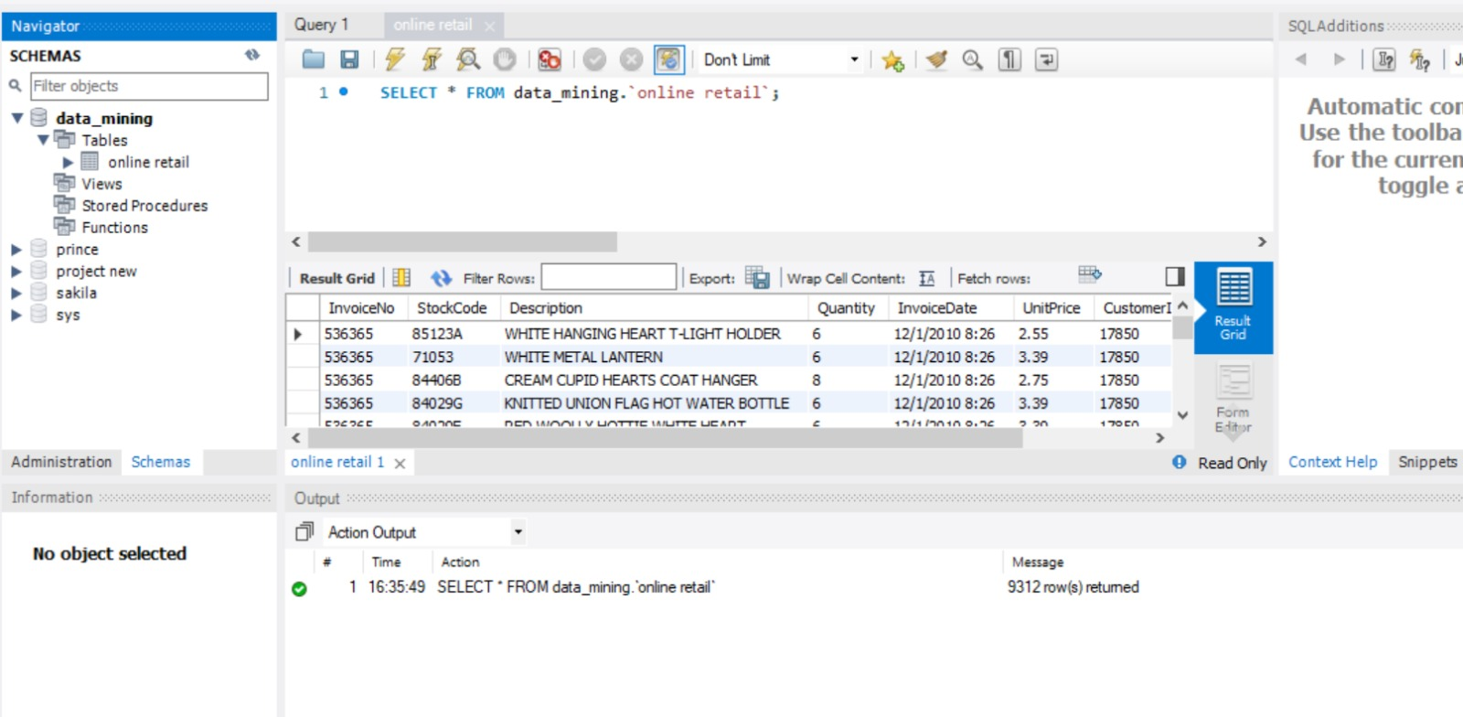

**2. Average Order Value by Country**

Calculate the average order value for each country to identify where your most valuable customers are located.

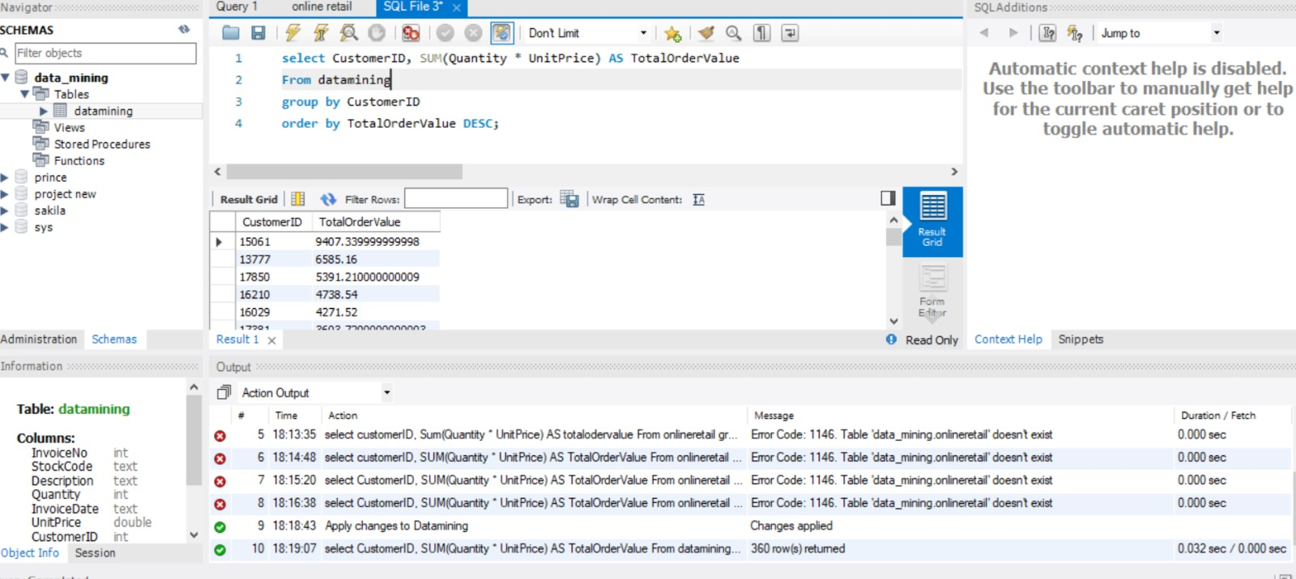

**3. Customer Churn Analysis**

Identify customers who haven't made a purchase in a specific period (e.g., last 6 months) to assess churn.

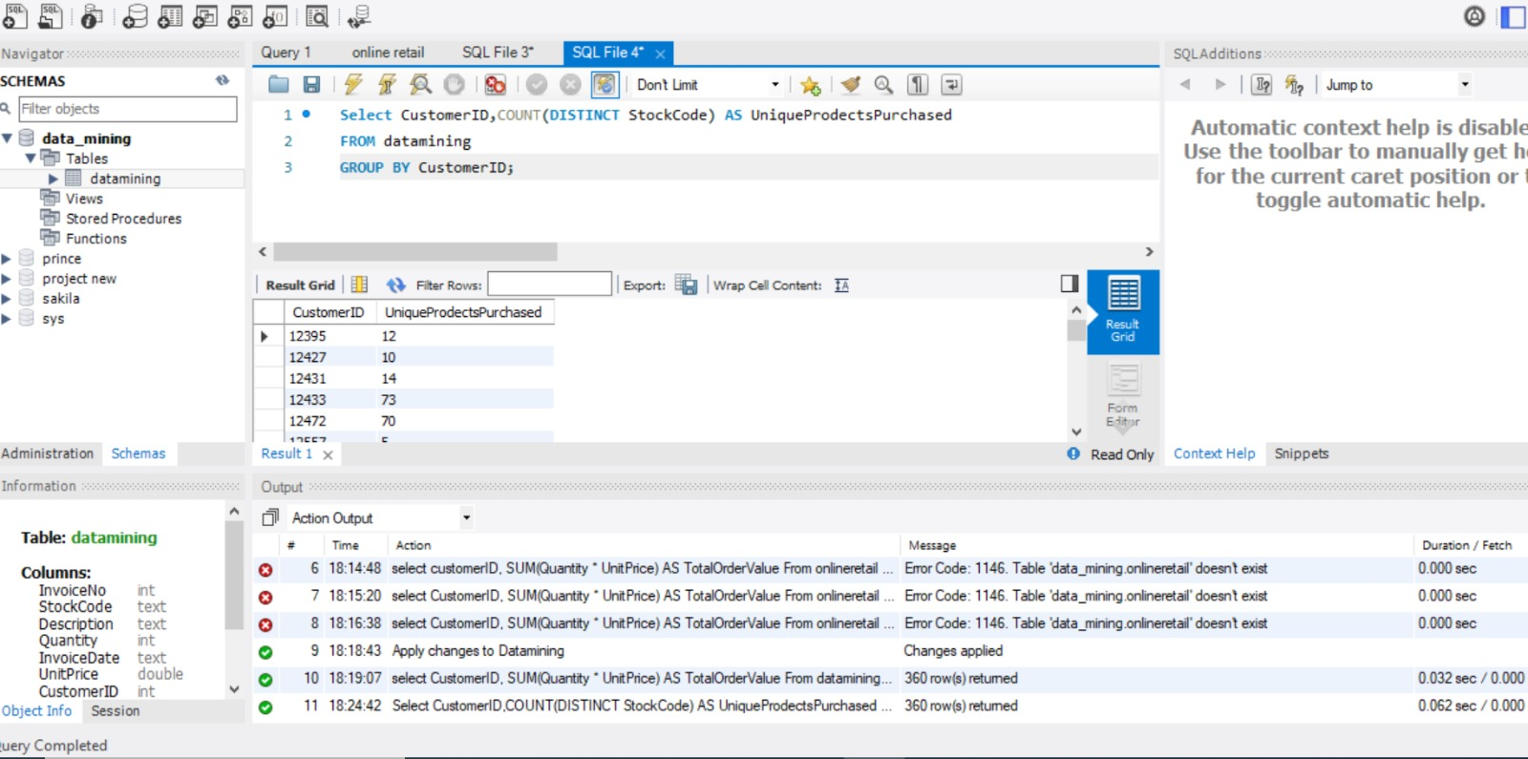

**4. Product Affinity Analysis**

Determine which products are often purchased together by calculating the correlation between product purchases.

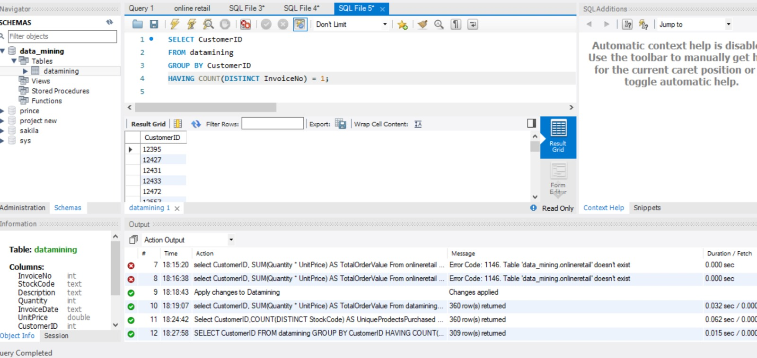

**5. Time-based Analysis**

Explore trends in customer behavior over time, such as monthly or quarterly sales patterns.

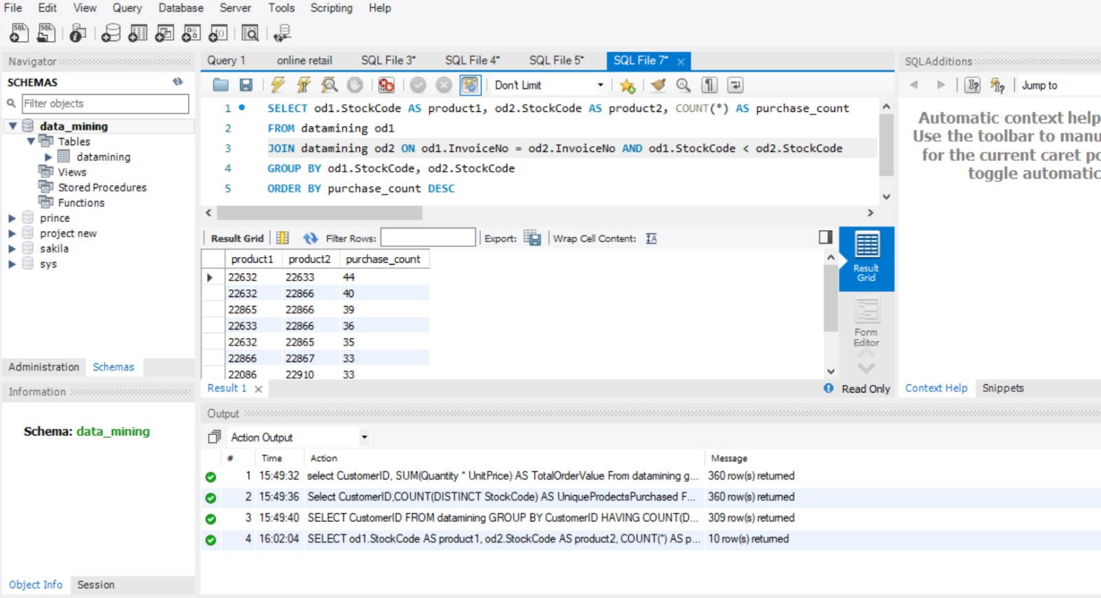

**MY GitHub Profile:**

https://github.com/fsl-khan