LAB 1: Steps for Analysis & Design of Beam in SAP2000
Problem Statement: Design Logitudinal and Shear reinforcement for rectangualr Beam with following input data:
No of Spans:2, Span1 = 20ft, Span2 =25ft
x-section: 15x12 in
fc’ = 4000psi
fy=60,000psi
wd = 20 psf
wl=60 psf
Use ACI Code 2005
Sol:
- File>New Model, change units to K,ft,F and selecte the beam from template.
- Check Use Custom Grid Spacing and Locate origin and press Edit Grid button.
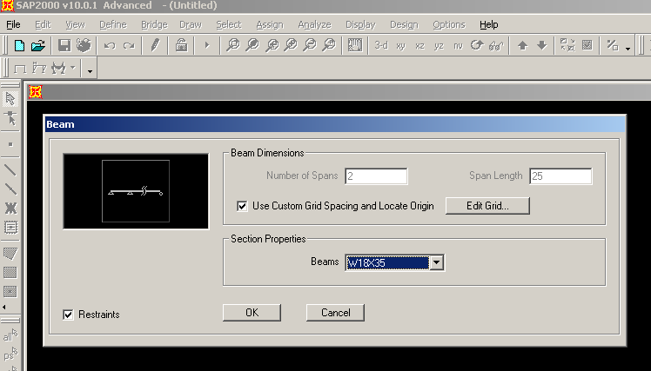
In x-Grid Data, type x1 = -20, x2 = 0, x3 = 25. Press ok to close Define Gride Data and then again press ok to return to the main window.

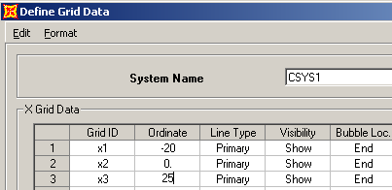
- Click Option > Preference> Concrete Frame Design. Select ACI 318-05/IBC 2003 in Design Code.

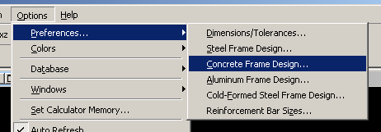
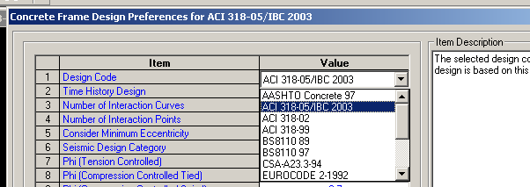
- The next step is to use define menu. Goto Define>Materials, select concrete and press modify/showMaterial button to open Material Property Data.Check that unit weight = 0.15, Modulus of Elasticy = 3600ksi, fc’ = 4ksi, fy = 60ksi and fys =60ksi. In any text box, when you press shift+Enter, a calculator opens where you can check values in different units.
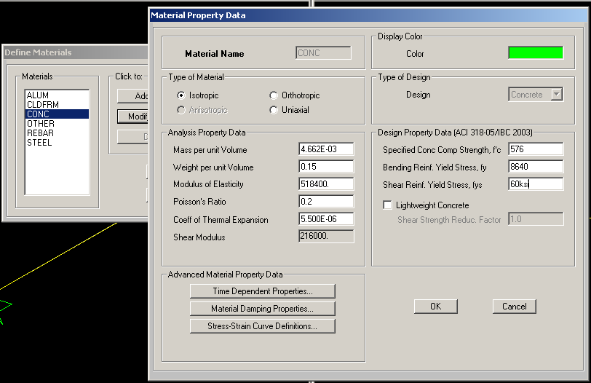
- Goto Define>Frame Sections. In Choose Property Type to Add, select Add Rectangular in drop down combo box, then, press Add New Property to open Rectangular Section dialog box. Section Name = B15x12, Depth (t3) = 15in, Width (t2) = 12in. Now press Concrete Reinforcement button to open Reinforcement Data. Design Type = Beam, Top = 2.5in, bottom = 2.5in and then press ok buttons to return to the main window.

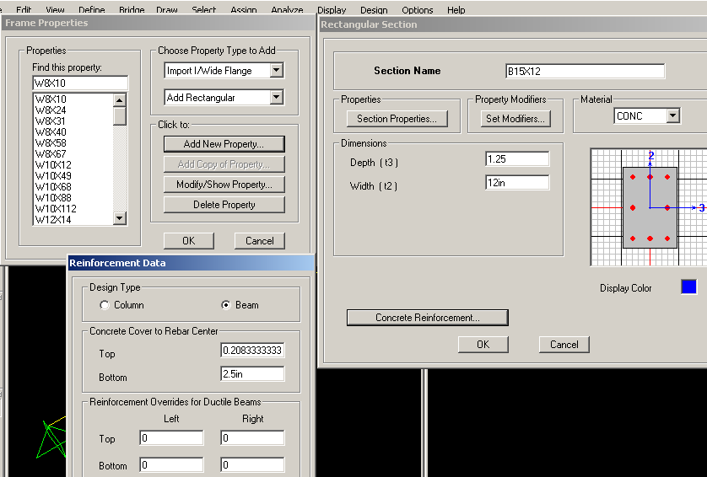
- Press Define> Load Cases. By default, there will a dead load with self weight multiplier as 1. So the self weight will be calculated by the program. Add live load with following data. Load name = Live, Type = Live and then press Add new Load button. Press OK Buttons to return to the main window.
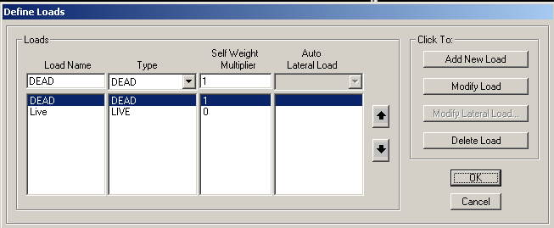
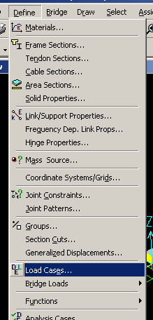
- Define> Load Combination, press Add New Combo button. Set following as:
Response Combination name = FDL
Combination Type = Linear Add
Case Name = Dead, Scale Factor = 1.2, click Add button
Case Name = Live, Scale Factor = 1.6, click Add button
Press OK Buttons to return to the main Menu.
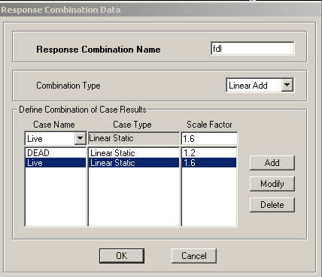
- Press Define > Add Default Design Combo to open Design Combination. Select Concrete frame design and Convert to User combinations (Editable). This will add the combination based upobn the design code in use. These combinations can be seen from Define>Load Combination.
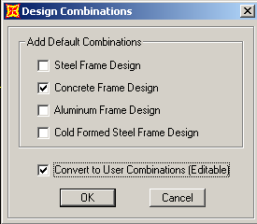
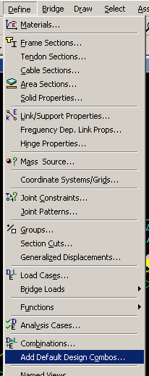

- The next step is to use Assign Menu. Select both members by clicking and press Assign> Frame Sections. Select B15x12 in Properties Listbox and press ok. You can also use All button in the select toolbar or Ctrl+A to select all members.
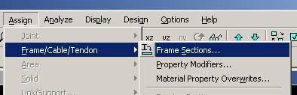
- Select previous section by pressing ps button on select toolbar or Select> Get Previous Selection. Press Assign > Frame/Cable/Tendon Loads>Distributed . Load Case Name = Dead
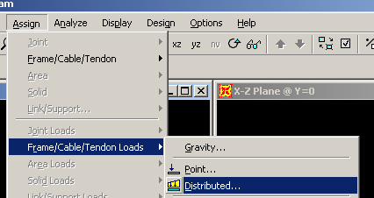
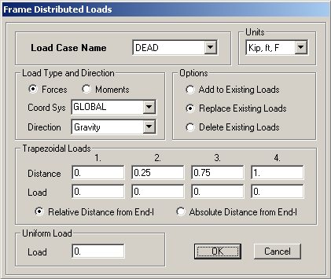
Under Uniform Load, Load = 20 psf. Repeat the same process and select Load Case Name = Live while Load =60 psf Under Uniform Load.

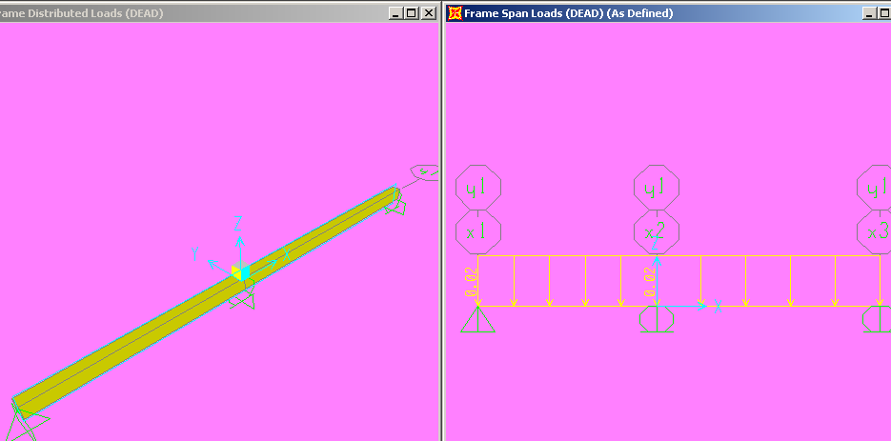
- Save the file in a new folder. Goto Analyze> Set Option, select frame to set displacement DOF.

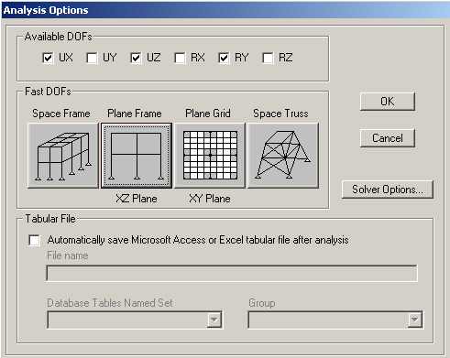
- Press Analyze>Run Analysis (F5). Select modal in Case Name and click to Run/Do Not Run Case. Then, click Run Now button.

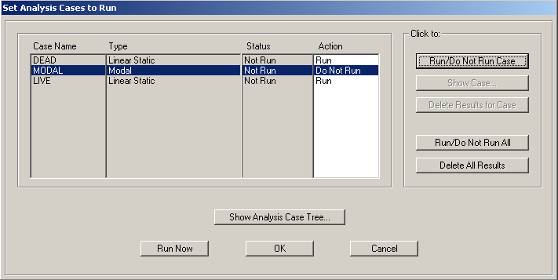

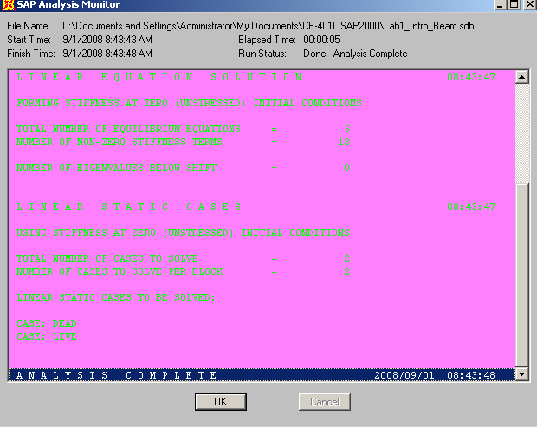

Check whether Analysis Complete or not in sap Analysis monitor Window. Also scroll for errors / warning. Press ok and you will see the deformed shape due to Dead load.

- To check reactions press Joints on display toolbar. Select Load case to see its reaction. To check shear force and bending moment, click Frame/Cables on same toolbar. In Member Force Diagram for Frames, select fdl in Case/Combo Name, Moment 3-3 in Compnent and Show value on Diagram in Option to see bending moment diagram of the structure.Right click on any member to see detailed Shear, Bending and Deflection curve for the selected member.
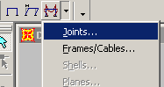
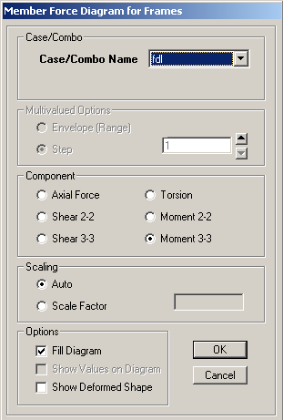

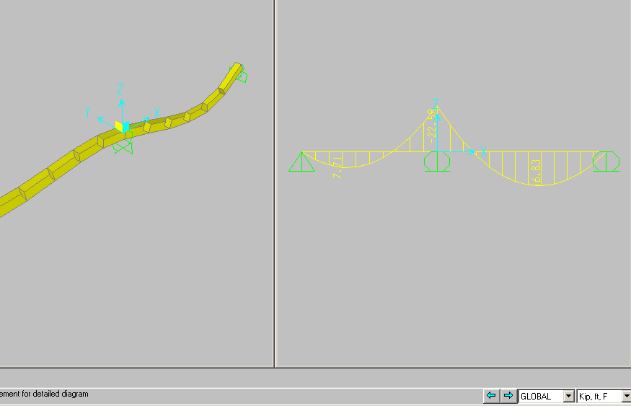
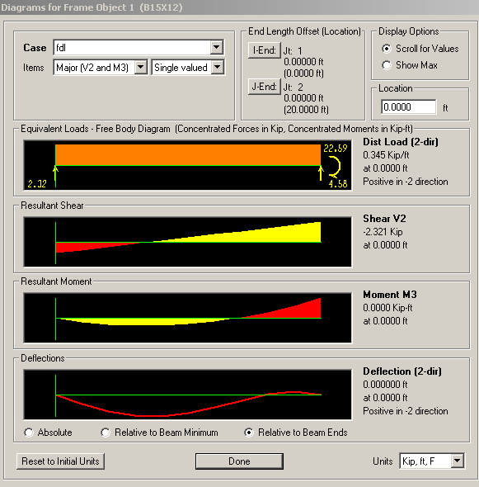
- Now we will use design menu. Goto Design>Concrete Frame Design> Select Design Combos. Add fdl in design combo list and remove the default combo.

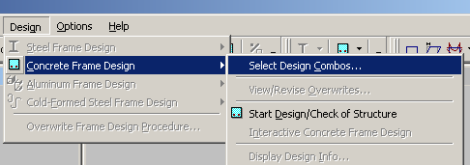
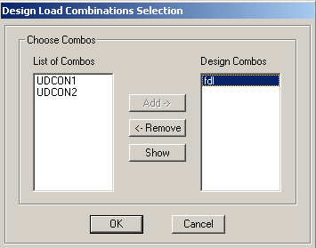

- Goto Concrete Frame Design>Start Design/Check of Structure. Select Kip,in,F

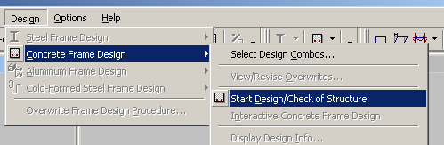
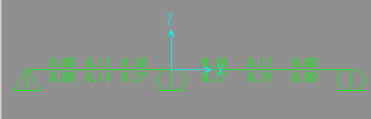
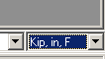
Area of steel at bottom and top section will be shown. Right click any member to see the detail of reinforcement. Press Flex Details button to see the detailed data at particular station.
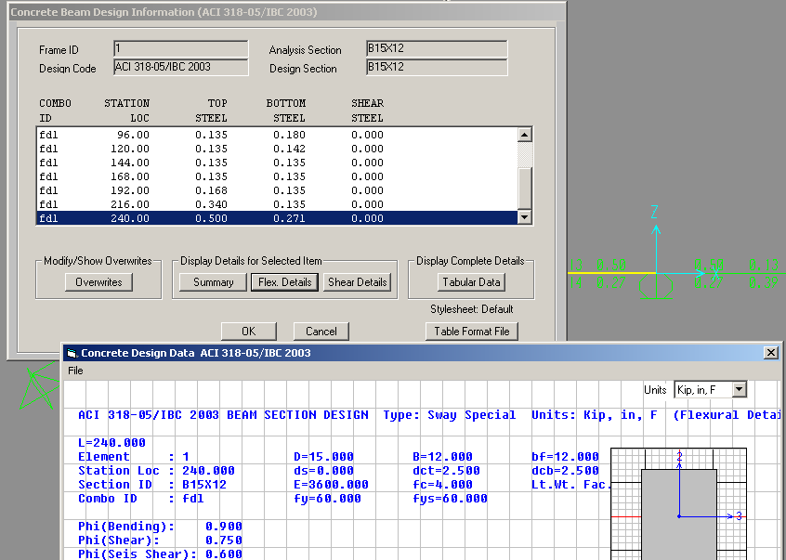

- Check the capacity by Design>Concrete Frame Design>Verify all Members passed.

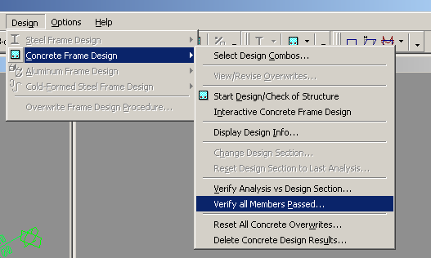

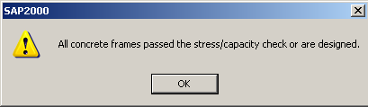

So the basic steps of analysis and design lies in Define, Assign, Analyze and Design menu.
- Next step is to use Excel sheet to find longitudinal and shear bars. Then main steel area in bottom bar is 0.14 sq. in. As 0.14 sq.in was less than min reinforcement, so, we have used min As = 0.5 sq.in for which we get 2-#5 bars (0.62 sq.in )

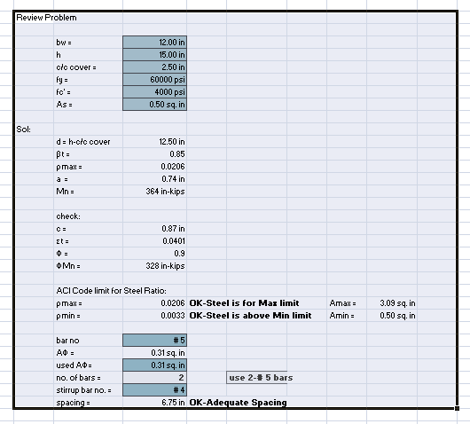
- The calculated Shear steel was 0.00 sq.in. So, use max spacing of 11 in. c/c.
