Design Document

CS 4321 - Software Engineering 1

Group Name [LumberYard]

Group Member Names

Ben Hafer, Michael Anderson, Fifi Smith-Quayson, Sean Holcomb,

Gennedy Evtodiev

Date: September 26th, 2016

1. **Development Technology**

We are going to design our Lumber Yard Project, around a client server design utilizing a html page for user interface and php scripting for the back end processing. We also plan to utilize a SQL database to store information about inventory levels and order histories.

1. **System Domain Model**

***Class: Cut***

|  |  |
| --- | --- |
| ***Field(types of cuts)*** | ***Description*** |
| *quan* | *Keeps track of quantity* |
| val | Value of the cut |
| areas | Subareas it creates |
| Parentid  Id  Mytype  Length  Width  Height  price | id of its parent cut  its id for the cut  string name of the lumber cut  length of lumber in cut  width of lumber in cut  height of lumber in cut  price of piece of lumber in the cut |

***Class: Area***

|  |  |
| --- | --- |
| ***Field(types of cuts)*** | ***Description*** |
| *height* | *Height of an area* |
| *wid* | *Width of an area* |
|  | *“ “* |
|  |  |

***Class: BUYWOOD***

|  |  |
| --- | --- |
| ***Field(types of cuts)*** | ***Description*** |
| *1 X 1* | *Types of lumber with corresponding price, desired amount, and current stock.* |
| *…* | *“ “* |
| *8x8* | *“ “* |
|  |  |

|  |  |
| --- | --- |
| ***Method*** | ***Description*** |
| *getInputs()* | *Gets the values from user form entries* |
| *fillOrder(formVals)* | *Fills order out as much as possible given current inventory, makes for incomplete order* |
| *displayOrder()* | *Shows the order that had just been placed(receipt)* |

***Class: ViewInventory***

|  |  |
| --- | --- |
| ***Method*** | ***Description*** |
| *DisplayStock()* | *Displays the current inventory levels* |
| *…* |  |

***Class: CutWood***

|  |  |
| --- | --- |
| ***Field*** | ***Description*** |
| *File1*  *File2* |  |
|  |  |

|  |  |
| --- | --- |
| ***Method*** | ***Description*** |
| *checkInputFIles(file1,file2)* | *Parses input files(if exist) for format, and get data* |
| *cutWood(int data values)* | *Analyzes given dimensions, calculates best combination of lumber cuts* |
| *coolWithUser(bool choice)* | *Confirms with user before executing cuts* |
| *displayCuts()* | *Show the produced lumber, and updated inventory* |

***Class: Receipts***

|  |  |
| --- | --- |
| ***Field*** | ***Description*** |
| *None* | *Merely displays previous order histories* |
| *…* |  |

|  |  |
| --- | --- |
| ***Method*** | ***Description*** |
| *PopulateReciepts()* | *Displays table of previous orders, sorted by date or order amount/size* |

1. **System Model**



1. **Sequence Diagrams**

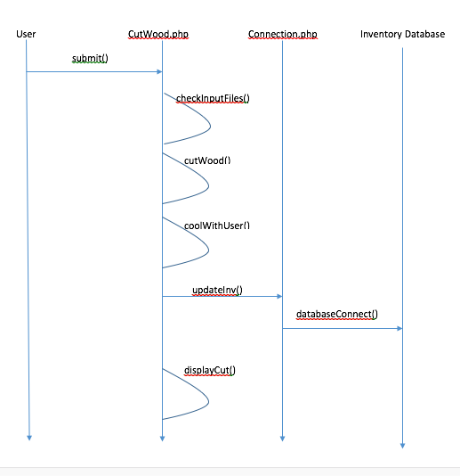

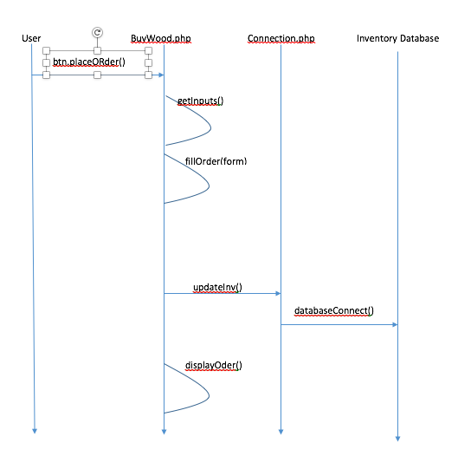

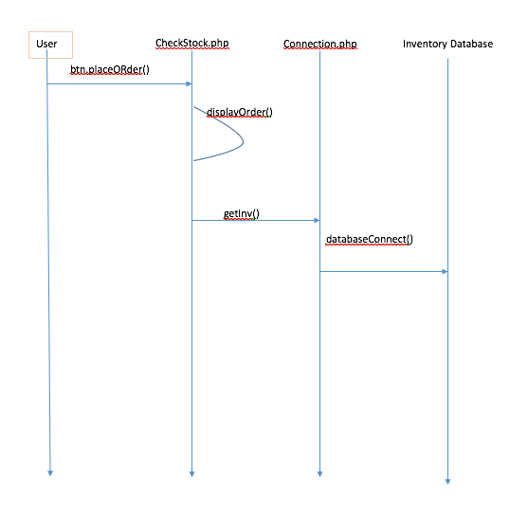

1. **User Interface**

