End-point: Login

URL: /api/login

Request:

{

"cpf": "43677183876",

"password": "1234",

"device_name": "api_moongo"

}

Response:

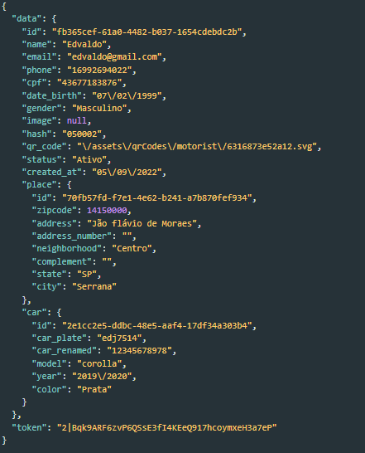

End-point: Resetar Senha

URL: /api/reset/password

Request:

{

"cpf": "44444444444"

}

Response:

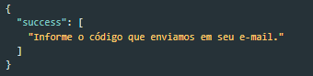

End-point: Verificar codigo

URL: /api/verify/token/password

Request:

{

" token": "123"

}

Response:

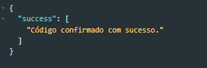

End-point: Criar Nova Senha

URL: /api/ new/password

Request:

{

"password": "1234",

"cpf": "43677183871",

"code": "4209"

}

Response:

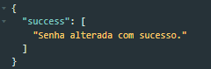

End-point: Verificar dados do usuário para se cadastrar

URL: /api/ verify/profile

Request:

{

"company": "Moongo",

"email": "jose@gmail.com",

"phone": "16992694025",

"cpf": "43677183885"

}

Response:

