Appendix A: Survey Items Used to Estimate Trust in Civil Servants
National and cross-national surveys have often included questions tapping trusting attitudes over the past half-century, but the resulting data are both sparse, that is, unavailable for many countries and years, and incomparable, generated by many different survey items. In all, we identified 17 such survey items that were asked in no fewer than five country-years in countries surveyed at least twice; these items were drawn from 132 different survey datasets. These items are listed in the table below, along with the dispersion ($α$) and difficulty ($β$) scores estimated for each from the DCPO model. Question text may vary slightly across survey datasets, but not, roughly speaking, by more than the translation differences across languages found within the typical cross-national survey dataset. Lower values of dispersion indicate questions that better identify publics with a higher level of trust from those with lower. Items have one less difficulty score than the number of response categories. Survey dataset codes correspond to those used in the DCPOtools R package; they appear in decreasing order of country-years contributed.
Together, the survey items in the source data were asked in 98 different countries in at least two time points over 36 years, from 1973 to 2022, yielding a total of 1,814 country-year-item observations. The underlying survey items span 1973–2022, but the TCS country–year series begins in 1986 because earlier years do not provide sufficient coverage for stable estimation under our inclusion rules. The TCS scores of country-years with more observed items are likely to be estimated more precisely. The estimates for country-years with fewer (or no) observed items rely more heavily (or entirely) on the random-walk prior and are therefore less certain.
Table A1: Indicators Used in the Unidimensional Latent Variable Model of Trust in Civil Servants / TCS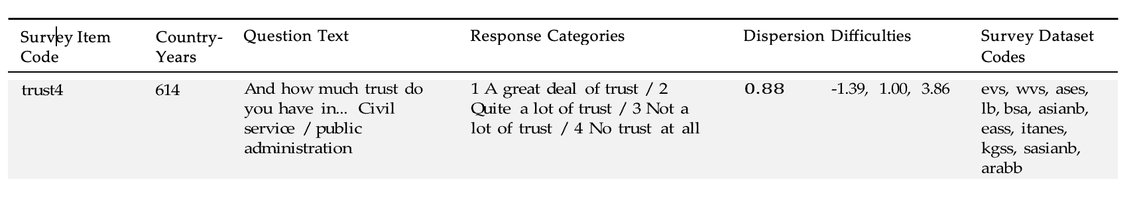

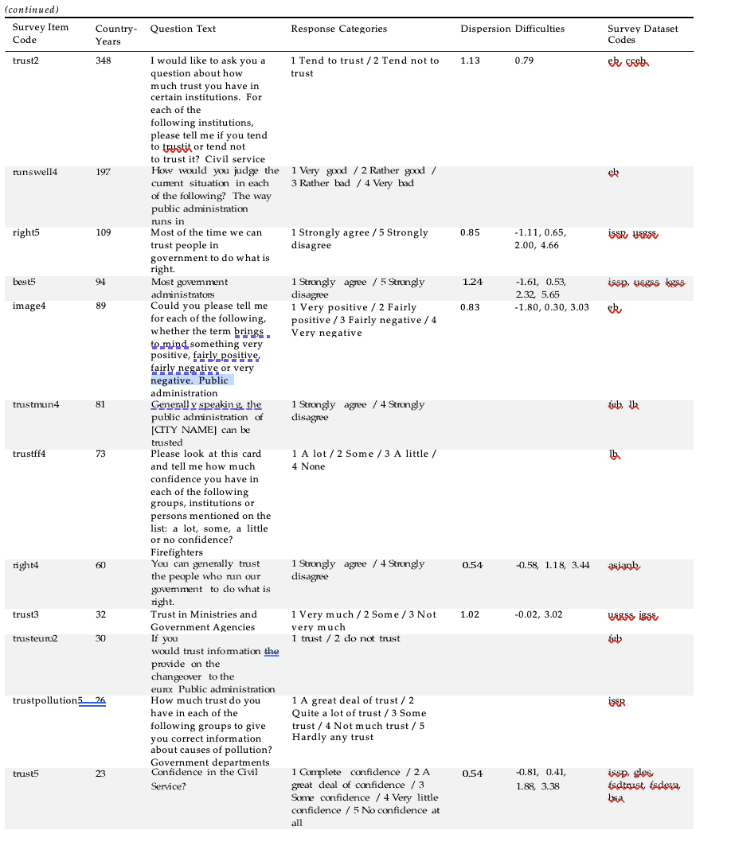

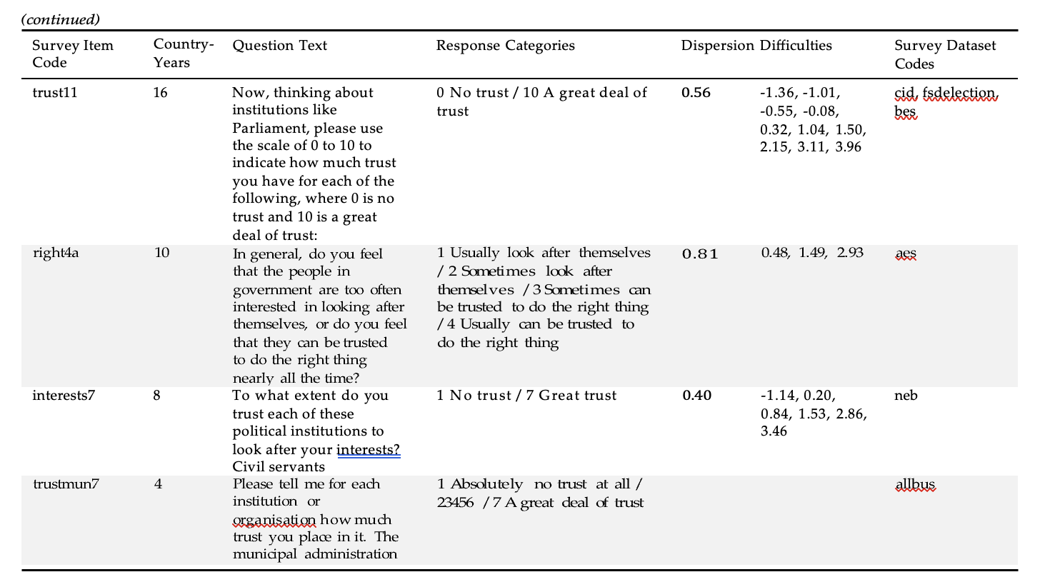
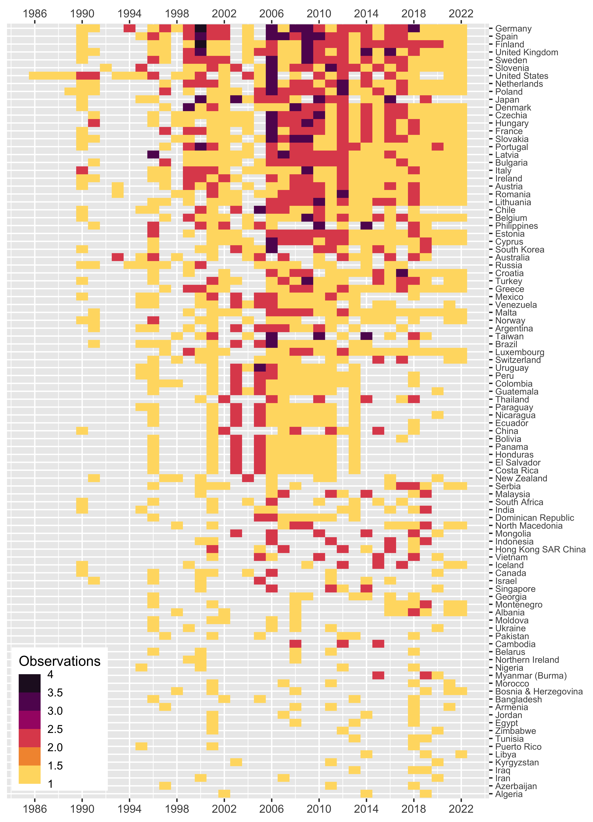
Source Data Observations by Country and Year

Appendix B: The DCPO Model
A number of recent studies have developed latent variable models of public opinion based on cross-national survey data (Caughey et al., 2019; see Claassen, 2019; Kolczynska et al., 2020; McGann et al., 2019). To estimate trust in civil servants across countries and over time, we employ the latest of these methods that is appropriate for data that is not only incomparable but also sparse, the Dynamic Comparative Public Opinion (DCPO) model elaborated in Solt (2020c). The DCPO model is a population-level two-parameter ordinal logistic item response theory (IRT) model with country-specific item-bias terms.
DCPO models the total number of survey responses expressing at least as much trust in civil servants as response category $r$ to each question $q$ in country $k$ at time $t$, $y_{ktqr}$, out of the total number of respondents surveyed, $n_{ktqr}$, using the beta-binomial distribution:
𝑎𝑘𝑡𝑞𝑟 = 𝜙𝜂𝑘𝑡𝑞𝑟 (1)
𝑏_{𝑘𝑡𝑞𝑟} = 𝜙(1 − 𝜂_{𝑘𝑡𝑞𝑟}) (2)
𝑦_{𝑘𝑡𝑞𝑟} ∼ BetaBinomial(𝑛_{𝑘𝑡𝑞𝑟}, 𝑎_{𝑘𝑡𝑞𝑟}, 𝑏_{𝑘𝑡𝑞𝑟}) (3)

where $ϕ$ represents an overall dispersion parameter to account for additional sources of survey error beyond sampling error and $η_{ktqr}$ is the expected probability that a random person in country $k$ at time $t$ answers question $q$ with a response at least as positive as response $r$.
This expected probability, $η_{ktqr}$, is in turn estimated as follows:
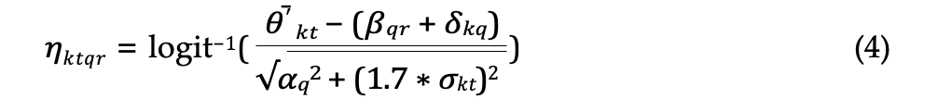

In this equation, $β_{qr}$ represents the difficulty of response $r$ to question $q$, that is, the degree of trust in civil servants the response expresses. The $δ_{kq}$ term represents country-specific item bias: the extent to which all responses to a particular question $q$ may be more (or less) difficult in a given country $k$ due to translation issues, cultural differences in response styles, or other idiosyncrasies that render the same survey item not equivalent across countries. The dispersion of question $q$, its noisiness in relation to our latent variable, is $α_{q}$. The mean and standard deviation of the unbounded latent trait of trust in civil servants are ${\overset{‾}{θ'}}_{kt}$ and $σ_{kt}$, respectively.
Random-walk priors are used to account for the dynamics in ${\overset{‾}{θ'}}_{kt}$ and $σ_{kt}$, and weakly informative priors are placed on the other parameters. The dispersion parameters $α_{q}$ are constrained to be positive and all survey responses are coded with high values indicating more trust in civil servants to fix direction. For each question $q$ the difficulties for increasing response categories $r$ are constrained to be increasing. The sum of $δ_{kq}$ across all countries $k$ is set to zero for each question $q$:

Finally, the logistic function is used to transform ${\overset{‾}{θ'}}_{kt}$ to the unit interval and so give the bounded mean of latent trust in civil servants, ${\overset{‾}{θ}}_{kt}$, which is our parameter of interest here (see Solt, 2020c: 3–8).
The DCPO model accounts for the incomparability of different survey questions with two parameters. First, it incorporates the difficulty of each question’s responses, that is, how much trust in civil servants is indicated by a given response. That each response evinces more or less of our latent trait is most easily seen with regard to the ordinal responses to the same question: strongly agreeing with the statement “Most government administrators (civil servants) can be trusted to do what is best for the country,” exhibits more trust in civil servants than simply agreeing, which shows more trust than responding “disagree,” which in turn is a more trusting response than “strongly disagree.” But this is also true across questions. Second, the DCPO model accounts for each question’s dispersion, its noisiness with regard to our latent trait. The lower a question’s dispersion, the better that changes in responses to the question map onto changes in trust in civil servants. Together, the model’s difficulty and dispersion estimates work to generate comparable estimates of the latent variable of trust in civil servants from the available but incomparable source data.
To address the sparsity of the source data—the fact that there are gaps in the time series of each country, and even many observed country-years have only one or few observed items—DCPO uses simple local-level dynamic linear models, i.e., random-walk priors, for each country. That is, within each country, each year’s value of trust in civil servants is modeled as the previous year’s estimate plus a random shock. These dynamic models smooth the estimates of trust in civil servants over time and allow estimation even in years for which little or no survey data is available, albeit at the expense of greater measurement uncertainty.

Solt (2020c) demonstrates that the DCPO model provides a better fit to survey data than the models put forward by Claassen (2019) or Caughey et al. (2019). The McGann et al. (2019) model depends on dense survey data unlike the sparse data on trust in civil servants described in the preceding section. Kolczynska et al. (2020) is the very most recent of these five works and builds on each of the others, but the MRP approach developed in that piece is suitable not only when the available survey data are dense but also when ancillary data on population characteristics are available, so it is similarly inappropriate to this application.
The ordinal responses to question $q$ are coded to range from 1 (expressing the least trust in civil servants) to $R$ (expressing the most trust in civil servants), and $r$ takes on all values greater than 1 and less than or equal to $R$.
Estimating $δ_{kq}$ requires repeated administrations of question $q$ in country $k$, so when responses to question $q$ are observed in country $k$ in only a single year, the DCPO model sets $δ_{kq}$ to zero by assumption, increasing the error of the model by any country-item bias that is present. Questions that are asked repeatedly over time in only a single country pose no risk of country-specific item bias, so $δ_{kq}$ in such cases are also set to zero.
The dispersion parameters $α_{q}$ are drawn from standard half-normal prior distributions, that is, the positive half of N(0, 1). The first difficulty parameters for each question, $β_{q1}$, are drawn from standard normal prior distributions, and the differences between $β$s for each $r$ for the same question $q$ are drawn from standard half-normal prior distributions. The item-bias parameters $δ_{kq}$ receive normally-distributed hierarchical priors with mean 0 and standard deviations drawn from standard half-normal prior distributions. The initial value of the mean unbounded latent trait for each country, ${\overset{‾}{θ'}}_{k1}$, is assigned a standard normal prior, as are the transition variances $σ_{\overset{‾}{θ'}}^{2}$ and $σ_{σ}^{2}$; the initial value of the standard deviation of the unbounded latent trait for each country, $σ_{k1}$, is drawn from a standard lognormal prior distribution. The overall dispersion, $ϕ$, receives a somewhat more informative prior drawn from a gamma(4, 0.1) distribution that yields values that are well scaled for that parameter.

