DBMS (CSE-2007)

*Tathagat Banerjee*

*17BCE7100*

Q 1. Write a query in SQL to display the third highest salary in the employee table.

Answer 1:

(select (Salary) from database1.employ where Salary <(select max(Salary) from database1.employ where Salary <(Select max(Salary) from database1.employ)));

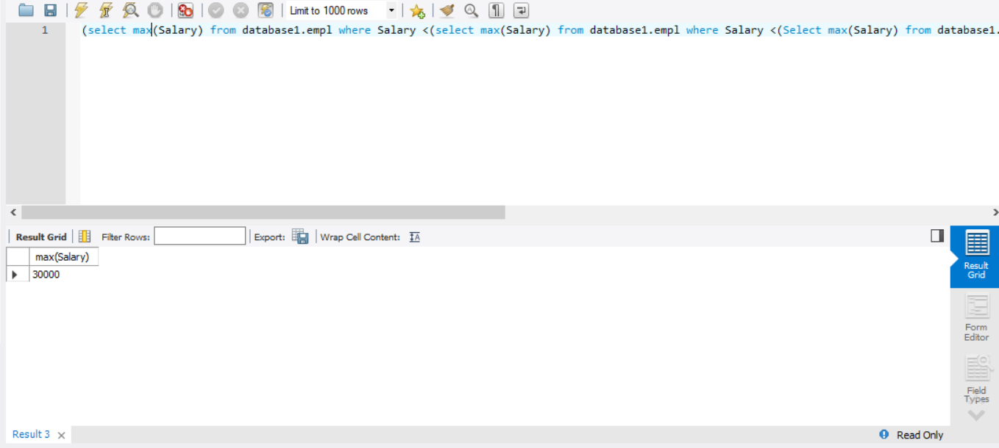

Q2. Write a query in SQL to display the name of the employee who takes the third highest

Salary.

Answer 2

select e_name from database1.empl where Salary in(select max(Salary) from database1.empl where Salary <(select max(Salary) from database1.empl where Salary <(Select max(Salary) from database1.empl)));

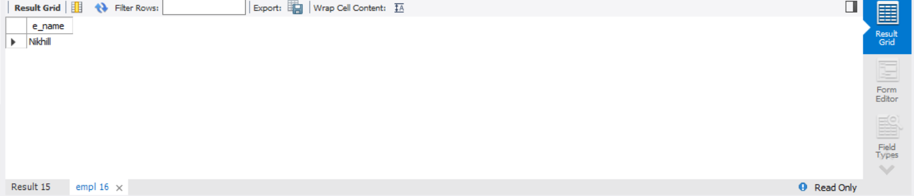

Q3. Write a query in SQL to display the employee names whose salaries are greater than the

average salary of all employees.

Answer 3

select * from database1.empl where Salary >(select avg(Salary) from database1.empl);

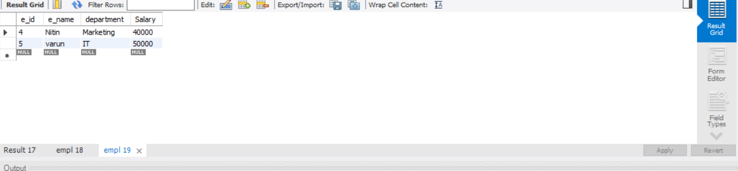

Q4. Write a query in SQL to display the department names for which the minimum salaries

offered are greater than the average salary of all employees.

Answer 4

select department from database1.empl group by department having min(Salary) > (select avg(Salary) from database1.empl);

