DBMS (CSE-2007)

*Tathagat Banerjee*

*17BCE7100*

**Q 1. Write a query in SQL to display the third highest salary in the employee table.**

***Answer 1:***

(select (Salary) from database1.employ where Salary <(select max(Salary) from database1.employ where Salary <(Select max(Salary) from database1.employ)));

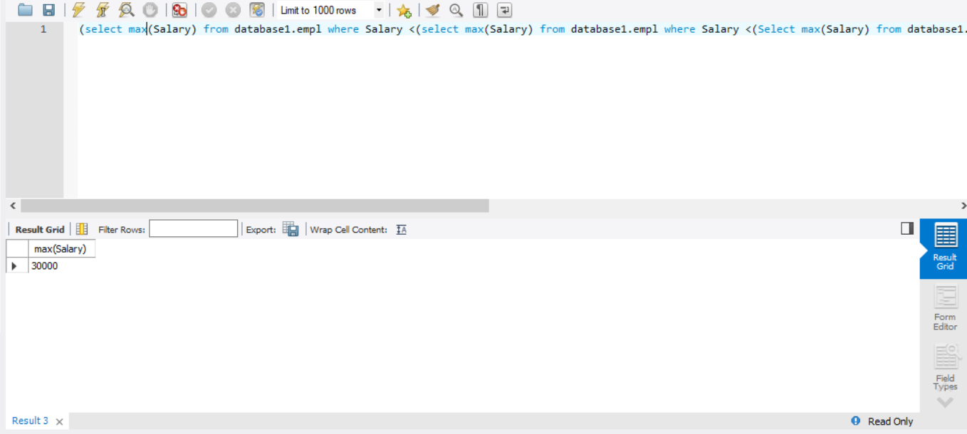

**Q2. Write a query in SQL to display the name of the employee who takes the third highest**

**Salary.**

***Answer 2***

select e_name from database1.empl where Salary in(select max(Salary) from database1.empl where Salary <(select max(Salary) from database1.empl where Salary <(Select max(Salary) from database1.empl)));

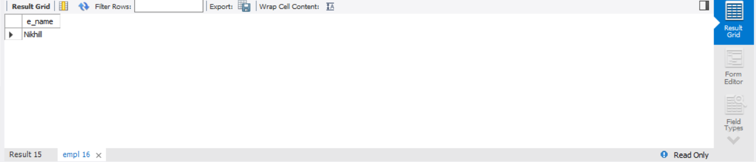

*Q3. Write a query in SQL to display the employee names whose salaries are greater than the*

*average salary of all employees.*

***Answer 3***

select * from database1.empl where Salary >(select avg(Salary) from database1.empl);

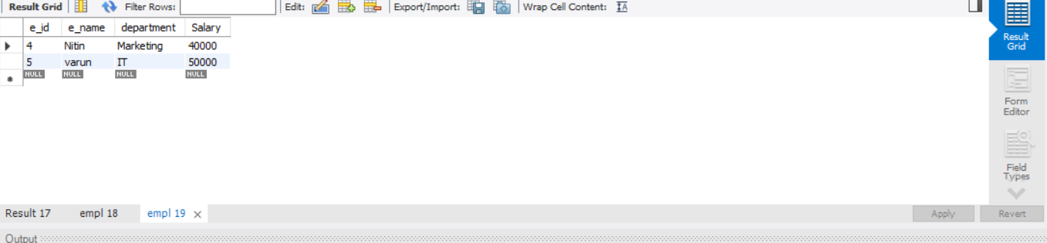

**Q4. Write a query in SQL to display the department names for which the minimum salaries**

**offered are greater than the average salary of all employees.**

***Answer 4***

select department from database1.empl group by department having min(Salary) > (select avg(Salary) from database1.empl);

