DBMS (CSE-2007)

*Tathagat Banerjee*

*17BCE7100*

***Q 1. Find the titles of all movies directed by Steven Spielberg.***

***Answer 1:***

SELECT title FROM database1.movie where director = 'Steven Spielberg';

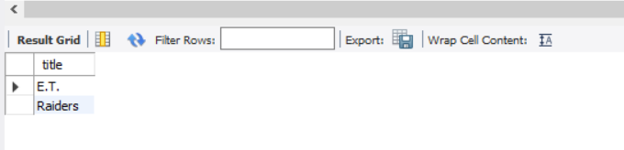

***Q2. Find all years that have a movie that received a rating of 4 or 5, and sort them in increasing order.***

***Answer 2***

select year from database1.movie where mID in (select mID from database1.rating where stars in (4,5)) order by year;

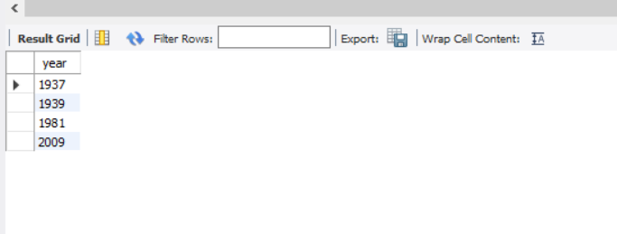

***Q3. Find the titles of all movies that have no ratings.***

***Answer 3***

select title from database1.movie where mID not in (select mID from database1.rating );

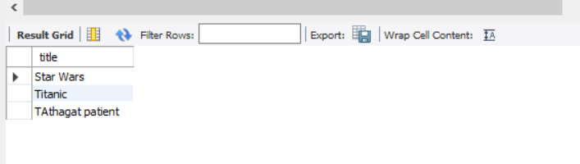

***Q4. Find the names of all reviewers who have ratings with a NULL value for the date.***

***Answer 4***

select name from database1.reviewer where rID in (select rID from database1.rating where ratingDate is null);

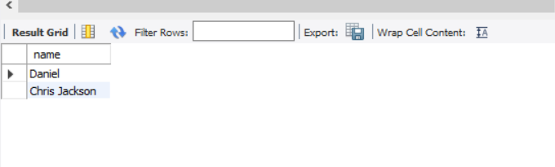

***Q5. Find the titles of all movies not reviewed by Chris Jackson.***

***Answer 5***

select title from database1.movie where mID not in (select mID from database1.rating where rID = (select rID from database1.reviewer where name = 'Chris Jackson'));

