Finn Saunders-Zurn

CSCI 351 Data Comm & Networks

HW 1

First Few Packets:



Last Few Packets:

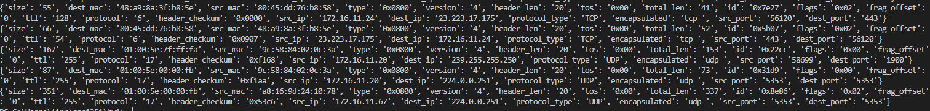



Filtering on these 10 packets:

Host filter:

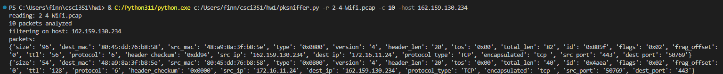

Port filter:

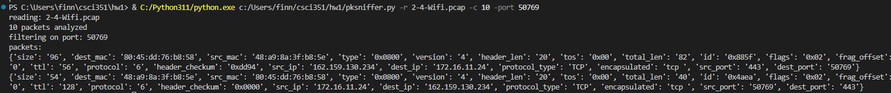

Ip filter: (Not sure if this is correct, my filter checks for ip version = 4)

TCP filter:

UDP filter:

ICMP filter: (Had to filter on different packets)

Net filter:

