Results of the Trigger Run Sizes

Sara Miller

June 19, 2017

## Loading tidyverse: ggplot2  
## Loading tidyverse: tibble  
## Loading tidyverse: tidyr  
## Loading tidyverse: readr  
## Loading tidyverse: purrr  
## Loading tidyverse: dplyr

## Conflicts with tidy packages ----------------------------------------------

## filter(): dplyr, stats  
## lag(): dplyr, stats

##   
## Attaching package: 'lubridate'

## The following object is masked from 'package:base':  
##   
## date

# Background

The trigger run sizes on the Scform sheet of the SFMM (Catch-CPUE) model were updated for the Tah for the Tahltan stock in the D-10641 and D-108 fishery.

**Prior results (used in models from 2014-2016)** Data used from 1994 through 2013.Data through 2011 is SPA and data from 2012 on is GSI.

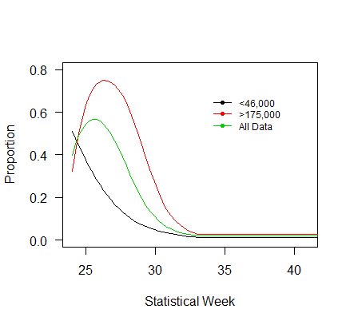 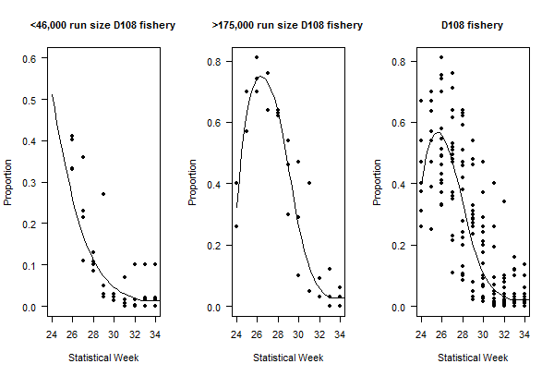 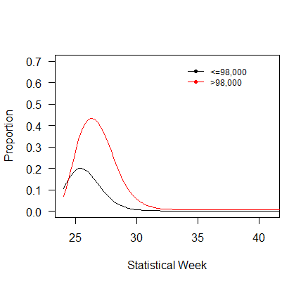 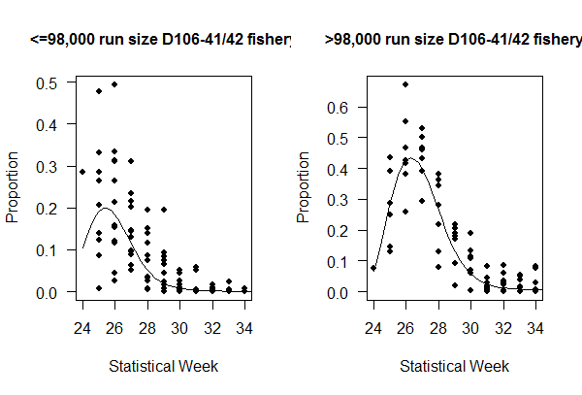 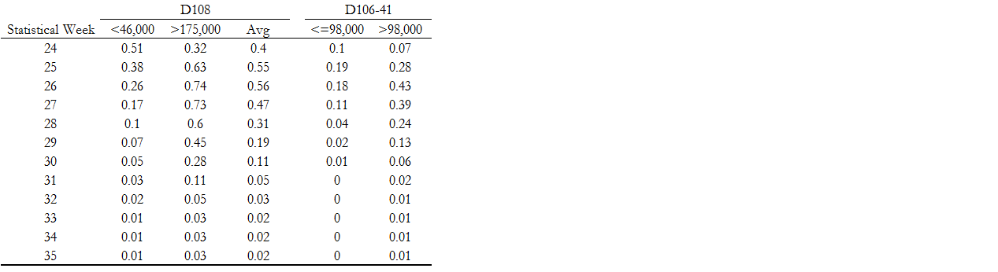

**Current results (used in models from 2017)**

