**User’s Manual of IMP-X-FDR**

Contents

Aim 2

1. Installation 3

2. FDR-recalculation 3

2.1. Input files 3

2.2. Support libraries 4

2.3. Output files 5

3. Venn diagrams 7

4. Physicochemical properties 8

4.1. Input file 8

4.2. Support library 8

4.3. Normalisation and comparison to theoretical crosslinks 8

4.4. Output Files 9

4.4.1. Isoelectric Point 9

4.4.2. Hydrophobicity 10

4.4.3. Frequency of amino acids in crosslinks 10

4.4.4. Frequency of aromatic amino acids (F, W, Y) 11

4.4.5. Molecular weight 12

4.4.6. Neighbours of the crosslinkers binding amino acid 12

4.4.7. Retention time vs physicochemical properties 13

# Aim

The main aim of IMP-X-FDR is to provide an easy to use and automated way for calculation of the real false discovery rate (FDR) of crosslink search results obtained from any peptide-library system. This makes it a valuable tool for testing novel crosslinkers, to compare acquisition strategies or to benchmark crosslink search algorithms.

Additional functionalities are the comparison of crosslink IDs found from different replicates or across different search engines using Venn diagrams as well as to investigate intrinsic properties (mass, pI value, amino-acid sequences analyses, …) of the crosslinks dependent on retention time. The tool thereby allows a comparison of the physicochemical properties of identified crosslinks vs those theoretically formed within the peptide library used.

# Installation

* After downloading IMP-X-FDR to any local directory, simply execute “IMP_X_FDR.exe”

In case of missing supporting programs -like Python- on your system, you will be automatically redirected to the respective installation website. Install the suitable version for your computer.

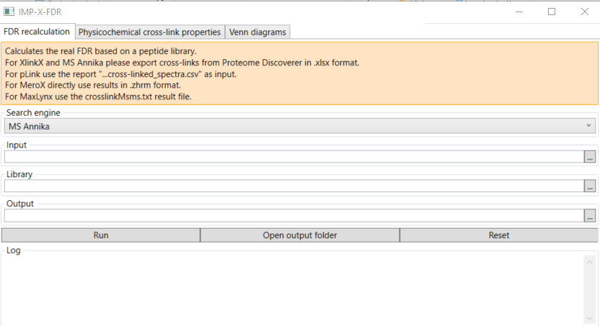

Figure 1: Design of IMP-X-FDRs GUI

# FDR-recalculation

## 2.1. Input files

If you have chosen **MS Annika** or **XlinkX**, the input file you need for the “FDR-recalculation” can be generated from Proteome Discoverer by exporting the (filtered) crosslink list to Microsoft Excel. The script was tested using exports from Proteome Discoverer v 2.5.

For **MeroX** a “.zhrm” result file will be used as input. The software will temporarily convert it in a “.zip” data, extract the necessary information and then bring the file to its initial form. The script was created using version 2.0.1.4 of MeroX. For MeroX files this script an also be run from the command prompt, where you can give two optional arguments:

Figure 2: Optional arguments, MeroX – refer to Decoy analysis in MeroX to see scores for specific FDR (Figure 3)

For example, if the number of the crosslinks delivered by the IMP-X-FDR doesn’t match the number shown by the software (if it happens, it normally differs by 1 or 2 crosslinks), this is because MeroX performs an extra filtering. The extra filtering can be also performed by “merox_master_score.py” script when used in via command prompt and adding the optional arguments.

The advantage of this feature is that one can run multiple FDR-Check searches by just changing the intra- and interscore cut-off value without having to perform multiple MeroX searches by changing the FDR value.

The image below shows, where to find the cut-off values of a MeroX search with a defined FDR of 1%.

Figure 3: Example, scores for specific FDR, from MeroX (Iacobucci, C. et al. Nat. Protoc., 2018)

The needed file of **pLink 2** searches for the FDR-Check script is found in the pLink 2 output subdirectory “reports” with the default extension “filtered_crosslinked_spectra.csv”.

For **MaxLynx** the “crosslinkMSMS.txt” file as given by MaxQuant in the combined/txt folder. IMP-X-FDR converts MaxLynx inputs automatically to the format used for MS Annika and runs FDR calculation with the same script as used for Annika.

## 2.2. Support libraries

The support library files for the published datasets based on ribosomal peptides as well as our previously published Cas9 data (Beveridge, R. et al., Nat Commun, 2020) are provided within the resources/libraries folder. They are needed to support IMP-X-FDR in grouping crosslink IDs to correct (within the same peptide group) and incorrect crosslinks (connected peptides within different peptide groups).

In case another peptide library system will be utilized, the structure and the extension of the document (.xlsx) must be kept consistent, as indicated in Figure 4. The sequences contained in the first group are followed directly (without any empty cells) by the next groups. The numbers in column B are only mandatory if a physiochemical investigation is performed and indicate the position of the crosslinker-binding amino-acid in the peptide sequence minus one. To define the respective groups a ‘x’ is listed in column B.

Figure 4: Structure of library support files

## 2.3. Output files

1. “**[name]_output.csv**”

The main output data is a csv document, which returns a detailed list of the crosslinks containing information about their sequences, theoretical origin-proteins, position in protein, their score and if the crosslinks are formed within the same group (considered as true) or not (considered as false).

Figure 5:Structure of main "output" file

1. “[**name]**_**XLs.svg**” (Fig. 6A)

Case 1: Real FDR is above 5%:

First bar shows the type of crosslinks in the results delivered by the XL-search engines together with the real FDR. The second and third bars are obtained by filtering the results until the FDR reaches or less than or equal to 5% and 1%.

Case 2: Real FDR is less than 5%, but greater than 1%:

First bar shows the type of crosslinks in the results delivered by the XL-search engines together with the real FDR. The third bar is obtained by filtering the results until the FDR reaches less than or equal to 1%.

Case 3: Real FDR is less than 1%:

In this case there will be only one bar displaying the real FDR without any filtering

1. **“[name]_XLs_at_specific_score.svg”** (Fig. 6B)

Case 1: real FDR is above 5%:

First point: lowest accepted score, real FDR

Second point: the lowest score at which the real FDR is less or equal to 5%

Third point: the lowest score at which the real FDR is less or equal to 1%

Case 2: real FDR is under 5% and above 1%

First point: lowest accepted score, real FDR

Second point: the lowest score at which the real FDR is less or equal to 1%

Case 3: real FDR is under 1%

First and only point: lowest accepted score, real FDR

1. **“[name]_FDR_specific_score.svg” (Fig. 6C)** shows the distribution of the crosslinks depending on the score.

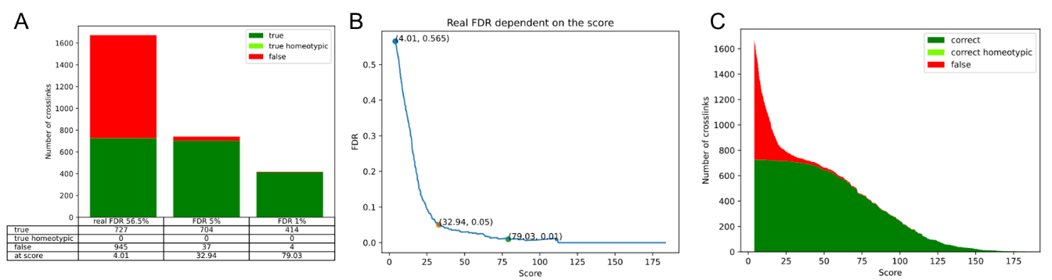

Figure 6: **A**: # of unique XL sites as given by search engine and # of XL sites post-score cut-off to achieve a real FDR of 5 or 1% respectively, **B**: real FDR at specific score, **C**: XL sites at specific score

1. “[**name]_output_venn_input.xlsx**”

Is used as input for the Venn diagram option (as described in) and overcomes the different XL output formats by distinct search engines.

# Venn diagrams

To generate a uniform data structure of identified cross links across different search engines, we have implemented the “…output_venn_input.xlsx” file which is an output of “FDR-recalculation”. The script selects common features of crosslinks, that are present in each software (i.e. position of XL in protein A and B, sequence A and B and protein name A and B) and sorts them alphabetically. The score is not considered by the Venn script, as each software has different methods of scoring a crosslink.

When comparing more than one result, Venn diagrams for all, “true” or “false” XLs together with more detailed information is saved in a “.xlsx”. For a maximum of three result files weighted diagrams are generated, when comparing 4 results an unweighted Venn diagram will be displayed.

Figure 7: All, “true” or “false” XL-Venn diagrams

Furthermore, a document with three different sheets for all, “true” and “false” crosslinks will be created. If the overlap of specific crosslinks should be investigated or common features of false crosslinks identified, the user can find lists of the crosslinks present in each area within said document.

# Physicochemical properties

All properties were calculated by using the Bio.SeqUtils package from Biopython (except for the frequency of the neighbors). The code was adapted for crosslinks but except for the mass determination the crosslinker itself was not considered.

Source: <https://biopython.org/docs/1.75/api/Bio.SeqUtils.html> The frequency of the nearest neighbours to the binding amino acid was calculated by using the package "seqlogo". Source: <https://pypi.org/project/seqlogo/>

## 4.1. Input file

This tool is only compatible with Proteome Discoverer results (i.e. “MS Annika” or “XlinkX”), which can be generated by exporting the (filtered) CSM list to Microsoft Excel (≠ XL list that is used for FDR recalculation)

## 4.2. Support library

For the three (sub-)libraries the correct results with regard of the “WGGGGR” sequence protecting the N-terminus of every peptide prior to digestion will be delivered in the function “most frequent neighbours of the binding amino acid”. In case, the user wants to utilize another library, an undigested form should be supplied for the function of the “most frequent neighbours of the binding amino acid” to work correctly. For all the other properties and functions the digested form would be advantageous. Additional information can be found in Chapter 2.2

## 4.3. Normalisation and comparison to theoretical crosslinks

We generate comparisons between “reality” and “theory”, which are calculated by assuming that each peptide from each group builds a crosslink (with only one CSM) with itself and with all the other peptides from the same group. Homeotypic duplicates are be filtered out of the pool.

Normalisation is performed as follows:

densitybool, default: False

If True, draw and return a probability density: each bin will display the bins raw count divided by the total number of counts *and the bin width* (density = counts / (sum(counts) * np.diff(bins))), so that the area under the histogram integrates to 1 (np.sum(density * np.diff(bins)) == 1)

If *stacked* is also True, the sum of the histograms is normalized to 1.

Source: <https://matplotlib.org/stable/api/_as_gen/matplotlib.pyplot.hist.html>

Through the normalisation process, the area of all the bins in histograms summed up will be equal to 1.

For normalization, both “theory” and “reality” results are normalized to 1 (“density=True”). Due to that, some bins from the real results can be higher than the bins from the theoretically maximum reachable numbers of crosslinks (e.g., Peptide library 1 = 1018). The normalization is done on the CSM level, consequently a crosslink with 10 CSMs, can influence the result 10 times more than the same crosslink with just one CSM.

In the unnormalized version, the area of all bins will be not equal, therefore neither the “reality”, nor the “theory” will be equal to one. In this case, the analysis is done on the crosslink level, hence duplicate CSMs will be eliminated, and two crosslinks have the same weight in the results, regardless of their CSM counts.

## 4.4. Output Files

### 4.4.1. Isoelectric Point

The pI value is calculated for each peptide of the identified crosslink and is weighted by the number of K, R, H, D, E present.

AHHKEGGR Peptide A

|

MTKEEGGR Peptide B

$$pI value\left(Crosslink\right)=\frac{pI value\left(Peptide A\right)*5 + pI value\left(Peptide B\right)*4}{5+4}$$

In the case of pI calculation, the lysins connected by the crosslinker are also included in the algorithm to focus on the isoelectric properties of the initial peptides influencing the formation of crosslinks.

Figure 8: Isoelectric point; XL level; areas not normalised; weighted to frequency of KRHDE

### 4.4.2. Hydrophobicity

The gravy index of the crosslink is calculated based on Kyte and Doolittle scale (Kyte J., Doolittle R. F., J Mol Biol., 1982). Every amino acid possesses an empirically determined gravy value, which is used to calculate a weighted average considering the length of both peptides. Of note even though the crosslinker itself is not included the analysis allows for a comparative overview to the theoretical results.

$Gravy value\left(Crosslink\right)$ =

$$=\frac{\left[Gravy value\left(Peptide A\right)* Length\left(Peptide A \right)+ Gravy value\left(Peptide B\right)* Length\left(Peptide B\right)\right]}{Length\left(Peptide A\right)+Length\left(Peptide B\right)}$$

Aromaticity- Frequency of aromatic amino acids

|  |  |  |  |  |  |  |  |  |  |  |  |  |  |  |  |  |  |  |  |
| --- | --- | --- | --- | --- | --- | --- | --- | --- | --- | --- | --- | --- | --- | --- | --- | --- | --- | --- | --- |
| **R** | **K** | **N** | **D** | **Q** | **E** | **H** | **P** | **Y** | **W** | **S** | **T** | **G** | **A** | **M** | **C** | **F** | **L** | **V** | **I** |
| -4.5 | -3.9 | -3.5 | -3.5 | -3.5 | -3.5 | -3.2 | -1.6 | -1.3 | -0.9 | -0.8 | -0.7 | -0.4 | 1.8 | 1.9 | 2.5 | 2.8 | 3.8 | 4.2 | 4.5 |

Figure 9:Hydrophobicity; XL level; areas not normalised

### 4.4.3. Frequency of amino acids in crosslinks

The image below shows the frequency (# specific amino acid/ total number of amino acids per CSM) of each amino acid regardless of their position in the peptide across all CSMs. The crosslinker reactive amino acids are also included in the calculation.

Figure 10: Frequency of each amino acid within all identified CSMs of a file

### 4.4.4. Frequency of aromatic amino acids (F, W, Y)

The acids phenylalanine (F), tryptophan (W) and tyrosine (Y) are considered aromatic. As these amino acids might alter the reactivity of neighbouring functional groups and as they are sterically demanding their frequency might give information if there is any influence on the formation/ ability for detection of a crosslink.

Calculation is explained based on the following example:

AA**Y**MTKEMPR Peptide A (length = 10, number of aromatic amino acids = 1)

|

ST**W**PQNKPQ**F**RPeptide B (length = 11, number of aromatic amino acids = 2)

=

Figure 11: Aromaticity XL level areas not normalised

### 4.4.5. Molecular weight

For the molecular weight the mass of the connected peptides and the crosslinker are summed. Importantly, the program ignores all other chemical modifications, which might alter the calculated mass vs real mass. This however, improves comparability to the theoretical crosslinks formed in silico.

Figure 12:Molecular weight XL level areas not normalised

### 4.4.6. Neighbours of the crosslinkers binding amino acid

To address if the direct chemical environment of crosslinker reactive amino acids influences its reactivity we report three amino acids to the left and to right of the crosslinker bound amino acid. Below we show the position frequency matrix structure from the analysed structures, where each row represents the following characteristics:

* first row - third neighbour from the left (farthest left)
* second row - second left neighbour (middle left located)
* third row - first left neighbour (closest left)
* fourth row - first neighbour on the right (closest right)
* fifth row - second neighbour from the right (middle located right)
* sixth row - third neighbour on the right (farthest right)

Figure 13: neighbours of the crosslinker’s binding position CSM

We report in the one-letter amino acid code and the special characters “*”, “X” and “-”

|  |  |
| --- | --- |
| X | Any |
| * | Translation stop |
| - | empty space (beyond the end of peptide sequence) |

### 4.4.7. Retention time vs physicochemical properties

We here display the retention time versus above-described physiochemical properties of each CSM.

Figure 14: physicochemical (mass-top left; isoelectric point-top right; gravy value-bottom left; aromaticity fraction-bottom right) properties over retention time