We present a modular system for generating linguistic expressions from underlying clause structures (UCS), implemented in Java and Prolog. The system uses a UCS representation based on Dik & Hengeveld (1997), the expression component is based on a revised version of the implementation described in Samuelsdorff (1989).

The system can be used to evaluate and improve the theory of Functional Grammar (FG) with respect to theoretical and representational issues in language generation. By means of its modular architecture it could act as the language generation component in a larger FG-based NLP system.
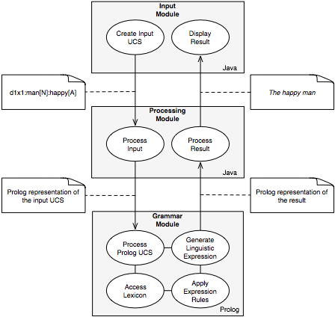

DIK, Simon C. 1997. The Theory of Functional Grammar, Part 1: The Structure of the Clause. Kees Hengeveld (ed.) 2nd rev. ed. Berlin, New York: Mouton de Gruyter.

SAMUELSDORFF, Paul O. 1989. Simulation of a Functional Grammar in Prolog. In: CONNOLLY, John H. & Simon C. DIK (eds.). Functional Grammar and the Computer. 29-44. Utrecht, Providence: Foris Publications.

