

**AN ONLINE BOOKSTORE**

**MSc Information Systems with Computing**

STELIN FRANCIS ([10592005](mailto:%31%30%35%39%320%30%35@%6dyd%62%73%2ei%65))

NITHIN JOSEPH (10606808)

**Supervisor: Paul Larid**

**April 2022**

**Table of contents**

1. Abstract……………………………………………………………3

2. Introduction………………………………………………………..3

3. frontend……………………………………………………………3

3.1 About HTML………………………………………………….3

3.2 About CSS…………………………………………………….4

3.3 Java Script…………………………………………………….4

3.4 Bootstrap………………………………………………………4

4.backend……………………………………………………………4

4.1 Django framework…………………………………………….4

4.2 Sqlite3…………………………………………………………4

5.Github…………………………………………………………….5

6.Website Illustration……………………………………………….6

6.1 The Login Page………………………………………………..6

6.2 The List page………………………………………..………...7

6.3 The Details page……………………………………………….8

6.4 The Checkout Page…………………………………………..9

7.Conclusion……………………………………………….……..10

8.Individual Contribution……………………………….………..10

9.Reference List…………………………………………………..10

**1.Abstract**

The main objective of the project is to create an online bookstore where customers can browse and buy books based on title, author, and subject. The consumer can place an online order for their preferred books using a debit card or credit card after seeing them displayed to them in a tabular manner.

**2.Introduction**

The system of online book stores offers a wide range of advantages. An individual customer is under no obligation to search for a specific book. By just launching the software on a computer with an active internet connection and a web browser, one may quickly buy the book of his or her choice while lounging in their favorite chair. This helps the consumer save a great deal of time and effort. Our project's goal is to create a simple e-commerce website for the online sale of books. The website enables users to look for various books across several categories that are for sale. By enabling the customer to put the book of their choice in a shopping cart, it simplifies the purchasing process. The user can then finish the transaction by using a credit or debit card.

**3.Frontend**

The process of developing a website's graphical user interface using HTML, CSS, and JavaScript so that visitors can view and interact with it is known as front-end web development.

**3.1 HTML**

HTML code ensures that text and graphics are formatted correctly for your Internet browser. Without HTML, a browser would be unable to display text as an element, load images, or add other elements. To alter a page's appearance, Cascading Style Sheets are overlaid on top of HTML's fundamental page structure.

**3.2 CSS**

CSS enhances a website's front end, which also enhances user experience. Without CSS, websites would undoubtedly be less aesthetically pleasing and much harder to navigate. In addition to layout and format, CSS is also in charge of font color.

**3.3 JAVA SCRIPT**

JavaScript has evolved over the past 25 years into a robust and approachable programming language for use with web browsers. JavaScript is a computer language used to build sophisticated interactive websites, browser games, and connections between servers and websites and web applications.

**3.4 BOOTSTRAP**

It features a big variety of components, a good grid system, styling for different HTML elements, from buttons to typography, and support for JavaScript plugins, improving its flexibility. It is very easy to set up and understand..

**4.BACKEND**

The back-end, often referred to as the server-side, is made up of the server, which provides data on demand, the application, which routes it, and the database, which arranges the data.

**4.1 Django Framework**

a sophisticated Python web framework Django encourages rapid development and efficient, useful design. It was made by skilled programmers and takes care of a lot of the hassles related to web development, freeing you up to focus on creating your app without having to reinvent the wheel. It is both free and open source.

Amazingly speedy.

Django was developed to enable building apps from scratch as easy as possible for developers.

Security is ensured

Due to its focus on security, Django helps developers avoid many common security mistakes.

exceptionally scalable

Django's quick and flexible scaling features are used by some of the busiest websites on the internet.

**4.2 Sqlite3**

An alternative SQL query language can be used to access the database using the SQLite C library without the requirement for a separate server process. SQLite is a lightweight disk-based database. SQLite can be used by some apps to store internal data.

**5.Github**

GitHub is a platform for group collaboration and version control. It makes it possible for you and other individuals to collaborate remotely on projects. In this tutorial, you will learn about GitHub basics like repositories, branches, commits, and pull requests.

GitHub Repository: <https://github.com/fstelin/Stelin>

**6.Website illustration**

**6.1 The Login Page**

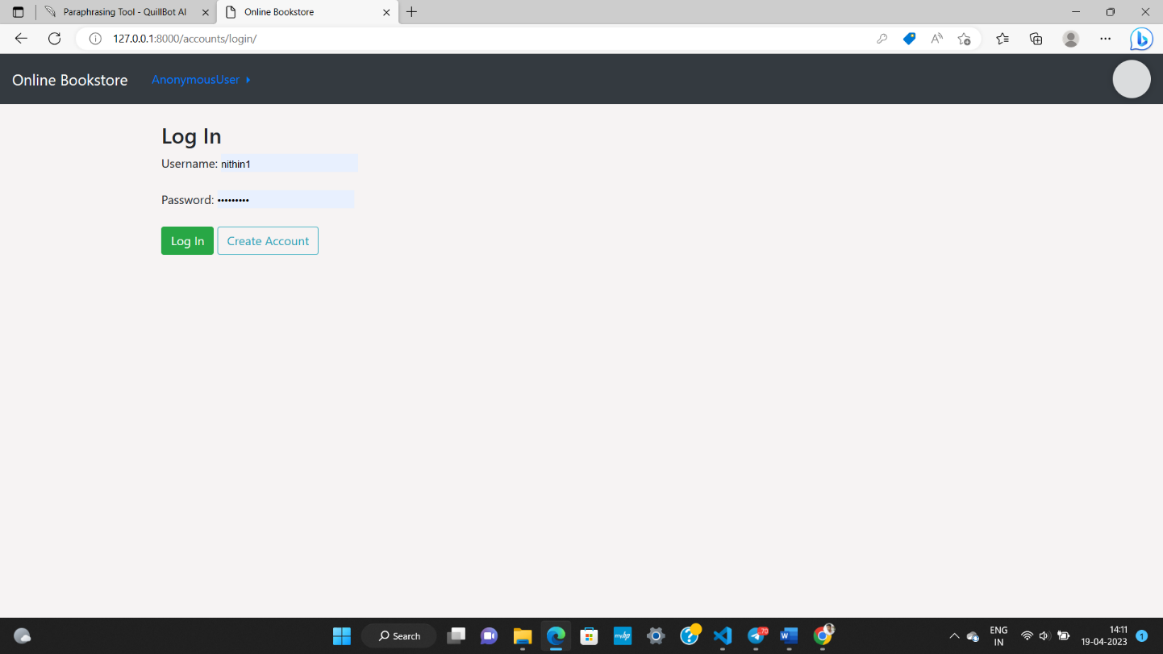

The website's login page that requests user identification and authentication, which is typically done by inputting a username and password combination. Access to the complete website is made possible by logins**.**

**6.2 The List page**

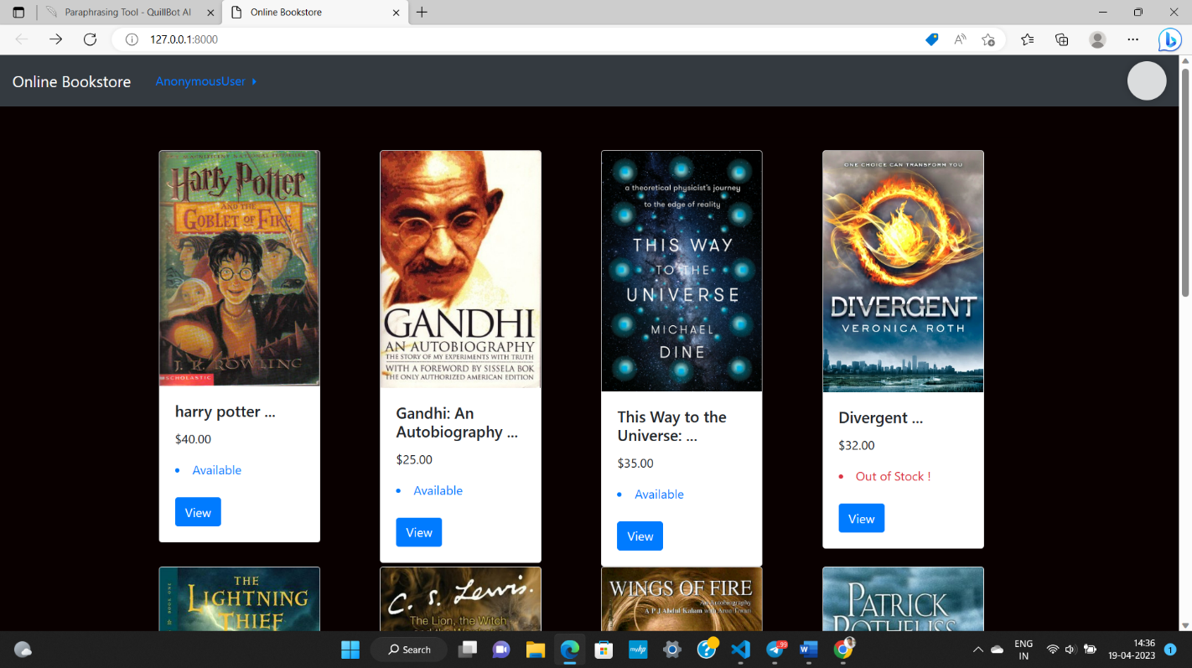

In this page we can see all books and by clicking the view button we can go to the details page of all individual books

**6.3 The details page**

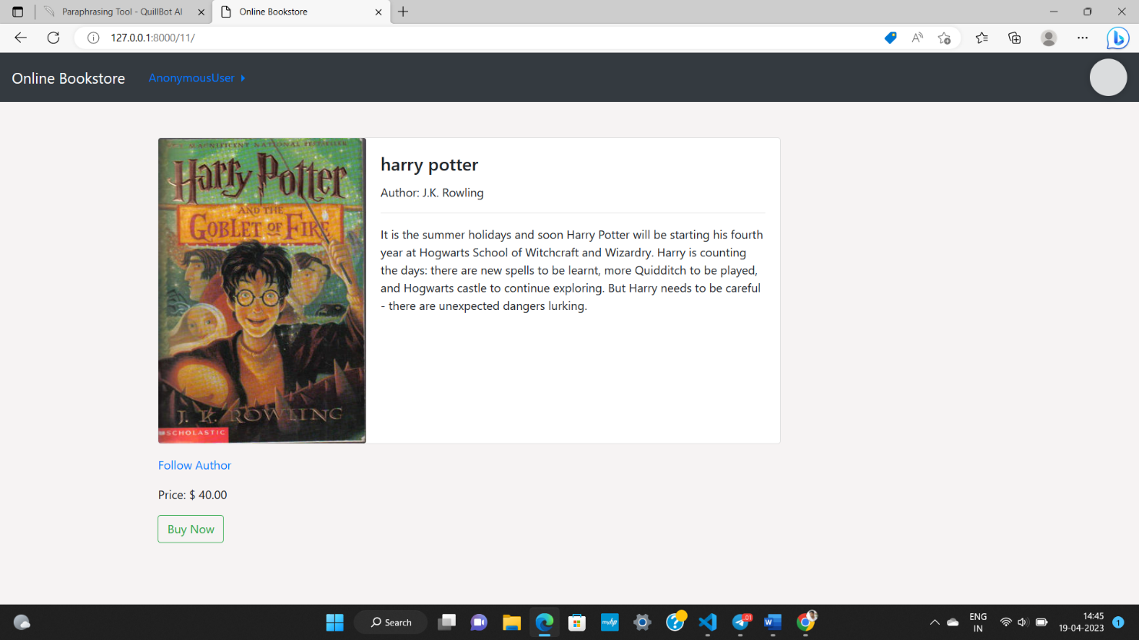

In this page we can see the complete details of a page including name,picture,price,author and details. we have a buy now button and by clicking that we can go to payment options.

**6.4 The checkout page**

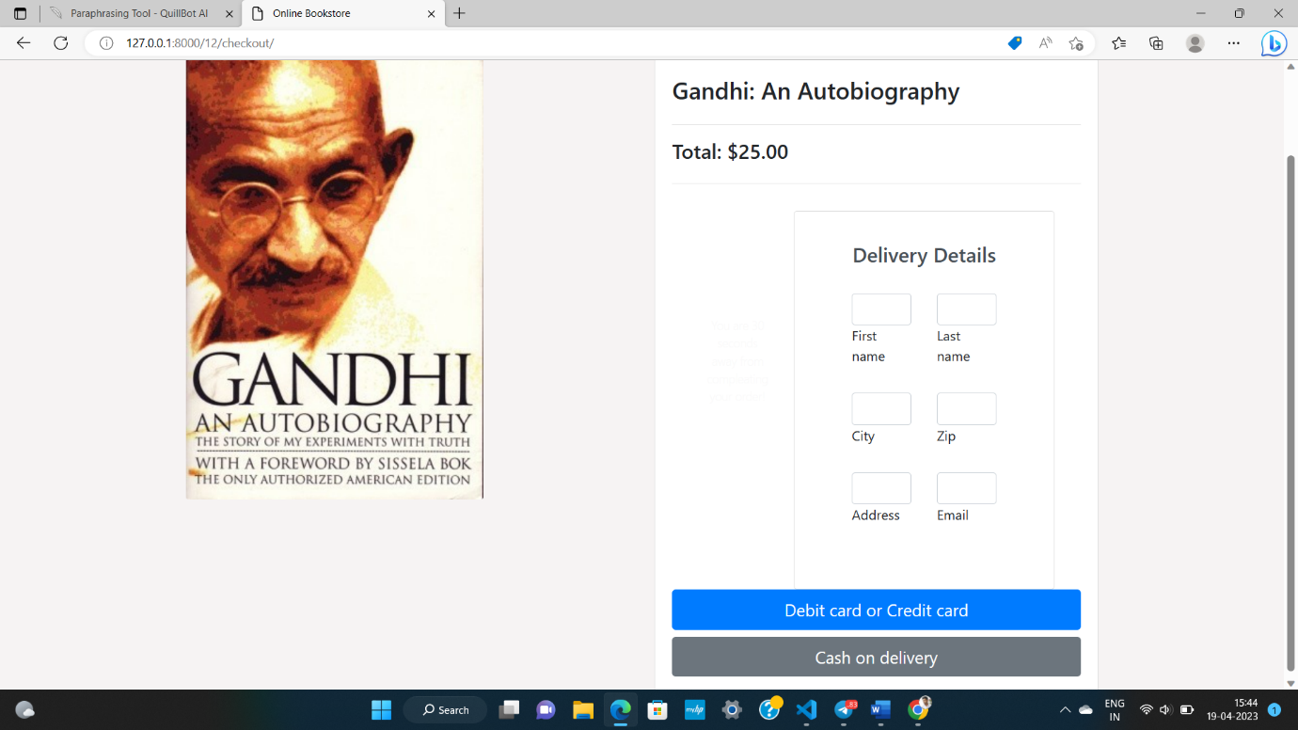

In this page you can fill the shipping address and choose the payment options.

**8.Conclusion**

Online bookstores have many advantages over their physical counterparts, including the ability to shop in one location rather than having to visit various locations, which takes up a lot of time. Online bookstores also help users avoid the issue of books being out of stock at physical stores by having a large number of vendors from various locations sell their books in one location. This project decreases the workload on the store owner by keeping track of the quantity of books available, which books are available, and how many books are bought and sold. It is effective at preserving user records and performing operations on them.

**9.Individual contribution**

Nithin joseph created the frontend by using html,css and javascript.

Stelin francise created the backend by using Django frame work.

**10.Reference list**

**1.** <https://www.w3schools.com/django/>

**2.** <https://www.javatpoint.com/django-tutorial>

**3.** <https://www.w3schools.com/html/html_css.asp>

**4.** <https://www.theguardian.com/books/2019/sep/21/best-books-of-the-21st-century>

**5.** <https://www.tutorialspoint.com/javascript/index.htm>

**6.** <https://www.tutorialspoint.com/django/index.htm>