M/Q-M/V Correlations diagnostics
Table des matières
Abstract 2
Methodology 4
Diagnostics summary 5
Diagnostics 1 — Correlation Matrix of 9 themes LS returns by Universe 7
Diagnostics 2 — Rolling L/S Return Correlations 10
Corr(PMOM, Value) 11
Corr(PMOM, Earnings_Value) 12
Corr(PMOM, Quality) 12
Corr(PMOM, Investment) 13
Diagnostics 3 — Yearly L/S Return Correlations & Super-factor LS Returns 15
Diagnostics 4 — Trailing Corr Predictiveness by DD Regime 21
$\text{Corr}(PMom,Value)$ signal → V and WFP forward returns 22
$\text{Corr}(PMOM,Quality)$ signal → Q and WFP forward returns 23
Appendix 24
Matt’s email 24

Abstract
Matt’s email (see Appendix) from April 15th proposed that negative return correlation between value and momentum implies Value has a mechanical bet AGAINST momentum that should lead to a drag on performance, most particularly in low DD, when momentum should do well.
Value = STREV – PMOM + lagged something
Any stocks whose price rises gets less good on value through the denominator, which explains the V mechanical bet against PMOM.
*Work on part in grey by including math of this.
Matt questioned if neutralizing V to M improved V performance in a low DD environment. Neutralizing V and/or Q to M would make each bet more independent.
In this document, I do a few diagnostics to try to answer if it is promising to test this further.
What the diagnostics show:
-Across the 9 factor themes and over the whole history, LS monthly returns correlations, PMOM/Earnings_Value correlations str the most negative in SPX/MXEA/MXWO. It does not reproduce in MXEF/MXAP, where correlations are close to 0.
-Rolling 12M Corr(PMOM, Value) has a negative mean in SPX and MXWO and has become more negative 2010+. Corr(PMOM, Earnings_value) is negative/more negative in each index.
-Year over year, Corr(PMOM, Value) is positively correlated with Value annual returns across each universe (0.28 to 0.43). Lower correlation goes with weaker V performance. For quality, the relation is mixed.
-Conditioning on DD state, in low DD, Value and WFP have lower forward returns when rolling 12M Corr(PMOM, Value) < 0 in each universe. In high DD, the relation is mixed and counts are lower.
The diagnostics support Matt’s hypothesis about value having a negative bet against momentum, hurting our performance mostly when momentum does best in low DD.

Methodology
Construct long-short holdings for M/Q/V and WFC
*For WFP, I will use static equally weighted M/Q/V rather than using DD timing.

Momentum, quality, value, WFP holdings:
Momentum = PMOM 22%, FMOMA 39%, FMOMFS 39%
Quality = GP1Y 1/3, FCF2A1Y 1/3, Investment 1/3
Value = Earnings_Value 37.5%, FCF_Value 37.5%, TYTD2EV1Y 25%
WFC = Momentum 1/3, Quality 1/3, Value 1/3

With long-short holdings, I compute long-short returns at each EOM for each universe.

L/S Active Weight Construction
For each stock $i$ at date $t$, given factor score $s_{i}$ and variance $σ_{i}^{2}$:
$$h_{i}^{n}=\frac{s_{i}}{σ_{i}^{2}}$$
$$h_{i}^{mc}=h_{i}^{n}-\overset{‾}{h^{n}}$$
$$h^{max}=max⁡\left(∣min⁡(h^{mc})∣,max⁡(h^{mc})\right)$$
$$w_{i}^{active}=\overset{ˉ}{s}⋅\frac{h_{i}^{mc}}{h^{max}}$$
Where:
- $s_{i}$ = LS_Zstd neutralized factor score
- $σ_{i}^{2}$ = average of annualized 1Y and 3Y variance (clipped at 98th percentile)
- $\overset{ˉ}{s}=0.02$ = max active weight cap
- $\overset{‾}{h^{n}}$ = cross-sectional mean of $h^{n}$

Diagnostics summary
Diagnostics 1 — Correlation Matrix of 9 Themes LS returns by Universe
-In SPX/MXEA/MXWO, PMOM/Earnings_Value LS returns have the most negative correlation (-0.37/-28/-0.48). MXEF/MXAP show a flat correlation overall.
-Investment is also negatively correlated with PMOM/FMOMA in SPX/MXEA/MXWO (PMOM -0.12/-0.18-0.30). This is not true in MXEF/MXAP. Profit do not show negative correlations with momentum themes.

Diagnostics 2 — Rolling L/S Return Correlations
PMOM/Value correlations:
-SPX/MXWO have a negative overall correlation mean/median. This is truer in 2010’s and 2020’s.
-MXEA has a flat mean/median overall correlation, but negative in the 2020’s.
-MXEF-MXAP have a positive overall correlation mean/median.
PMOM/Earnings_Value correlations:
-PMOM/Earnings_Value correlations mean/median are more negative than PMOM/Value in each index. Mean/median in negative in each index.
PMOM/Quality correlations:
-SPX/MXWO overall correlation mean/median are slightly positive, while other indexes are more positive.
PMOM/Investment correlations
-PMOM/Investment overall correlations mean/median are negative in SPX/MXEA/MXWO, as opposed to PMOM/Quality.

Diagnostics 3 — Yearly L/S Return Correlations & Factor Returns
-Corr(PMOM, V) is positively correlated with Value returns between 0.28 and 0.43, depending on index. This means lower Corr(PMOM, V) tends to produce lower value returns in each index.
-Corr(PMOM, Q) is not always highly positively correlated with Quality returns (mixed signals). This means we can’t draw the same conclusion for quality as we do for value.

Diagnostics 4 — Trailing Corr Predictiveness by DD Regime
Corr(PMOM, Value):
-In low DD, where Momentum does best, both Value and WFP have lower return when Corr(PMOM, Value) is <0 in each index.
-In high DD, Value has higher return when Corr(PMOM, Value) >0 in SPX/MXEA/MXWO, but not in MXEF/MXAP. Count is low to draw conclusions on this.
-Overall, this probably goes in favor of neutralizing value to PMOM.
Corr(PMOM, Quality):
-In low DD, where Momentum does best, Quality has lower return when Corr(PMOM, Quality) <0 is SPX, but not elsewhere.
-This probably does not go in favor of neutralizing quality to PMOM.

Diagnostics 1 — Correlation Matrix of 9 themes LS returns by Universe
What: Full-history pairwise L/S returns correlation matrices of the 9 theme factors, by universe
9 themes (3 Value × 3 Quality × 3 Momentum):
- Value: Earnings_Value, FCF_Value, TYTD2EV1Y
- Quality: GP1Y, FCF2A1Y, Investment
- Momentum: PMOM, FMOMA, FMOMFS
Correlations computed:
L/S Return Correlation — full-sample correlation of monthly L/S return series (9×9 matrix)
Output: 9×9 heatmap tables per universe.

Summary:
-In SPX/MXEA/MXWO, PMOM/Earnings_Value LS returns have the most negative correlation (-0.37/-28/-0.48). MXEF/MXAP show a flat correlation overall.
-Investment is also negatively correlated with PMOM/FMOMA in SPX/MXEA/MXWO (PMOM -0.12/-0.18-0.30). This is not true in MXEF/MXAP. Profit do not show negative correlations with momentum themes.

SPX Index:
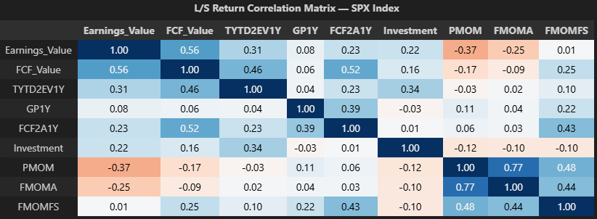
-PMOM/Earnings_Value are the most negatively correlated (-0.37), followed by FMOMA/Earnings_Value (-0.25).
-Investment is also negatively correlated with all 3 momentum themes (-0.12/-0.10/-0.10) but not profit.
MXEA Index:
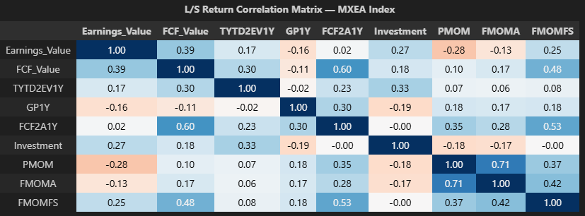
-PMOM/Earnings_Value are the most negatively correlated (-0.28). FMOMA/Earnings_Value is also negatively correlated to a smaller degree (-0.13).
-Investment is negatively correlated with PMOM/FMOMA (-0.18/-0.17)) but profit is not.

MXWO Index:
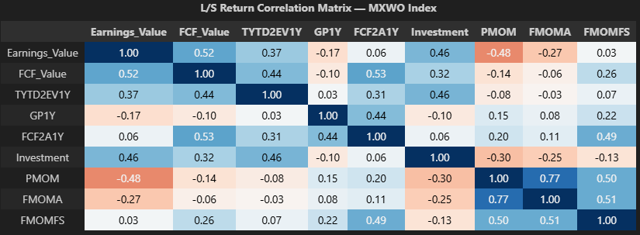
-PMOM/Earnings_Value are the most negatively correlated (-0.48). FMOMA/Earnings_Value has a negative correlation too (-0.27).
-Investment is also negatively correlated with all 3 momentum themes (-0.30/-0.25/-0.13) but profit is not.

MXEF Index:
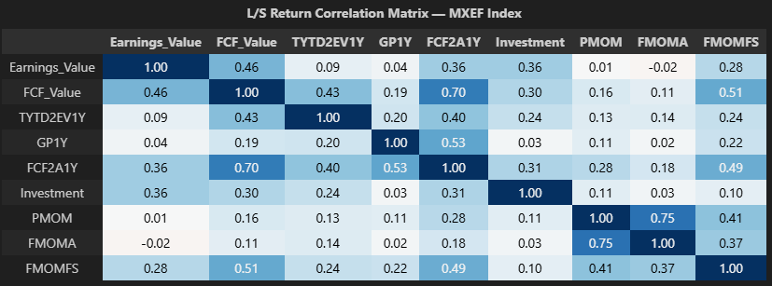
-PMOM/Earnings_Value have a correlation of 0.01. FMOMA/Earnings_Value have a correlation of -0.02.
-Investment has a small positive correlation with 3 momentum themes.
-Negative correlations we saw in SPX/MXEA/MXWO do not reproduce here.

MXAP Index:
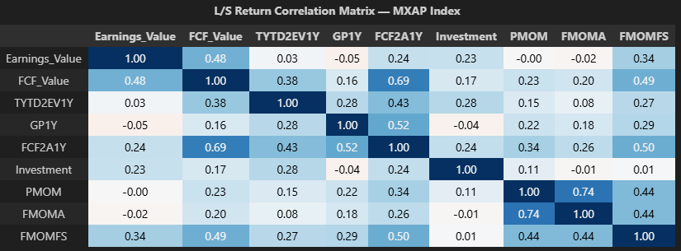
-PMOM/Earnings_Value have a correlation of 0.00. FMOMA/Earnings_Value have a correlation of -0.02.
-Investment has a small positive correlation with PMOM (0.11) and correlation of +/-0.01 with FMOMA/FMOMFS.
-Negative correlations we saw in SPX/MXEA/MXWO do not reproduce here.

Diagnostics 2 — Rolling L/S Return Correlations
What: Rolling 12m correlations of monthly L/S returns between PMOM vs Value and PMOM vs Quality.
Correlations computed:
- $\text{Corr}(R_{t}^{PMOM},R_{t}^{Value})$ — rolling 12m windows
- $\text{Corr}(R_{t}^{PMOM},R_{t}^{Earnings_Value})$ — rolling 12m windows
- $\text{Corr}(R_{t}^{PMOM},R_{t}^{Q})$ — rolling 12m windows
- $\text{Corr}(R_{t}^{PMOM},R_{t}^{Investment})$ — rolling 12m windows
Output: Summary distribution tables (Mean, Std, Min, P25, Median, P75, Max) per universe × window + time-series charts.

Summary:
PMOM/Value correlations:
-SPX/MXWO have a negative overall correlation mean/median. This is truer in 2010’s and 2020’s.
-MXEA has a flat mean/median overall correlation, but negative in the 2020’s.
-MXEF-MXAP have a positive overall correlation mean/median.
PMOM/Earnings_Value correlations:
-PMOM/Earnings_Value correlations mean/median are more negative than PMOM/Value in each index. Mean/median in negative in each index.
PMOM/Quality correlations:
-SPX/MXWO overall correlation mean/median are slightly positive, while other indexes are more positive.
PMOM/Investment correlations
-PMOM/Investment overall correlations mean/median are negative in SPX/MXEA/MXWO, as opposed to PMOM/Quality.

Corr(PMOM, Value)
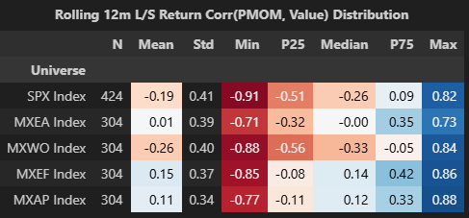
-SPX/MXWO have a negative PMOM/Value correlation mean/median. MXEA have a flat mean/median and MXEF/MXAP have a positive mean/median.
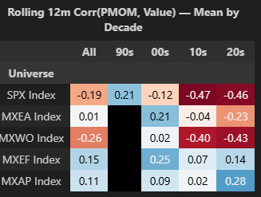
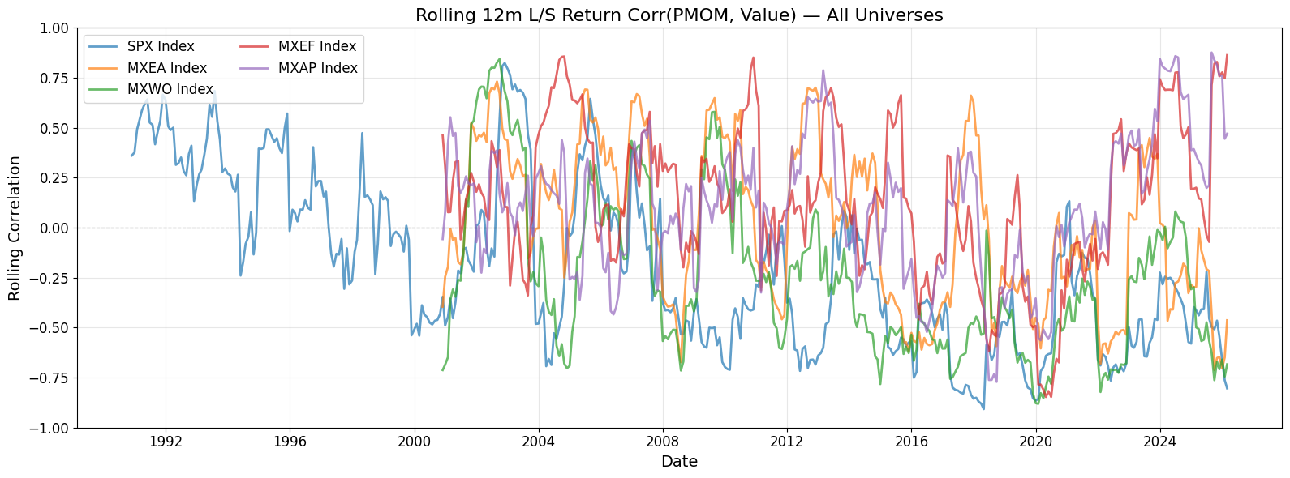
-SPX/MXWO PMOM/Value correlation became more negative 2010’s+. It was positive in the 90’s.
-MXEA PMOM/Value became more negative in the 2020’s, to a smaller degree.

Corr(PMOM, Earnings_Value)
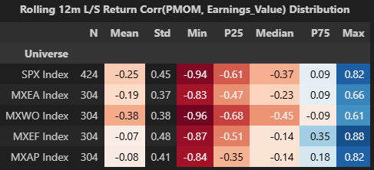
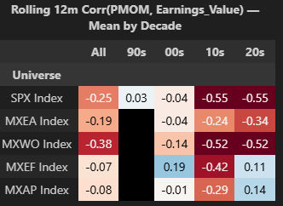
-PMOM/Earnings_Value correlations mean/median are more negative than PMOM/Value in each index. Mean/median in negative in each index.

Corr(PMOM, Quality)
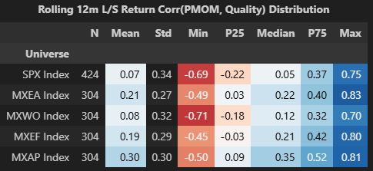
-SPX/MXWO PMOM/Quality mean/median are slightly positive, while other indexes are more positive.
-We could use Investment only instead of Quality since we saw in diagnostic 1 that it was returns were negatively correlated with PMOM.
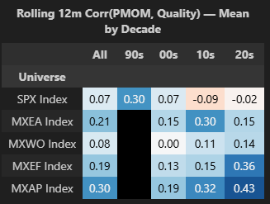
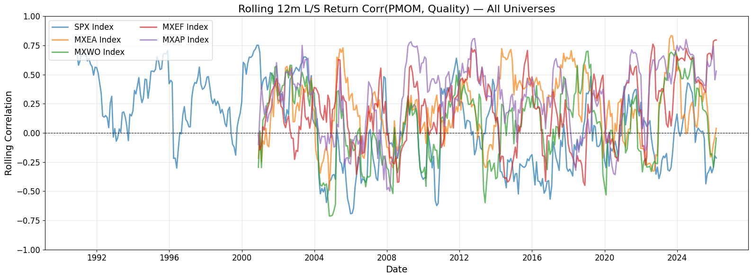

Corr(PMOM, Investment)
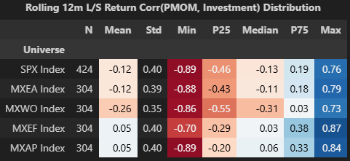
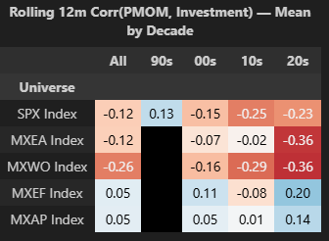
-PMOM/Investment correlations mean/median are negative in SPX/MXEA/MXWO, as opposed to PMOM/Quality.

Diagnostics 3 — Yearly L/S Return Correlations & Super-factor LS Returns
What: Within-year monthly L/S return correlations and cumulative yearly factor returns.
Correlations computed:
- $Corr(R_{m}^{PMOM},R_{m}^{Value})$ — yearly (within-year monthly returns)
- $Corr(R_{m}^{PMOM},R_{m}^{Earnings_Value})$ — yearly (within-year monthly returns)
- $Corr(R_{m}^{PMOM},R_{m}^{Quality})$ — yearly (within-year monthly returns)
- $Corr(R_{m}^{PMOM},R_{m}^{Investment})$ — yearly (within-year monthly returns)
Output: Yearly table for each universe with correlations + M/PMOM/V/EV/Q/Inv/WFP returns. Cross-correlation matrix of yearly correlations vs yearly returns.

Summary:
-Corr(PMOM, V) is positively correlated with Value returns between 0.28 and 0.43, depending on index. This means lower Corr(PMOM, V) tends to produce lower value returns in each index.
-Corr(PMOM, Q) is not always highly positively correlated with Quality returns (mixed signals). This means we can’t draw the same conclusion for quality as we do for value.

SPX Index:
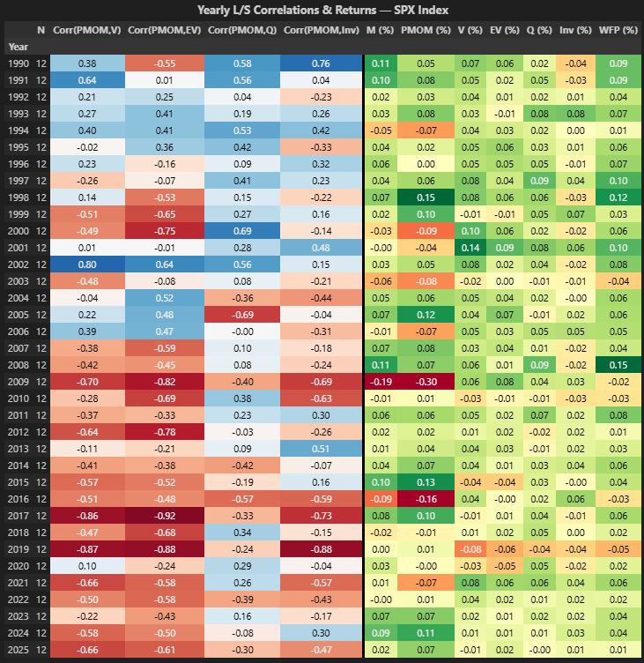
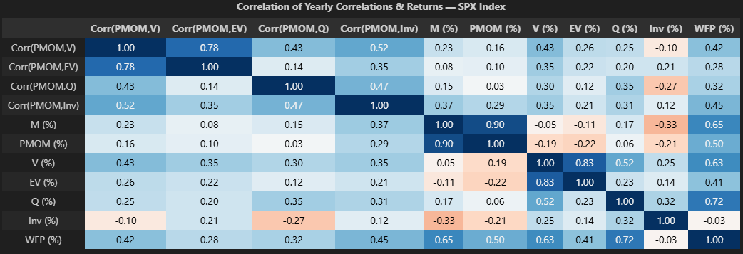
-Corr(PMOM, V) is positively correlated with V returns (0.43) and positively correlated with WFP returns (0.42).
-Corr(PMOM, Q) is positively correlated with Q returns (0.35) and positively correlated with WFP returns (0.32).
MXEA Index:
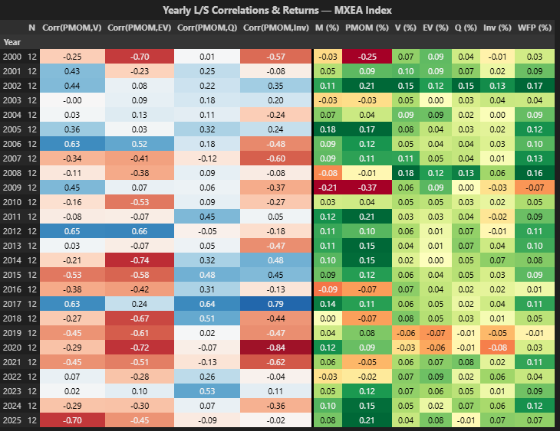
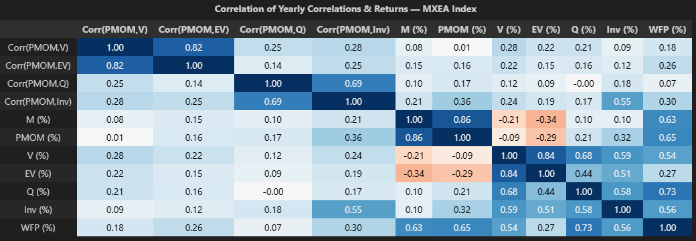
-Corr(PMOM, V) is positively correlated with V returns (0.28) and positively correlated with WFP returns (0.18).
-Corr(PMOM, Q) is uncorrelated with Q returns (0.00) and uncorrelated with WFP returns (0.07).

MXWO Index:
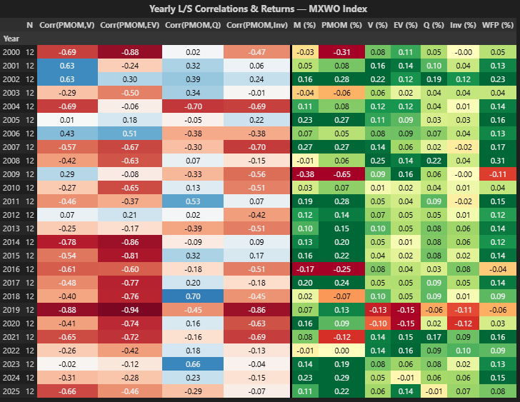
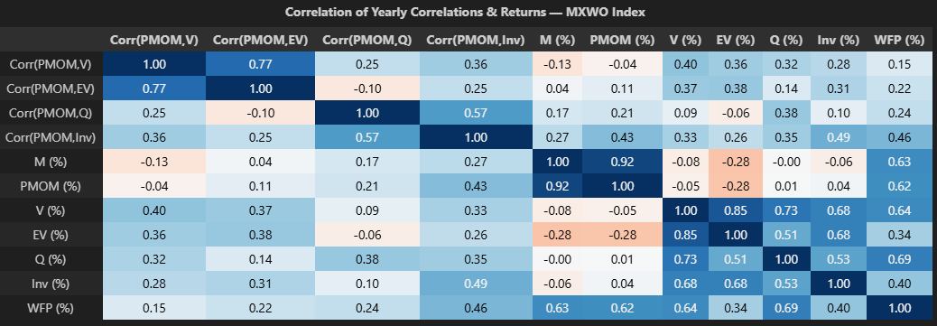
-Corr(PMOM, V) is positively correlated with V returns (0.40) and positively correlated with WFP returns (0.15).
-Corr(PMOM, Q) is positively correlated with Q returns (0.38) and positively correlated with WFP returns (0.24).

MXEF Index:
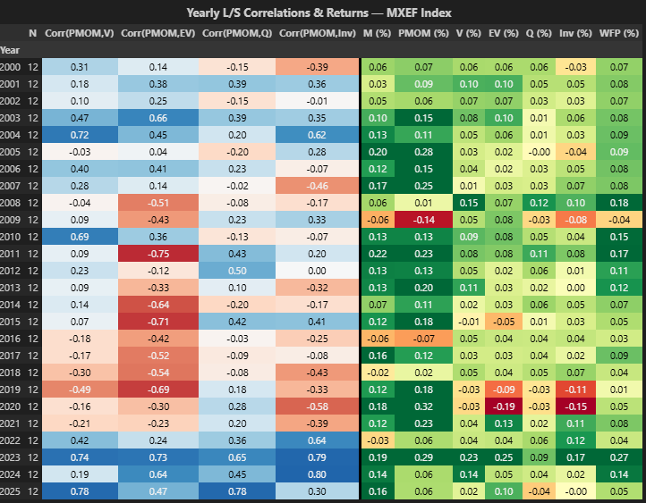
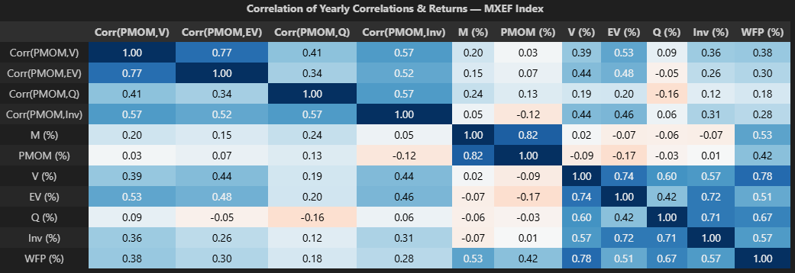
-Corr(PMOM, V) is positively correlated with V returns (0.39) and positively correlated with WFP returns (0.38).
-Corr(PMOM, Q) is negatively correlated with Q returns (-0.16) and positively correlated with WFP returns (0.18).

MXAP Index:
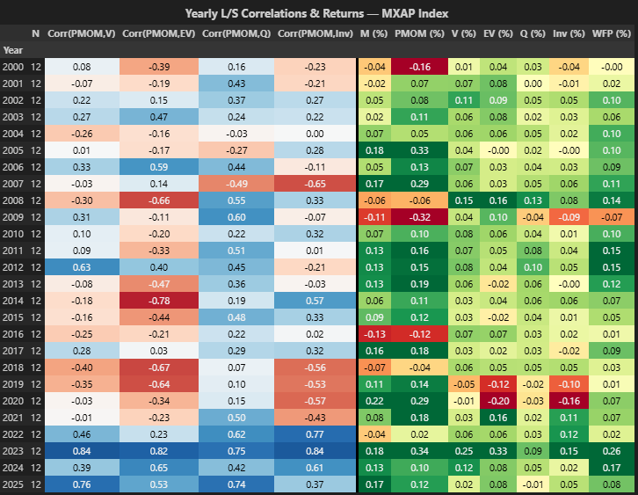
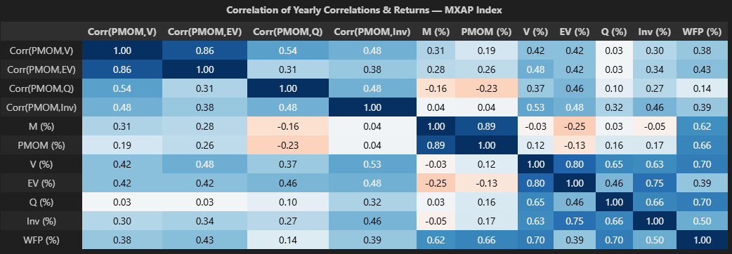
-Corr(PMOM, V) is positively correlated with V returns (0.42) and positively correlated with WFP returns (0.38).
-Corr(PMOM, Q) is positively correlated with Q returns (0.10) and positively correlated with WFP returns (0.14).

Diagnostics 4 — Trailing Corr Predictiveness by DD Regime
What: Does the sign of the trailing 12m rolling correlation between PMom and Value (or Quality) predict next-month factor returns? Conditioned on DD state.
Signal: Trailing 12m rolling $\text{Corr}(R^{PMOM},R^{V})_{t-1}$ and $\text{Corr}(R^{PMOM},R^{Q})_{t-1}$ (lagged 1 month)
Split: Sign-based — Corr < 0 vs Corr ≥ 0
Returns shown (annualized %):
- For $\text{Corr}(M,V)$ signal → V and WFP forward returns
- For $\text{Corr}(M,Q)$ signal → Q and WFP forward returns
States: LOW_DD, HIGH_DD, All DD
Output: Per universe, a table with Corr<0 / Corr≥0 / Δ columns, grouped by DD state.

Summary:
Corr(PMOM, Value):
-In low DD, where Momentum does best, both Value and WFP have lower return when Corr(PMOM, Value) is <0 in each index.
-In high DD, Value has higher return when Corr(PMOM, Value) >0 in SPX/MXEA/MXWO, but not in MXEF/MXAP. Count is low to draw conclusions on this.
-Overall, this probably goes in favor of neutralizing value to PMOM.
Corr(PMOM, Quality):
-In low DD, where Momentum does best, Quality has lower return when Corr(PMOM, Quality) <0 is SPX, but not elsewhere.
-This probably does not go in favor of neutralizing quality to PMOM.

$\text{Corr}(PMom,Value)$ signal → V and WFP forward returns
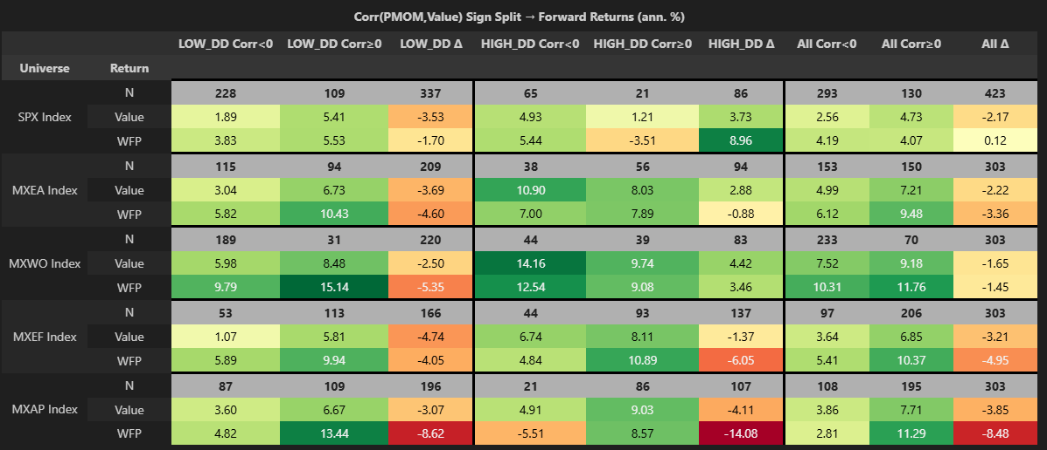
-In low DD, where Momentum does best, both Value and WFP have lower return when Corr(PMOM, Value) is <0 in each index.
-In high DD, Value has higher return when Corr(PMOM, Value) >0 in SPX/MXEA/MXWO, but not in MXEF/MXAP. Count is low to draw conclusions on this.
-Overall, this probably goes in favor of neutralizing value to PMOM.

$\text{Corr}(PMOM,Quality)$ signal → Q and WFP forward returns
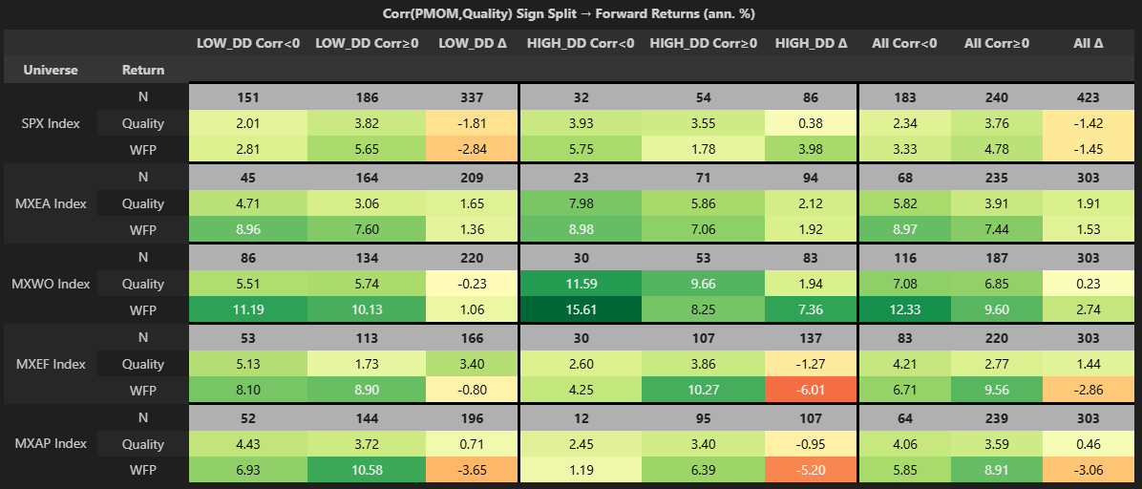
-In low DD, where Momentum does best, Quality has lower return when Corr(PMOM, Quality) <0 is SPX, but not elsewhere.
-This probably does not go in favor of neutralizing quality to PMOM.

Appendix

Matt’s email
Once in my prior job, I started to look at the extent to which a negative correlation of Q or V with M hurt performance when in lowDD (when momentum should do well), and in some initial results found this to be true.
For example, when correl(V,M)<<0, neutralizing V to M improved V performance in a lowDD environment.

Why does this make sense?
Say correl(V,M)=r(V,M)= - 0.5 in a lowDD environment (typical for some of our strategies).
lowDD means M should do well, so with this correlation of -0.5 means V has a mechanical bet AGAINST momentum that should lead to a drag on performance because momentum does well in this environment.

Connection to live strategy performance
I was reminded of this result by looking at the most recent attribution results by region, where basically it looks like r(V,M) and r(Q,M) tended to be lower in strategies that have done less well.
For this I took the longest possible history results from Felix’s powerBI tool (BELOW-APPENDIX).
Copied Q and V returns into a spreadsheet (note these are NOT annualized)
By eye estimated average correlations between M and Q or V (r(X,M) below, X = Q or V).
Then compared results (below).
We can see that within each of Q and V, there is a strong correlation between return and r(X,M).
Sample sizes here are not large of course (N=8), but sensibility is strong (negative correl of Q or V with M in a lowDD environment):
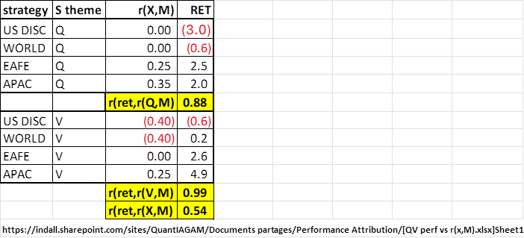

What might we do about this?
Basically, we could neutralize Q to M and Neutralize V to M to “fix” this, and make these three bets (M, Q, V) more independent (would want to empirically check what all 3 pairwise correlations look like after this, especially Q vs V).
In other words, for each of Q and V, add M to the list of RHS variables used in neutralization.
Some details:
Do we neutralize X only if r(X,M)<0, OR regardless of r(X,M)? (again, for X in {Q, V})
former approach allows Q, V to benefit from right way exposure to momentum, at cost of perhaps loading too much on M.
note we could backtest w/wo the r<0 restriction to compare empirically…..
(Notradezone details, vs impact around r=0 too small to care).
Do we neutralize X only in a lowDD environment, OR always?
In a highDD environment, betting AGAINST M likely to help IF r(X,M)<0 (if r(X,M)>0 then NOT neutralizing likely HURTS…)
Note we could neutralize in all environments, then analyze results by DD state, though empirics here complicated by whether r(X,M)< or >0…
For M in neutralization, use overall M, or use PMOM? Use of PMOM links effects more closely to DD state.
Note that neutralization to M will impact turnover of Q or V to extent that |r(M,X)|>0 – i.e. the higher the magnitude of correlation with M… (not clear to me if TO will rise or fall here, as we’re REMOVING a higher TO component in M).
In the end, it might be cleanest to simply neutralize Q and V to M always, though I’d like to digest this more first. If we did that, r(Q,V) might end even higher than it is now, would have decide how to address that.

Follow up email
Though PERHAPs the case could be made to neutralize Q to pmom if and only if r(pmom,Q) is <0, done individually by Q factor AND/OR outside of a lowDD state.
Why would you do this just for Q, but not for V?

ALSO in quality some pieces have more -ve correlations than others (eg investment).
R(PMOM, Profit) are positively correlated on full history, but r(PMOM, Investment) is not.

Diagnostic 2:
The tables below would be well complemented by a Value IR by region by decade table, results very easy to visualize (AND could add the correlation between the correl(M,V) table and the IR(V) table)

Corr(PMOM, Value):
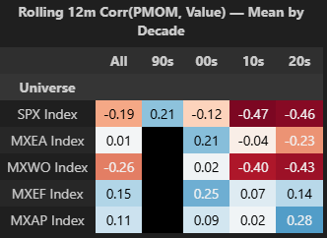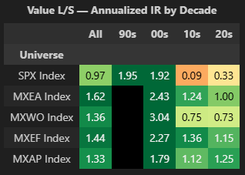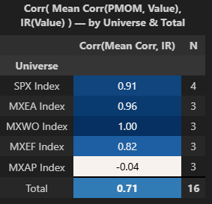
Corr(PMOM, Quality):
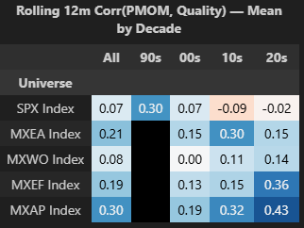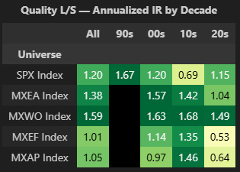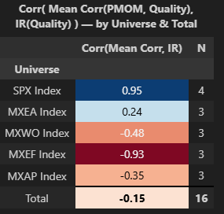

Corr(PMOM, Earnings_value)
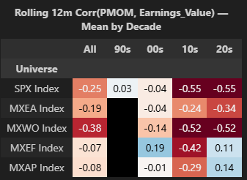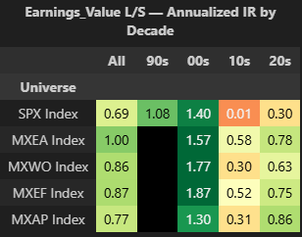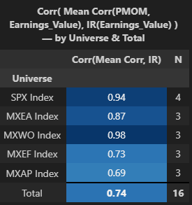
Corr(PMOM, Investment):
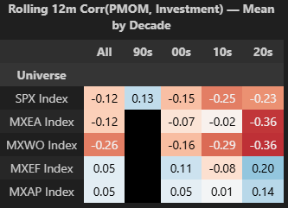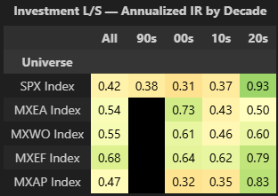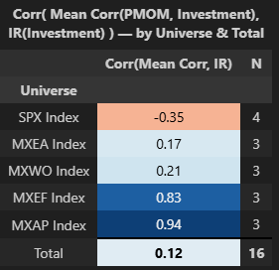

Diagnostic 3:
MK: Below I cut out a few columns to “see” results better. Super interesting to see
- -ve r(M,V) in years like 99/00 when US quant tended to struggle, similar 2003,
- The most -ve r(M,Q) in the table is 2005, a lowDD year when Quality struggled
- In general, r(M,V) and r(M,Q) are lower later than earlier, consistent with the US becoming more challenging
- (I’D LIKE TO DO AVERAGES BY DECADE HERE…)

FS: I added a table that shows averages by decade below.

SPX Index:

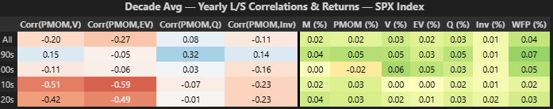
MXEA Index:

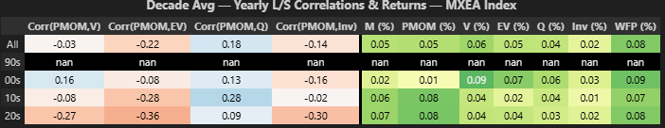
MXWO Index:

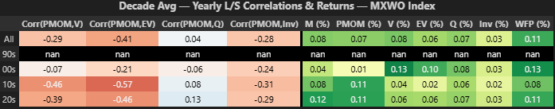
MXEF Index:

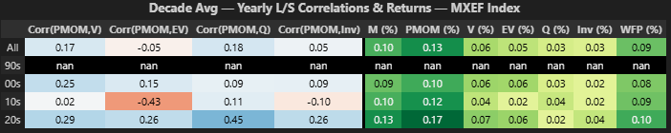
MXAP Index:

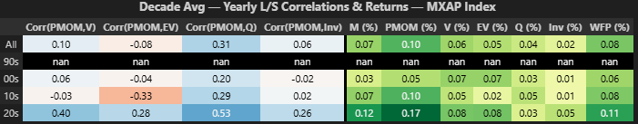

Diagnostic 4:
VALUE:
-In low DD, where Momentum does best, both Value and WFP have lower return when Corr(PMOM, Value) is <0 in each index.
-In high DD, Value has higher return when Corr(PMOM, Value) >0 in SPX/MXEA/MXWO, but not in MXEF/MXAP. Count is low to draw conclusions on this.
-Overall, this probably goes in favor of neutralizing value to PMOM.
MK: YOUR LOW DD WORDS DON’T DO THIS JUSTICE – VALUE RETURNS ARE ROUGHLY 1.5X – 5X HIGHER IN >0 THAN <0 CORRELATIONS, HIGHER IN EVERY CASE AND HIGHER ON AVERAGE BY ROUGHLY 2.5X, THAT’S HUGE!
FS: Fair enough. I will modify my comment for yours in the document.
MK: GOOD TO ADD MEAN/MEDIAN ROWS TO A TABLE LIKE THIS.
FS: Below I reprinted the tables both for quality and value with a mean/median row.
QUALITY:
-In low DD, where Momentum does best, Quality has lower return when Corr(PMOM, Quality) <0 is SPX, but not elsewhere.
-This probably does not go in favor of neutralizing quality to PMOM.
MK; WE LIKELY WANT TO ISOLATE QUALITY FROM PMOM IN LOWDD (NEUTRALIZE) EVEN IF IT ONLY WOULD HAVE CLEARLY HELPED FOR US BACKTESTS.

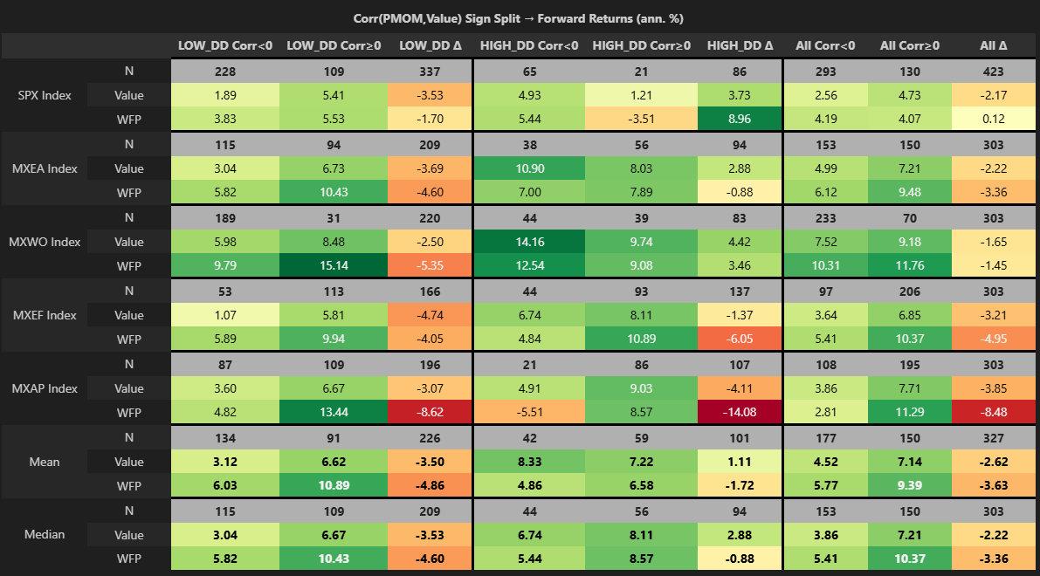
-On average in low DD, value returns are more than 2X in >0 than in <0. They are higher in every case.
