PMOM Neutralization
Table des matières
Abstract 2
Methodology 3
Summary 4
1 Factor/Themes/Super Factors correlations with PMOM 5
1.1 Cross sectional theme score correlations with PMOM 5
1.2 L/S returns correlations with PMOM 7
2 Super factor/factor theme LS performance with/without PMOM neutralization 9
Full sample without DD state 9
Conditional on DD state 13
3 WFP performance with/without neutralization 18
4 Annual returns – WFP variants vs PMOM 24
5.2 Corr universe mean correlation 29

Abstract

Methodology
Baseline: Factor scores neutralized to standard risk factors, but not to PMOM nor 12M MOM.
_P: Baseline that is also neutralized to PMOM.
_M: Baseline that is also neutralized to Mom12MX1M

I will compare LS returns of a baseline version of factor theme/super factor/WFC (Weighted factor composite) with the corresponding versions that are neutralized either to PMOM or Mom12MX1M.
The PMOM/Mom12MX1M factor that were used for neutralization are z-score factors that are neutralized to other risk factors and standardized.

*I use the term weighted factor composite, as opposed to weighted factor portfolio because it is more exact in the sense that these are not portfolios…they are just composites of each super factors. They are the z-score that would maximized in an optimization in order to build a portfolio.

Construct long-short holdings for M/Q/V and WFC
*For WFC, I will use static equally weighted M/Q/V rather than using DD timing.

Momentum, quality, value, WFC holdings:
Momentum = PMOM 22%, FMOMA 39%, FMOMFS 39%
Quality = GP1Y 1/3, FCF2A1Y 1/3, Investment 1/3
Value = Earnings_Value 37.5%, FCF_Value 37.5%, TYTD2EV1Y 25%
WFC = Momentum 1/3, Quality 1/3, Value 1/3

L/S Active Weight Construction
For each stock $i$ at date $t$, given factor score $s_{i}$ and variance $σ_{i}^{2}$:
$$h_{i}^{n}=\frac{s_{i}}{σ_{i}^{2}}$$
$$h_{i}^{mc}=h_{i}^{n}-\overset{‾}{h^{n}}$$
$$h^{max}=max⁡\left(∣min⁡(h^{mc})∣,max⁡(h^{mc})\right)$$
$$w_{i}^{active}=\overset{ˉ}{s}⋅\frac{h_{i}^{mc}}{h^{max}}$$
Where:
- $s_{i}$ = LS_Zstd neutralized factor score
- $σ_{i}^{2}$ = average of annualized 1Y and 3Y variance (clipped at 98th percentile)
- $\overset{ˉ}{s}=0.02$ = max active weight cap
- $\overset{‾}{h^{n}}$ = cross-sectional mean of $h^{n}$

Summary

1 Factor/Themes/Super Factors correlations with PMOM

1.1 Cross sectional theme score correlations with PMOM
Correlation average across dates:
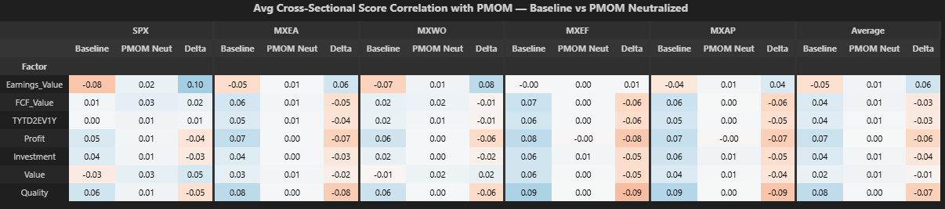
With PMOM neutralization versus baseline:
-Corr(Earnings_Value, PMOM) goes UP from -0.05 to +0.01 on average (far right column).
-On average across universes and dates, all factor theme Corr(Factor theme, PMOM) are between 0.00 and 0.01.

Correlation standard deviation across dates:
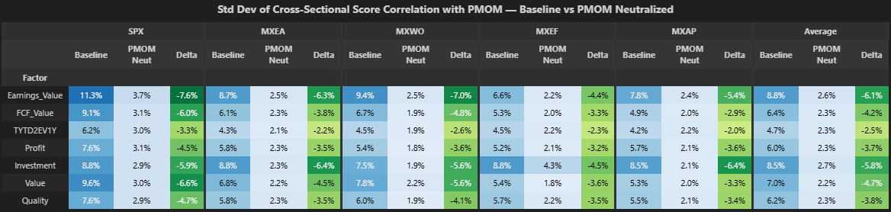
With PMOM neutralization versus baseline:
-Standard deviation of Corr(Factor theme, PMOM) went from a range of 4.7-8.8% to a range of 2.2-2.7%.

All in all, corr(Factor theme, PMOM) goes close to 0 with PMOM neutralization and standard deviation of Corr(Factor theme, PMOM) decreases by ~60%. This is a good confirmation that the neutralization to PMOM worked in eliminating the factor themes exposure to PMOM.

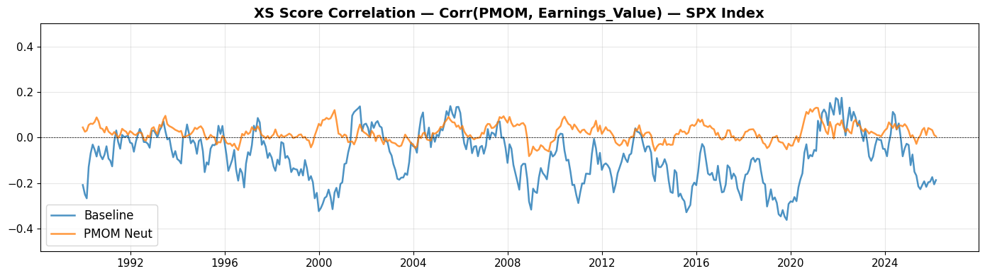
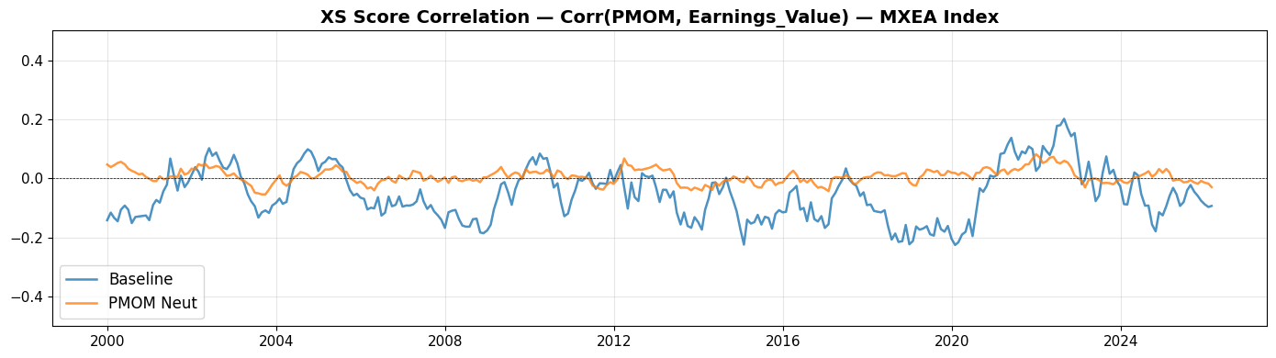
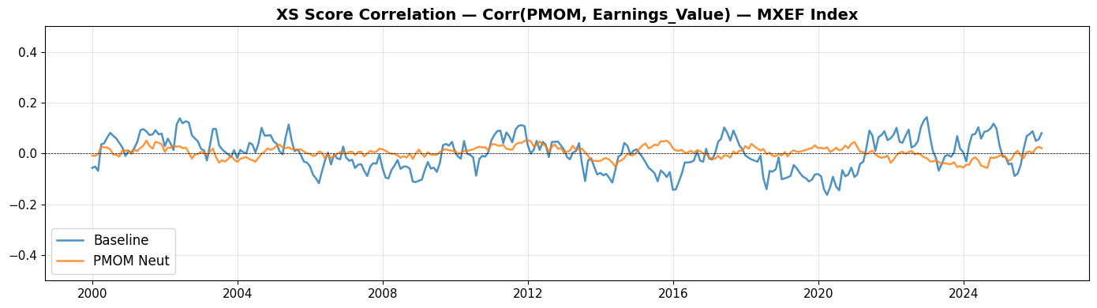

1.2 L/S returns correlations with PMOM
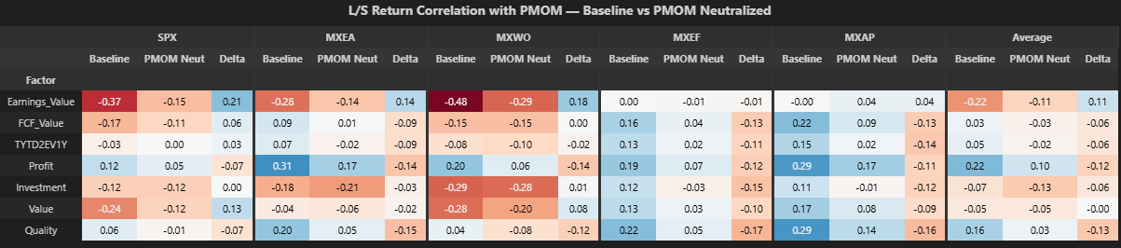
With PMOM neutralization versus baseline:
-Corr(Earnings_Value, PMOM) goes UP from -0.22 to -0.11 on average across universes (far right column).
-Corr(FCF_Value/ TYTD2EV1Y, PMOM goes DOWN from 0.03/0.05 to -0.03/-0.02 on average. This effect is marginal.
-Corr(Investment, PMOM) goes DOWN from -0.07 to -0.13 on average,
-All in all, PMOM neutralization only reduces correlation of Earnings_value with PMOM LS returns (and Value, to a smaller degree).

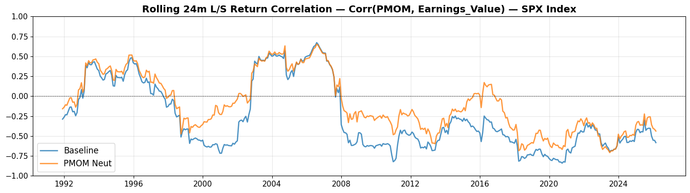
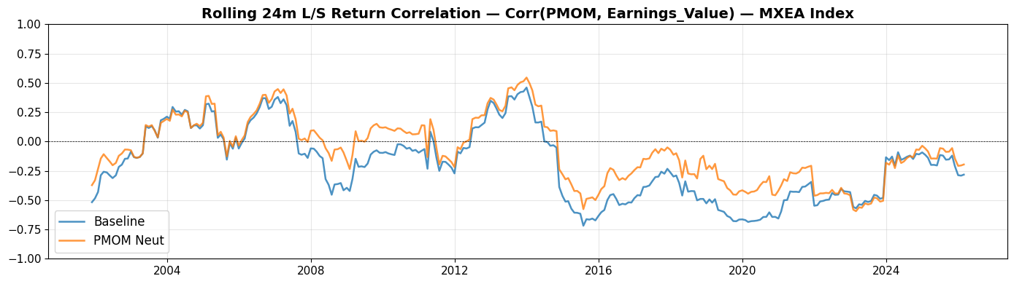
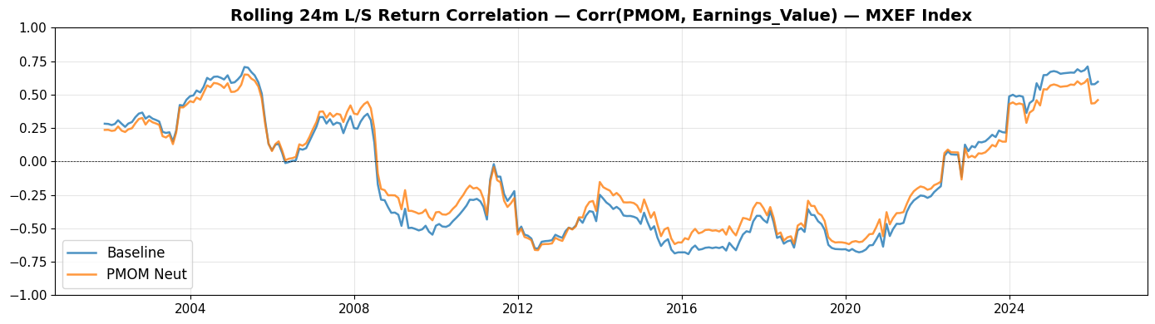
-Looking at the graphs, the trends in LS return correlations are still very similar between baseline and PMOM neutralization version.

2 Super factor/factor theme LS performance with/without PMOM neutralization

Full sample without DD state
This section looks at factor theme LS performance (returns/vol/IR) with versus without neutralization to PMOM. I don’t split the universe into low/high DD state yet. This will come in the following section.
Baseline: Factor theme WIHTOUT PMOM neutralization.
PMOM neut: Factor theme WITH PMOM neutralization.

Summary:
With PMOM neut vs baseline:
-On average, only earnings_value have its IR improved (IR +0.06). Return is decreased -2 bps on average.
-Earnings_Value has its IR modestly improved in each universe (IR between +0.04 to +0.08)
-Value IR is unchanged on average. It is slightly improved in SPX/MXWO, but not elsewhere.
-Profit/Investment/Quality has decreased IR -0.05/-0.02/-0.07 on average.

-The improvement in Earnings_Value IR is mostly due to a decrease in volatility as return is increased in SPX/MXEA (+7/+6 bps), but not in MXEA/MXWO/MXAP (-8/-11/-3 bps).

Average across universes:
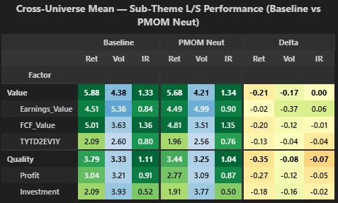
With PMOM neut vs baseline:
-There is a modest IR improvement of +0.06 in Earnings_Value. Returns are unchanged (-2 bps) and vol is decreased -37 bps.
-Value’s IR is unchanged.
-FCF_Value/TYTD2EV1Y/Profit/Investment all have lower return and lower IR with PMOM neutralization (IR between -0.01 and -0.05)

SPX Index:
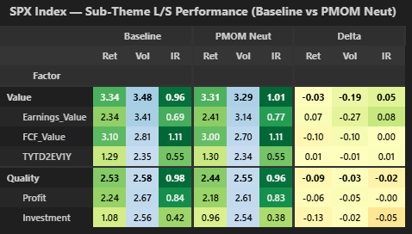
With PMOM neut vs baseline:
-There is an IR improvement of +0.08 in Earnings_Value. Returns are slightly increased +7 bps and vol is decreased -27 bps.
-Value IR is increased +0.05.
-FCF_Value/TYTD2EV1Y/Profit have unchanged IR.
-Investment IR is decreased -0.05, profit unchanged and quality decreased -0.02.

MXEA Index:
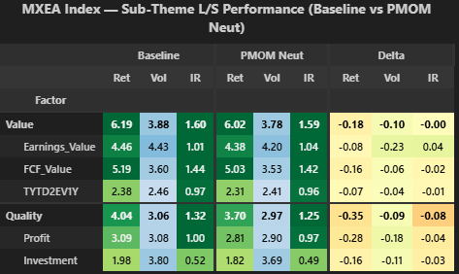
With PMOM neut vs baseline:
-There is a modest IR improvement of +0.04 in Earnings_Value. Returns are slightly decreased -8 bps and vol is decreased by 23 bps.
-Value IR is unchanged.
-FCF_Value/TYTD2EV1Y/Profit/Investment all have lower return and lower IR with PMOM neutralization (IR between -0.01 and -0.04).

MXWO Index:
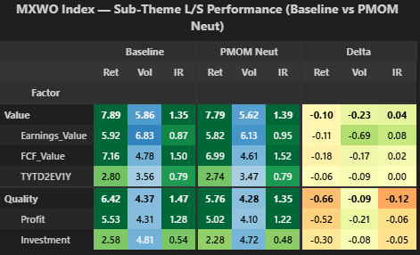
With PMOM neut vs baseline:
-There is a modest IR improvement of +0.08 in Earnings_Value. Returns are decreased -11 bps and vol is decreased -69 bps.
-Value IR is slightly increased +0.04.
-FCF_Value/TYTD2EV1Y IR is +0.02/0.00.
-Profit/Investment IR is decreased -0.06/-0.05.

MXEF Index:
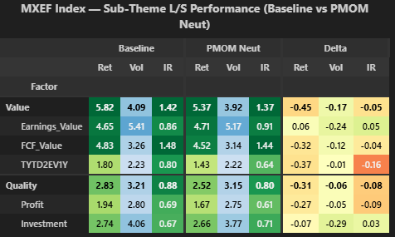
With PMOM neut vs baseline:
-There is a modest IR improvement of +0.05 in Earnings_Value. Returns are slightly increased +6 bps and vol is decreased -24 bps.
-Value IR is decreased -0.05.
-FCF_Value/TYTD2EV1Y IR is decreased -0.04/-0.16.
-Profit IR is decreased -0.09 but investment IR is increased +0.03.

MXAP Index:
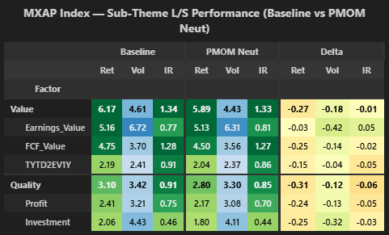
With PMOM neut vs baseline:
-There is a modest IR improvement of +0.05 in Earnings_Value. Returns are slightly decreased -3 bps and vol is decreased -42 bps.
-Value IR is decreased -0.01.
-FCF_Value/TYTD2EV1Y/Profit/Investment all have lower return and lower IR (IR between -0.02 and -0.05).

Conditional on DD state
This section looks at factor theme LS performance (returns/vol/IR) with versus without neutralization to PMOM, conditional to DD state.
Baseline: Factor theme WIHTOUT PMOM neutralization.
PMOM neut: Factor theme WITH PMOM neutralization.

Summary:
Low DD:
-On average Earnings_Value has return increased +22 bps, vol deceased -42 bps and IR increased +0.10.
-The direction is the same in each universe (return +, vol -, IR +).
-On average, Value has decreased return -18 bps, decreased vol -16 bps, unchanged IR.
-FCF_Value/TYTD2EV1Y/Profit/Investment all have decreased IR on average.
High DD:
-Earnings_Value’s IR is decreased on average -0.07.
-FCF_Value/TYTD2EV1Y/Profit/Investment all have IR between +0.00 to +0.06.

Average across universes:
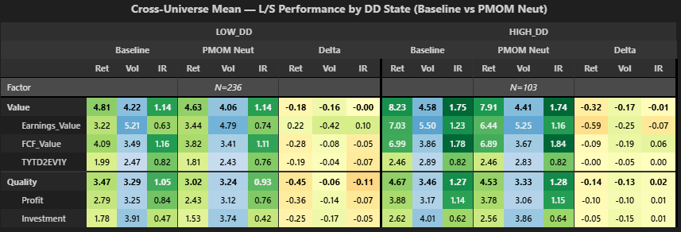
With PMOM neut vs baseline:
Low DD:
-Earnings_Value’s return is increased +22 bp, Vol decreased -42 bps and IR increased +0.10.
-Value’s return is decreased -18 bps, vol is decreased -16 bps and IR is unchanged.
-FCF_Value/TYTD2EV1Y/Profit/Investment all have decreased IR between -0.05 and -0.07.
High DD:
-Earnings_Value/Value’s IR is decreased -0.07/-0.01.
- FCF_Value/TYTD2EV1Y/Profit/Investment have slightly increased IR between +0.00 to +0.06.

SPX Index:
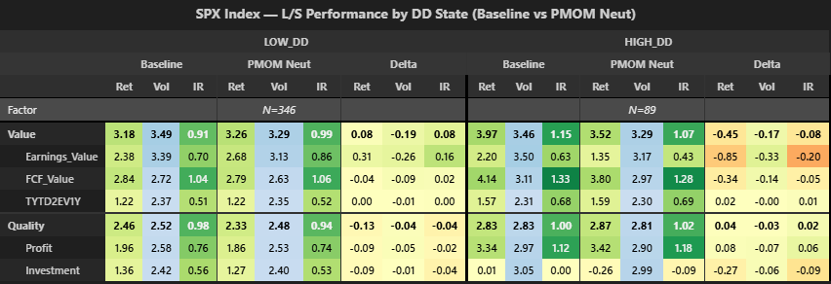
With PMOM neut vs baseline:
Low DD:
-Earnings_Value’s return is increased +31 bp, vol is decreased -26 bps and IR is increased +0.16.
-Value’s return is increased +8 bps and IR is increased +0.08.
-FCF_Value/TYTD2EV1Y/Profit/Investment all have barely changed IR between -0.04 to +0.02.
High DD:
-Earnings_Value/Value’s IR is decreased -0.20/-0.08.
- FCF_Value/TYTD2EV1Y/Profit/Investment have changed IR between -0.09 to +0.06.

MXEA Index:
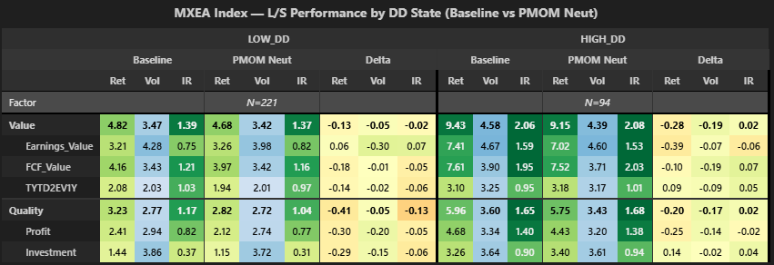
With PMOM neut vs baseline:
Low DD:
-Earnings_Value’s return is increased +6 bp, vol is decreased -30 bps and IR is increased +0.07.
-Value’s return is decreased -13 bps and IR is decreased -0.02.
-FCF_Value/TYTD2EV1Y/Profit/Investment all decreased IR between -0.05 and -0.06.
High DD:
-Earnings_Value IR is decreased -0.06, though value’s IR is increased +0.02.

MXWO Index:
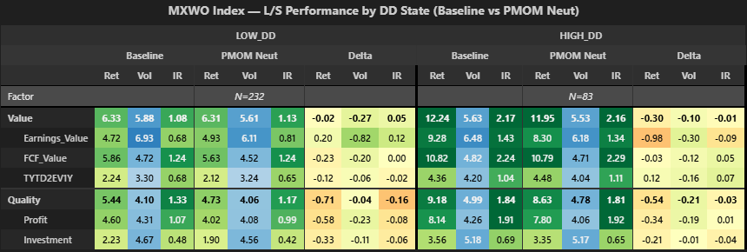
With PMOM neut vs baseline:
Low DD:
-Earnings_Value’s return is increased +20 bp, vol is decreased -81 bps and IR is increased +0.12.
-Value’s return is decreased -2 bps and IR is increased +0.05.
High DD
-Earnings_Value/Value IR is decreased -0.09/-0.01.

MXEF Index:
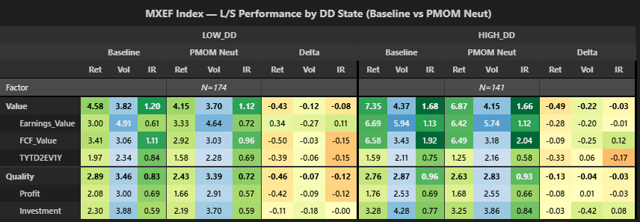
With PMOM neut vs baseline:
Low DD:
-Earnings_Value’s return is increased +34 bp, vol is decreased -27 bps and IR is increased +0.11.
-Value’s return is decreased -43 bps and IR is decreased -0.08.
High DD
-Earnings_Value/Value IR is decreased -0.01/-0.03.

MXAP Index:
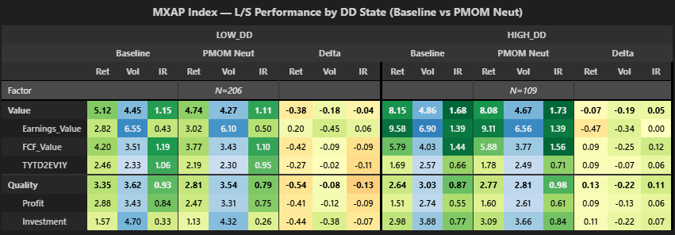
With PMOM neut vs baseline:
Low DD:
-Earnings_Value’s return is increased +20 bp, vol is decreased -45 bps and IR is increased +0.06.
-Value’s return is decreased -38 bps and IR is decreased -0.04.
High DD
-Earnings_Value is unchanged and Value’s IR is increased +0.05.

3 WFC performance with/without neutralization
In this section, I show Weighted Factor Composite (WFC) using 3 versions + baseline.
Baseline: 1/3 static weight on each super factor theme.
PMOM neut (Q + V): Baseline weights, but Quality AND Value are neutralized to PMOM.
PMOM neut (V): Baseline weights, but Value only neutralized to PMOM.
PMOM neut (Earn_V): Baseline weights, but Earnings_Value neutralized to PMOM.

I don’t use DD timing because I show performance conditional on DD state and DD timing factor weighting would affect the interpretation of the signal.

Summary:
Q+V neutralized to PMOM vs baseline:
-Returns are decreased on average in each DD state (low/high DD on average -29/-8 bps) and in each universe.
-Vol is decreased in both state on average (low/high DD -12/-16 bps). This is not the case in SPX Index, where it is increased +4/+10 bps in low/high DD.
-On average, IR is decreased -0.02 in low DD and increased +0.02 in high DD.
-I don’t see any pattern we can use with Q+V neutralized to PMOM.
Value only neutralized to PMOM vs baseline:
-Returns are decreased on average in each DD state (low/high DD -6/-6 bps).
-In low DD, return is increased +2 bps in SPX Index, but unchanged or decreased in other universes.
-IR are decreased on average in each DD state (low/high DD -0.01/-0.01).
-In low DD, IR is decreased in each universe, except MXEF (+0.01) and MXAP (+0.00).
-I don’t see any pattern we can use with Value only neutralized to PMOM.
Earnings_Value neutralized to PMOM vs baseline:
-Returns are increased +5 bps on average in low DD and decreased -8 bps in high DD. Sign of this is true in each universe.
-IR is decreased both in low and high DD on average (low/high DD -0.01/-0.03). In low DD, IR is changed between -0.02 to +0.02 depending on universe.

Average across universes:
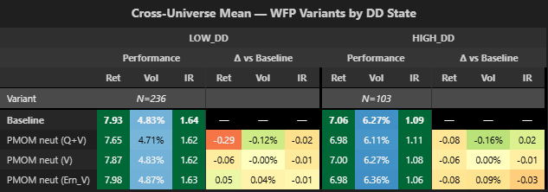
Q+V neutralized to PMOM:
-Both low/high DD, return decreased -29/-8 bps, vol decreased -12/-16 bps. IR decreased -0.02 in low DD and increased +0.02 in high DD.
Value only neutralized to PMOM:
-Both low/high DD, return decreased -6 bps, vol stayed unchanged and IR decreased -0.01.
Earnings_Value only neutralized to PMOM:
-In low DD, return increased +5 bps, vol increased +4 bps and IR decrease -0.01.
-In high DD, return decreased -8 bps, vol increased +9 bps and IR decreased -0.03.

SPX Index:
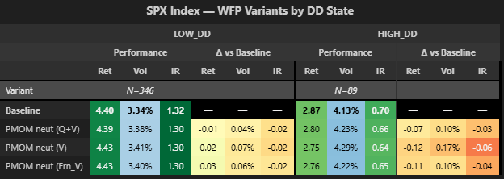
Q+V neutralized to PMOM:
-Both low/high DD, return decreased -1/-7 bps, vol increased +4/+10 bps and IR decreased -0.02/-0.03.
Value only neutralized to PMOM:
-In low DD, return increased +2 bps, vol increased +7 bps and IR decreased -0.02.
-In high DD, return decreased -12 bps, vol increased +17 bps and IR decreased -0.06.
Earnings_Value only neutralized to PMOM:
-In low DD, return increased +3 bps, vol increased +6 bps and IR decreased -0.02.
-In high DD, return decreased -11 bps, vol increased +10 bps and IR decreased -0.04.

MXEA Index:
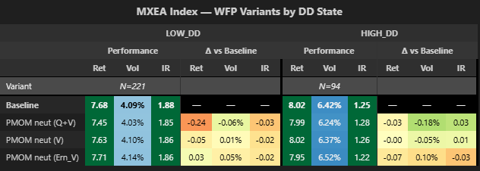
Q+V neutralized to PMOM:
-Both low/high DD, return decreased -24/-3 bps, vol decreased -6/-18 bps. In low DD, IR decreased -0.03, but increased +0.03 in high DD.
Value only neutralized to PMOM:
-In low DD, return decreased -5 bps, vol increased +1 bps and IR decreased -0.02.
-In high DD, return was unchanged, vol decreased -5 bps and IR increased +0.01.
Earnings_Value only neutralized to PMOM:
-In low DD, return increased +3 bps, vol increased +5 bps and IR decreased -0.02.
-In high DD, return decreased -7 bps, vol increased +10 bps and IR decreased -0.03.

MXWO Index:
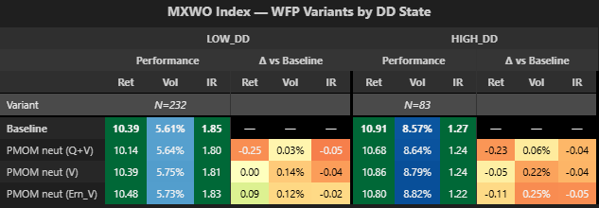
Q+V neutralized to PMOM:
-Both low/high DD, return decreased -25/-23 bps, vol increased +3/+6 bps and IR decreased -0.05/-0.04.
Value only neutralized to PMOM:
-In low DD, stayed unchanged, vol decreased -14 bps and IR decreased -0.04.
-In high DD, return decreased -5 bps, vol increased +22 bps and IR decreased -0.04.
Earnings_Value only neutralized to PMOM:
-In low DD, return increased +9 bps, vol increased +12 bps and IR decreased -0.02.
-In high DD, return decreased -11 bps, vol increased +25 bps and IR decreased -0.05.

MXEF Index:
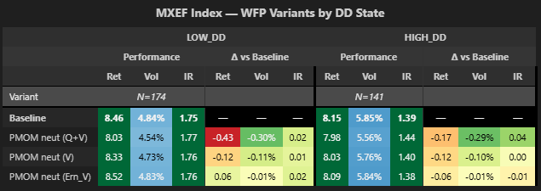
Q+V neutralized to PMOM:
-Both low/high DD, return decreased -43/-17 bps, vol decreased -30/-29 bps and IR increased +0.02/+0.04.
Value only neutralized to PMOM:
-Both low/high DD, return decreased -12/-12 bps, vol decreased -11/-10 bps IR did +0.01/+0.00.
Earnings_Value only neutralized to PMOM:
-In low DD, return increased +6 bps, vol decreased -1 bps and IR increased +0.02.
-In high DD, return decreased -6 bps, vol decreased -1 bps and IR decreased -0.01.

MXAP Index:
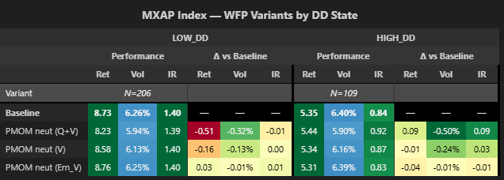
Q+V neutralized to PMOM:
-In low DD, return decreased -51 bps, vol decreased -32 bps and IR decreased -0.01.
-In high DD, return increased +9 bps, vol decreased -50 bps, IR increased +9 bps.
Value only neutralized to PMOM:
-In low DD, return decreased -16 bps, vol decreased -13 bps and IR stayed unchanged.
-In high DD, return decreased -1 bps, vol decreased -24 bps and IR increased +0.03.
Earnings_Value only neutralized to PMOM:
-In low DD, return increased +3 bps, vol decreased -1 bps and IR increased +0.01.
-In high DD, return decreased -4 bps, vol decreased -1 bps and IR decreased -0.01.

