PMOM Neutralization
Table des matières
Abstract 2
Methodology 3
Summary 5
1 Factor/Themes/Super Factors correlations with PMOM 6
1.1 Cross sectional theme score correlations with PMOM 6
1.2 L/S returns correlations with PMOM 7
2 Super factor/factor theme LS performance with/without PMOM neutralization 9
3 WFC performance with/without neutralization 16
Appendix 23
1.1 Cross sectional Corr(PMOM, Earning_Value) graphs 23

Abstract

Methodology
Two factor scores compared through the document:
Baseline: Factor scores neutralized to standard risk factors, but not to PMOM.
PMOM-neut: Same as baseline, but additionally neutralized cross sectionally to PMOM at every level (single factor, factor theme, super factor). The PMOM score used for neutralization is itself a z-score neutralized to standard risk factors and standardized.
*A run using Mom12Mx1M instead of PMOM gave nearly identical results across all sections, so only PMOM-neut results are shown in this document. Mom12Mx1M is 1/3 of PMOM.

Factor score hierarchy:
Single factor -> factor theme -> super factor -> WFC (Weighted factor composite)
*I use WFC instead of WFP because WFP refers to a portfolio and the naming was confounding.
Value = Earnings_Value 37.5%, FCF_Value 37.5%, TYTD2EV1Y 25%
Quality = GP1Y 1/3, FCF2A1Y 1/3, Investment 1/3
Momentum = PMOM 22%, FMOMA 39%, FMOMFS 39%
WFC = Momentum 1/3, Quality 1/3, Value 1/3 (Static weight, no DD-timing)

Neutralization variants:
Baseline: Nothing
WFC(Q+V): Value and quality (super) and everything below
WFC(V): Value (super) and everything below
WFC(EV): Earnings_Value (theme) and its single factors
*For each variant WFC(X), everything at and below X is PMOM-neutralized. Levels above X are recomposed from the neutralized output and non-neutralized to PMOM, only re-neutralized to usual risk factors.

L/S Active Weight Construction
For each stock $i$ at date $t$, given factor score $s_{i}$ and variance $σ_{i}^{2}$:
$$h_{i}^{n}=\frac{s_{i}}{σ_{i}^{2}}$$
$$h_{i}^{mc}=h_{i}^{n}-\overset{‾}{h^{n}}$$
$$h^{max}=max⁡\left(∣min⁡(h^{mc})∣,max⁡(h^{mc})\right)$$
$$w_{i}^{active}=\overset{ˉ}{s}⋅\frac{h_{i}^{mc}}{h^{max}}$$
Where:
- $s_{i}$ = LS_Zstd neutralized factor score
- $σ_{i}^{2}$ = average of annualized 1Y and 3Y variance (clipped at 98th percentile)
- $\overset{ˉ}{s}=0.02$ = max active weight cap
- $\overset{‾}{h^{n}}$ = cross-sectional mean of $h^{n}$

Universes:
MXWO (World), SPX (S&P500), MXEA (EAFE), MXEF (Emerging markets), MXAP (APAC)

DD states:
DDsmooth is the 10-month smoothed drawdown indicator.
Low DD: DDsmooth > -10%
High DD: DDsmooth <= -10%

Summary

1 Factor/Themes/Super Factors correlations with PMOM
This section examines through correlations of factor themes with PMOM whether PMOM neutralization effectively removes the PMOM exposure embedded in Value and Quality factor themes.
  - Cross sectional score correlations with PMOM
  - L/S return correlations with PMOM
The score correlations capture the remaining cross-sectional exposure to PMOM after its neutralization. It should 0 out after PMOM neutralizaion. The return correlations capture the full time series co-movement of factor L/S returns with PMOM returns. The final effect is less clear.
Summary:
PMOM neutralization eliminates score-level correlation of factor themes with PMOM but only partially at the return level. The effect is most pronounced for Earnings Value (−0.22 to −0.11), where a meaningful LS return correlation remains

1.1 Cross sectional theme score correlations with PMOM
Correlation average across dates:
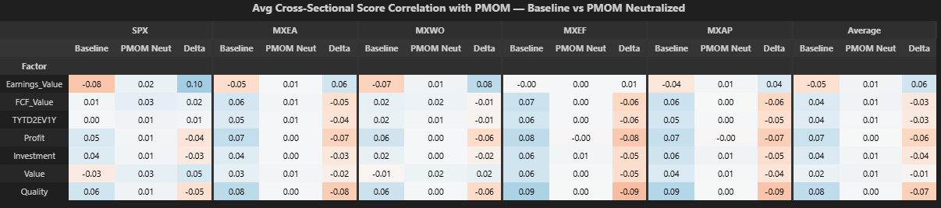
With PMOM neutralization versus baseline:
-Corr(Earnings_Value, PMOM) goes UP from -0.05 to +0.01 on average (far right column).
-On average across universes and dates, all factor theme Corr(Factor theme, PMOM) are between 0.00 and 0.01.

Correlation standard deviation across dates:
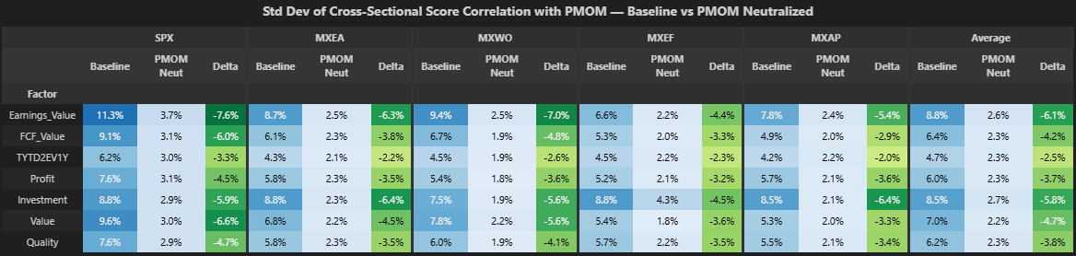
With PMOM neutralization versus baseline:
-Standard deviation of Corr(Factor theme, PMOM) went from a range of 4.7-8.8% to a range of 2.2-2.7%, a reduction of roughly 60%.

  - Summary
PMOM neutralization works as designed at the score level: cross-sectional Corr(theme, PMOM) decreases to close to 0 on average and its standard deviation is reduced by roughly 60%. This confirms that the neutralization removes the score level exposure to PMOM almost completely.

L/S returns correlations with PMOM
Full sample L/S returns correlations:
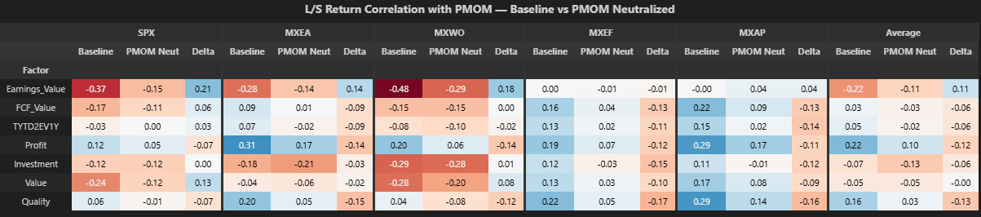
With PMOM neut vs baseline:
-Corr(Earnings_Value, PMOM) goes UP from -0.22 to -0.11 on average across universes (far right column). This is the largest reduction across factor themes but is still negative.
-Corr(FCF_Value/ TYTD2EV1Y, PMOM goes DOWN from 0.03/0.05 to -0.03/-0.02 on average after neutralization. This magnitude is small.
-Corr(Investment, PMOM) goes DOWN from -0.07 to -0.13 on average,

All in all, PMOM neutralization substantially reduces, but does not eliminate, the negative L/S return correlation between Earnings_Value and PMOM. This effect is to a lesser degree with Value as a super factor vs PMOM. For factor returns that were not strongly correlated with PMOM, the effect is minor.

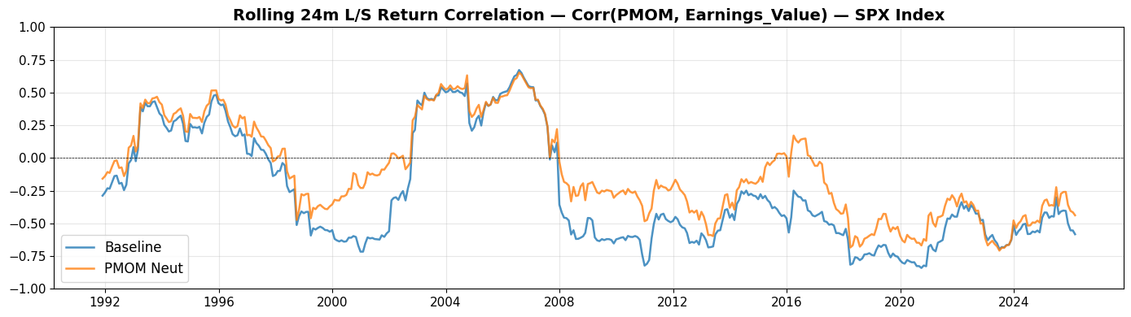
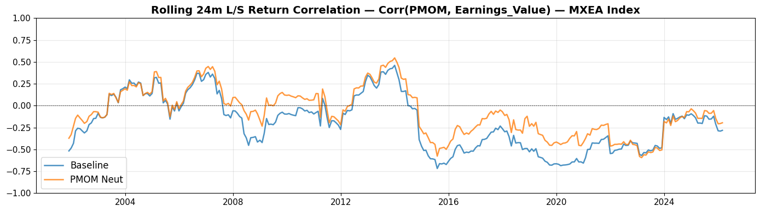
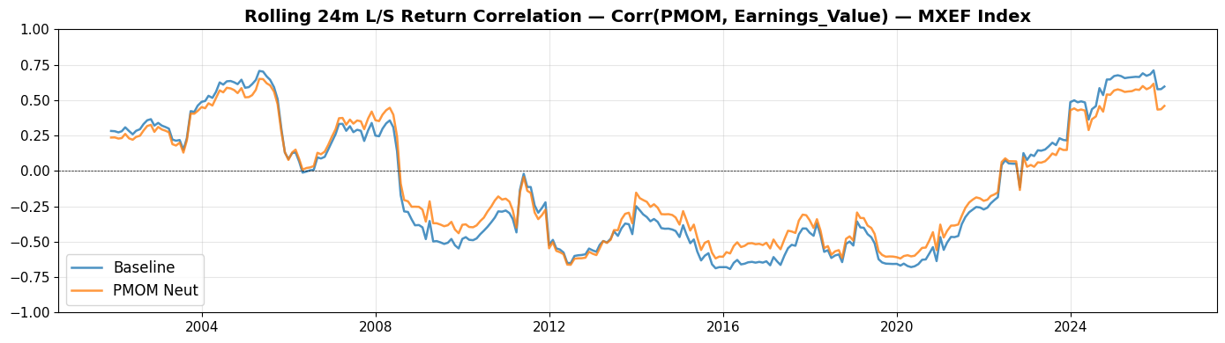
-Looking at the graphs, the trends in LS return correlations are still very similar between baseline and PMOM neutralized versions across all universes. The neutralization shifts the level upward (less negative), but preserves the shape and trends of correlation through time.

2 Super factor/factor theme LS performance with/without PMOM neutralization
This section looks at factor theme LS performance (returns/vol/IR) WITH and WITHOUT neutralization to PMOM, full sample AND conditional to DD state.

The hypothesis is that in low DD, when PMOM is best, removing value’s anti-PMOM tilt should help (positive IR delta). In high DD, when PMOM crashes, value’s anti-PMOM tilt should help and removing it should hurt (negative IR delta).

Baseline: Factor theme WIHTOUT PMOM neutralization.
PMOM neut: factor theme WITH PMOM neutralization.

Summary:
PMOM neutralization produces the DD state flip for Earnings_Value, but not for other value/quality factor themes.
-Low DD, Earnings_Value return +22 bps, vol -42 bps, IR +0.10. This is sign-consistent across universes and consistent with the hypothesis.
-High DD, Earnings_Value return -59 bps, vol -25 bps, IR -0.07. This is sign-consistent across universes and consistent with the hypothesis.
Value super factor sometimes moves in the same direction as Earnings_Value under PMOM neutralization, but the effect is often diluted or offset by other value factor themes, resulting in inconsistent IR impact.
The full sample PMOM neutralization on Earnings_Value partially cancels out in high DD, which supports PMOM neutralization only in low DD.

Average across universes:
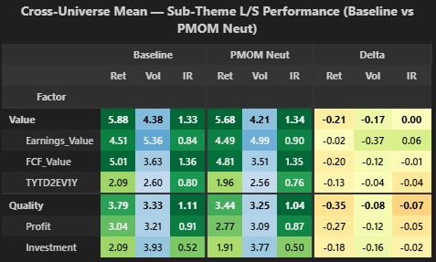
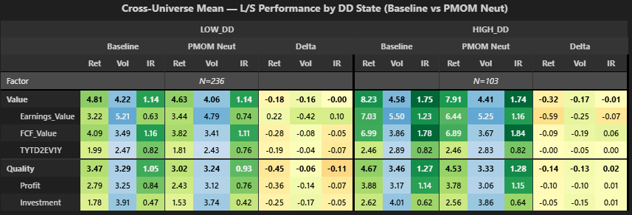
With PMOM neutralization vs baseline,
Full sample (top table):
-Earnings_value is the only factor theme with an IR improvement (+0.06 on average). The improvement comes from decrease in vol (-37 bps on average) rather than a return increase (-2 bps on average)
Low DD:
-Earnings_Value, return +22 bps, vol -42 bps, IR +0.10. IR improvement comes from higher return and lower vol.
-Value super factor, return -18 bps, vol -16 bps, IR unchanged. Return/IR improvements from Earnings_Value are offset by FCF_Value/TYTD2EV1Y.
-Other factor themes have negative IR delta.
High DD:
-Earnings_Value, return -59 bps, vol -25 bps, IR -0.07.
-Other factor themes have flat or positive IR delta with negative return delta.
SPX Index:
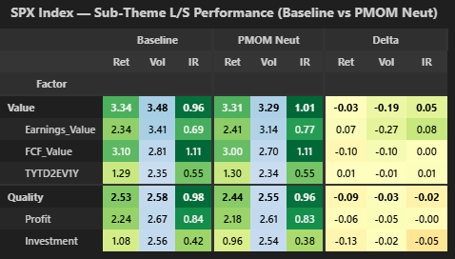
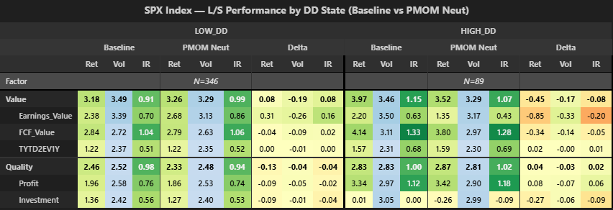
With PMOM neut vs baseline:
Full sample (top table):
-Earnings_value is the only factor theme with a meaningful IR improvement (+0.08), and value super factor to a lesser degree.
Low DD:
-Earnings_Value, return +31 bps, vol -26 bps, IR +0.16. IR improvement comes from higher return and lower vol.
-Value super factor, return +8 bps, vol -19 bps, IR +0.08.
-Other factor themes have flat or negative return delta and flattish IR.
High DD:
-Earnings_Value, return -85 bps, vol -33 bps, IR -0.20.
-Other factor themes have IR delta between -0.09 and +0.06.

MXEA Index:
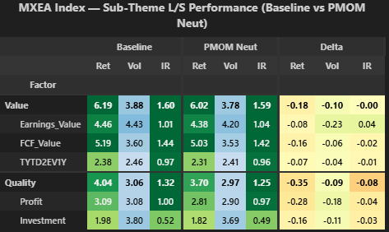
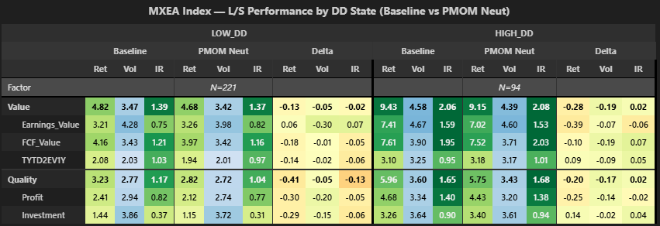
With PMOM neut vs baseline:
Full sample (top table):
-Earnings_value Is the only factor theme with an IR improvement (+0.04). Value super factor is flat.
Low DD:
-Earnings_Value, return +6 bps, vol -30 bps, IR +0.07. IR improvement comes from higher return and lower vol.
-Value super factor, return -13 bps, vol -5 bps, IR -0.02.
-Other factor themes have negative IR delta.
High DD:
-Earnings_Value, return -39 bps, vol -7 bps, IR -0.06.
-Other factor themes have IR delta between -0.02 and +0.07.

MXWO Index:
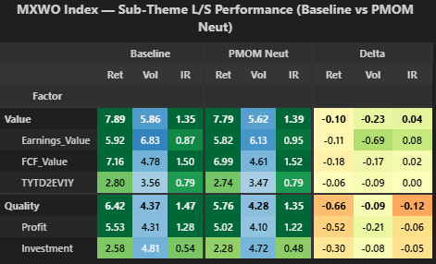
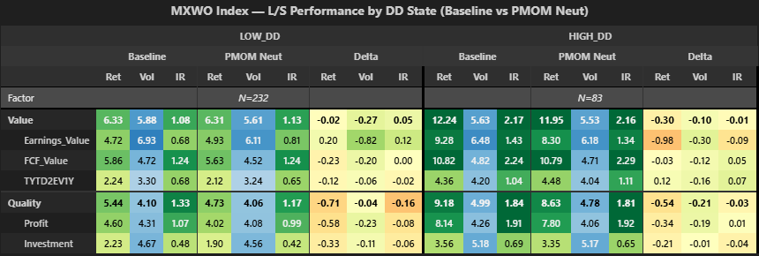
With PMOM neut vs baseline:
Full sample (top table):
-Earnings_value is the only factor theme with a meaningful IR improvement (+0.08), and value super factor to a lesser degree (+0.04).
Low DD:
-Earnings_Value, return +20 bps, vol -82 bps, IR +0.12. IR improvement comes from higher return and lower vol.
-Value super factor, return -2 bps, vol -27 bps, IR +0.05.
-Other factor themes have flat or negative IR delta.
High DD
-Earnings_Value, return -98 bps, vol -30 bps, IR -0.09.
-Other factor themes have IR delta between -0.04 and +0.07.

MXEF Index:
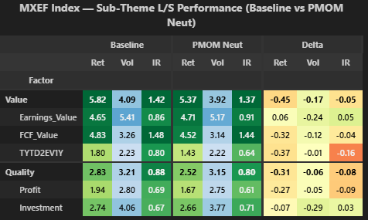
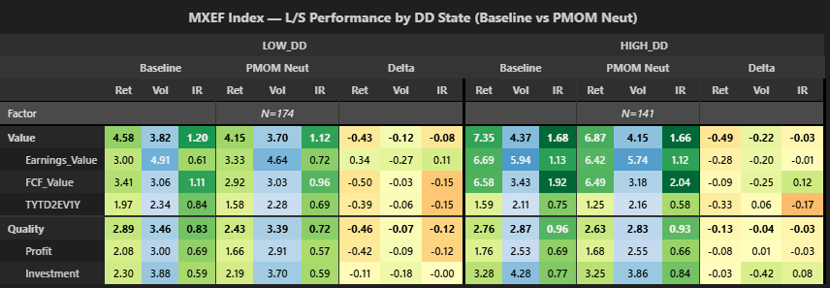
With PMOM neut vs baseline:
Full sample (top table):
-Earnings_value has in IR improvement of +0.05. Value super factor has negative IR change (-0.05).
Low DD:
-Earnings_Value, return +34 bps, vol -27 bps, IR +0.11.
-Value super factor, return -43 bps, vol -12 bps, IR -0.08.
-Other factor themes have negative IR delta between -0.00 and -0.15.
High DD
-Earnings_Value, return -28 bps, vol -20 bps, IR -0.01.
-Other factor themes have IR delta between -0.17 and +0.12.

MXAP Index:
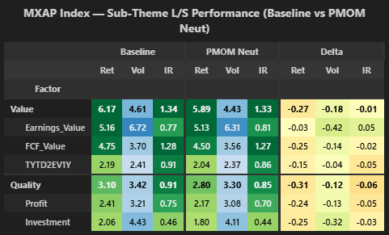
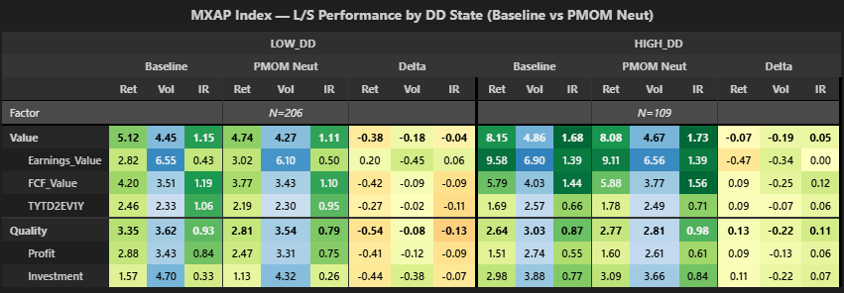
With PMOM neut vs baseline:
Full sample (top table):
-Earnings_value IR is the only factor theme with a meaningful IR improvement (+0.05).
Low DD:
-Earnings_Value, return +20 bps, vol -45 bps, IR +0.06.
-Value super factor, return -38 bps, vol -18 bps, IR -0.04.
-Other factor themes have negative IR delta.
High DD
-Earnings_Value, return -47 bps, vol -34 bps, IR unchanged,
-Other factor themes have positive IR delta between 0.06 and 0.12.

3 WFC performance with/without neutralization
In section 2, we confirmed the hypothesis that PMOM neutralization on Earnings_Value produces the predicted DD state effect (Low DD IR +0.10, High DD IR -0.07, sign-consistent across universes). Section 3 asks whether this factor theme findings propagates to the Weighted Factor Composite (WFC), which is the z-score we use in portfolio optimization.

Baseline: 1/3 static weight on each super factor theme.
PMOM neut (Q + V): Baseline weights, but Quality AND Value neutralized to PMOM.
PMOM neut (V): Baseline weights, but Value only neutralized to PMOM.
PMOM neut (Earn_V): Baseline weights, but Earnings_Value only neutralized to PMOM.
*I don’t use DD timing because I show performance conditional on DD state and DD timing factor weighting would affect the interpretation of the signal.

Summary:
The factor theme finding in section 2 is consistent with theory, though it does not propagate cleanly to the WFC composite because EC is only 12.5% of the WFC weight (1/3 Value * 37.5% Earnings_Value = 12.5%).

PMOM neut (Q + V) vs baseline:
-Low DD on average, return -29 bps, IR -0.02.
-High DD on average, return -8 bps, IR +0.02.

PMOM neut (V) vs baseline:
-Low DD on average, return -6 bps, IR -0.01.
-High DD on average, return -6 bps, IR -0.01.

PMOM neut (Earn_V) vs baseline:
-Low DD on average, return +5 bps, IR -0.01.
-High DD, return -8 bps, IR -0.03.
-In low DD, return is increased in each universe.

*Talk about IR changes very small.
*Talk about DD timing from which we decrease Value (and so earnings_value) even more in low DD, so the marginal effect would be even smaller.
*Try to explain some possible reasons why it worked in section 2, but not in section 3, notably the volatility case.

Average across universes:
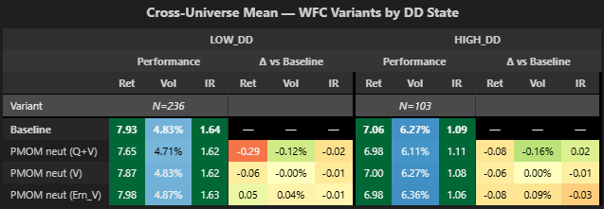
PMOM neut (Q + V) vs baseline:
-Low DD, return -29 bps, vol -12 bps, IR -0.02.
-High DD, return -8 bps, vol -16 bps, IR +0.02
PMOM neut (V) vs baseline:
-Low DD, return -6 bps, vol -0 bps, IR -0.01.
-High DD, return -6 bps, vol +0 bps, IR -0.01.
PMOM neut (Earn_V) vs baseline:
-Low DD, return +5 bps, vol +4 bps, IR -0.01.
-High DD, return -8 bps, vol +9 bps, IR -0.03.
SPX Index:
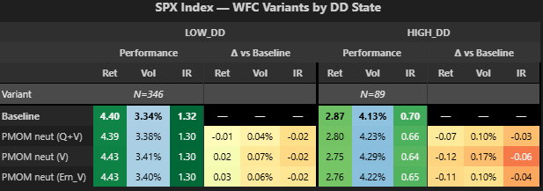
PMOM neut (Q + V) vs baseline:
-Low DD, return -1 bps, vol +4 bps, IR -0.02.
-High DD, return -7 bps, vol +10 bps, IR -0.03.
PMOM neut (V) vs baseline:
-Low DD, return +2 bps, vol +7 bps, IR -0.02.
-High DD, return -12 bps, vol +17 bps, IR -0.06.
PMOM neut (Earn_V) vs baseline:
-Low DD, return +3 bps, vol +6 bps, IR -0.02.
-High DD, return -11 bps, vol +10 bps, IR -0.04.

MXEA Index:
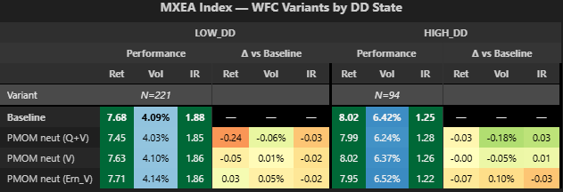
PMOM neut (Q + V) vs baseline:
-Low DD, return -24 bps, vol -6 bps, IR -0.03.
-High DD, return -3 bps, vol -18 bps, IR +0.03.
PMOM neut (V) vs baseline:
-Low DD, return -5 bps, vol +1 bps, IR -0.02.
-High DD, return -0 bps, vol -5 bps, IR +0.01.
PMOM neut (Earn_V) vs baseline:
-Low DD, return +3 bps, vol +5 bps, IR -0.02.
-High DD, return -7 bps, vol +10 bps, IR -0.03.

MXWO Index:
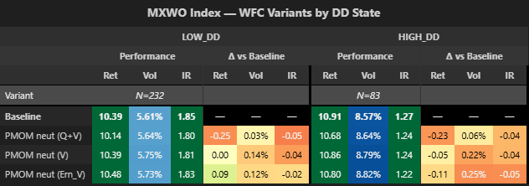
PMOM neut (Q + V) vs baseline:
-Low DD, return -25 bps, vol +3 bps, IR -0.05.
-High DD, return -23 bps, vol +6 bps, IR -0.04.
PMOM neut (V) vs baseline:
-Low DD, return +0 bps, vol +14 bps, IR -0.04.
-High DD, return -5 bps, vol +22 bps, IR -0.04.
PMOM neut (Earn_V) vs baseline:
-Low DD, return +9 bps, vol +12 bps, IR -0.02.
-High DD, return -11 bps, vol +25 bps, IR -0.05.

MXEF Index:
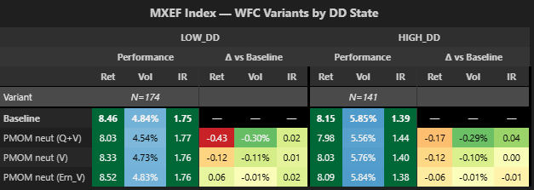
PMOM neut (Q + V) vs baseline:
-Low DD, return -43 bps, vol -30 bps, IR +0.02.
-High DD, return -17 bps, vol -29 bps, IR +0.04.
PMOM neut (V) vs baseline:
-Low DD, return -12 bps, vol -11 bps, IR +0.01.
-High DD, return -12 bps, vol -10 bps, IR +0.00.
PMOM neut (Earn_V) vs baseline:
-Low DD, return +6 bps, vol -1 bps, IR +0.02.
-High DD, return -6 bps, vol -1 bps, IR -0.01.

MXAP Index:
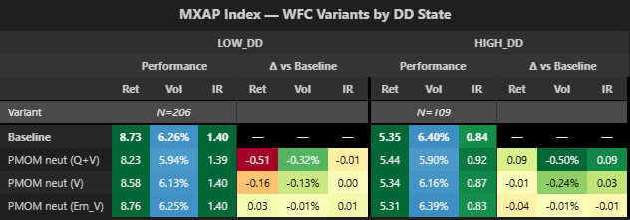
PMOM neut (Q + V) vs baseline:
-Low DD, return -51 bps, vol -32 bps, IR -0.01.
-High DD, return +9 bps, vol -50 bps, IR +0.09.
PMOM neut (V) vs baseline:
-Low DD, return -16 bps, vol -13 bps, IR +0.00.
-High DD, return -1 bps, vol -24 bps, IR +0.03.
PMOM neut (Earn_V) vs baseline:
-Low DD, return +3 bps, vol -1 bps, IR +0.01.
-High DD, return -4 bps, vol -1 bps, IR -0.01.

Appendix

1.1 Cross sectional Corr(PMOM, Earning_Value) graphs
