DAS DEUTSCHE ALPENKORPS
1915 - 1918
By
Patrick Steinmann, Spasteur de Mont Tonnerre, Urica and Wonderdoctor
OpenGen-Kaiser General efile, 2021

Intro
When the WWI started, the German Empire didn't have any unit which was specialized in mountain warfare. After suffering greatly at the hands of the French Chasseurs Alpins during the first moths of the conflict, and witnessing the effectiveness of the Austrian Kaiserschützen, the Germans decided to create a similar force.

That was how, in May 1915, they joined several Bavarian and Prussian Jaeger and Guards battalions to create three mountain infantry regiments with their own artillery, machine guns, and even aviation. The Alpenkorps was born, and soon it became one of the best known and most feared German units of the Great War.

The new elite division fought in the Alps, the Balkans, the West Front and Romania, achieving incredible feats and earning the respect of its enemies. Those soldiers, wearing the Edelweiss as their insignia, wrote some of the most glorious pages of the history of German military and, even though the division disbanded after the end of the WWI, its legend is remembered even today.

This short campaign (10 scenarios) tells the tale of those brave men who fought for their country more than 100 years ago. You’ll follow the military life of a fictional German officer called Hugo Bauernschmitt, starting in the Alps in 1915 and ending in 1918 in the Western Front.
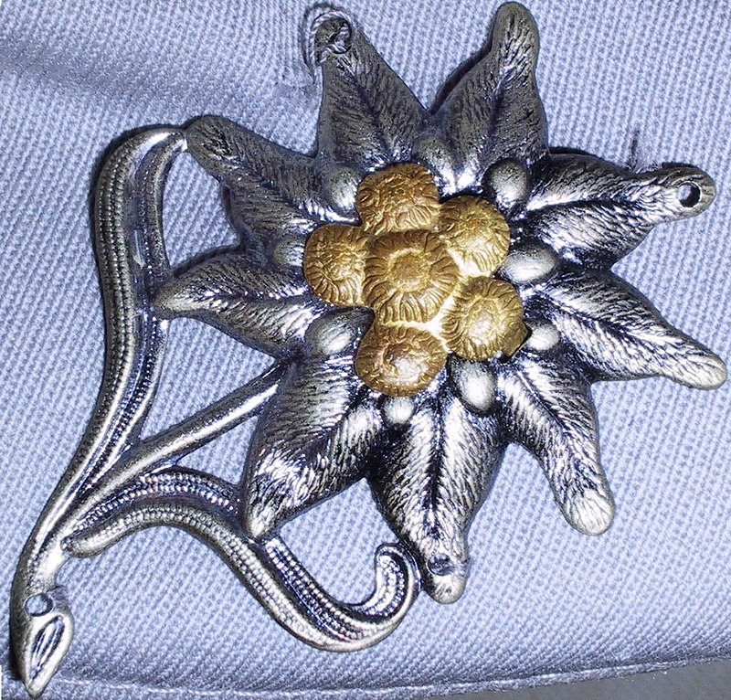

The Edelweiss, insignia of the Alpenkorps

Note: we don’t support any kind of political movement or ideology. This campaign only tries to represent some of the main battles involving the Alpenkorps during the WWI in the wargame OpenGen.

The campaign flow
This campaign has 10 scenarios in total. Every victory will take you to the next scenario. In the first four battles, even a loss will be enough.

Scenario list:

Number | Scenario Name | Author | Date | Map (number)
0 | Trentino: Col di Lana | Wonderdoctor | Jul 4th, 1915 | Col di Lana (1451)
1 | The conquest of Serbia | Urica | Nov 11th, 1915 | Ibar Valley (1453)
2 | Verdun | Spasteur de Mont Tonerre | May 31st, 1916 | East Bank Verdun (1081)
3 | Roterturmpass | Patrick Steinmann | Sep 25th, 1916 | Sibiu (451)
4 | Ramnicu Sarat | Patrick Steinmann | Dec 22nd, 1916 | Ramnicu Sarat (1304)
5 | Marasesti | Urica | Aug 6th, 1917 | Jassy (336)
6 | Karfreit | Urica | Oct 24th, 1917 | Caporetto (450)
7 | Tomba | Urica | Nov 25th, 1917 | Tomba (1552)
8 | Kemmelberg | Urica | Apr 25th, 1918 | Armentieres 1918 (1362)
9 | Épehy | Wonderdoctor | Sep 17th, 1918 | Épehy (1450)

Setup

Create a Kaiser General folder into the main OpenGen folder (it usually is C:\OpenGen). Unzip the newest Kaiser General efile into the Kaiser General folder (usually C:\OpenGen\KAISER).
Then unzip the file AK_Campaign.7z into the Kaiser General efile’s scenario folder (usually C:\OpenGen\KAISER\scenario).

You can download the efile from the Open General Installer webpage:

http://www.open-general.com/installer-efiles.php

Requirements

OpenGen, at least the 0.93.4 version. You can download the OpenGen game from Luis Guzman’s webpage:

http://luis-guzman.com/

Soundup (sound files). You can download it from Kaiser General webpage

http://sites.google.com/site/jkpanzer/graphics/efile

Or from the Open General Installer webpage:

http://www.open-general.com/installer-core.php

Openicons (icon files). They are really easy to install. Unzip the Datup into your main OpenGen folder, usually c:\OpenGen. You can find the latest Openicons here:

http://www.open-general.com/installer-core.php

Maps: The needed maps can be found on the next link: http://pg2mapfinder.gilestiel.eu/

The OG game can automatically download the maps you need from the OG repository, too. You just have to select that option in the game settings.

Acknowledgements

Special thanks to…

Luis Guzmán, creator of the OpenGen program and the Suite.

Juan Carlos Preciado, creator of the KG efile.

Finally...

These files are free; we made it only for fun. We hope you take fun too playing them. You are not allowed to modify or to sell the files of the campaign without permission of the authors.
For any commentary about the campaign you can write in the OG forum:

http://forum.open-general.com/index.php

The authors are not responsible from any bad use or damaged caused by these files. We haven’t any political interest with this campaign; which was only made for historical and fun purposes for OpenGen.

