Bulgarian campaign, 1929-1918
By
Urica
OpenGen-Kaiser General efile 2011-2012
Updated in August 2014

Background

At the end of the Russo-Turkish War the Ottoman and Russian Empires signed, on 3 March 1878, the Treaty of San Stefano.
Among its clauses the treaty proposed the creation of an autonomous Principality of Bulgaria, which would border the Black Sea to the east, the Aegean Sea to the south, Albania and Serbia to the west and Romania to the north. However, other European powers didn’t agree with this concept of a Greater Bulgaria, so on 13 July 1878 the Treaty of Berlin revised the Treaty of San Stefano.
According the Treaty of Berlin, two autonomous Bulgarian regions would be created within the borders of the Ottoman Empire: the Principality of Bulgaria and the province of Eastern Rumelia. Although both regions joined soon afterwards, in 1885, and Bulgaria became a fully independent kingdom in 1908, the resulting state was much smaller than what San Stefano stated.
In Bulgaria, irredentist policies soon became popular, and the full implementation of the Treaty of San Stefano was the central point of Bulgarian foreign policy until the end of the 2nd World War. In order to achieve its dream of a Greater Bulgaria that would become the main power in the Balkans, the Bulgarian government created the greatest army among all of the recently created countries in Southeastern Europe.
From 1912 to 1918 that militaristic policy led Bulgaria into three different wars:
First Balkan War (1912-1913): Allied with Greece, Serbia and Montenegro, Bulgaria defeated the Ottoman Empire, which lost the majority of its remaining European territories. However, and although, of all the allies, Bulgaria was the country that made the greatest contribution to the war effort, Bulgarians focused too much on defeating the Turks in Eastern Thrace (the lands surrounding Istambul), so their territorial gains were comparatively few. In the meantime, Serbia liberated all of Vardar Macedonia, and Greece occupied Aegean Macedonia, two regions that Bulgaria claimed.
Interallied War or Second Balkan War (1913): A few months after the First Balkan War ended, Bulgaria attacked Serbia and Greece, hoping to achieve a quick victory that would grant her the region of Macedonia. But, exhausted after months of war against Turkey, things didn’t go as planned. The Greeks defeated the Bulgarians at Kilkis (Kukush), and forced them to retreat. Serbia thwarted the Bulgarian offensive and, to make thing still worse, Romania and the Ottoman Empire sided with Serbia and Greece. After a few weeks of war, Bulgaria was completely defeated, had to give Southern Dobruja to Romania and lost most of the land that she had obtained during the First Balkan War.
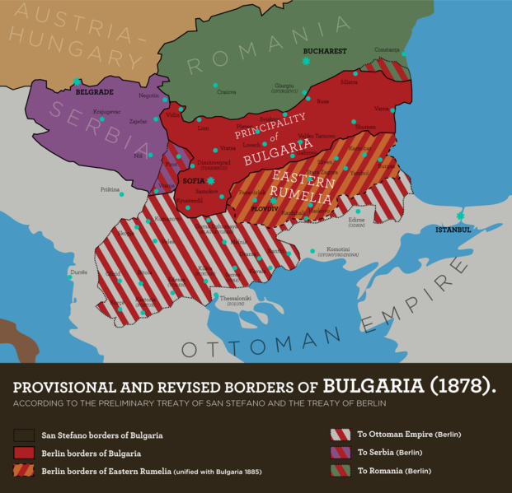
First World War (1915-1918): Bulgaria saw this new war as an opportunity to recover some of the territories that she claimed. Both sides wanted the Bulgarian support and sent diplomats to Sofia with different offers. For some time the Bulgarian Government listened to all of the foreign delegations but finally, on 14 October 1915, Bulgaria entered the war on the Central Powers‘ side.
Bulgarian support was essential for the victories of 1915 against Serbia and of 1916 against Romania, but in Macedonia the Central Powers soon had to adopt a defensive strategy. Although in 1916 and 1917 Bulgaria had some defensive victories against the French and British expeditionary corps, she couldn’t break the Entente lines, and the front came to a stalemate that Bulgaria couldn’t afford. The economy of the country soon deteriorated, as did the morale among the soldiers and the civilians. However, the Bulgarian army resisted until the very end of the war, and it wasn’t defeated until September 1918, when a Franco-Serbian army broke the Macedonian front at the battle of Dobro Pole. A few days later Bulgaria had to ask for an armistice. She lost all the territories that she had taken during the war, as well as Western Thrace, and had to pay huge war reparations. There was a revolutionary attempt that had to be repressed, and Tsar Ferdinand had to abdicate and left the country.
This campaign recreates the main battles that took place during those six years of war.

Note: I don’t support any kind of political movement or ideology. This campaign only tries to represent the Bulgarian war efforts in the 1910’s in the wargame OpenGen.

The campaign flow

This is a mostly historical campaign that recreates the main military action involving Bulgaria during the 1910’s, but if the player manages to take a BV or a V at Dobro Pole, he may have the chance to earn a happier ending in Salonika.
The campaign has 25 scenarios in total (excluding two choices), and the longest path has 17.

Campaign scenario flow table.

Number | Scenario Name | Date | Map (number)
0 | Battle of Lozengrad | Oct 22nd, 1912 | Amiens (140)
1 | Battle of Lule Burgas | Oct 28th, 1912 | Lüleburgaz (936)
2 | Çatalca line | Nov 17th, 1912 | Çatalca (937)
3 | Battle of Bulair- Sarköy | Feb 8th, 1913 | Sarköy (939)
4 | Odrin fortress | Mar 24th, 1913 | Adrianople (941)
5 | Choice – The Interallied War | Jun 28th, 1913 | Europe (346)
6 | Bregalnica- counterattack at Krivolak | Jul 2nd, 1913 | Ebro (802)
7 | Battle of Kalimanci | Jul 18th, 1913 | Caporeto (450)
8 | Battle of Kukush and Lahna | Jul 2nd, 1913 | Kilkis (943)
9 | Kresna Gorge | Jul 27th, 1913 | Blagoevgrad- Gorna Dzhumaya (949)
10 | Choice – The Great War | Oct 14th, 1915 | Europe (346)
11 | Battle of Ovche Pole | Oct 16th, 1915 | Mulhouse (339)
12 | Battle of Krivolak | Nov 3rd, 1915 | Ebro (802)
13 | First battle of Doiran | Aug 9th, 1916 | Doiran (982)
14 | Battle of Malka Nidzhe | Sep 12th, 1916 | Bitola (873)
Number | Scenario Name | Date | Map (number)
15 | First battle of the Crna Bend | Oct, 5th, 1916 | Bitola (873)
16 | Second battle of Doiran | Apr 22nd, 1917 | Doiran (982)
17 | Second battle of the Crna Bend | May 5th, 1917 | Bitola (873)
18 | Morava offensive - Nis | Nov 3rd, 1915 | Kiev (229)
19 | Kosovo offensive - Pristina | Nov 20th, 1915 | Chambois (715)
20 | Battle of Dobrich | Sep 5th, 1916 | Iasi (461)
21 | First battle of Kobadin | Sep 17th, 1916 | Zborow (613)
22 | The bridgehead at Ryakhovo | Oct 1st, 1916 | Ryakhovo (992)
23 | Second battle of Kobadin | Oct 19th, 1916 | Zborow (613)
24 | Battle of Dobro Pole | Sep 15th, 1918 | Tapline (259)
25 | Third battle of Doiran | Sep 18th, 1918 | Doiran (982)
26 | Solun | Sep 28th, 1918 | Thessaloniki (944)

Scenario | BV | V | TV | L
0 (Lozengrad) | 1 | 1 | 1 | Loss
1 (Luleburgas) | 2 | 2 | 2 | Loss
2 (Çatalca) | 3 | 3 | 3 | 3
3 (Bulair – Sarköy) | 4 | 4 | 4 | Loss
4 (Odrin) | 5 | 5 | 5 | Loss
5 (Choice 1)
6 (Bregalnica) | 7 | 7 | 7 | Loss
7 (Kalimanci) | 10 | 10 | 10 | Loss
8 (Kukush) | 9 | 9 | 9 | Loss
9 (Kresna) | 10 | 10 | 10 | Loss
10 (Choice 2)
11 (Ovche Pole) | 12 | 12 | 12 | Loss
12 (Krivolak) | 13 | 13 | 13 | Loss
13 (Doiran 1) | 14 | 14 | 14 | 14
14 (Malka Nidzhe) | 15 | 15 | 15 | Loss
15 (Crna 1) | 16 | 16 | 16 | Loss
16 (Doiran 2) | 17 | 17 | 17 | Loss
17 (Crna 2) | 24 | 24 | 24 | Loss
18 (Nis) | 19 | 19 | 19 | Loss
19 (Pristina) | 20 | 20 | 20 | Loss
20 (Dobrich) | 21 | 21 | 21 | Loss
21 (Kobadin 1) | 22 | 22 | 22 | 22
22 (Ryakhovo) | 23 | 23 | 23 | Loss
23 (Kobadin 2) | 17 | 17 | 17 | Loss
24 (Dobro Pole) | 25 | 25 | Loss | Loss
25 (Doiran 3) | 26 | 26 | Loss | Loss
26 (Solun) | Win | Win | Win | Loss

Default experience of purchased units and protos
Scenarios 0 to 5 0 exp
Scenarios 6 to 12 and 18 to 19 99 exp
Scenarios 13 to 17 and 20 to 23 199 exp
Scenarios 24 to 26 299 exp
Setup

Create a Kaiser General folder into the main OpenGen folder (it usually is C:\OpenGen). Unzip the the newest Kaiser General efile into the Kaiser General folder (usually C:\OpenGen\KG2).
Then unzip the file Bulg_Campaign.zip into the Kaiser General efile´s scenario folder (usually C:\OpenGen\KG2\scenario).

You can download the efile from Kaiser General webpage:

http://sites.google.com/site/jkpanzer/graphics/efile

Requirements

OpenGen, at least the 0.90.32 version. You can download the OpenGen game from Luis Guzman´s webpage:

http://luis-guzman.com/

Soundup (sound files), at least the aug/2010 version. You can download it from Kaiser General webpage

http://sites.google.com/site/jkpanzer/graphics/efile

Openicons (icon files). They are really easy to install. Unzip the Datup into your main OpenGen folder, usually c:\OpenGen. You can find the latest Openicons here:

http://sourceforge.net/projects/opengeneral/files/DailyBuild/

Maps; The campaign needs the next maps, which can be found on the next link: http://pg2mapfinder.gilestiel.eu/
Adrianople (941), Amiens (140), Bitola (873), ), Blagoevgrad- Gorna Dzhumaya (949), Caporeto (450), Chambois (715), Çatalca (937), Doiran (982), Ebro (802), Europe (346, Iasi (461), Kiev (229), Kilkis (943), Lüleburgaz (936), Mulhouse (339), Ryakhovo (992), Sarköy (939), Tapline (259), Thessaloniki (944), Zborow (613)

The OG game can automatically download the maps you need from the OG repository, too. You just have to select that option in the game settings.

Acknowledgements

Special thanks to…

Juan Carlos Preciado, for being the author of the KaiserGeneral efile.

Luis Guzmán, creator of the OpenGen programme and the Suite.

Guille, for playtesting the campaign.

1-Terminator, for playtesting some scenarios of the campaign.

Blitzstoper, for playtesting some scenarios of the campaign.

Finally...

These files are free; I made it only for fun. I hope you take fun too playing it. You are not allowed to modify or to sell the files of the campaign without permission of the author.
For any commentary about the campaign you can email at.

delmarec@gmail.com

The author is not responsible from any bad use or damaged caused by these files. I haven’t any political interest with this campaign; which is only made for historical and fun purposes for OpenGen.

