Home of the brave
United Stares campaign
1898 - 1918
By
Urica
OpenGen-Kaiser General efile 2019

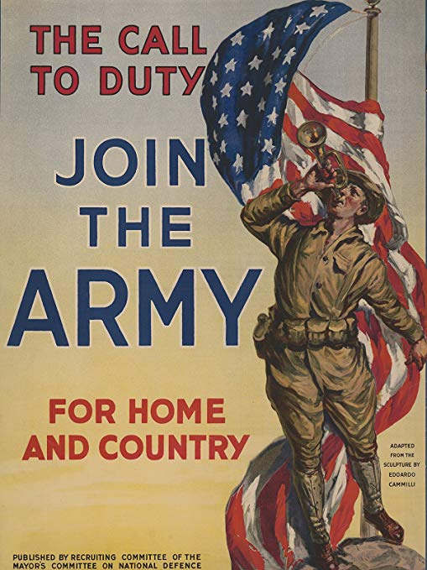

Intro

The XIX century is ending, and the United States of America has become one of the wealthiest countries in the world. This growing prosperity implies playing an increasingly important role in the international sphere. America has interests almost everywhere, and sometimes those interests can't be defended efficiently by peaceful means. When that happens, the small but highly motivated American Army must intervene. One way or another, the US will earn its rightful place among the greatest world powers.

From the island of Cuba to the exotic China, from the Philippine jungles to Mexico and the devastated French battlefields of the WWI, lead the American Army in this quest towards glory. Thanks to your effort, one day your country will be the most powerful in the world.
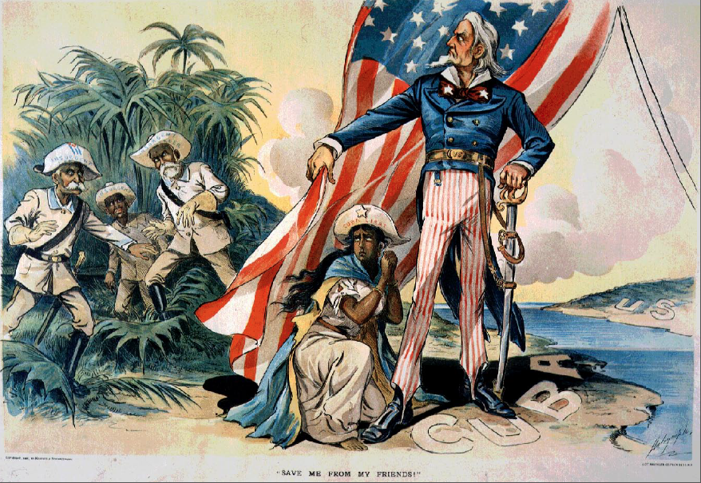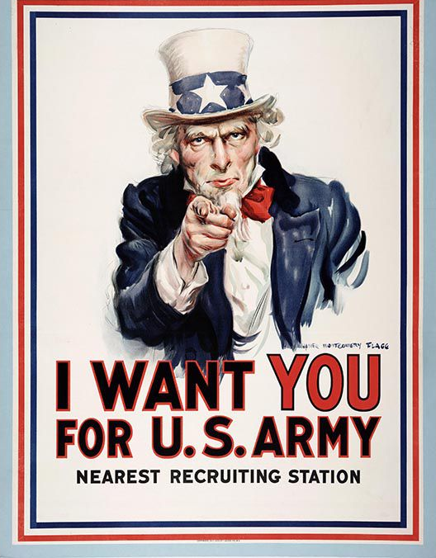

Historical Background
Not long after its independence, the United States of America sought to become an influential country in the world. Its expansion began at the expense of some Indian nations and Mexico, its weaker neighbour (1848). However, after those initial steps were taken, it expended the next years solving its domestic problems (American civil war, 1861-1865) and conquering and colonizing the Old West (1865-1885). Certainly, there were some exceptions (the American support of Mexican liberals against the conservatives and Emperor Maximilian, or the purchase of Alaska in 1867), but overall the United States didn’t behave as an interventionist power for nearly 30 years.

Around 1890, however, United States was free, one more time, to look for new goals. Quite logically, the young country gave priority to increasing its influence in the American continent (following the most expansionist interpretations of the Monroe Doctrine) and the Pacific.

Usually, that was done by mostly peaceful means, thanks to the constant activities of American investors, diplomats, lobbyists and “advisors” in foreign countries. One good example of that policy was the destabilization, and the subsequent annexation, of the Kingdom of Hawaii during the 1890’s. But, if necessary, the United States didn’t hesitate to use military force against other countries if that helped to fulfil its goals. Some examples of American military interventions during the 1890’s and the first years of the XX Century are:

- The Spanish- American war (1898), that gave the United States control over Cuba, Puerto Rico, Guam and the Philippines.

- The Banana wars (1898-1934), a series of occupations and interventions in several countries of Central America and the Caribbean.

- The Philippine- American war (1899-1902), against the Philippine rebels who rejected the American rule over the archipelago.

- The Boxer Rebellion (1899-1901), against Chinese anti-western nationalists.

- The Border war (1910-1919), a series of engagements in support of left-wing Mexican revolutionaries (Madero, Carranza, Obregón), and against either Mexican counter-revolutionaries (Huerta), either Mexican convencionistas (Pancho Villa).

In those wars the small American army proved that it could be extremely competent at the battlefield. So it’s not surprising that, when the WWI started in 1914, the Entente tried to obtain the support of the United States, while the Central Powers wished that the Americans would keep their neutrality.

Initially, the majority of the American public opinion rejected the idea of war. However, president Woodrow Wilson wished to favour Great Britain and the other Entente countries as much as possible. Soon, the United States became one of the most important material and financial suppliers of the Entente.

That way, the American merchants became the target of the German submarines. The sinking of American ships and especially of the British liner Lusitania in 1915, which caused the death of 128 American citizens, along with the anti-German war propaganda, gradually made many Americans change their point of view about the war, so in early 1917 the country supported entering the war on the side of the Entente. Having secured his re-election in 1916, Wilson was free to ask Congress declare war on the Germany, which it did on April 6, 1917.

The mobilization, transport and training of the American army took, approximately, one year. The first important engagement of the American soldiers took place at Cantigny, in late May, 1918. In the following six months, nearly two million Americans were decisive to thwart the German Spring Offensive and to allow the Entente to launch the final, victorious Hundred Days Offensive. Performing many heroic deeds, the Americans earned the respect of all the other belligerent countries. When the Armistice came, the United States, having risked very little, had become the main economic power in the world, and one of the greatest military powers. The era of the American pre-eminence in the world had come!

Note: I don’t support any kind of political movement or ideology. This campaign only tries to represent some of the main battles involving the White Army in Central and Eastern Russia in the wargame OpenGen.

The campaign flow

This campaign is linear, and has 14 scenarios in total. Any victory will take you to the next battle, and in the first seven scenarios even a loss will be enough to go on.

All the scenarios are (mostly) historical.

Scenario list.

Number | Scenario Name | Date | Map (number)
0 | Cuba: Las Guásimas | Jun 24th, 1898 | Las Guásimas 1898 (1172)
1 | Cuba: San Juan Hill/ El Caney | Jul 1st, 1898 | Santiago Cuba (1482)
2 | Manila | Feb 4th, 1899 | Manila 1898 (929)
3 | Zapote River | Jun 13th, 1899 | Cavite 1898 (1093)
4 | Tientsin | Jul 13th, 1900 | Tientsin (1283)
5 | Relief of Peking | Aug 5th, 1900 | Beijing (575)
6 | Guerrero | Mar 29th, 1916 | Sferro (632)
7 | Cantigny | May 28th, 1918 | Cantigny (611)
8 | War at the Marne: Belleau Wood | Jun 3th, 1918 | Belleau Wood (612)
9 | War at the Marne: Château-Thierry | Jul 15th, 1918 | Mezy (650)
10 | War at the Marne: The Entente counterattack | Jul 19th, 1918 | Fisnes (1236)
11 | Saint Mihiel | Sep 12th, 1918 | Saint Mihiel (1488)
12 | Saint Quentin Canal | Sep 29th, 1918 | Epehy (1450)
13 | Argonne | Oct 4th, 1918 | Argonne (1489)

Setup

Create a Kaiser General folder into the main OpenGen folder (it usually is C:\OpenGen). Unzip the newest Kaiser General efile into the Kaiser General folder (usually C:\OpenGen\KAISER).
Then unzip the file Hotb_Campaign.7z into the Kaiser General efile’s scenario folder (usually C:\OpenGen\KAISER\scenario).

You can download the efile from the Open General Installer webpage:

http://www.open-general.com/installer-efiles.php

Requirements

OpenGen, at least the 0.92.0.55 version. You can download the OpenGen game from Luis Guzman’s webpage:

http://luis-guzman.com/

Soundup (sound files). You can download it from Kaiser General webpage

http://sites.google.com/site/jkpanzer/graphics/efile

Or from the Open General Installer webpage:

http://www.open-general.com/installer-core.php

Openicons (icon files). They are really easy to install. Unzip the Datup into your main OpenGen folder, usually c:\OpenGen. You can find the latest Openicons here:

http://www.open-general.com/installer-core.php

Maps: The needed maps can be found on the next link: http://pg2mapfinder.gilestiel.eu/

The OG game can automatically download the maps you need from the OG repository, too. You just have to select that option in the game settings.

Acknowledgements

Special thanks to…

Juan Carlos Preciado, for being the author of the Kaiser General efile.

Luis Guzmán, creator of the OpenGen programme and the Suite.

Jurgen Smet, for his information about the air units that fought in the battles of the WWI in which the United States participated.

Marcos Martín and Mark, for playtesting the campaign, and for being the original designers of the scenarios 1 (San Juan Hill/ El Caney) and 10 (counterattack at the Marne), that I simply adapted.

Finally...

These files are free; I made them only for fun. I hope you take fun too playing the campaign. You are not allowed to modify or to sell the files of the campaign without permission of the author.
For any commentary about the campaign you can email at.

delmarec@gmail.com

The author is not responsible from any bad use or damaged caused by these files. I haven’t any political interest with this campaign; which is only made for historical and fun purposes for OpenGen.

