Ils ne passeront pas
French campaign
1884 - 1918
By
Patrick Steinmann, Spasteur de Mont Tonnerre, Urica and Wonderdoctor
OpenGen-Kaiser General efile, 2018

Intro
After the end of the Napoleonic Wars France increased its influence across the world, establishing colonies and protectorates in large areas of Africa, East Asia and the Pacific. Despite the revolutions, the regime changes and the terrible defeat of 1871 against Prussia, France expanded her colonial empire throughout the XIX Century, until it became the second largest in the world, after the British Empire.

In order to secure her colonies and, at the same time, prepare her future revenge against the hated Germans, the French Republic built a huge and modern army, capable of fighting everywhere in the world and against all kind of enemies. And, indeed, they had to fight in many conflicts all around the world. Many young French officers started their careers in the colonial wars and later, as mature men, fought against the Central Powers during the WWI.

Play this campaign and you’ll recreate some of the main battles of this historical period. You’ll follow the military life of a fictional French general called Jean-Babtiste Bertaux-Levillain, starting in Indochina in 1884 (when the protagonist is a 30-something years old Lieutenant-Colonel) and ending in 1918, with the Armistice of Compiègne and the end of the WWI (when Gen. Bertaux-Levillain is about to retire).



Emblem of the French Republic
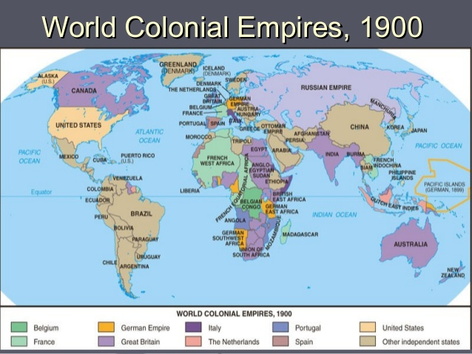

In light green, the French Empire in 1900

Historical background
There are four different wars that we have shown to you in this campaign:

Sino-French War (1884-1885): From their base in Cochinchina, the French defeated the Chinese and took over Tonkin (in modern northern Vietnam) and Annam (in modern central Vietnam) (2 scenarios).

Madagascar expedition (1894-1895): the French defeated the Merina Kingdom and annexed Madagascar (1 scenario).

Sidi Bou Othmane (1912): France annexed southern Morocco into the French protectorate of Morocco (1 scenario).

First World War (1914-1918): with much suffering, after four long years, and overcoming the risks of mutinies and revolutions, the protagonist finally defeated the Germans on the Western Front. He also participated in the Balkan Front (16 scenarios).

Note: we don’t support any kind of political movement or ideology. This campaign only tries to represent some of the main battles involving France, during the last years of the XIX century and the beginning of the XX century, in the wargame OpenGen.

The campaign flow
This campaign has 20 scenarios in total. Every victory will take you to the next scenario, and except for the scenarios 3, 11, 12, 14, 15 and 16, even a loss will be enough.

Scenario list:

Number | Scenario Name | Author | Date | Map (number)
0 | Sino-French War - Landing at Keelung | Wonderdoctor | Oct 1st, 1884 | Keelung (1334)
1 | Lang Son | Urica | Feb 9th, 1885 | Lang Son (1277)
2 | Madagascar Expedition - Tsarasoatra | Patrick Steinmann | Jun 29th, 1895 | Evinayong 1940 (1270)
3 | Sidi Bou Othmane | Spasteur de Mont Tonerre | Sep 6th, 1912 | Karachoum (462)
4 | Sarrebourg | Urica | Aug 19th, 1914 | Sedan 1870 (1304)
5 | Marne | Patrick Steinmann | Sep 5th, 1914 | Monthyon (464)
6 | The Race to the Sea | Wonderdoctor | Oct 10th, 1914 | La Bassee (465)
7 | Assault at Artois | Spasteur de Mont Tonerre | Dec 17th, 1914 | Lens (990)
8 | First Battle of Krithia | Patrick Steinmann | Apr 28th, 1915 | Helles (560)
9 | Chunuk Bair | Patrick Steinmann | Aug 6th, 1915 | Ari Burnu (561)
10 | Battle of Krivolak | Urica | Oct 27th, 1915 | Ebro (802)
11 | Verdun: Bois des Caures | Patrick Steinmann | Feb 21st, 1916 | Bois des Caures (865)
12 | Verdun: Fight for Fort Vaux | Urica | May 31st, 1916 | East Bank Verdun (1081)
13 | Verdun: The Great French Counter-Attack | Wonderdoctor | Oct 20th, 1916 | East Bank Verdun (1081)
14 | Chemin des Dames | Spasteur de Mont Tonerre | Apr 16th, 1917 | Fisnes (Aisne/Vesle/ Marne) (1236)
15 | Assault at Poelcappelle (Poelkapelle) | Urica | Oct 9th, 1917 | Ypres 1917 (1348)
16 | Hold Mont Kemmel (Kemmelberg) | Urica | Apr 25th, 1918 | Armentieres 1918 (1362)
17 | The River Matz Riposte | Patrick Steinmann | Jun 10th, 1918 | La Matz (247)
18 | The Marne Again | Spasteur de Mont Tonerre | Jul 15th, 1918 | Fisnes (Aisne/Vesle/ Marne) (1236)
19 | Hundred Days Offensive | Wonderdoctor | Nov 1st, 1918 | Escaut 1940 (930)

Setup

Create a Kaiser General folder into the main OpenGen folder (it usually is C:\OpenGen). Unzip the the newest Kaiser General efile into the Kaiser General folder (usually C:\OpenGen\KAISER).
Then unzip the file Ilsne_Campaign.7z into the Kaiser General efile’s scenario folder (usually C:\OpenGen\KAISER\scenario).

You can download the efile from the Open General Installer webpage:

http://www.open-general.com/installer-efiles.php

Ilsne_Campaign.7z also includes four audio files. You must paste them into the Kaiser General efile’s sound folder (usually C:\OpenGen\KAISER\sound).

Besides, the campaign can play a really nice short video just before the 11th scenario. However, the video file is too large to be hosted online. If you want to download it and install it (into the SMACK folder), write us on the JP Forum, and we’ll tell you where you can find it.

As an alternative, you can download the audio and video files from this link:

https://drive.google.com/drive/folders/1yogNXXixcK3cv9DmhxcfxhSi78M7CZ4v?usp=sharing

Requirements

OpenGen, at least the 0.91.3.16 version. You can download the OpenGen game from Luis Guzman’s webpage:

http://luis-guzman.com/

Soundup (sound files). You can download it from Kaiser General webpage

http://sites.google.com/site/jkpanzer/graphics/efile

Or from the Open General Installer webpage:

http://www.open-general.com/installer-core.php

Openicons (icon files). They are really easy to install. Unzip the Datup into your main OpenGen folder, usually c:\OpenGen. You can find the latest Openicons here:

http://www.open-general.com/installer-core.php

Maps: The needed maps can be found on the next link: http://pg2mapfinder.gilestiel.eu/

The OG game can automatically download the maps you need from the OG repository, too. You just have to select that option in the game settings.

Acknowledgements

Special thanks to…

Luis Guzmán, creator of the OpenGen program and the Suite.

Juan Carlos Preciado, creator of the KG efile.

randowe, for making beautiful maps for this campaign.

Finally...

These files are free; we made it only for fun. We hope you take fun too playing it. You are not allowed to modify or to sell the files of the campaign without permission of the authors.
For any commentary about the campaign you can write in the JP’s panzers forum:

http://www.panzercentral.com/forum/index.php

The authors are not responsible from any bad use or damaged caused by these files. We haven’t any political interest with this campaign; which was only made for historical and fun purposes for OpenGen.

